Generate the Execution Plan:

1. Using SQL Developer’s Execute Explain Plan button (F10)

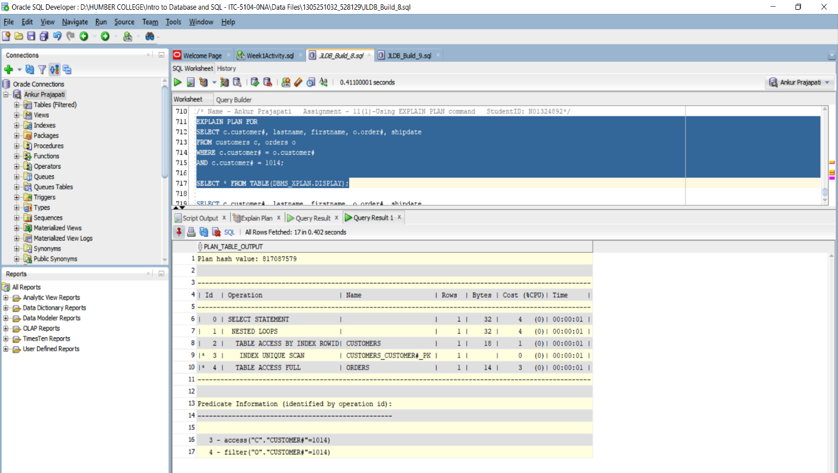

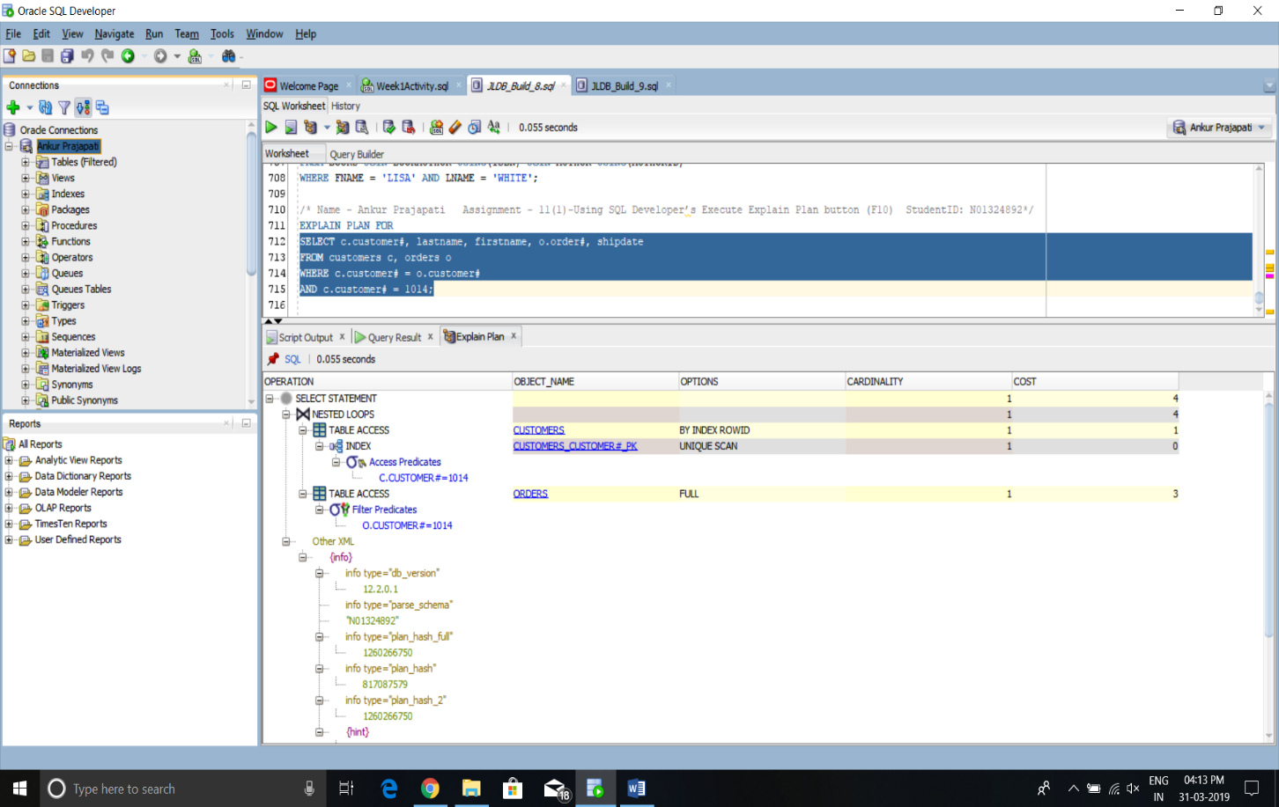

1. Using the EXPLAIN PLAN command (SQL statement).

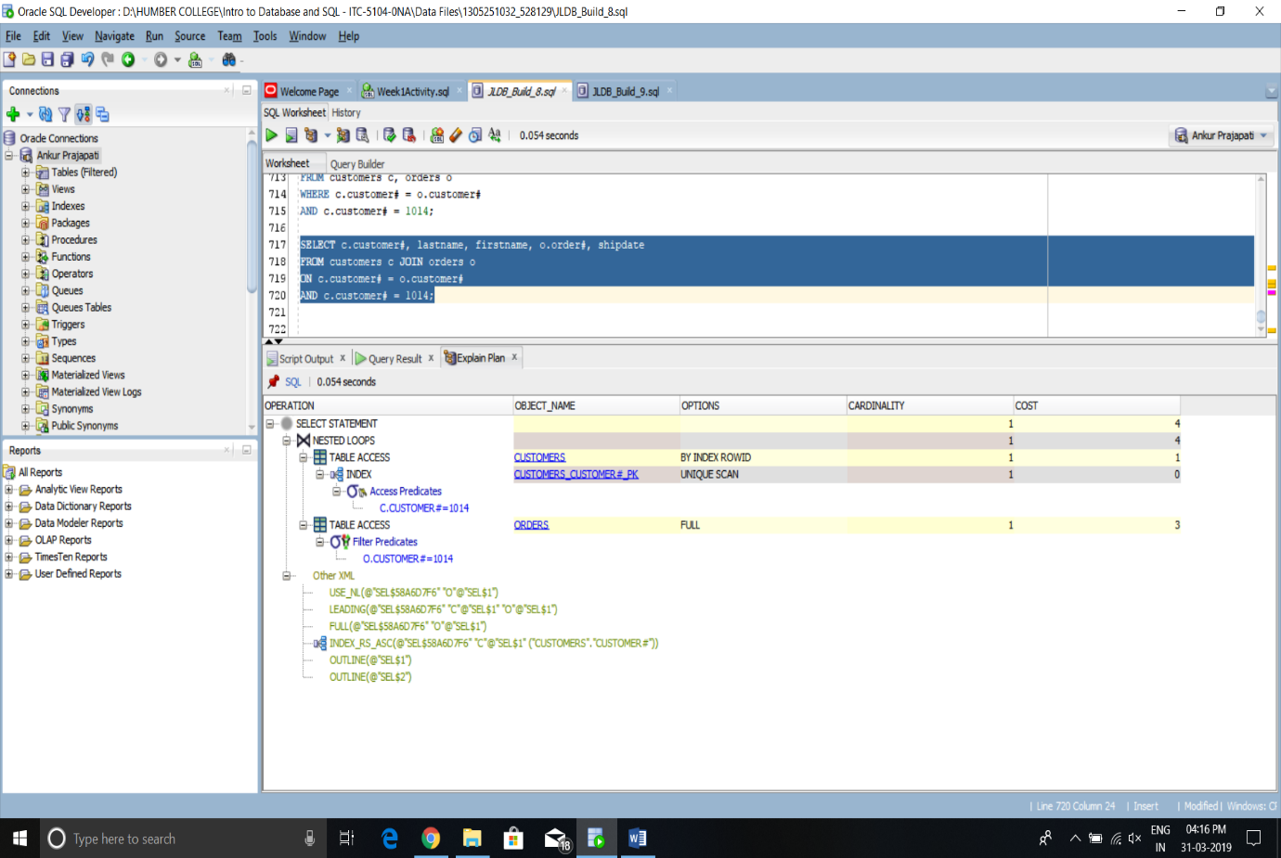

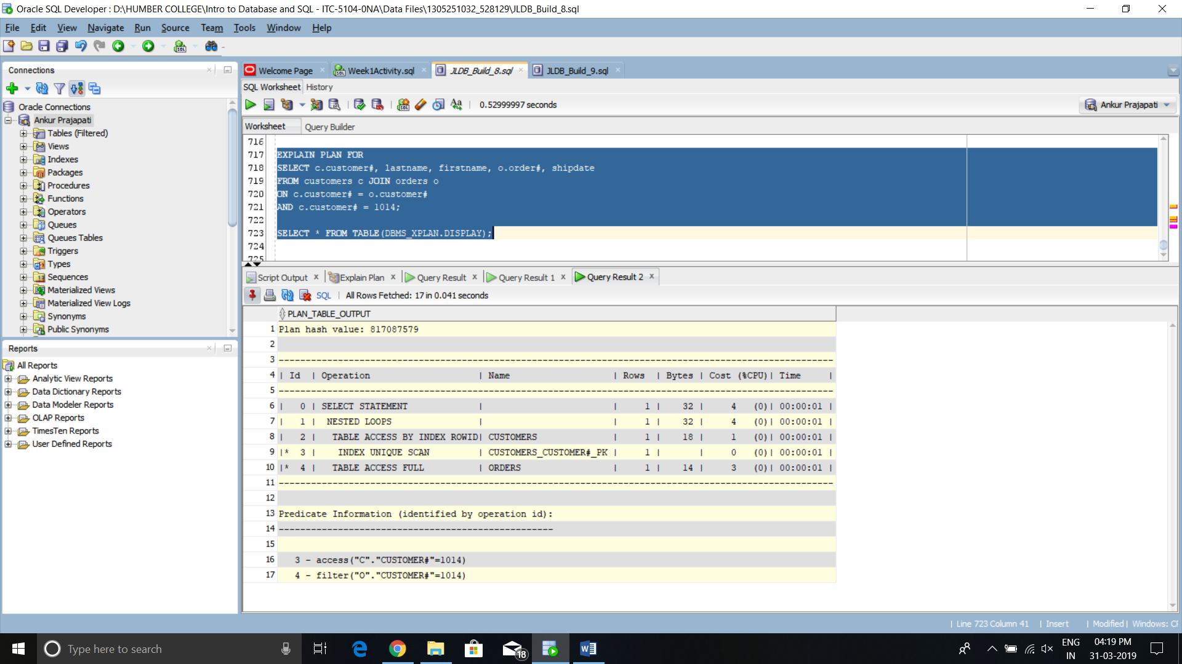

1. Display the generated explain plan information stored in a table named PLAN_TABLE:

