ITC 5104 Database Design and SQL

Hands-On Assignment# 9

1. Produce a list of all customer names in which the first letter of the first and last names is in uppercase and the rest are in lowercase.

**SELECT INITCAP(Firstname), INITCAP(Lastname) FROM CUSTOMERS;**

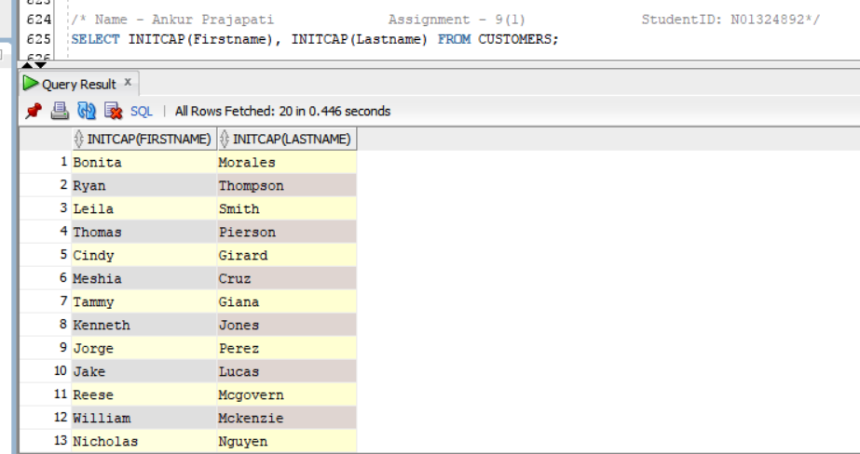

1. Create a list of all customer numbers along with text indicating whether the customer has been referred by another customer. Display the text “NOT REFERRED” if the customer wasn’t referred to JustLee Books by another customer or “REFERRED” if the customer was referred.

**SELECT firstname, lastname, NVL2(referred,'REFERRED', 'NOT REFERRED') as "Referred Status" FROM customers;**

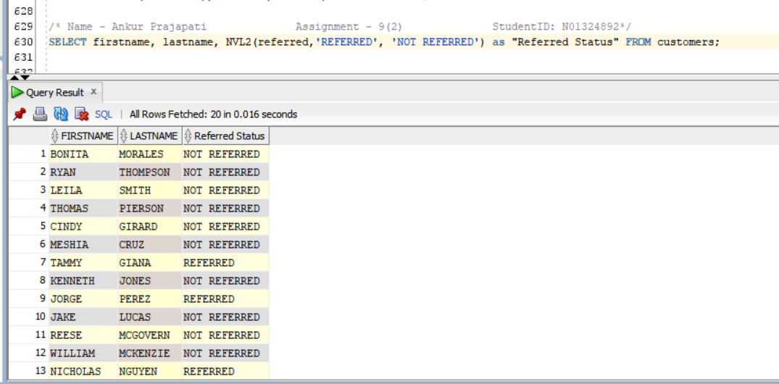

1. Determine the amount of total profit generated by the book purchased on order 1002. Display the book title and profit. The profit should be formatted to display a dollar sign and two decimal places. Take into account that the customer might not pay the full retail price, and each item ordered can involve multiple copies.

**SELECT title, TO_CHAR(quantity*(paideach-cost),'$999.99') AS "PROFIT" FROM books JOIN orderitems using(ISBN) WHERE order# = 1002;**

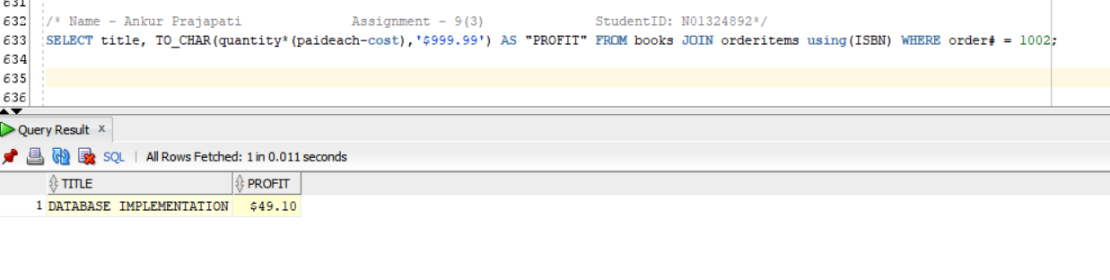

1. Display a list of all book titles and the percentage of markup for each book. The percentage of markup should be displayed as a whole number (that is, multiplied by 100) with no decimal position, followed by a percent sign (for example, .2793 = 28%). (The percentage of markup should reflect the difference between the retail and cost amounts as a percent of the cost.)

**SELECT title, ROUND((retail-cost)/cost*100,0)||'%' AS "Markup percentage" FROM BOOKS;**

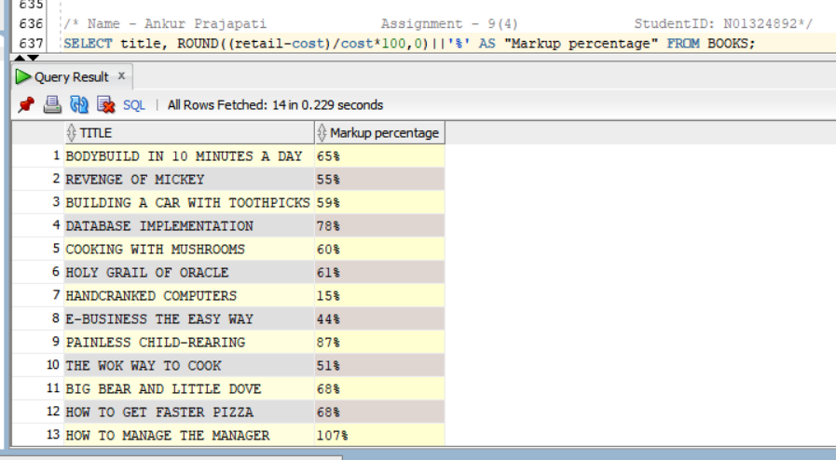

1. Display the current day of the week, hour, minutes, and seconds of the current date setting on the computer you’re using.

**SELECT TO_CHAR(current_date,'day.HH:MI:SS') AS "Current Day and Time"**

**from dual;**

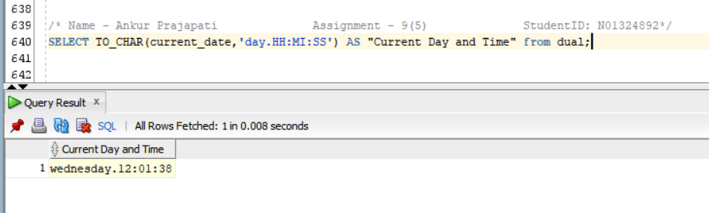

1. Create a list of all book titles and costs. Precede each book’s cost with asterisks so that the width of the displayed Cost field is 12.

**SELECT title, LPAD(cost,12,'*') AS "COST" FROM BOOKS;**

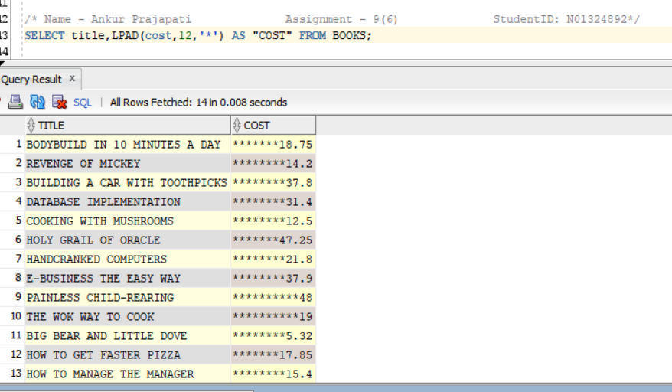

1. Determine the length of data stored in the ISBN field of the BOOKS table. Make sure each different length value is displayed only once (not once for each book).

**SELECT DISTINCT LENGTH(ISBN) AS "DataLength in ISBN" FROM BOOKS;**

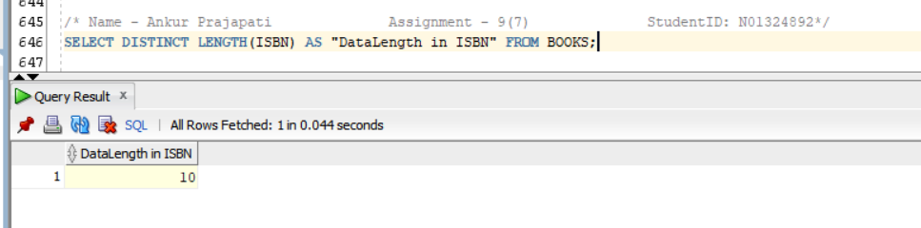

1. Using today’s date, determine the age (in months) of each book that JustLee sells. Make sure only whole months are displayed; ignore any portions of months. Display the book title, publication date, current date, and age.

**SELECT title, pubdate, SYSDATE, TRUNC(MONTHS_BETWEEN(SYSDATE, pubdate),0)Age FROM BOOKS;**

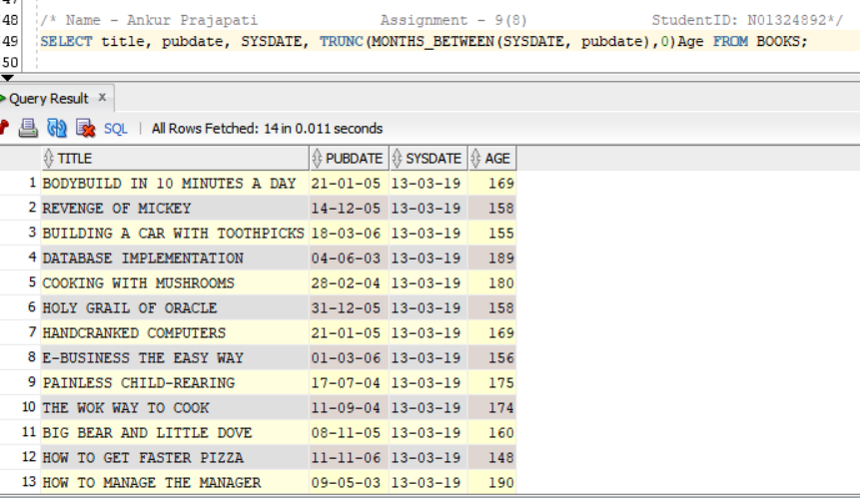

1. Determine the calendar date of the next occurrence of Wednesday, based on today’s date.

**SELECT NEXT_DAY(SYSDATE,'WEDNESDAY') AS "NEXT WEDNESDAY" FROM DUAL;**

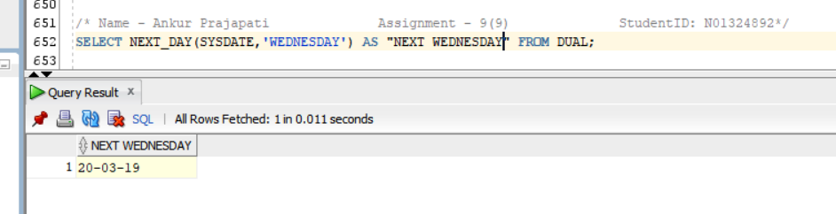

1. Produce a list of each customer number and the third and fourth digits of his or her zip code. The query should also display the position of the first occurrence of a 3 in the customer number, if it exists.

**SELECT customer#, SUBSTR(zip,3,2) AS "3rd and 4th Digit in Zip Code", INSTR(customer#,3) AS "Position of the first occurrence of a 3 in customer#"**

**FROM customers;**

