**Assignment#13**

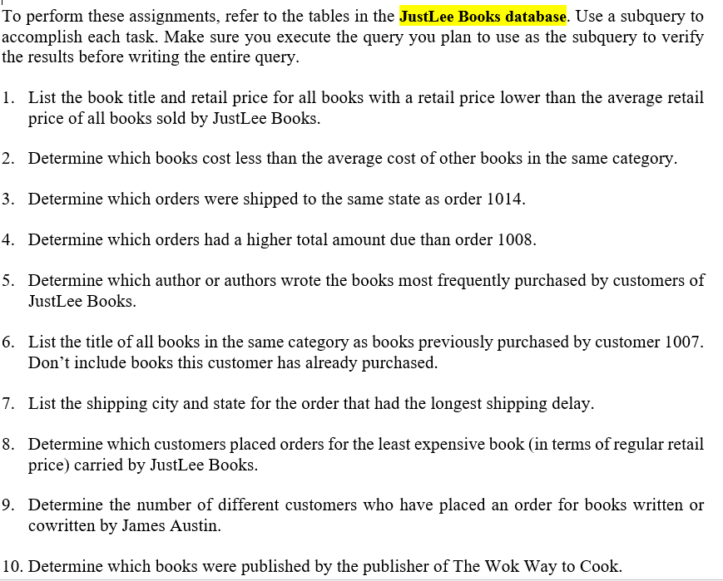

1. SELECT title, retail FROM books WHERE retail > (SELECT AVG (retail)FROM books);

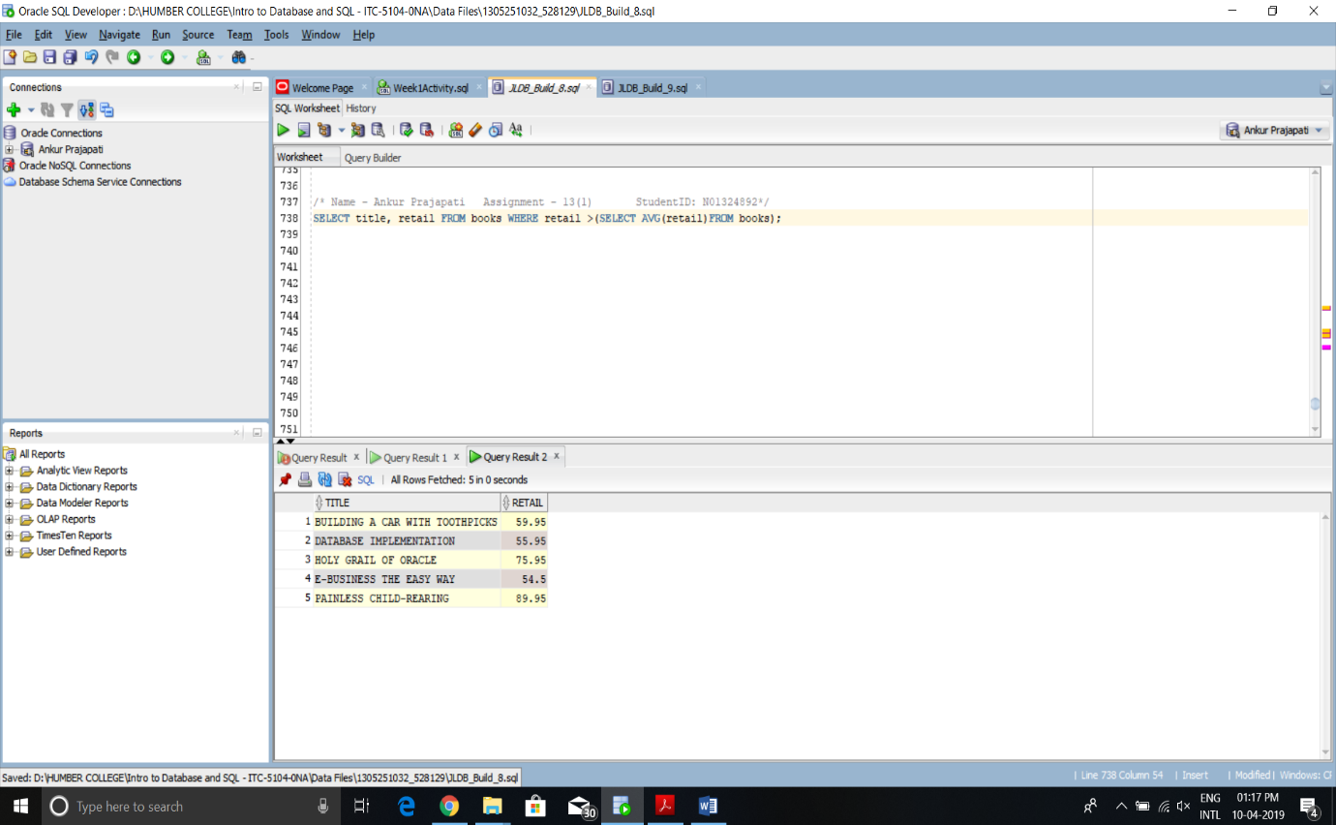

1. SELECT a.title, b.category, a.costFROM books a, (SELECT category, AVG(cost) averagecost FROM books GROUP BY category) b WHERE a.category = b.category AND a.cost < b.averagecost;

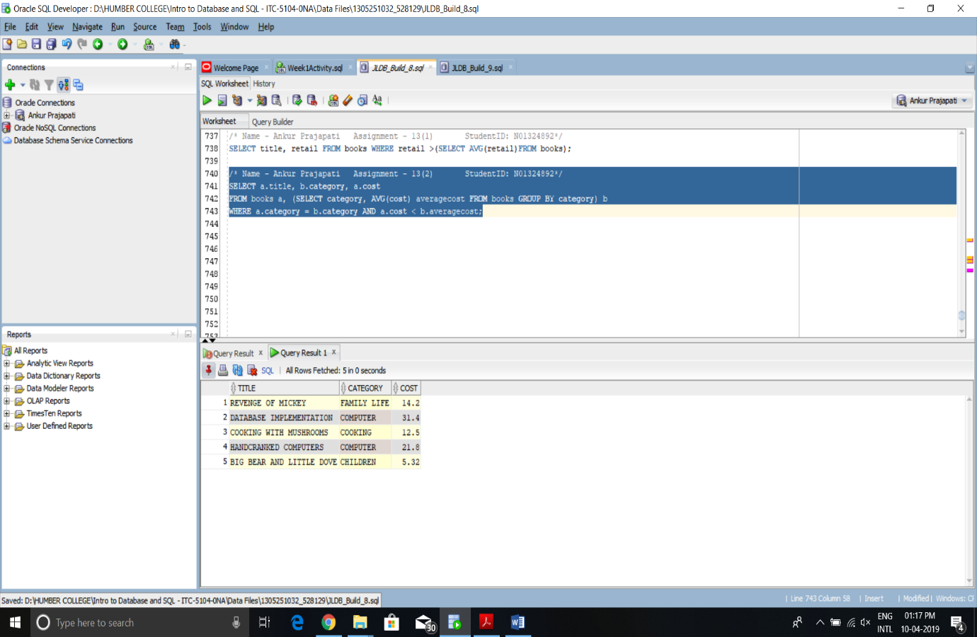

1. SELECT order# FROM orders WHERE shipstate = (SELECT shipstate FROM orders WHERE order# = 1014);

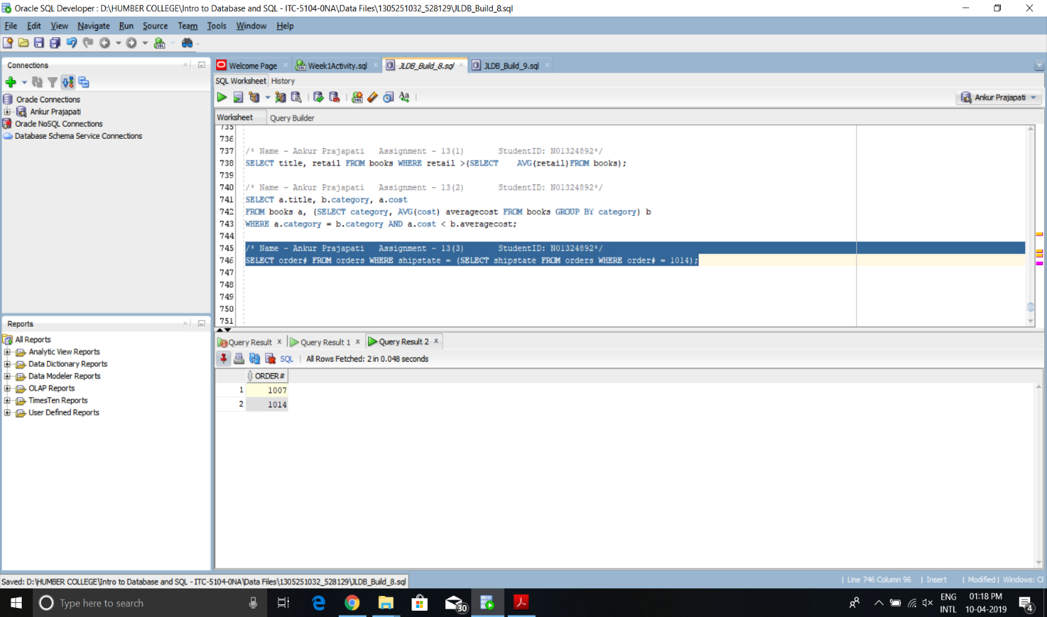

1. 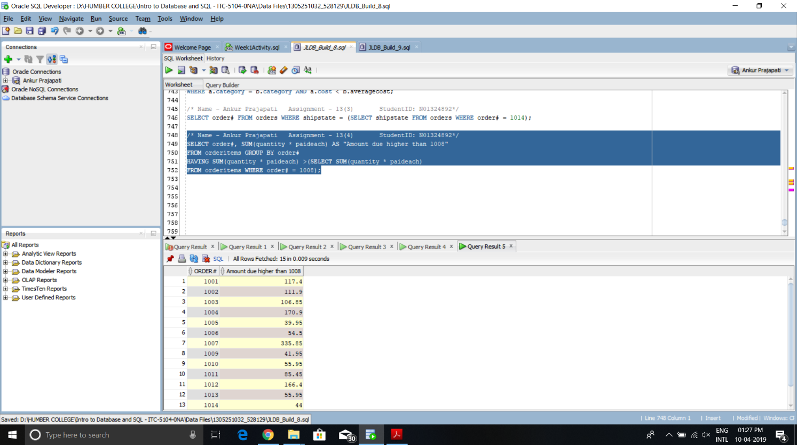SELECT order#, SUM(quantity * paideach) AS "Amount due higher than 1008" FROM orderitems GROUP BY order# HAVING SUM(quantity * paideach) > (SELECT SUM(quantity * paideach) FROM orderitems WHERE order# = 1008);
2. SELECT lname, fname FROM bookauthor JOIN author USING(authorid) WHERE isbn IN(SELECT isbn FROM orderitems GROUP BY isbn HAVING SUM(quantity)=(SELECT MAX(COUNT(*))FROM orderitems GROUP BY isbn));

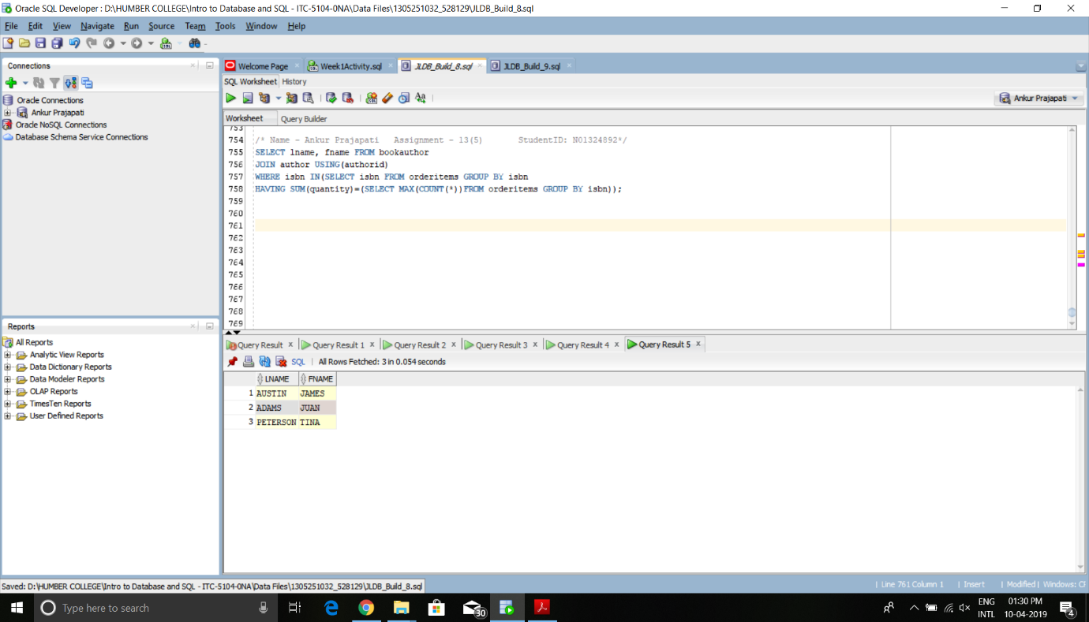

1. Select title From Books Where category IN (Select Distinct Category From Books Join orderitems using (isbn) JOIN Orders Using (order#) Where customer# = 1007) AND isbn NOT IN (Select isbn From orders Join Orderitems Using (order#) Where customer# = 1007);

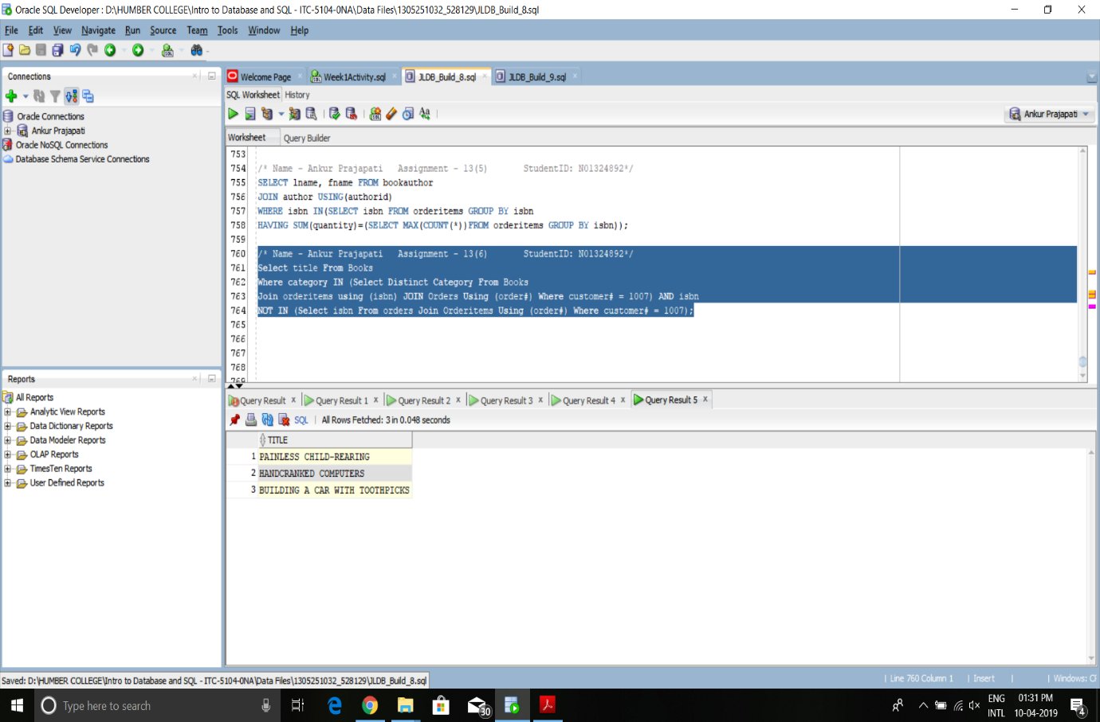

1. Select Shipcity, ShipState From Orders Where shipdate-orderdate = (Select MAX(shipdate-orderdate) From orders);

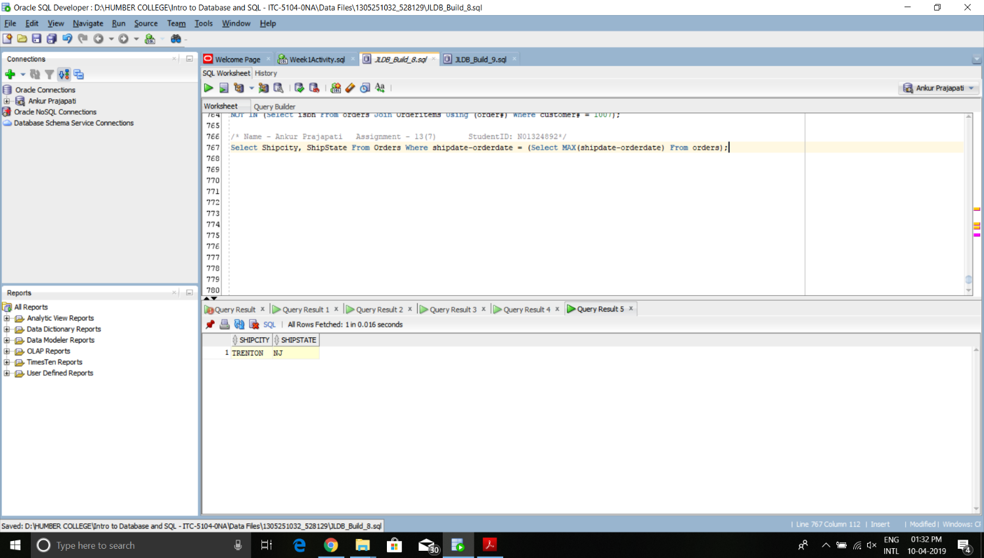

1. Select Firstname,Lastname, title From Customers Join Orders Using (customer#) Join orderitems Using (order#) Join books Using (isbn) Where retail = (Select Min (retail) from books);

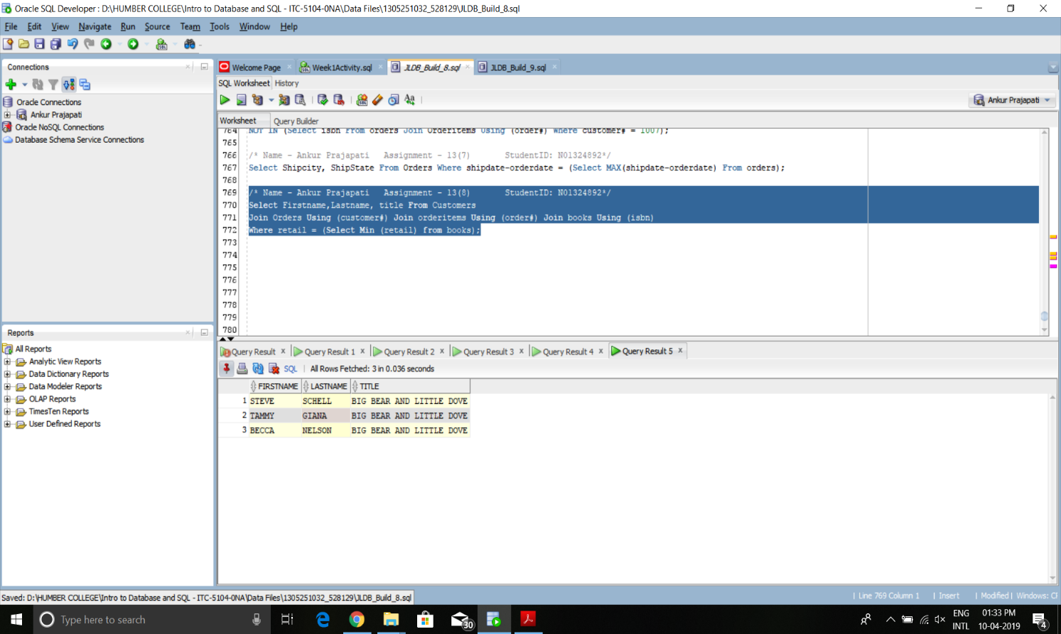

1. Select Count (Distinct Customer#) AS "Books written by James Austin" From Orders join orderitems using (order#) Where ISBN IN (select isbn From books join BOOKAUTHOR using (isbn) join Author using (authorid) WHERE lname= 'AUSTIN' AND fname = 'JAMES');

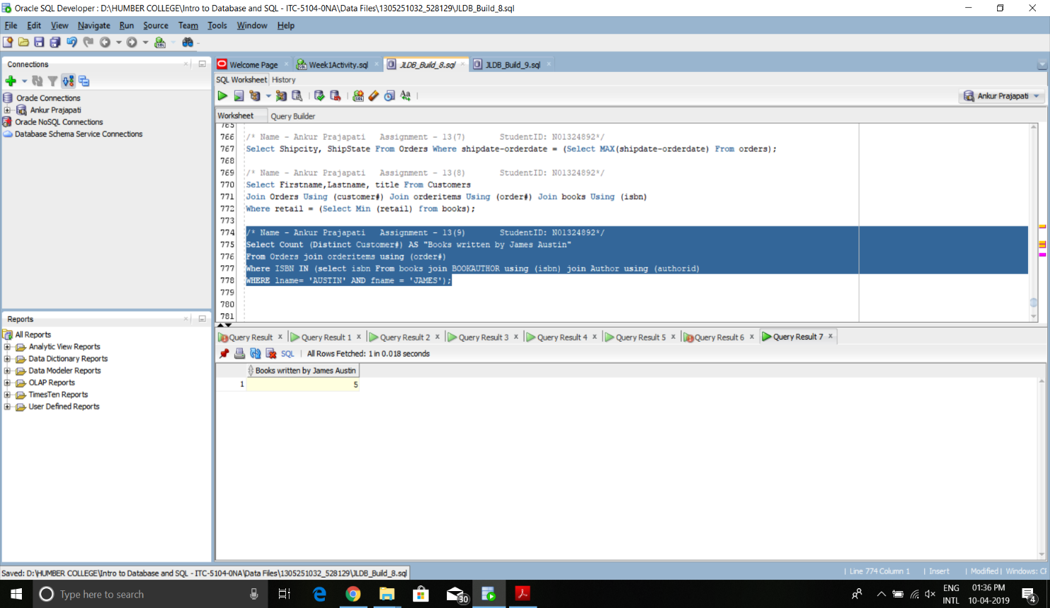

1. SELECT title FROM books WHERE pubid =(SELECT pubid FROM books WHERE title = 'THE WOK WAY TO COOK');

