**Question 1**

Normalize the following relation:

STUD_ID : Student’s Id number (unique)

NAME : Name of student

BATCH_NO : Batch number (student can belong to only one batch)

SLOT : Time and day during which the batch of students attends class

MODULE: : Module or subject (one batch will do several modules)

MARKS : Marks obtained in a module test

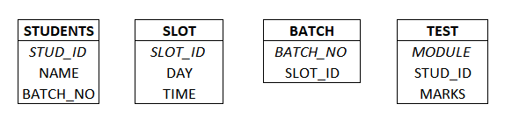

|  |  |  |
| --- | --- | --- |
| **Table Name: STUDENTS** | | |
| STUD_ID | NAME | BATCH_NO |
| (Student’s ID number(unique)) | Name of Student | Batch number |

|  |  |  |
| --- | --- | --- |
| **Table Name: SLOT** | | |
| SLOT_ID | DAY | TIME |
| (Slot’s ID number) | (Day of a particular slot) | (Timing of a particular slot) |

|  |  |
| --- | --- |
| **Table Name: BATCH** | |
| BATCH_NO | SLOT_ID |
| (Batch number of a particular batch) | (Slot’s ID number) |

|  |  |  |
| --- | --- | --- |
| **Table Name: TEST** | | |
| MODULE | STUD_ID | MARKS |
| (Module of a subject) | (Student’s ID number) | (Marks Obtained in a module) |

**Question 2**

In any payroll system it is normal to retain a copy of the pay-slip printed for each employee. A sample pay-slip is reproduced here:

= = = = = = = = = = = = = = = = = = = = = = = = = = = = = = = = = = = = = = = = = = = = =

XYZ Co. MONTH: APRIL’2019

NAME : JOHN DOE EARNINGS DEDUCTIONS

EMPNO : 083 BASIC : 1400 CPP Contrib : 10%

GRADE : A3 HRA (40%) : 560 CPP Amount : 140

BASIC : 1400 CCA (10%) : 140

LEAVE Availed Balance

CL : 4 8

EL : 4 6 Total : 2100 Total : 140

LWP: - - NET PAY :$1960.00

= = = = = = = = = = = = = = = = = = = = = = = = = = = = = = = = = = = = = = = = = = = = =

Note: CL – Casual Leave EL – Earned Leave LWP – Leave without Pay

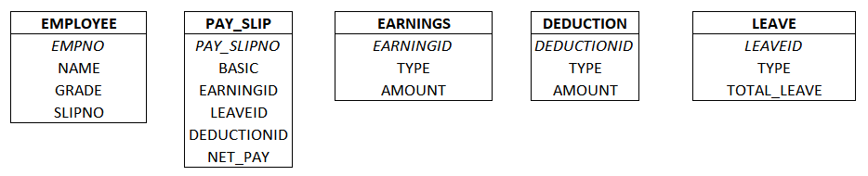

|  |  |  |  |
| --- | --- | --- | --- |
| **Table Name: EMPLOYEE** | | | |
| EMPNO | NAME | GRADE | SLIPNO |
| (Employee’s number(unique)) | Name of an Employee | Grade of an Employee | (Employee’s Slip number) |

|  |  |  |  |  |  |
| --- | --- | --- | --- | --- | --- |
| **Table Name: PAY_SLIP** | | | | | |
| PAY_SLIPNO | BASIC | EARNINGSNO | LEAVENO | DEDUCTIONNO | NET_PAY |
| (Pay Slip number of an Employee) | Basic Pay of an Employee | Earning ID of an Employee | (Employee’s Leave number) | (Deduction of an Employee) | (Total NET PAY of an Employee) |

|  |  |  |
| --- | --- | --- |
| **Table Name: EARNINGS** | | |
| EARNINGSNO | EARNING_TYPE | EARNING_AMOUNT |
| (Earning ID of an Employee) |  | (Total Amount Earned) |

|  |  |  |
| --- | --- | --- |
| **Table Name: DEDUCTION** | | |
| DEDUCTIONSNO | DEDUCTION _TYPE | DEDUCTION _AMOUNT |
| (Deducting ID of an Employee) | (Deduction Type) | (Total Deduction Amount) |

|  |  |  |
| --- | --- | --- |
| **Table Name: LEAVE** | | |
| LEAVENO | LEAVE_TYPE | TOTAL_LEAVE |
| (Employee’s Leave number) | (CL, EL, LWP) | (Total Leave) |

Give the third normal form for the table structure(s) that would hold the pay-slip data shown above.

**Question 3**

The Bill table contains: The Customer table has:

Bill No Customer Name

Customer Name Address

Date Customer Rating

Item No Phone Number

Quantity Contact Person

Rate

Value

Discount Rate

Discount Amount

Net amount

= = = = = = = = = = = = = = = = = = = = = = = =

CUSTOMER RATING DISCOUNT RATE

A 5%

B 3%

C 1%

D NIL

= = = = = = = = = = = = = = = = = = = = = = = =

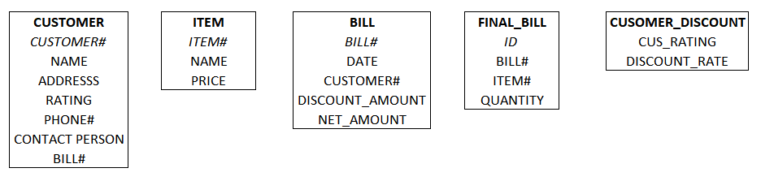

|  |  |  |  |  |  |  |
| --- | --- | --- | --- | --- | --- | --- |
| **Table Name: CUSTOMER** | | | | | | |
| CUSTOMER# | NAME | ADDRESS | RATING | PH# | CONTACT PERSON | BILL# |
|  |  |  |  |  |  |  |

|  |  |  |
| --- | --- | --- |
| **Table Name: ITEM** | | |
| ITEM# | NAME | PRICE |
|  |  |  |

|  |  |  |  |  |
| --- | --- | --- | --- | --- |
| **Table Name: BILL** | | | | |
| BILL# | DATE | CUSTOMER# | DISCOUNT_AMOUNT | NET_AMOUNT |
|  |  |  |  |  |

|  |  |  |  |
| --- | --- | --- | --- |
| **Table Name: FINAL BILL** | | | |
| ID | BILL# | ITEM# | QUANTITY |
|  |  |  |  |

|  |  |
| --- | --- |
| **Table Name: CUSTOMER_DISCOUNT** | |
| CUSTOMER_RATING | DISCOUNT_RATE |
|  |  |