**Hands on Assignment#6**

To perform the following assignments, refer to the tables created in the JLDB_Build_5.sql script at the beginning of the chapter.

1. Add a new row in the ORDERS table with the following data: Order# = 1021, Customer# = 1009, and Order date = July 20, 2009.

**Answer.**

**Insert INTO Orders(Order#, Customer#, ORDERDATE) VALUES ('1021', '1009', '20-Jul-2009');**

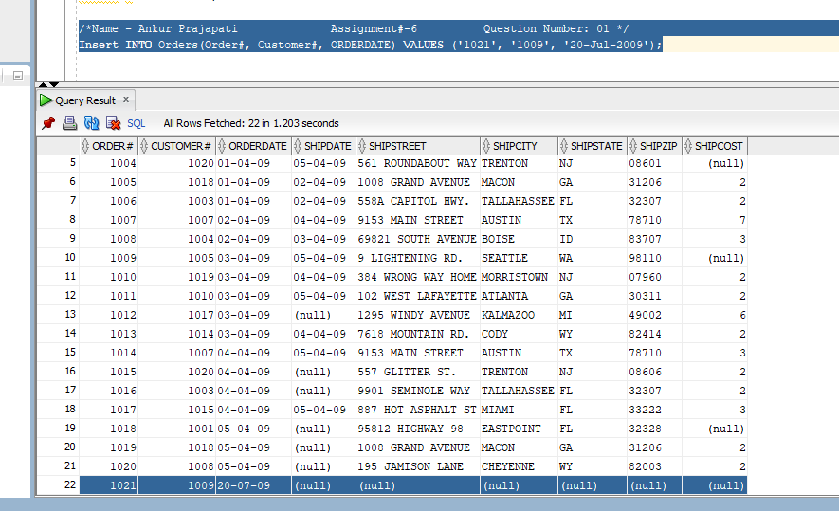

1. Modify the zip code on order 1017 to 33222.

**Answer.**

**Update Orders SET SHIPZIP = 33222 WHERE ORDER# = 1017;**

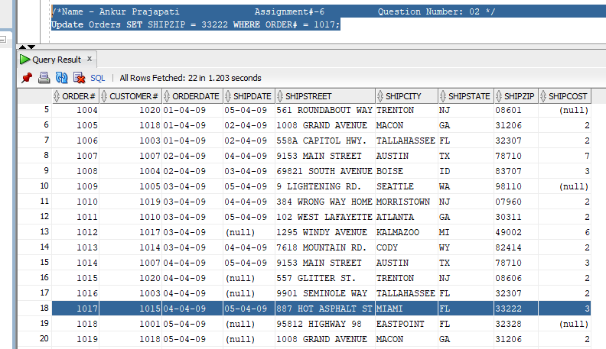

1. Save the changes permanently to the database.

**Answer.**

**COMMIT;**

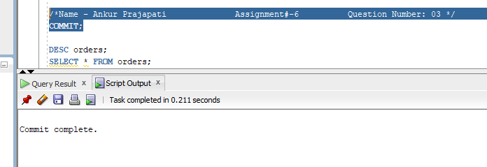

1. Add a new row in the ORDERS table with the following data: Order# = 1022, Customer# = 2000, and Order date = August 6, 2009. Describe the error raised and what caused the error.

**Answer.**

**Insert INTO Orders(Order#, Customer#, ORDERDATE) VALUES ('1022', '2000', '06-AUG-2009'); GIVES AN ERROR.**

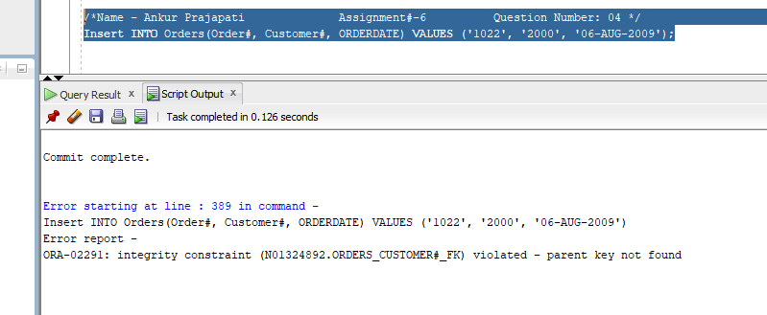

**Error Report:**

**ORA-02291: integrity constraint (N01324892.ORDERS_CUSTOMER#_FK) violated - parent key not found**

**Error raised because our Foreign key value has no matching primary key value. To add this new raw we have to add matching key for this foreign key or we should delete the foreign key.**

1. Add a new row in the ORDERS table with the following data: Order# = 1023 and Customer# = 1009. Describe the error raised and what caused the error.

**Answer.**

**INSERT INTO ORDERS (Order#, customer#)VALUES ('1023', '1009'); GIVES AN ERROR.**

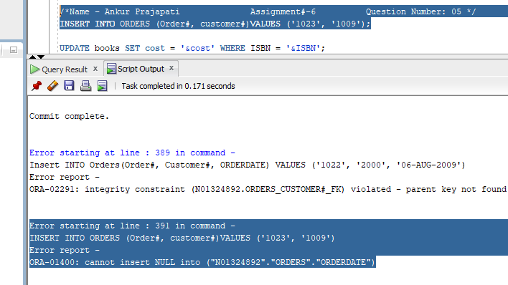

**Error Report:**

**ORA-01400: cannot insert NULL into ("N01324892"."ORDERS"."ORDERDATE")**

**Error Raised because we are trying to insert NULL into already listed objects. These objects can not accepts NULL values. We must have define orderdate column as NOT NULL. If we define a particular column NOT NULL then we have to put some value in each time we add a line.**

1. Create a script using substitution variables that allows a user to set a new cost amount for a book based on the ISBN.

**Answer.**

**UPDATE books SET cost = '&cost' WHERE ISBN = '&ISBN';**

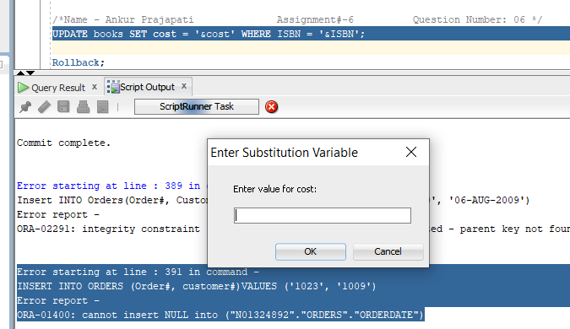

**Note: It will prompt a window to add cost followed by ISBN number of book.**

1. Execute the script and set the following values: isbn = 1059831198 and cost = $20.00.

**Answer.**

**UPDATE books SET cost = '&cost' WHERE ISBN = '&ISBN';**

Insert isbn = 1059831198 and cost = $20.00.

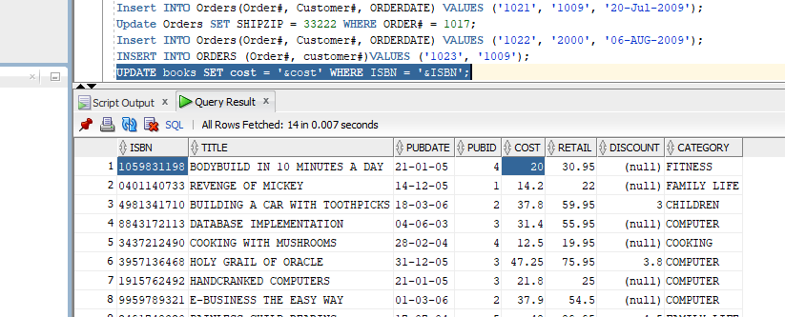

1. Execute a command that undoes the change in Step 7.

**Answer.**

**Rollback;**

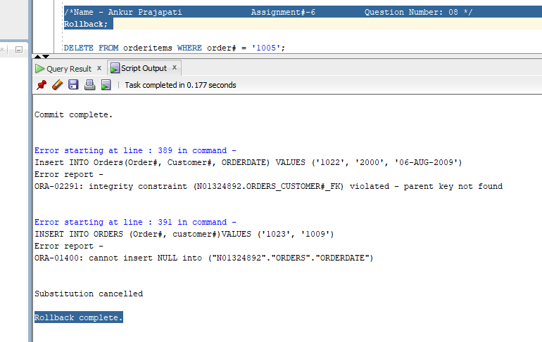

1. Delete Order# 1005. You need to address both the master order record and the related detail records.

**Answer.**

**DELETE FROM orderitems WHERE order# = '1005';**

**DELETE FROM orders WHERE order# = '1005';**

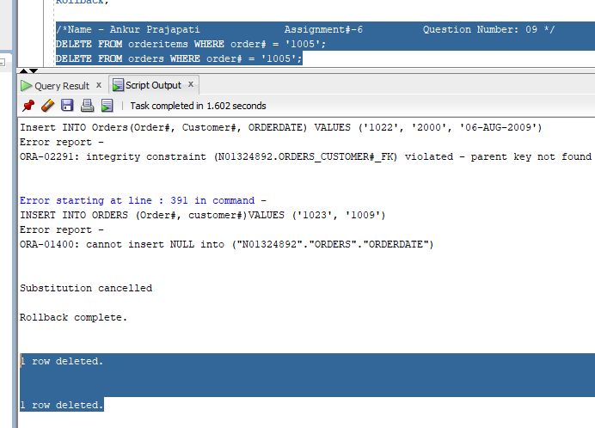

1. Execute a command that undoes the previous deletion.

**Answer.**

**Rollback;**

