Lab Assignment - 4

Name: Ankur Prajapati

StudentID: N01324892

1. 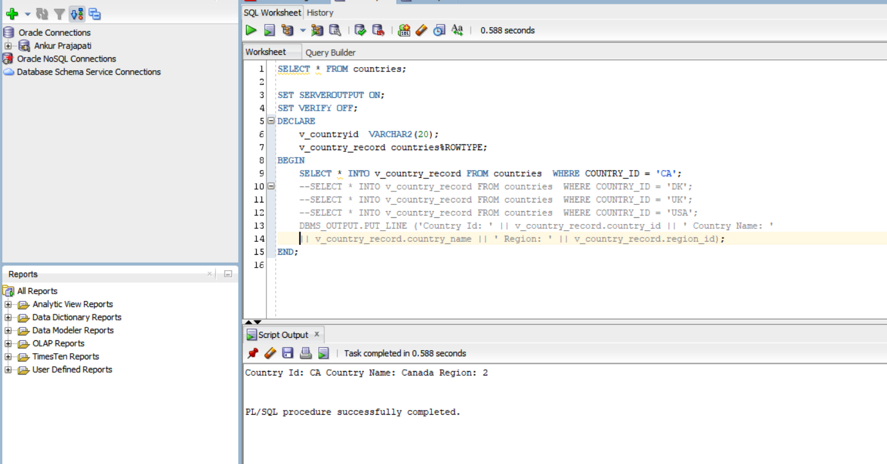**Step a to d:**

Here I have created variable v_countryid of type VARCHAR2 to store the information of the county id. Using that variable, I am printing record of Country ‘CA’. Note that the record v_country_record has the same type of table countries due to the %ROWTYPE.

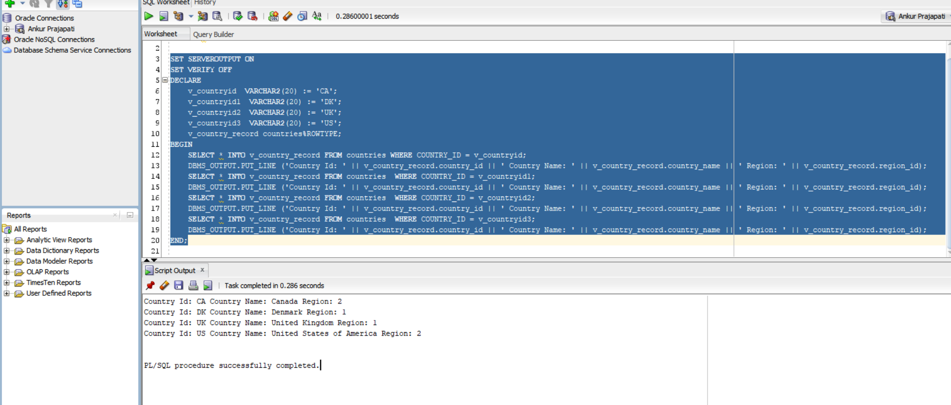**Step e:**

In step e, I am printing record related to the ‘ÇA’, ’DA’, ‘UK’, ‘US’.

1. 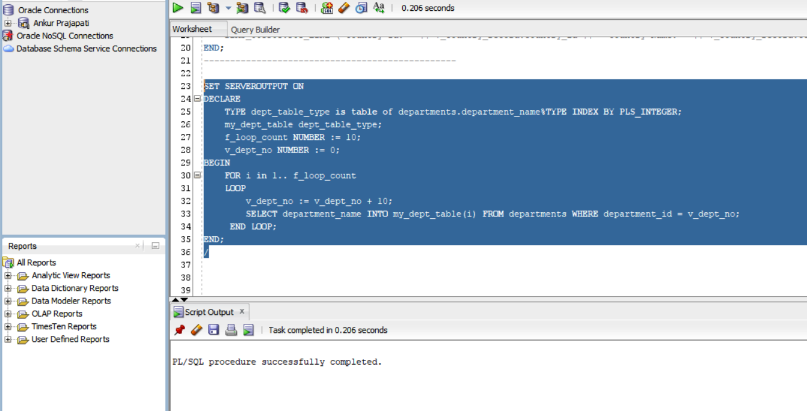**Step a to c:**

Here I have created dept_table_type and given the Index BY PLS_INTEGER and created two variables one for loop and other to increment the department number by 10.

In first loop it gets the value of department id and in second loop it gets the value of department name.

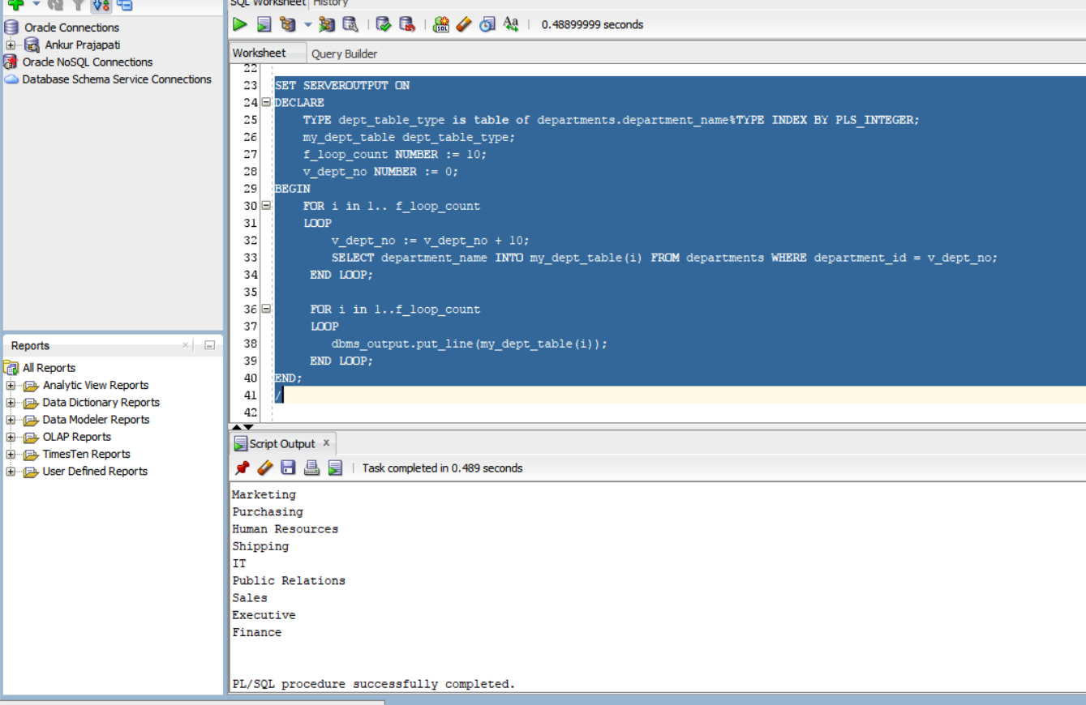**Step d:**

1. **Step a to c:**

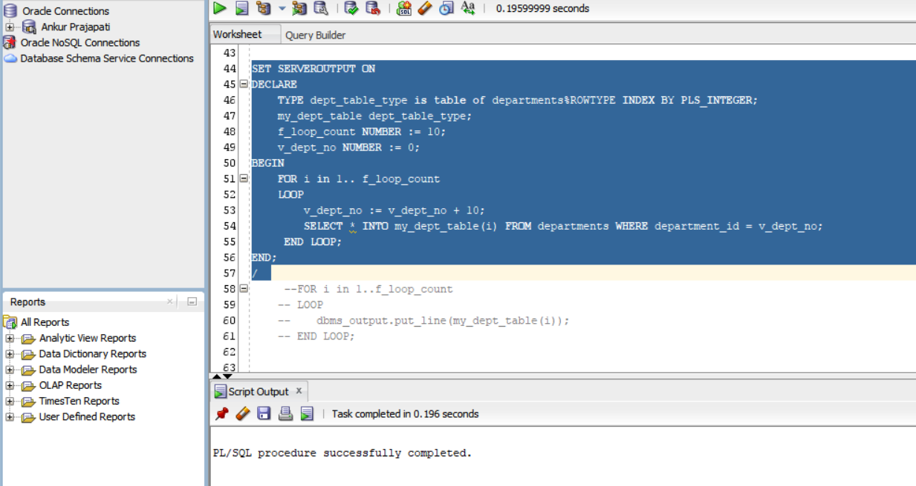

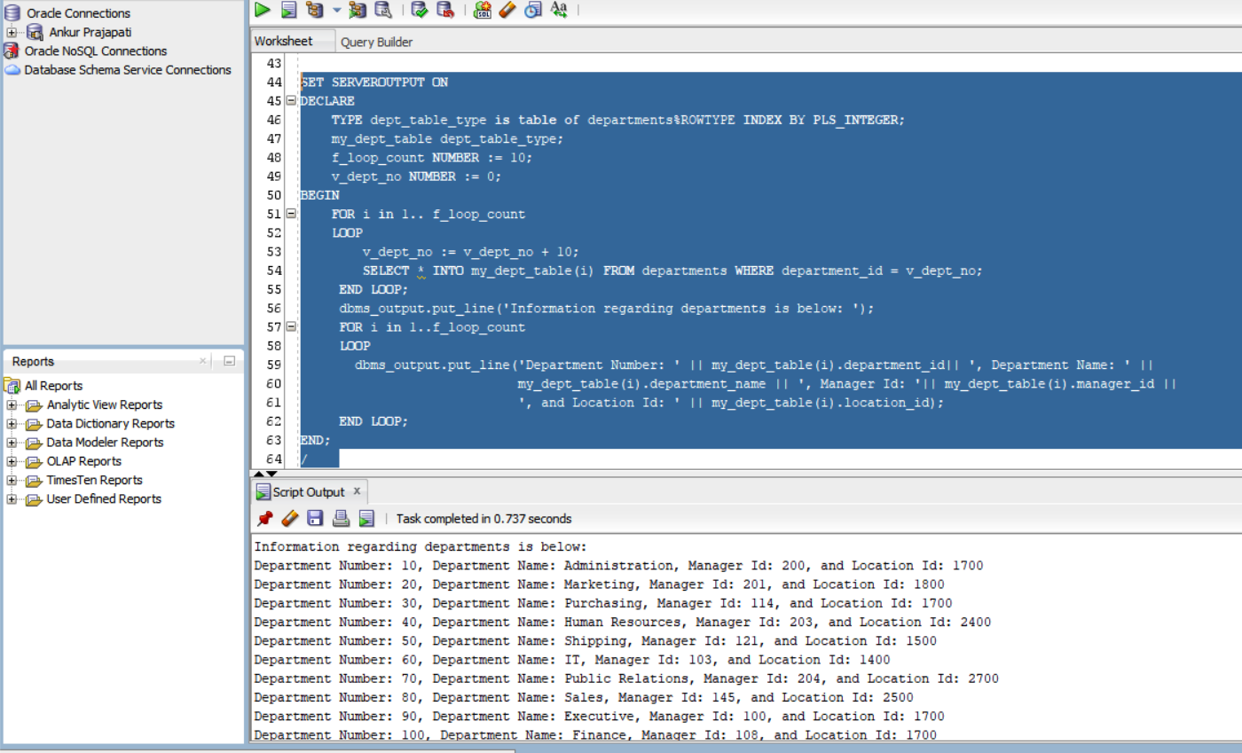Here I have modified the declaration part of dept_table_type to keep it same as the departments table using %ROWTYPE. Now instead of selecting only the department id I am storing all the values from the department table to my_dept_table using for Loop.

Because we are storing all the column information from the departments table now, we have to modify the second loop to print the column data in order to the records we have.