Practice 1:

Question 1:

Test Outputs:

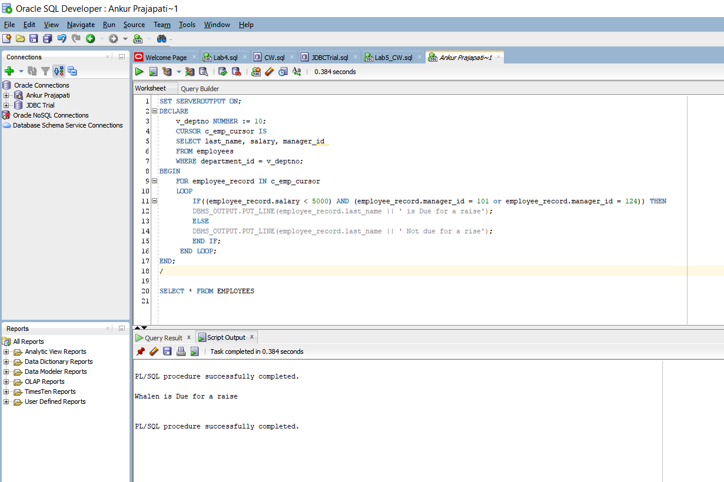

Here I have created CURSOR named c_emp_cursor and it selects last name, salary and manager id from employees where cdepartment id is same as v_deptno.

In executable section I used LOOP for employee_record in c_emp_cursor to print the output.

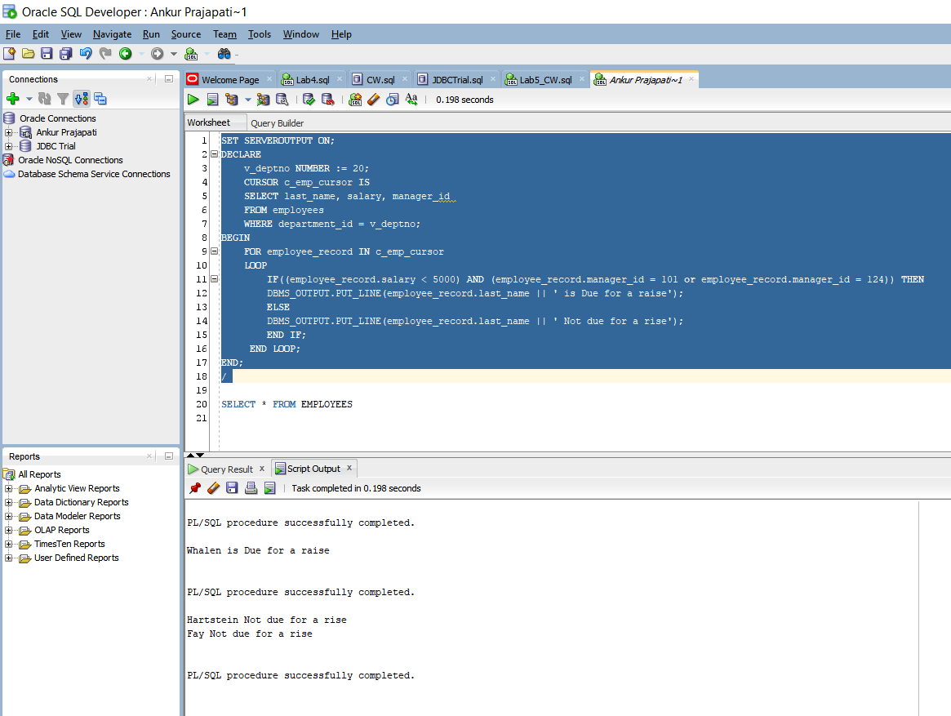

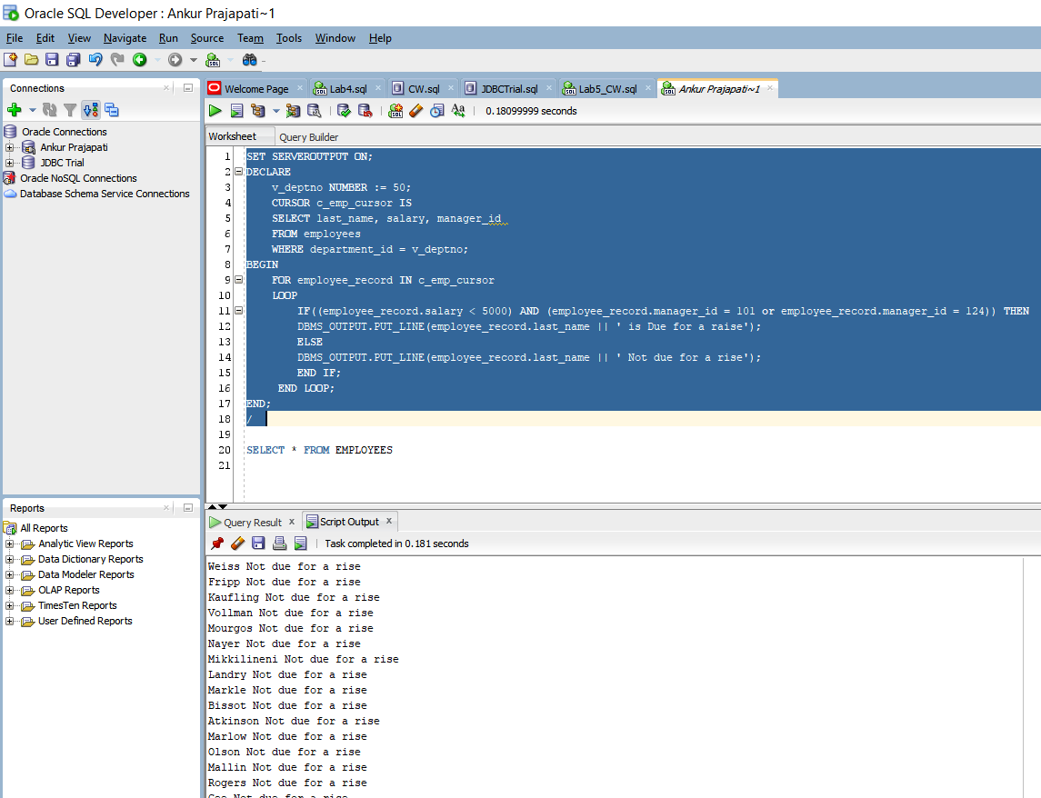

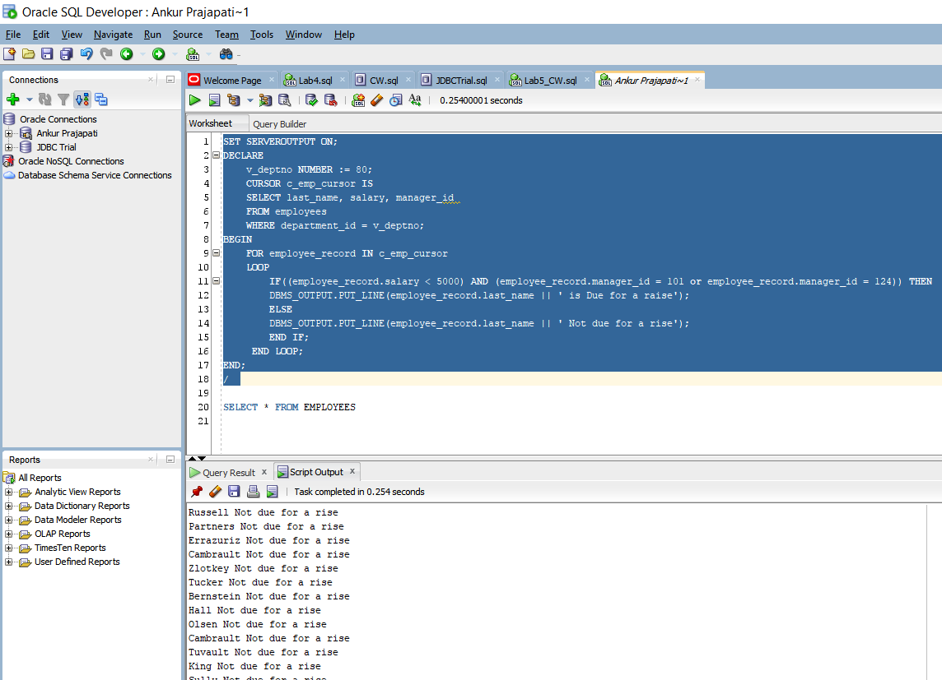

These above output shows for all the department id given in PDF.

Question 2:

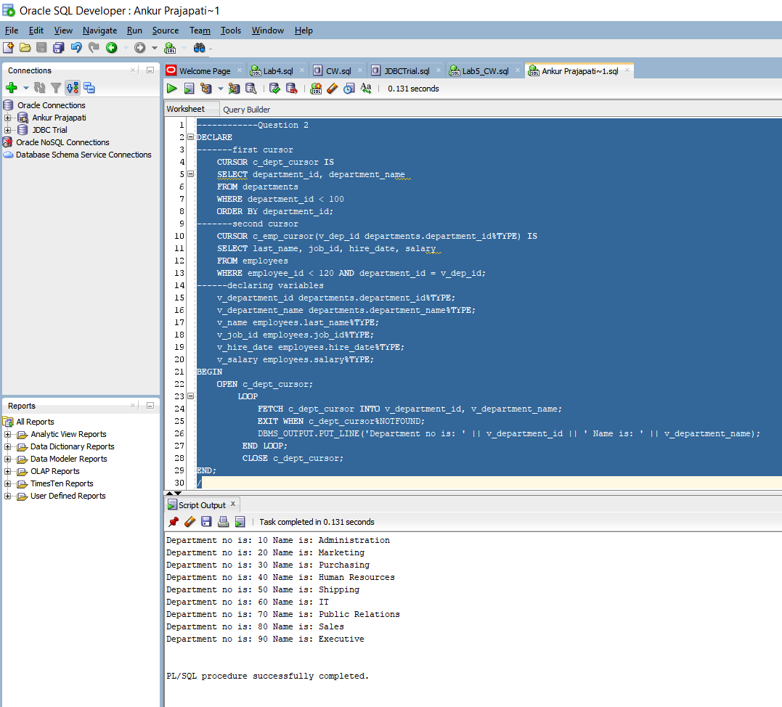

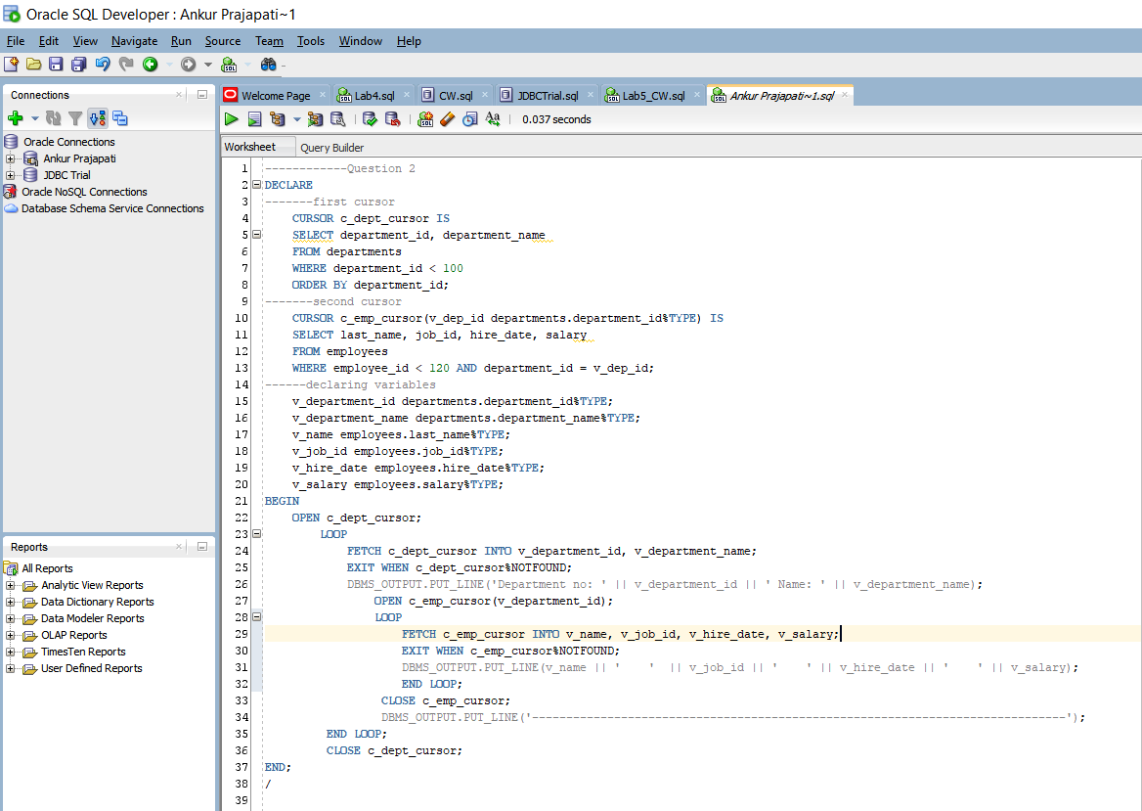

First, I declared cursor named c_dept_cursor which selects multiple rows where department id is less than 100. After that I declared second cursor named c_emp_cursor having parameter of v_dep_id which is having same data type of department_id column of department table.

After that I have declared variables as asked in PDF which will be used to print the output.

In Executable part I have opened c_dept_cursor and IN LOOP it fetches data from allocated data and if its not found then it will exit. When this cursor is opened, I opened another cursor c_emp_cursor with the parameter v_department_id and it fetches data and print it. If not found it will exit. It close Loop first and after that c_emp_cursor and after that it closes c_dept_cursor.

Output:

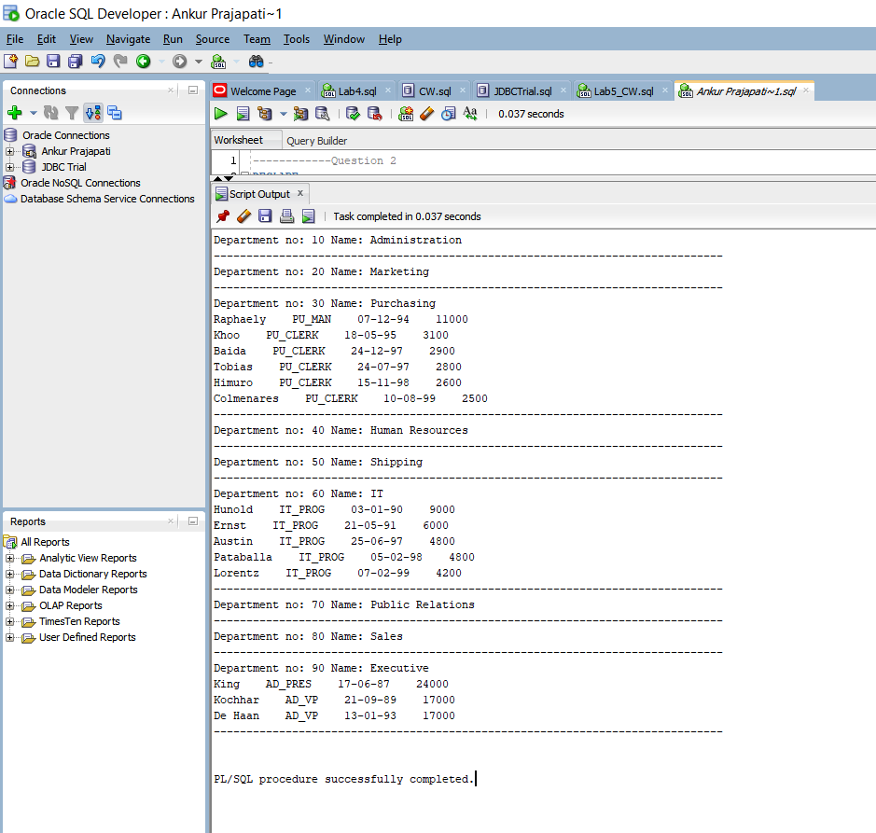

Practice 2:

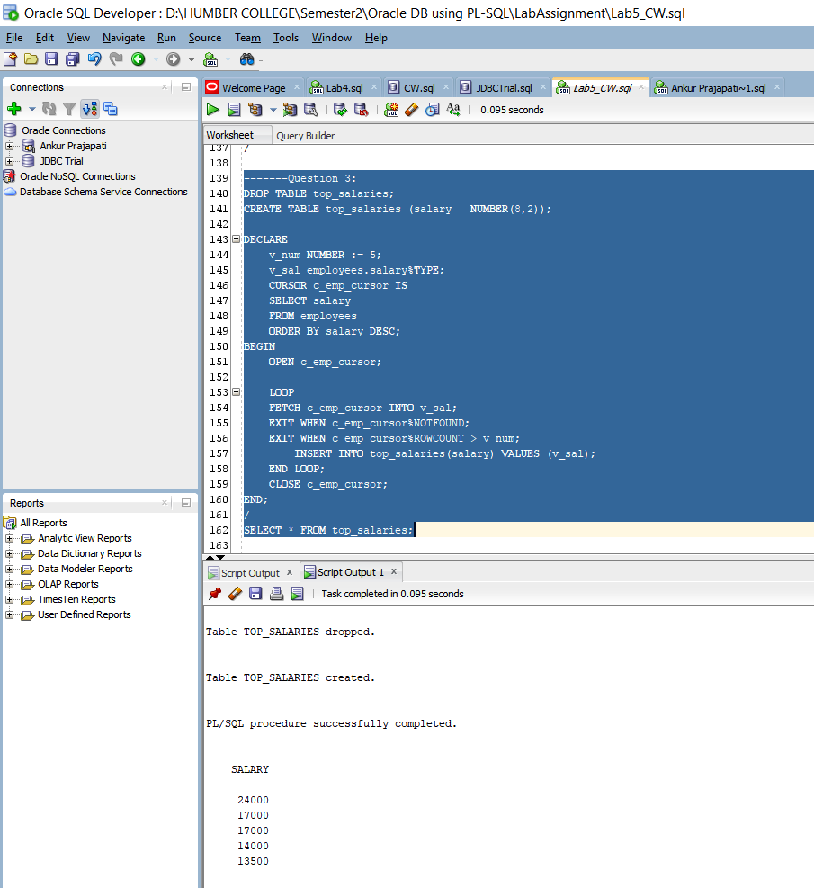

Here, I have created top_salaries table and declared cursor named c_emp_cursor which selects rows from employees table and orders it by salary in descending order. In executable section I am opening c_emp_cursor and in LOOP I am fetching it into v_sal variable where it stores the top 5 salaries. If c_emp_cursor is not found it will exit and if the %ROWCOUNT is grater than v_sal it will exit. At the end I closed the c_emp_cursor and used SELECT statement to print the top 5 salaries.

Practice 3:

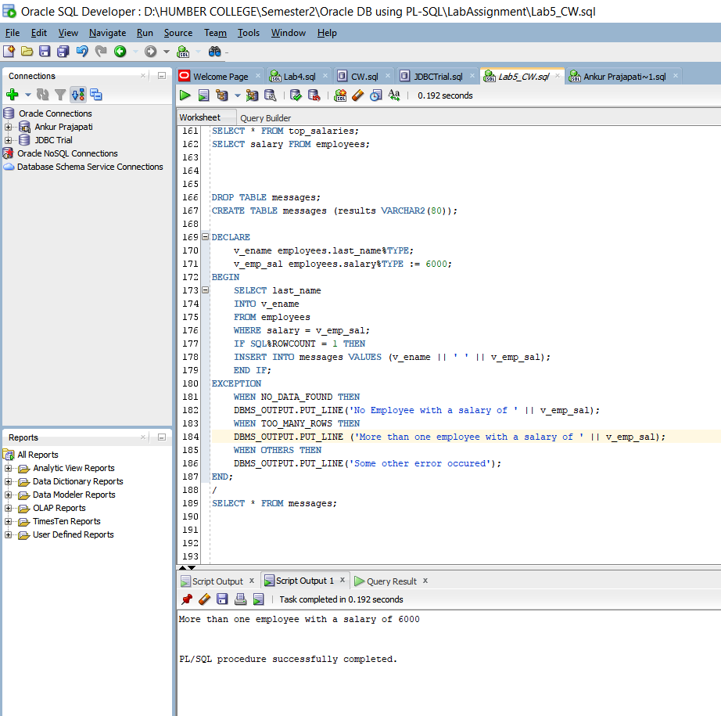

In declaration section v_emp_salary of employees.salary type is declared and initialized with 6000. Where in executable section it selects the row as per select statement and IF SQL%ROWCOUNT is 1 it will insert the sleceted data into message table.

In Exception section, there are three exceptions if the data is not found it will print, the message stored in NO_DATA_FOUND exception. If there are many rows then it will print the message stored in exception called TOO_MANY_ROWS. Suppose, anything else than these exceptions occurs it will show the exception message stored in OTHERS.

Note that here NO_DATA_FOUND and TOO_MANY ROWS are predefined exceptions of Orcale.

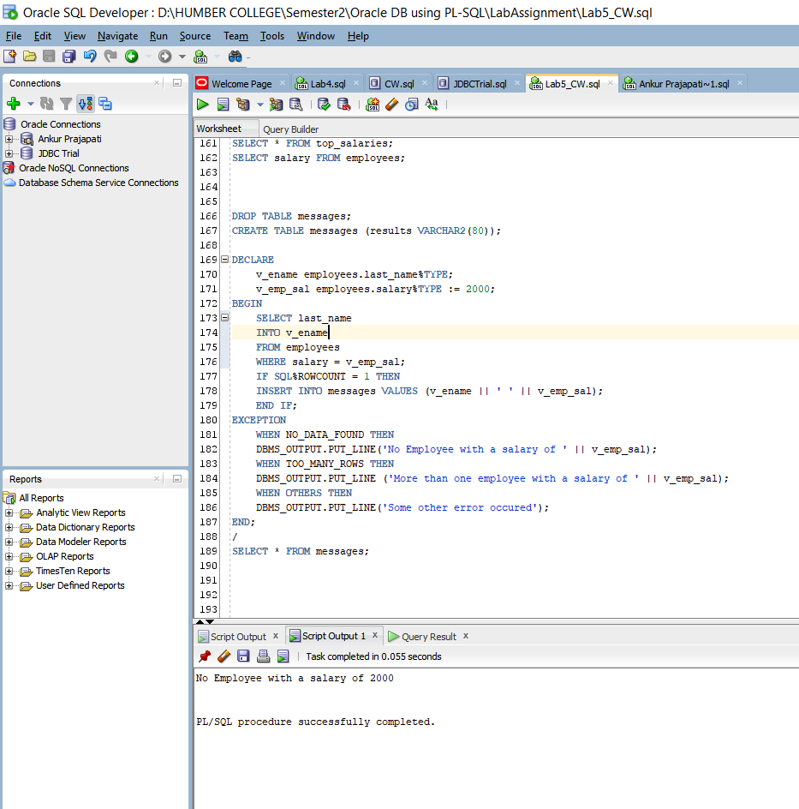

In here it prints message stored in exception NO_DATA_FOUND. Because there are no data with the salary 2000.

Practice 4:

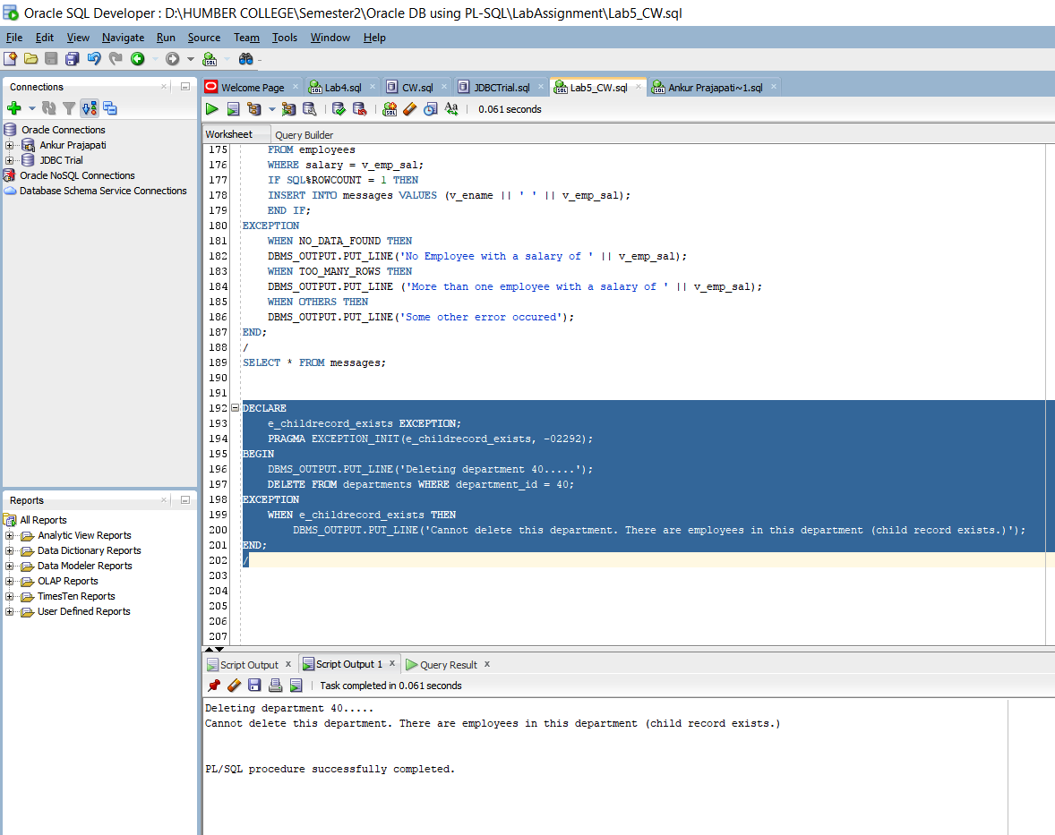

Here in declaration section I have declared e_childrecord_exists as an Exception. I used PRAGMA to link the declared exception with error code -2292. In executable section I am trying to delete data from departments tabloe where department id is 40. In Exception section I am printing the output message associated with that exception.