1. ADD_JOB Procedure:

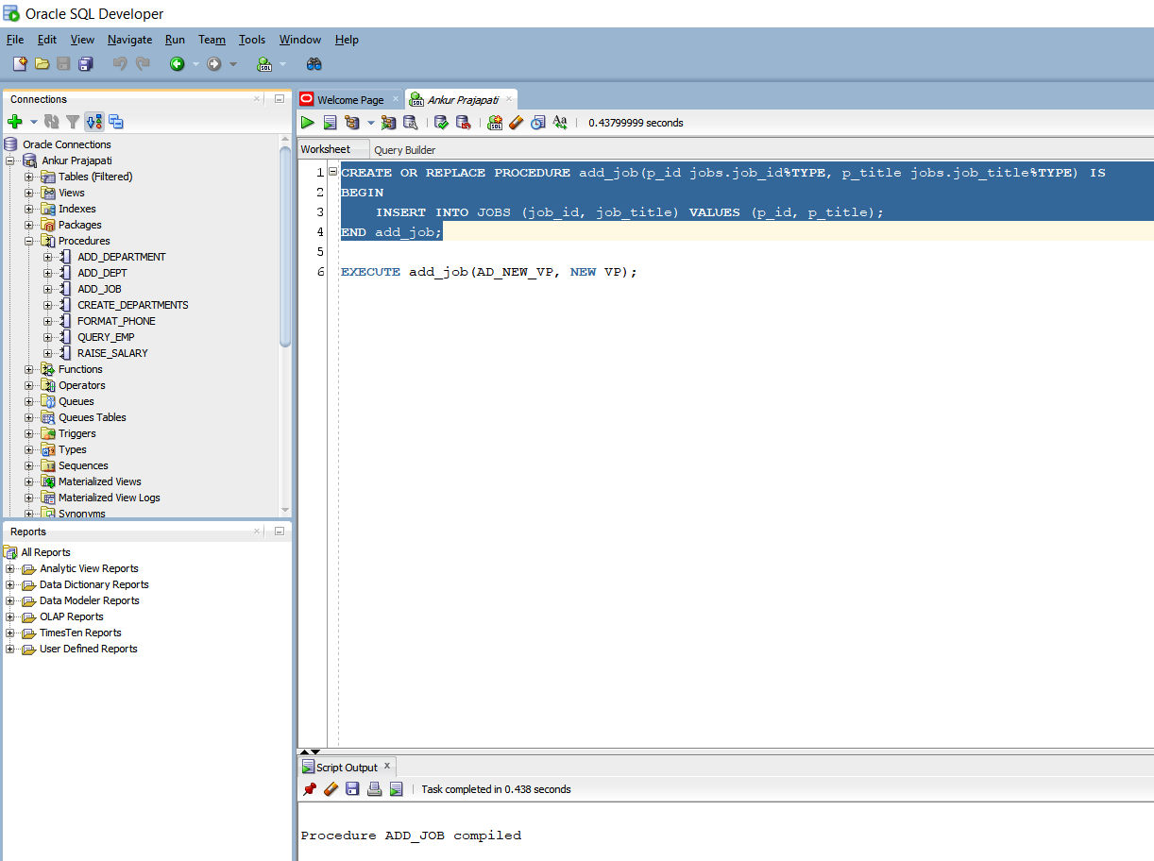

Here we are creating add_job procedure. As per the statement it will create new add_job procedure if it doesn’t exist otherwise it will drop it and again it will create. It will add job_id and job_title with using formal parameters p_id and p_title.

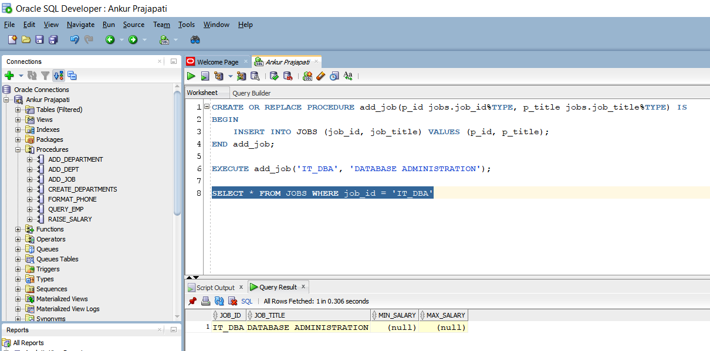

Here it will add new job with job_id having value of ‘IT_DBA’.

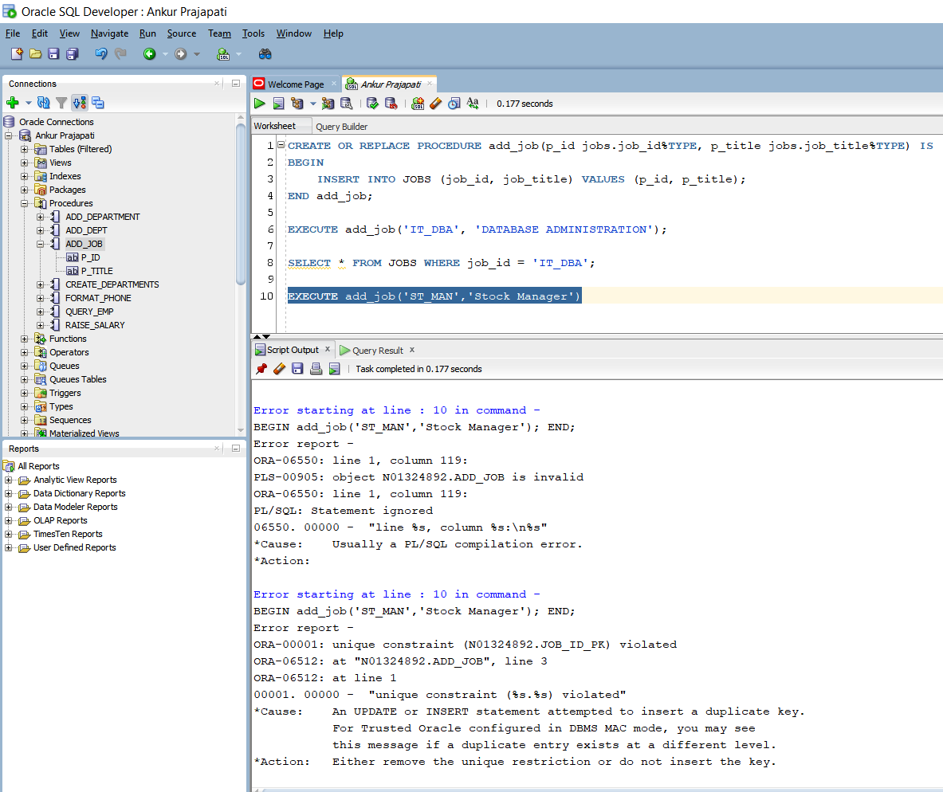

Here I am trying to add new job with job_id = ‘ST_MAN’ and job_title = ‘Stock Manager’ but it gives error of unique key constraint violation. It means there is same data with that job_id is available. It gives solution that either remove the unique restriction or do not insert the key.

1. UPD_JOB Procedure:

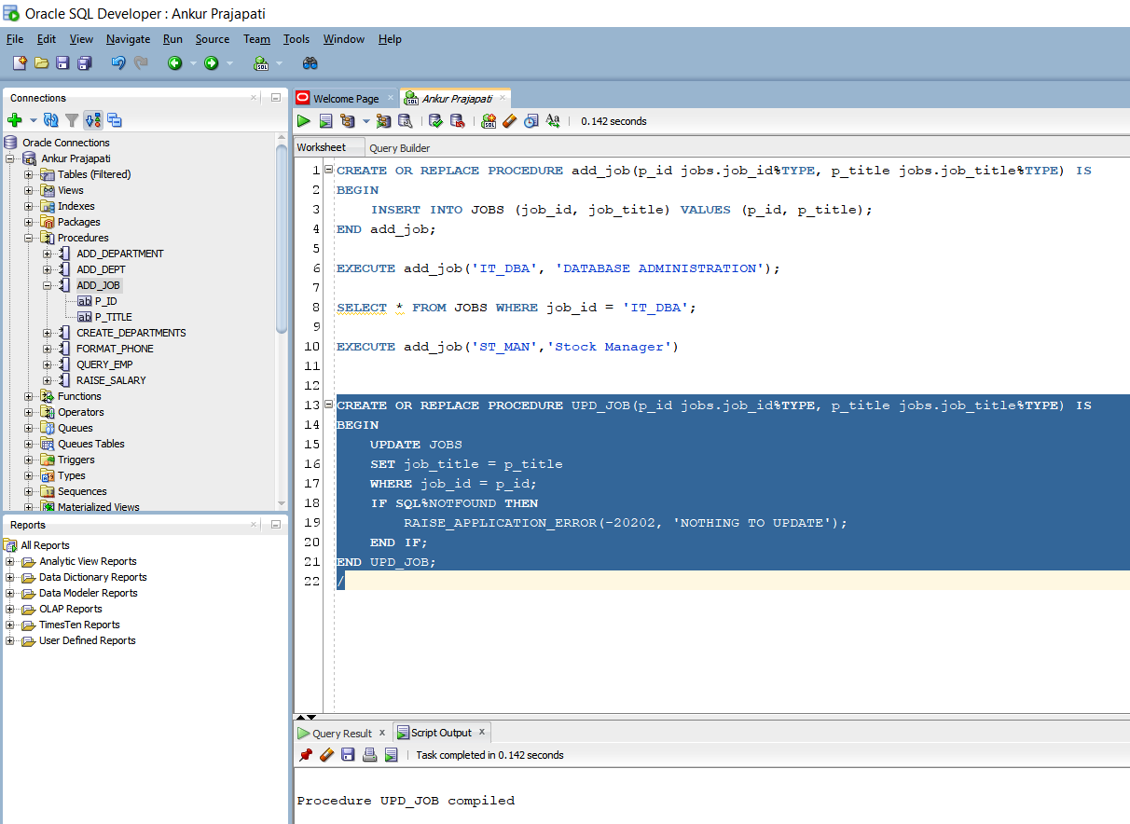

Here I am creating a procedure named UPD_JOB with formal parameters p_id with type of job_id, p_title with type of job_title. In this it sets job_title with p_title. If SQL%NOTFOUND then it will return message showing ‘Nothing To UPDATE’.

Basically, it job_id is not there then it won’t update and will return error.

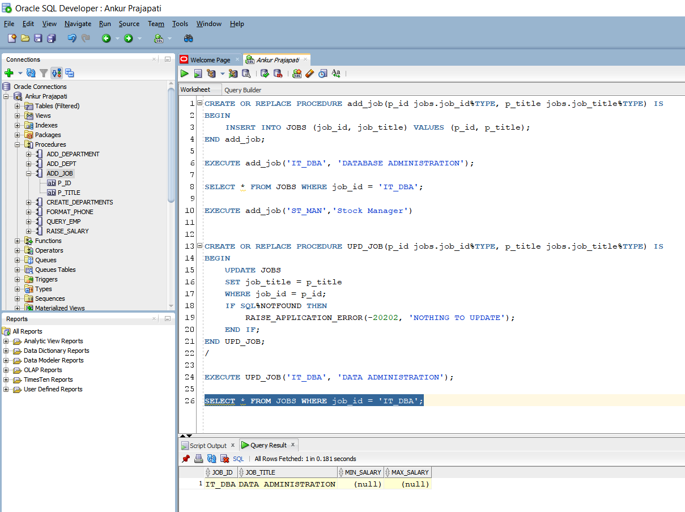

Here I am trying to update job with job_id = ‘IT_DBA’. First it was named as ‘DATABASE ADMINISTRATION’ to ‘DATA ADMINISTRATION’.

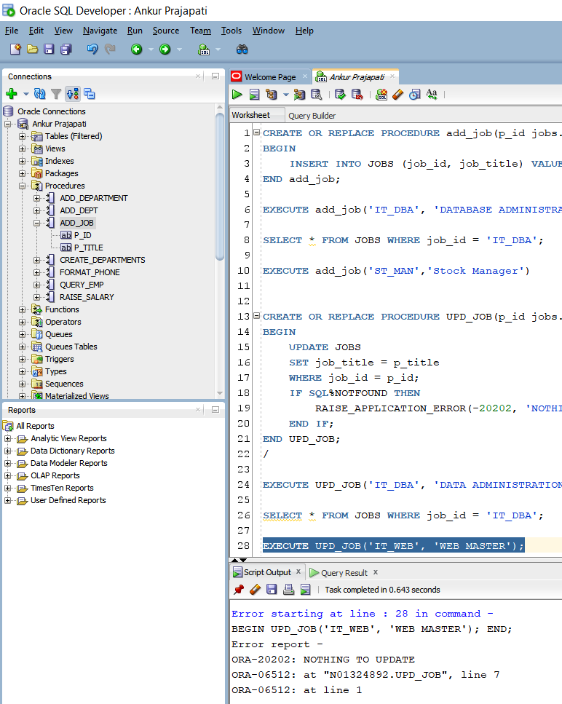

Here I am trying to update job having job_id = ‘IT_WEB’ but it’s not stored in database so it gives an error message notifying that ‘Nothing to Update’ associated to SQLERRORCode.

1. DEL_JOB Procedure:

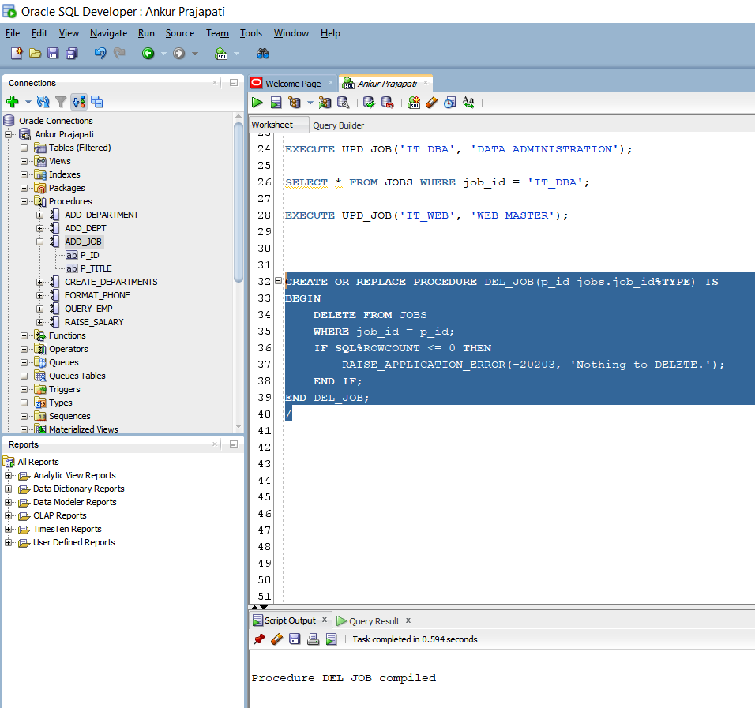

Here I am creating procedure named DEL_JOB with formal parameter p_id having type of job_id. It deletes job having same id in database.

If there is no row available to delete (SQL%ROWCOUNT is less than 0) then it will give error message that ‘Nothing To DELETE’ associated with SQLERRORCODE -20203.

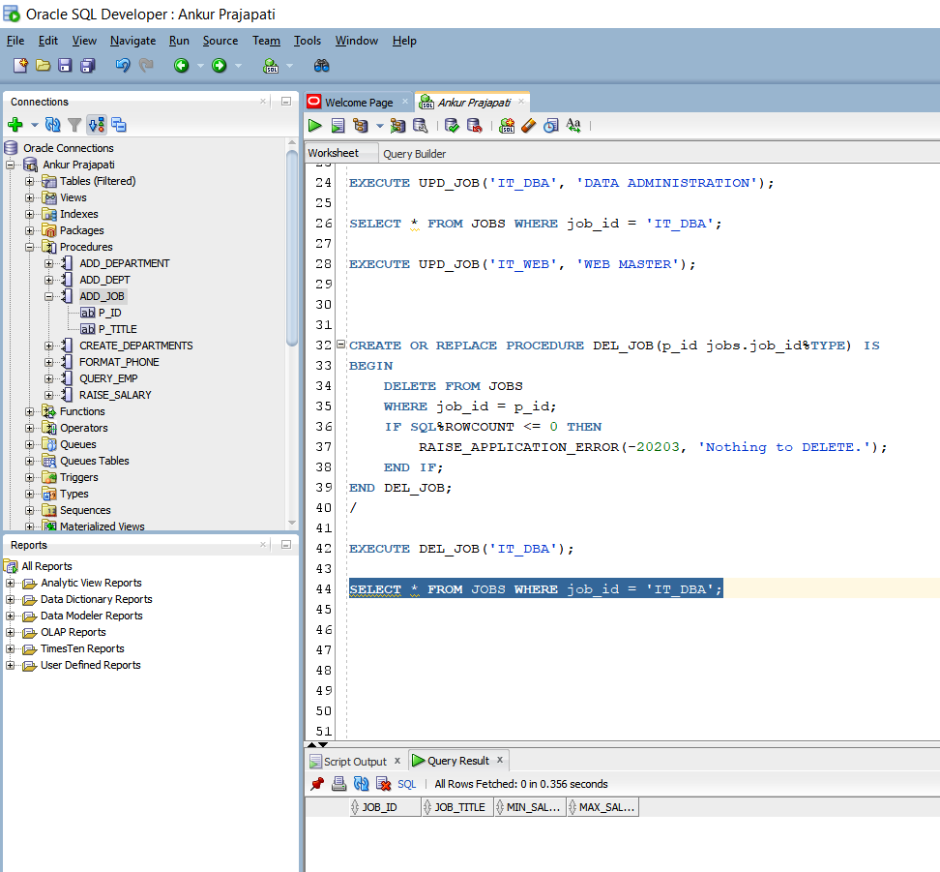

There is data stored in database with job_id = ‘IT_DBA’ and I have deleted it from here.

That’s why it is showing us the blank record.

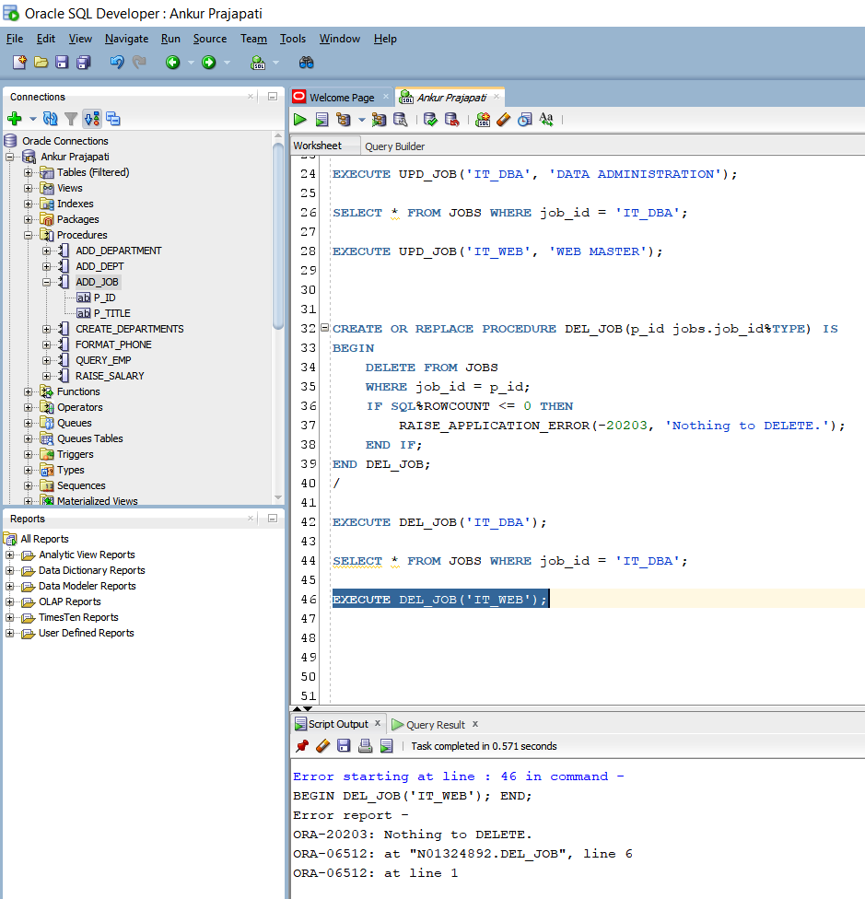

Here it will give error that there is nothing to delete because there is not record of job_id = ‘IT_WEB’.

1. GET_EMPLOYEE Procedure:

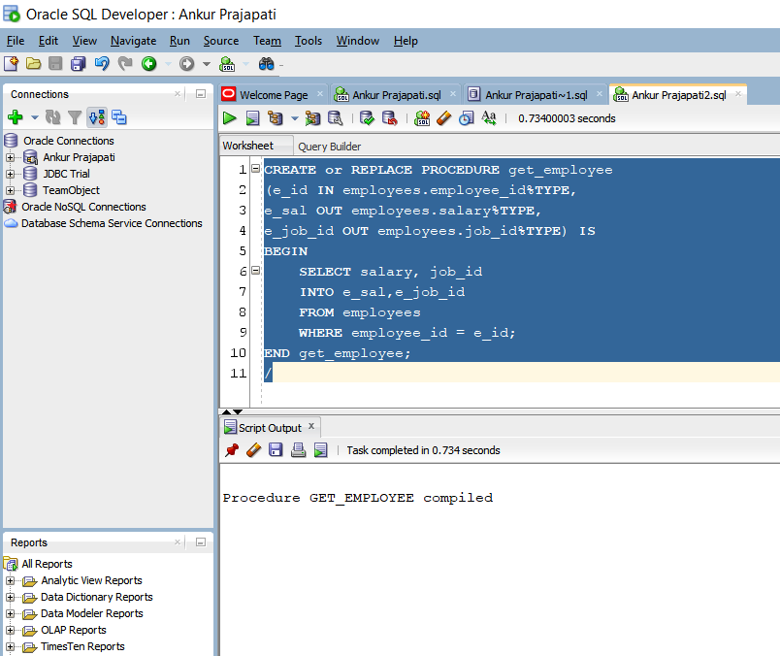

Here I am creating get_employee procedure with formal parameters e_Id with type of employees.employee_id, e_sal with type of employees.salary and e_job_id with type of employees.job_id where employee_id(actual parameter) is same as e_id(formal parameters).

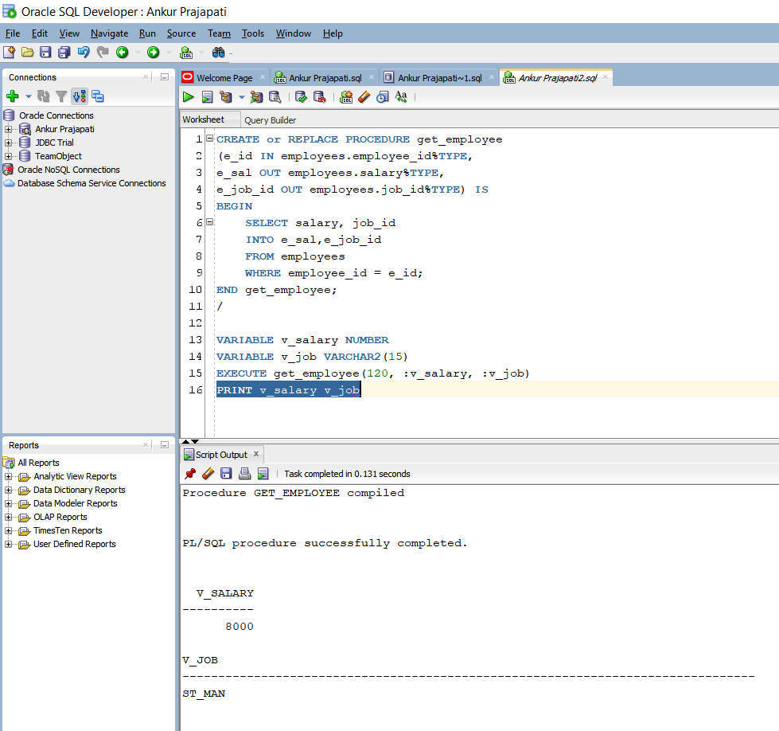

Here v_salary of NUMBER type and v_job of VARCHAR2 type is declared.

Here employee_id is 120 and based on that salary and job_id associated with it will be printed using bind variable. Note that here e_id is of TYPE IN which means we have to give it, where v_salary and v_job is of TYPE OUT that means it will give data to us.

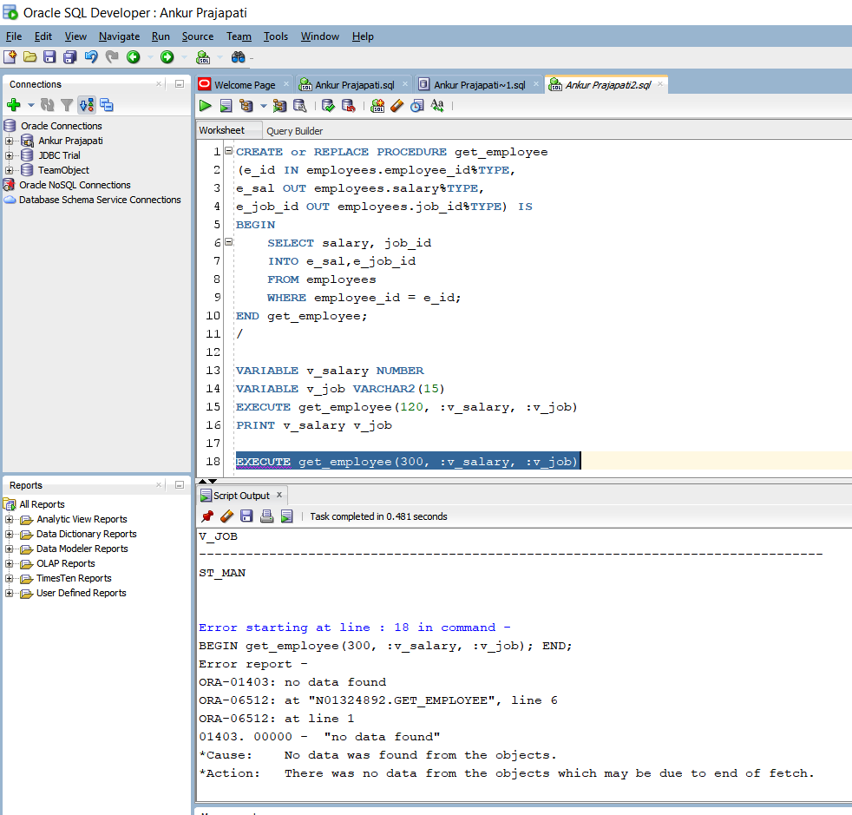

Here we tried to fetch data from employees table having employee id 300. But as you can see, we have no data for this. So that it gives an error no data found.

Practice 3: Creating Functions:

1. GET_JOB Function:

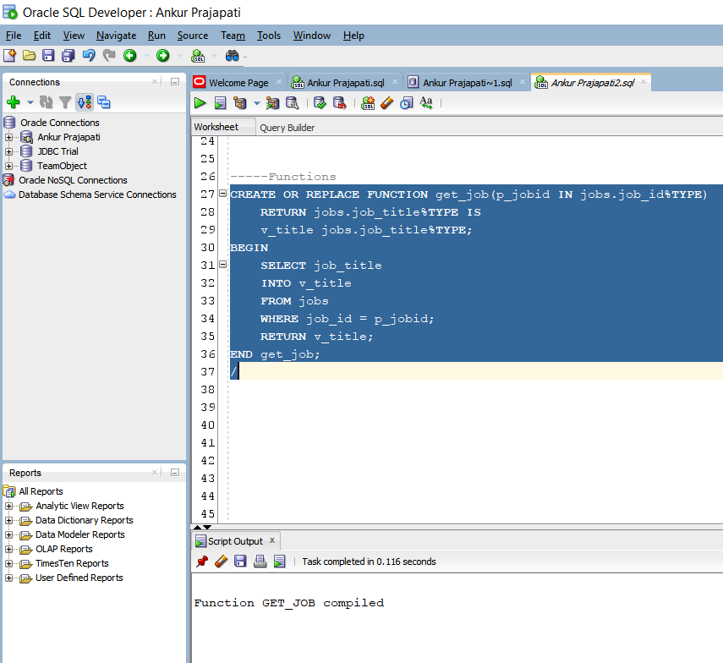

GET_JOB is compiled

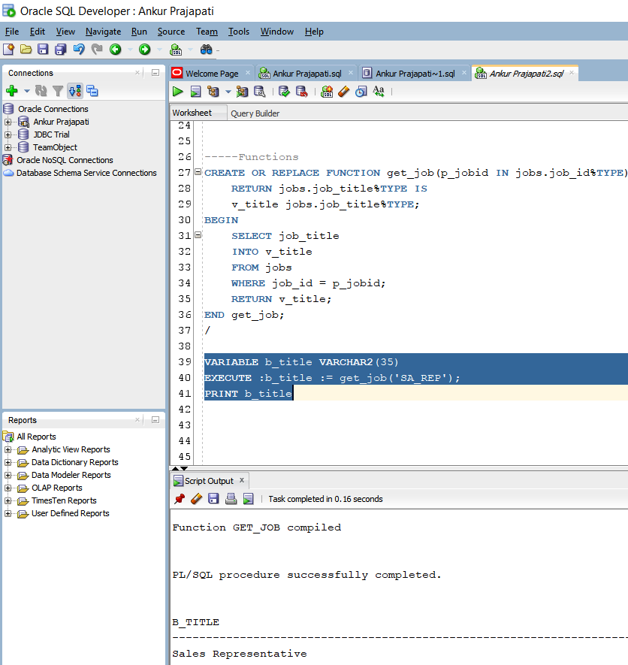

Here it gives job title from given job_id.

For example, SA_REP to SALES REPRESENTATIVE.

1. GET_ANNUAL_COMP Function:

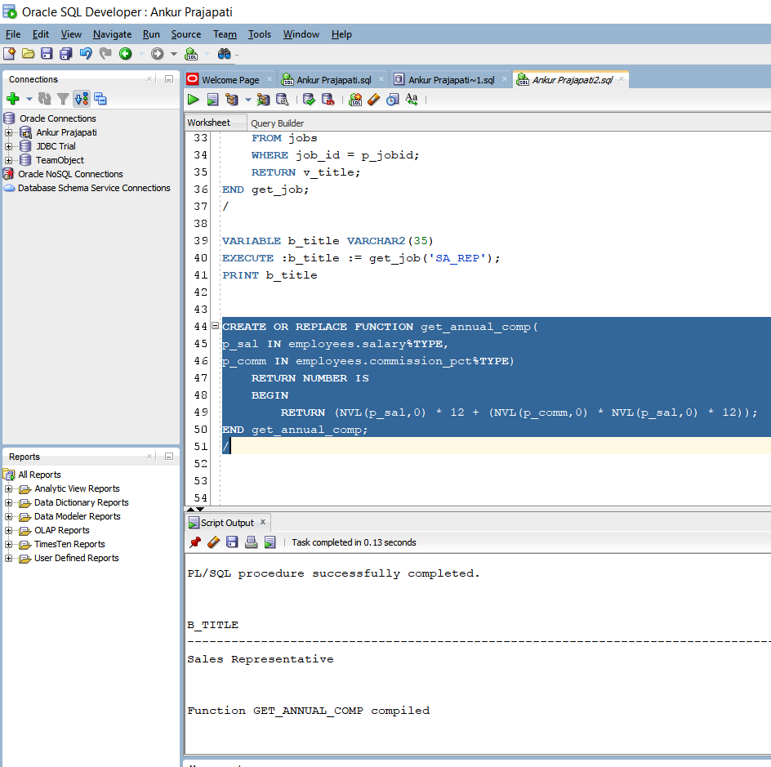

Get_annual_comp is compiled. And it returns annual compound salary.

Note that here NVL will ignore null values and it converts it to 0.

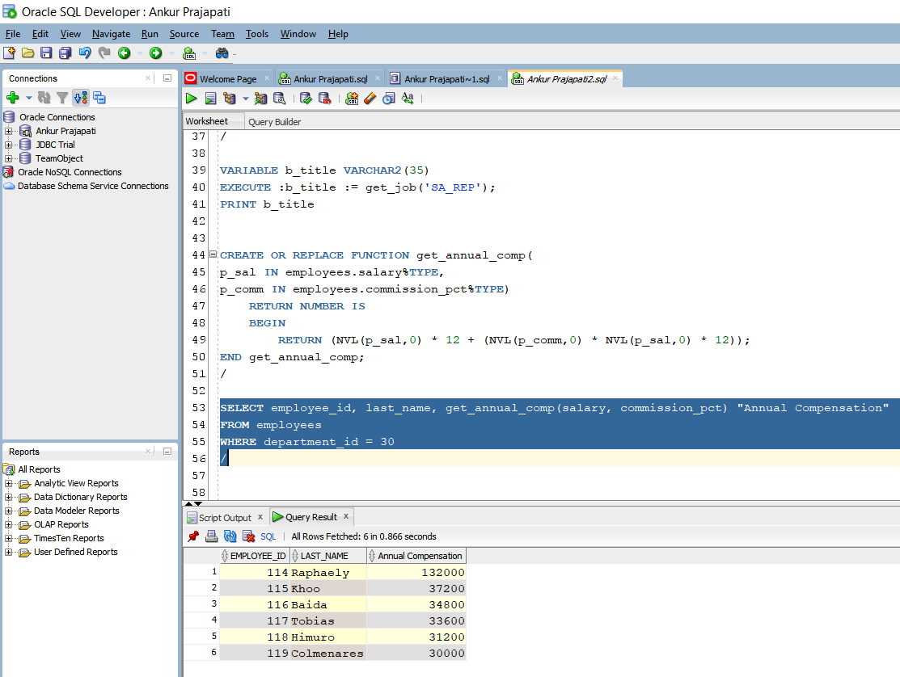

Fetching data of employees with id, last name and annual compensation where department id is 30.

1. ADD_EMPLOYEE:

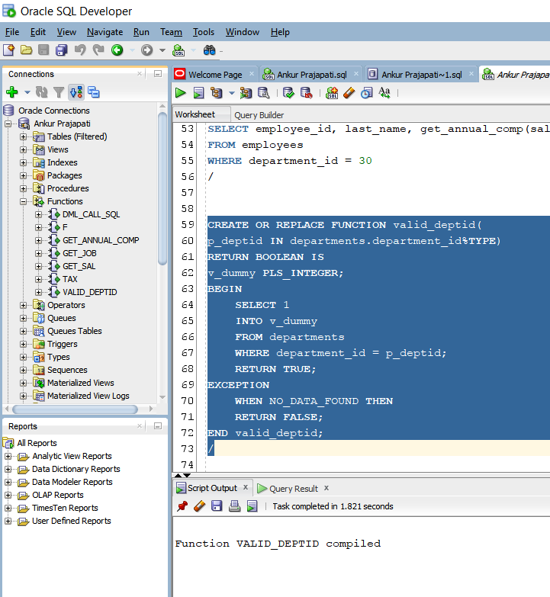

Creation of valid_deptid function.

We are selecting 1 into v-dummy which is PLS_INTEGER from departments table if the department id is there with given department id(p_deptid).

There is an Exception block is also included if we don’t have data then it will return false.

Creation of add_employee procedure. First, we declared all the formal parameters using data type from employees table.

In executable section, there is one IF condition which checks if the valid_deptid(v_deptid) is true or not. If it is true it will insert values into employees table. If it is not true then it will raise an application error notifying Invalid Department ID. Try again.

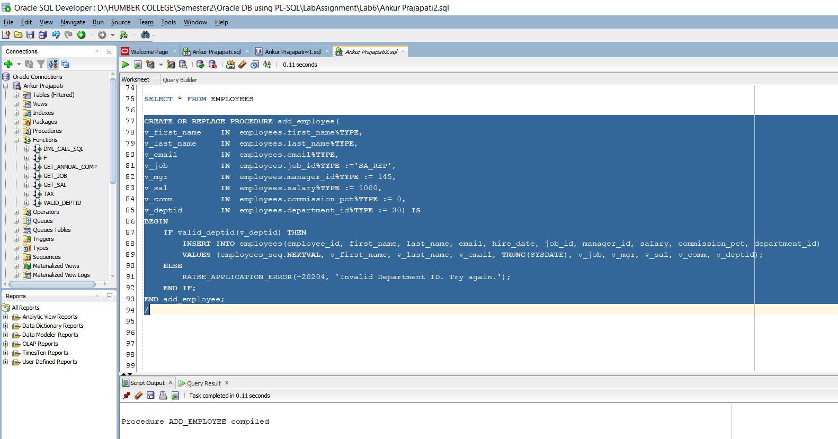

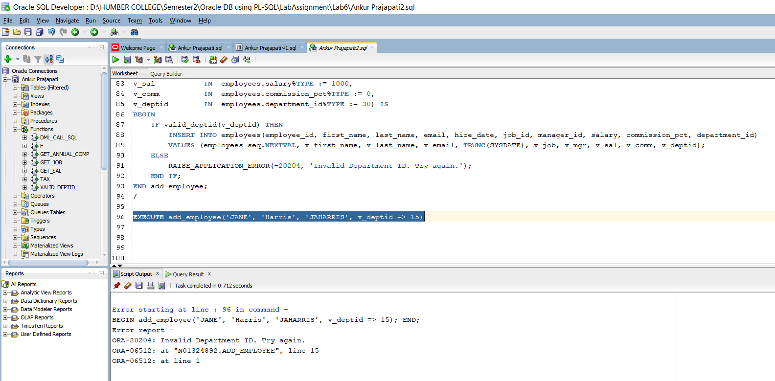

Here add_employee is executed and due to department id miss matching it gives invalid department id.

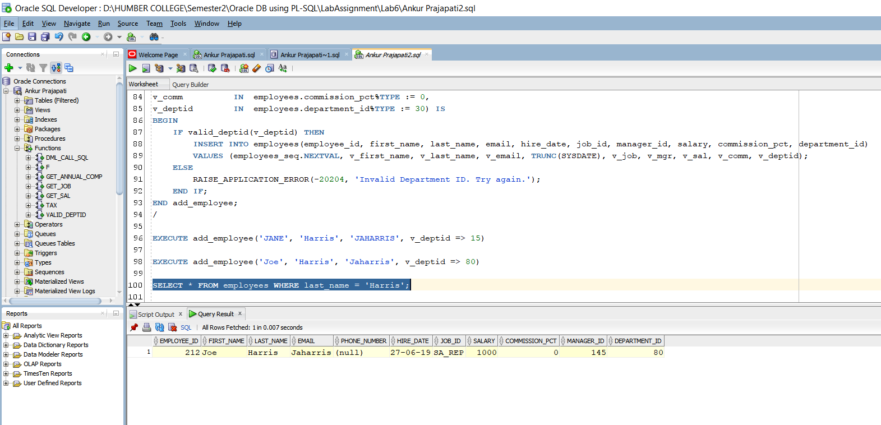

Adding new record here in table.

It prints the inserted record here.