**Practice 1 – 1:**

**A and b:**

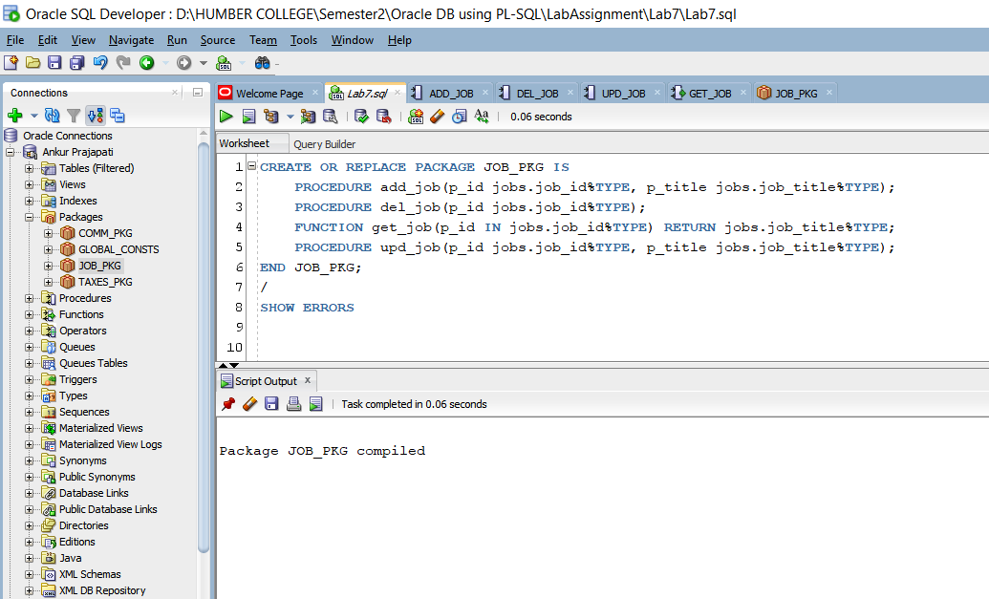

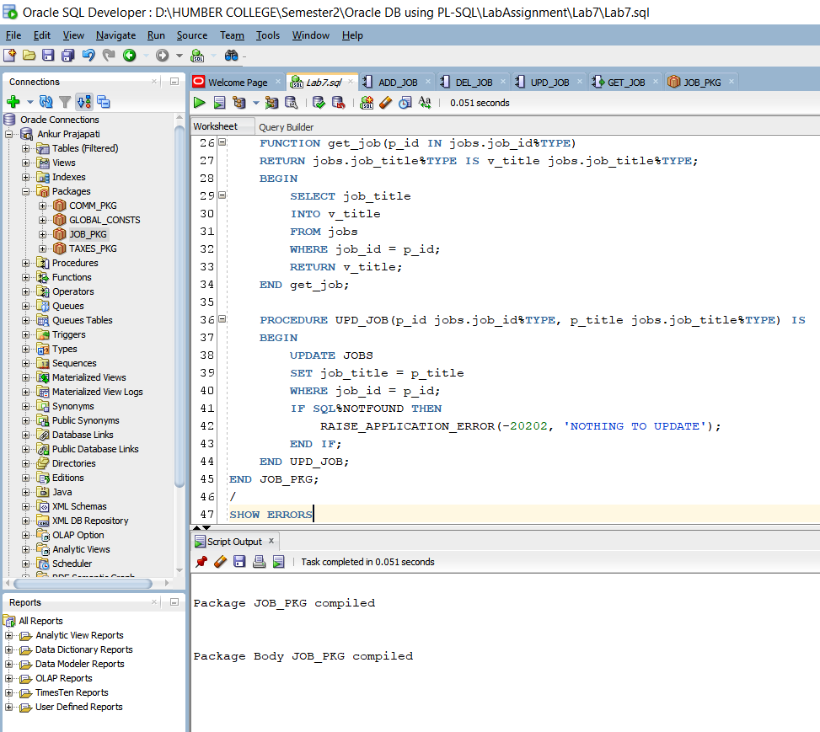

* Here in part a we are creating job_pkg specification with three procedures and one function headings. We are using procedures: add_job, del_job, get_job and upd_job function headings with formal parameters p_jobid with type of job_id of JOBS table.
* Here we have used SHOW ERROR, which will give us errors occurred in compilation time.
* As you can see here package job_pkg s compiled successfully for specification as well as body.

**Practice Question 1 - C:**

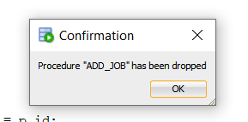

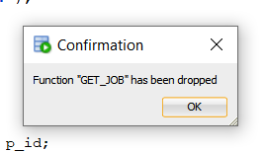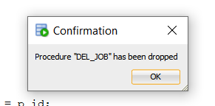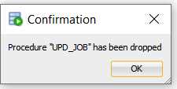

Dropping of all the procedures.

**Practice Question 1 - d:**

Executing of job_pkg.add_job(‘IT_SYSAN’, ‘System Analyst’);

Basically, it adds job of System Analyst with job_id IT_SYSAN.

**Practice Question 1 - e:**

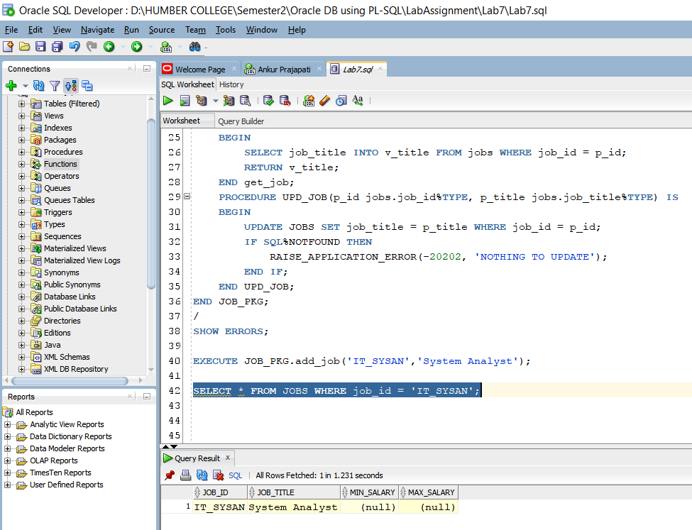

Here we are selecting job_id with IT_SYSAN. Basically, we are using select query.

**Practice 1 – 2:**

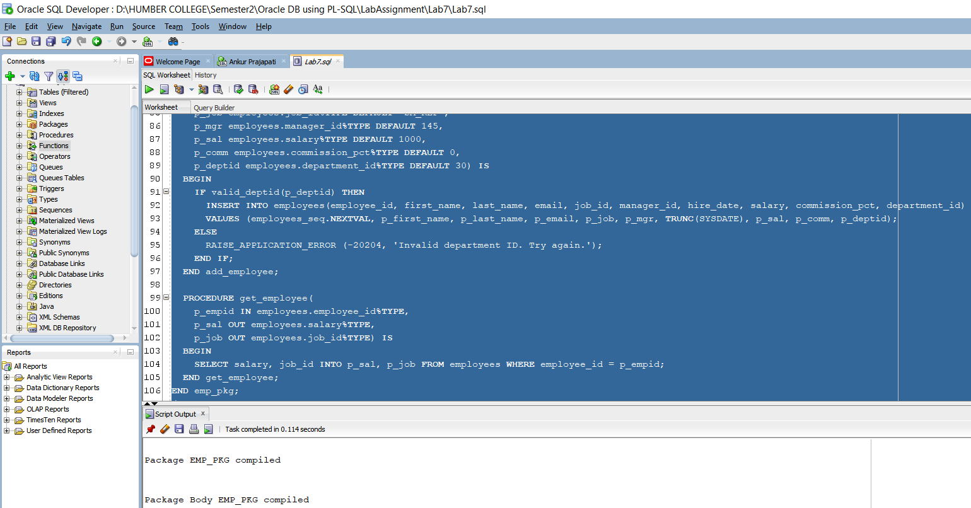

In this step we are basically adding add_employee and get_employee procedure with valid_deptid function in package specification and package body as public construct.

Here valid_deptid is private function that’s why its not declared in specification.

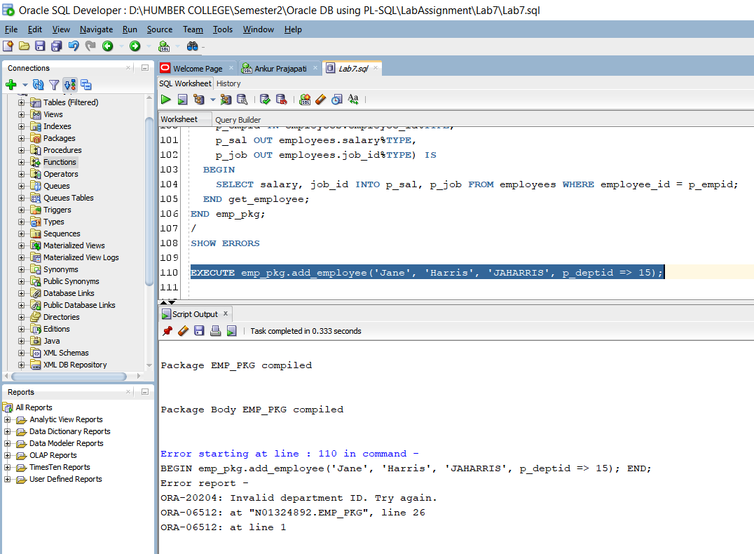

Here we are invoking emp_pkg.add_employee to add new employee in database for department id 15. But it gives an error that department_id is invalid.

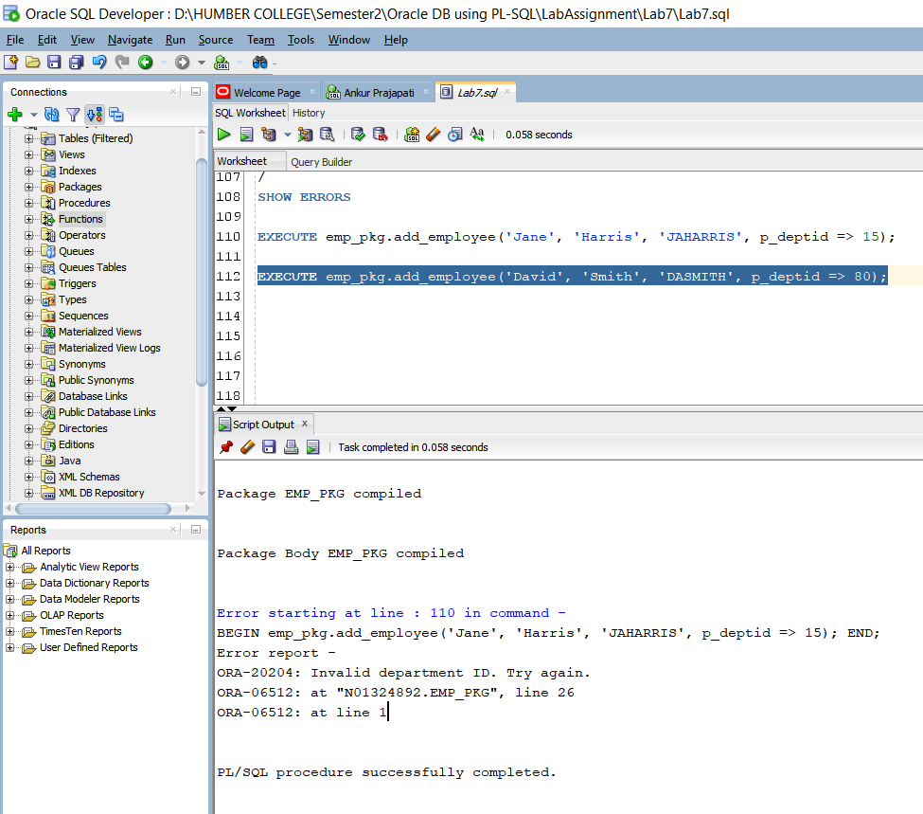

Same as before we are trying to add employee for department id 80. But it’s valid so it’s get added.

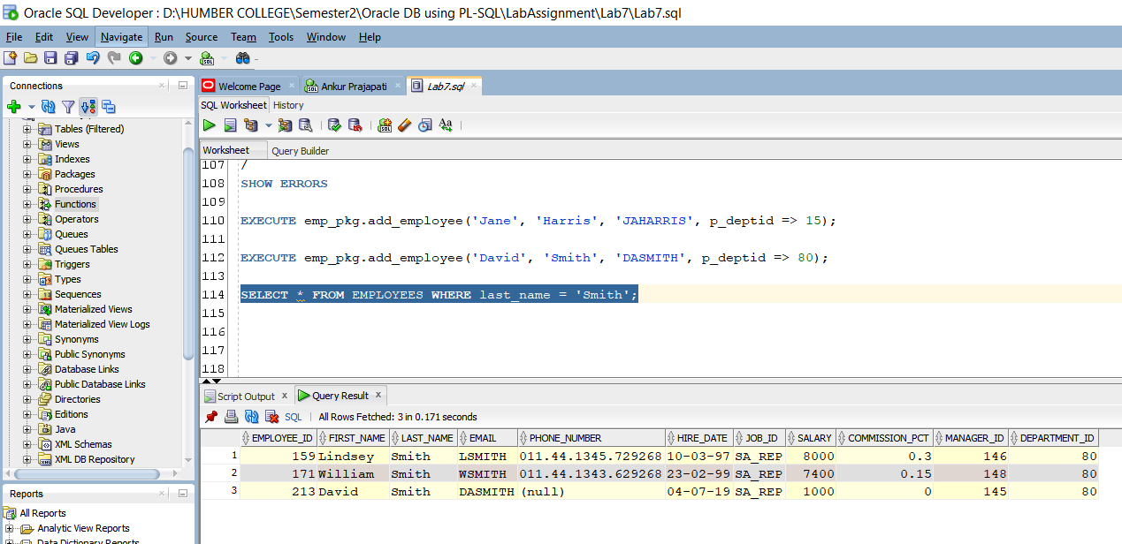

Printing all the employees where last name is Smith.

**Practice 2 – 1:**

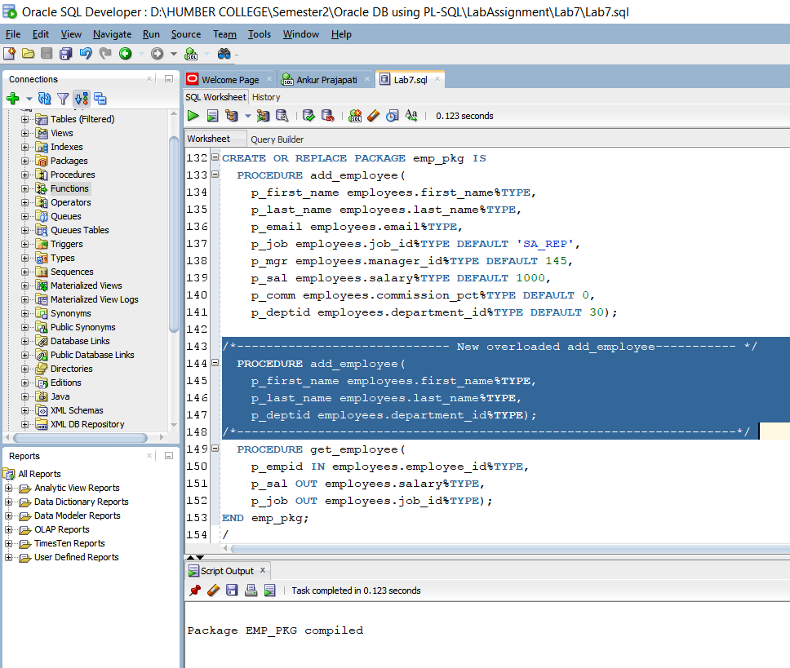

We are adding new procedure with 3 different parameters to provide overloading of add_employee.

It gets compiled successfully with overloading.

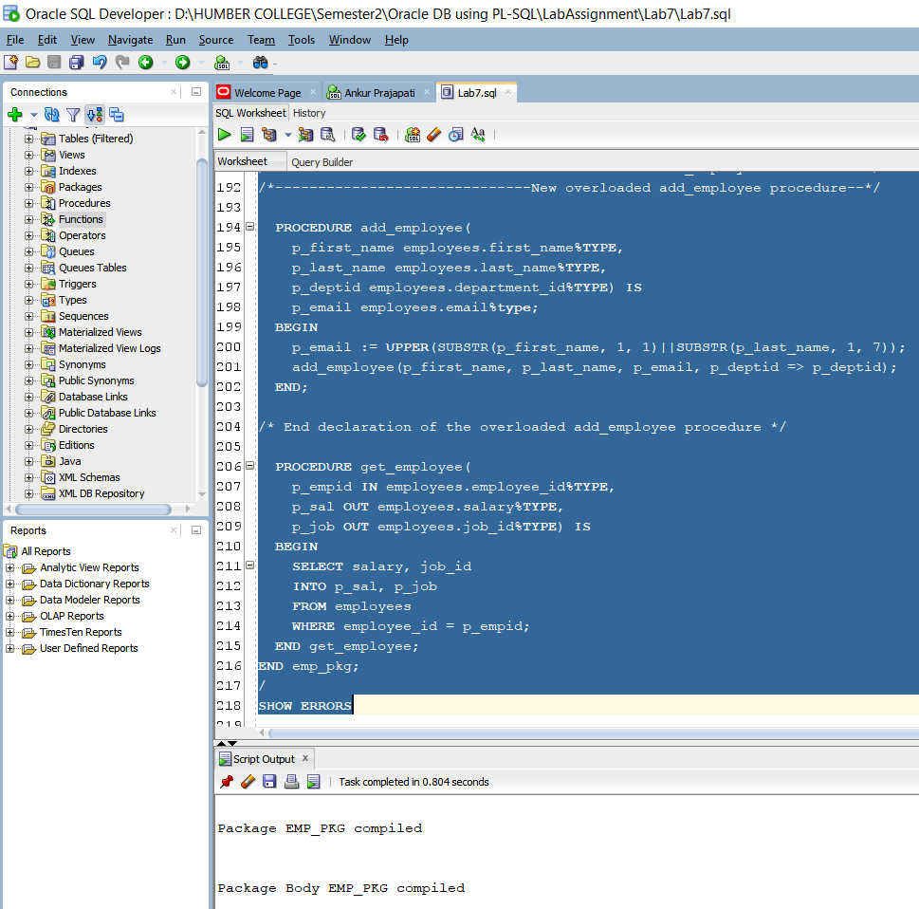

Here new added overloaded procedure we are actually formatting email address in uppercase latter with first seven letters of last name.

We are calling procedure to insert operation.

On compiling it gets compiled successfully.

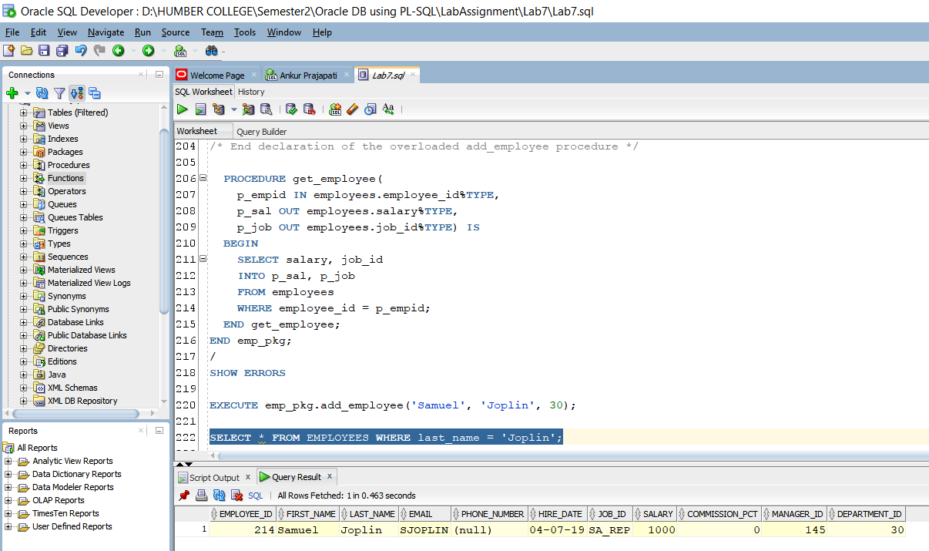

We have executed emp_pkg.add_employee with (‘Samuel’, ‘Joplin’, 30) to insert new record.

After that select query is used to print the inserted record where last_name is ‘Joplin’.

Note that the email is SJOPLIN here from first name and last name.

Practice 2 – 2:

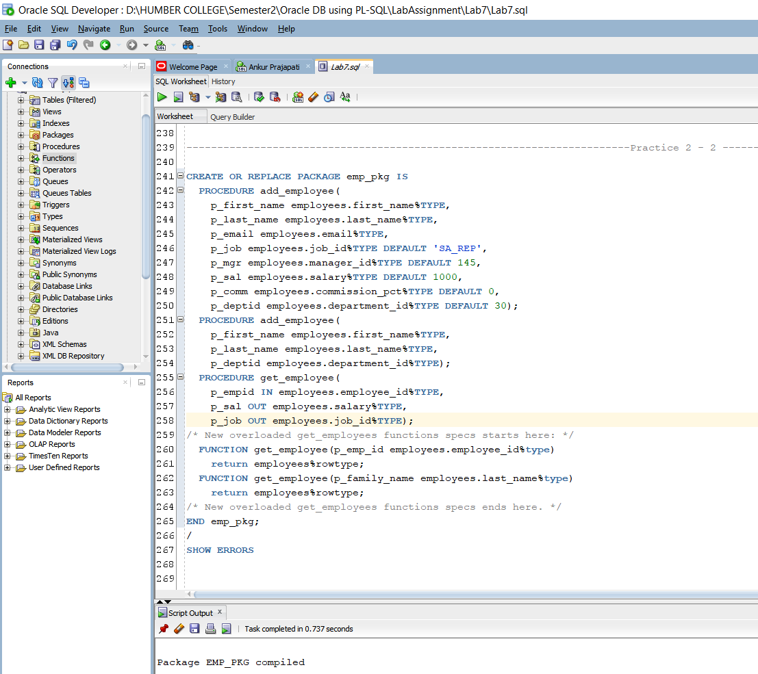

Here get_employee function which accept parameters p_empid of type employee_id and it returns value of type employees%rowtype.

It also accept p_family_name in type of employees.last_name%type and returns employees%rowtype.

It gets complied successfully.

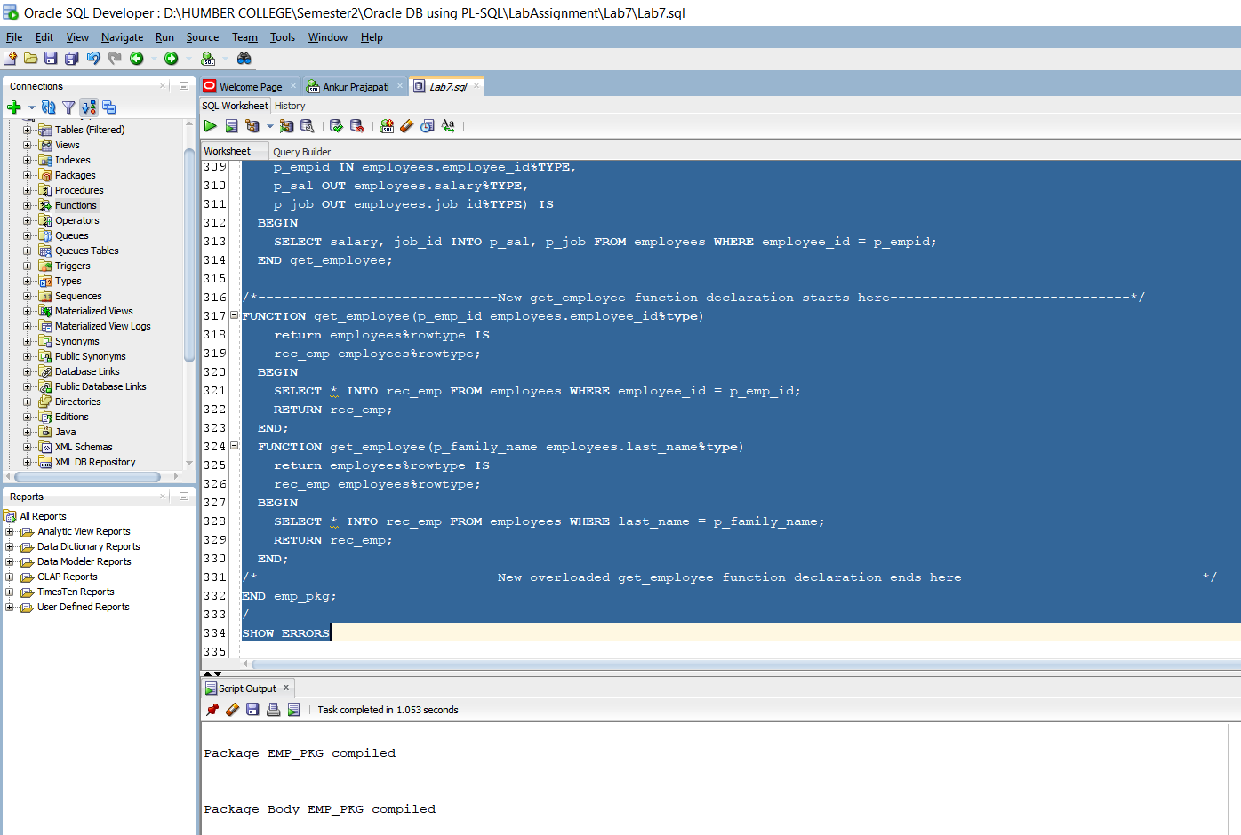

Two functions included in declaration with their parameters which returns record of type employees.

Where we are using employee’s id to query in first function and family name in second function. Note that here = (equality operator is used) to find last name from family name.

It gets complied successfully.

Adding print_employee specification and body to package.

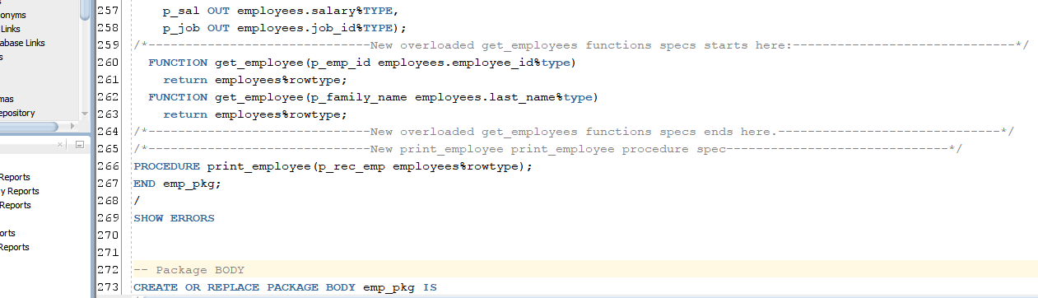

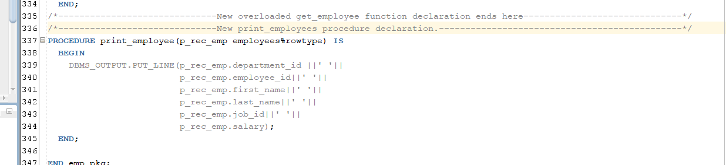

It displays department id, employee id, first name, last name, job id and salary.

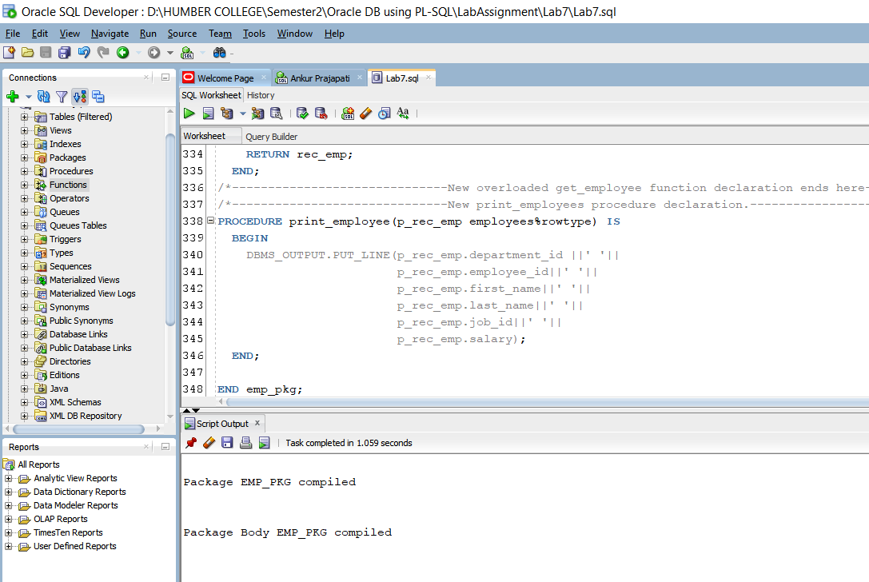

It gets complied successfully.

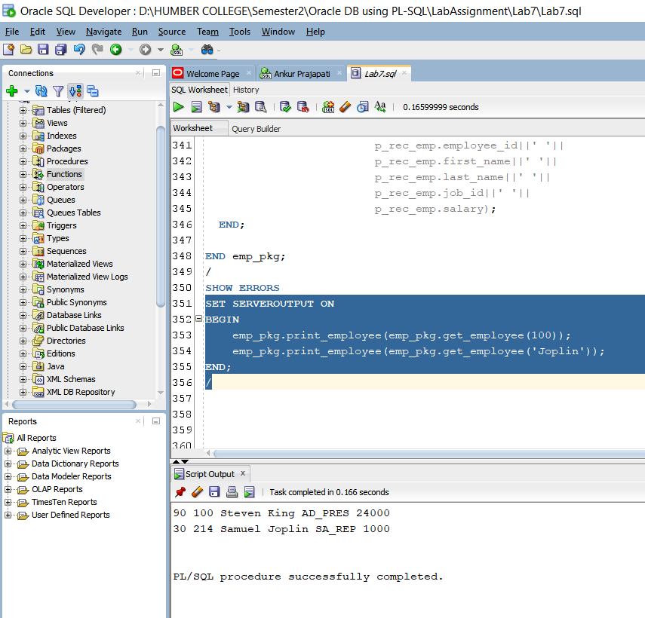

Use of anonymous block to invoke emp_pkg.print_employee with employee id and last name.

Practice 2 – 3:

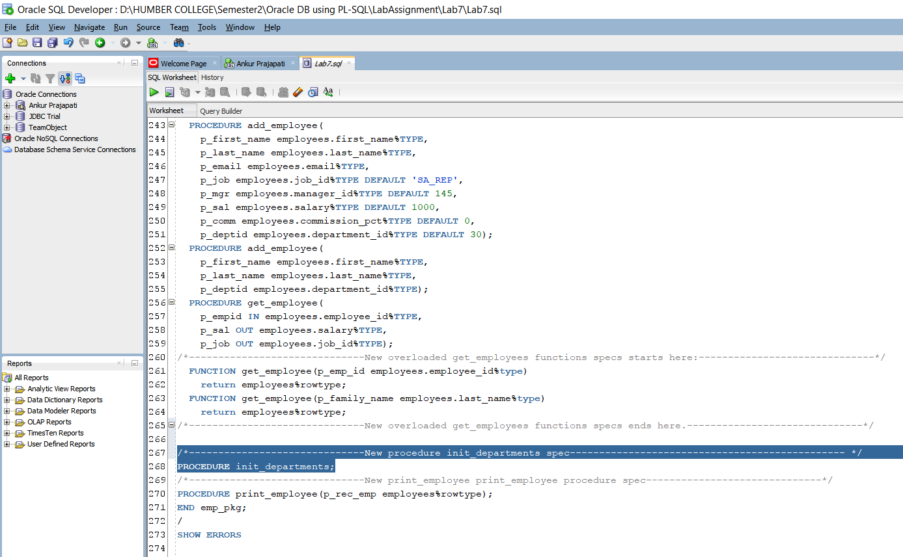

We are adding public procedure to emp_pkg to improve its’ performance. Here init_departments procedure is created in package specification.

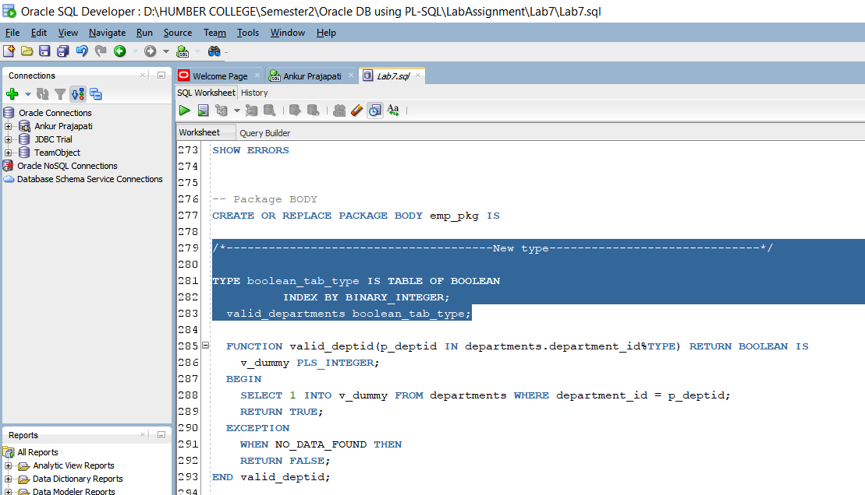

Implementation of init_departments procedures to store all department ids in private PL/SQL block. Boolean_tab_type is a table which has binary_integer for it’s index where valid_departments is a variable of that table.

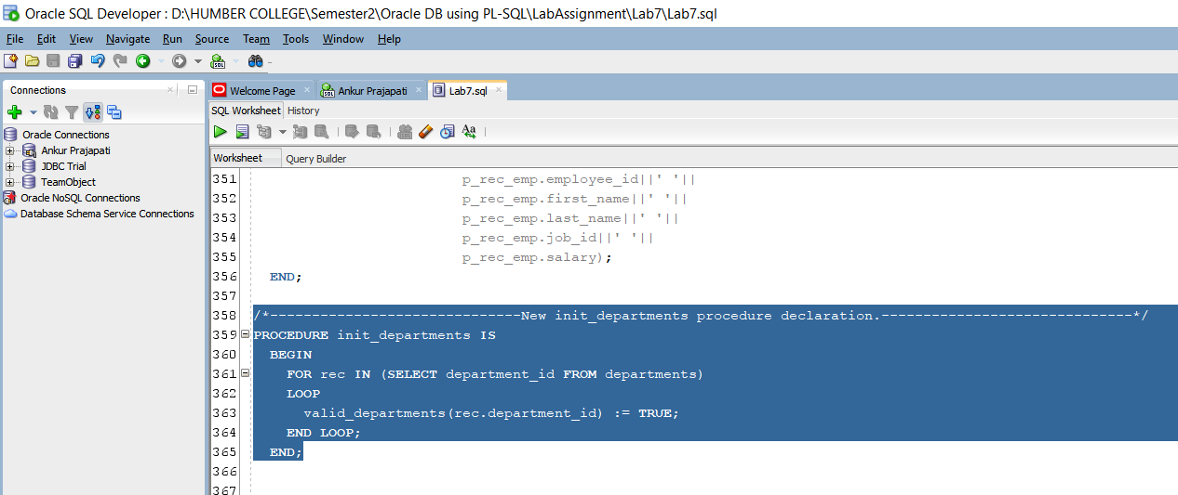

In this procedure init_departments it takes department_id from departments and it prints/sets true for each department id using FOR LOOP.

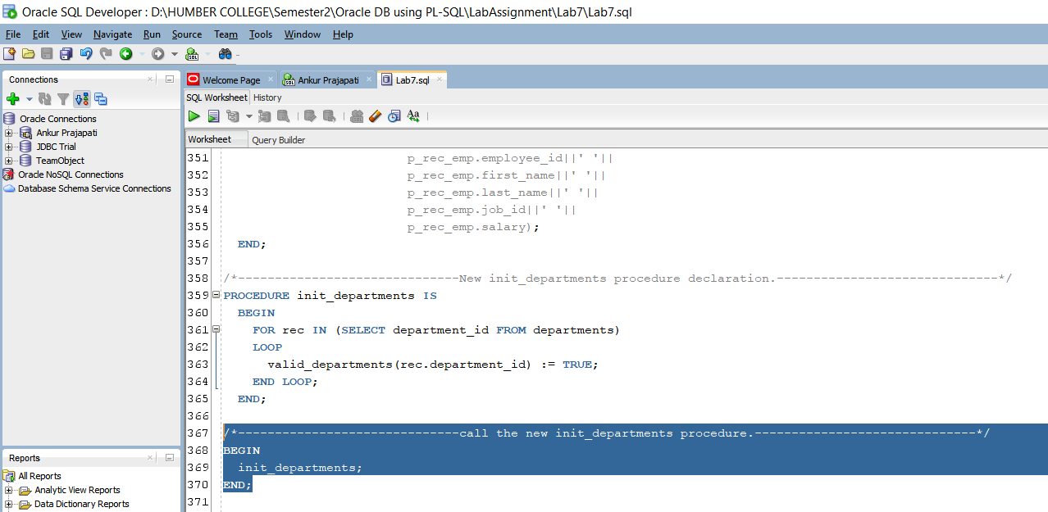

Creating initial block to call procedure init_departments.

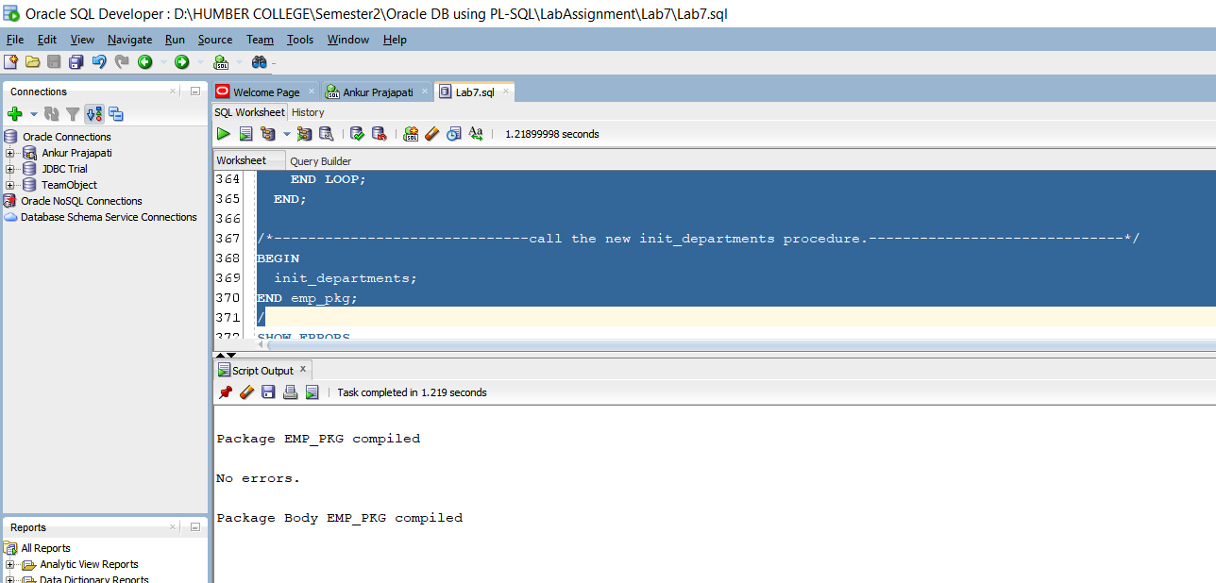

Compiling emp_pkg and It gets complied successfully.

Practice 2 – 4:

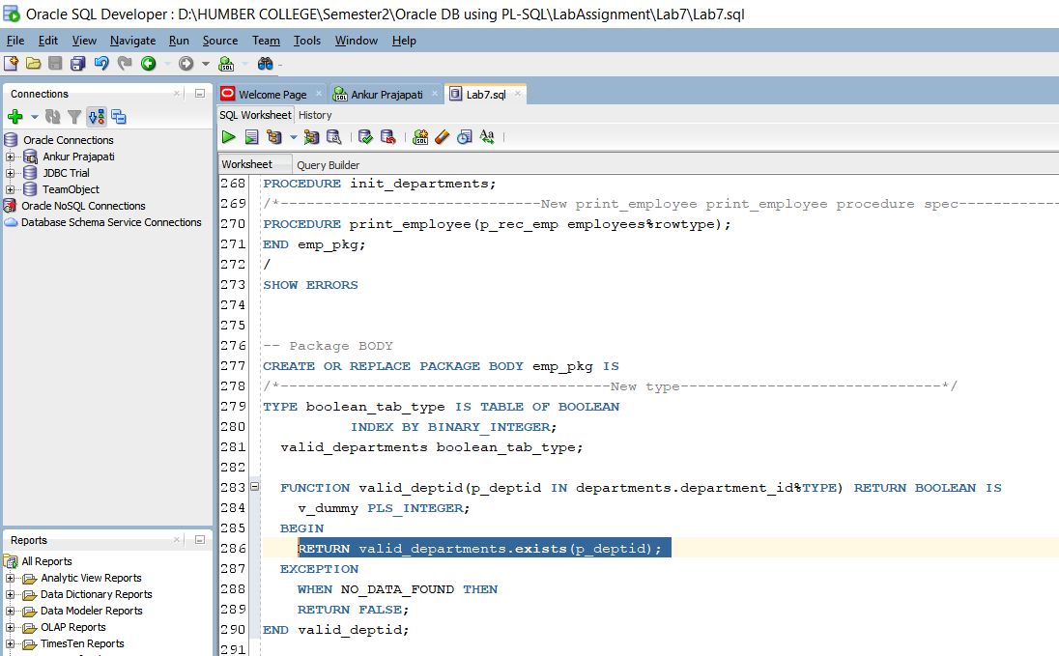

Modification of valid_departmentid instead of looping through to find valid department_id here we are calling our index type variable.

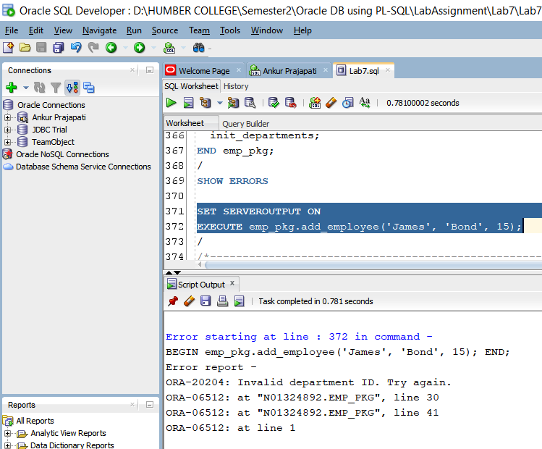

We are trying to add new employee record with first name James and alst name of Bond and department id 15.

It gives an error because department_id is invalid.

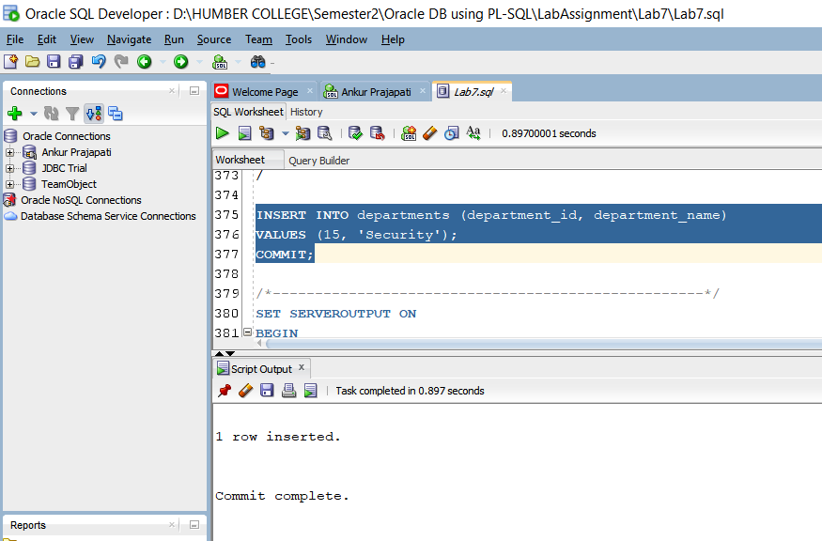

For that we have to add new department with department id 15 and department name ‘Security’.

Note that we have to commit to apply changes to database.

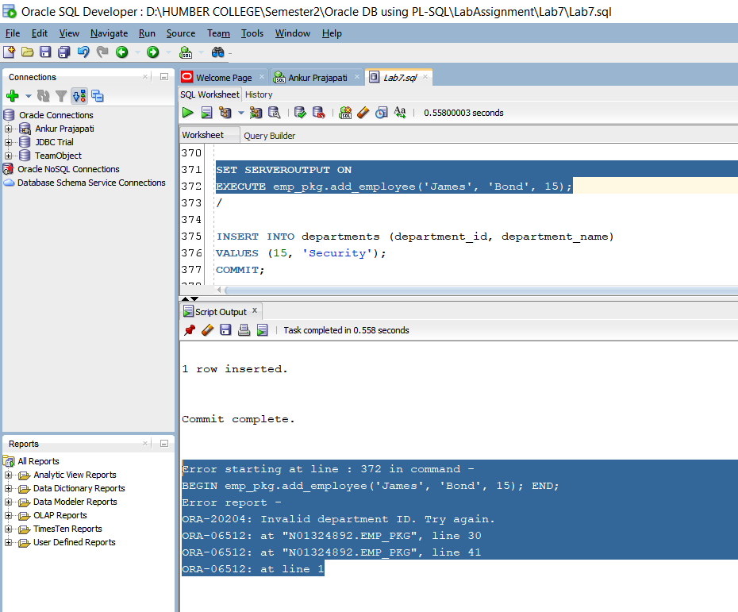

Again, we are trying to add this record here but it’s not added successfully.

Note that this department id of 15 with department name security is not there in init_departments.

To add this record successfully we have to call init_departments to initialize and add this department id 15 to table.

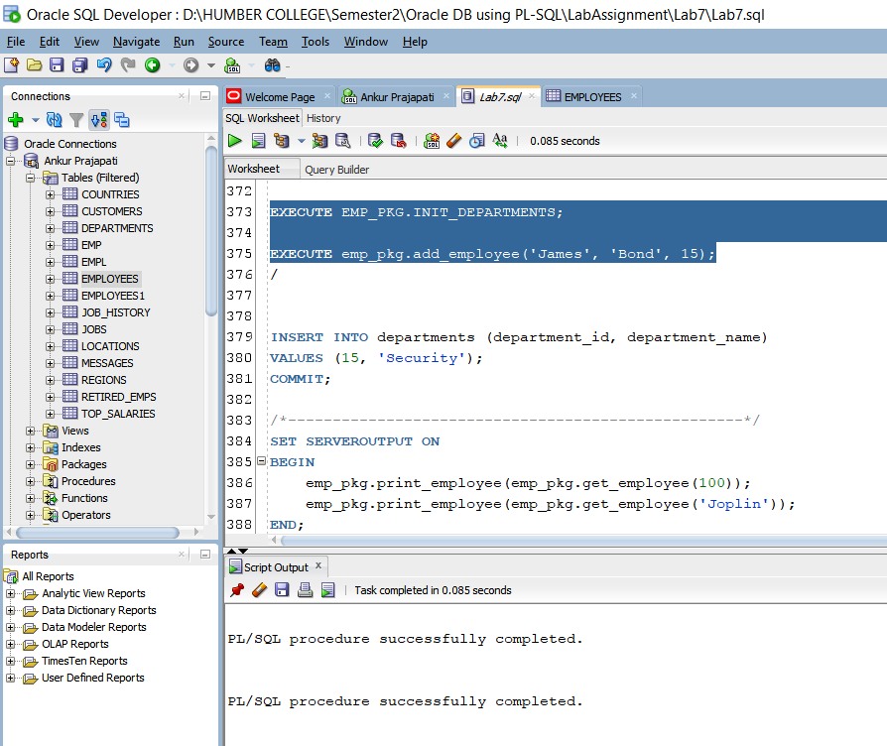

Calling of init_departments.

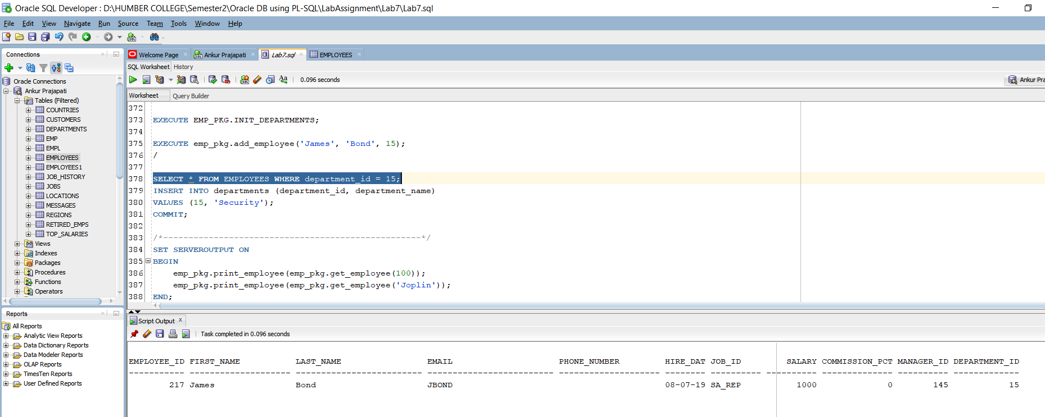

Select Query to get the data from to employees where department id is 15.

Note that we can now see the data here because we have called init_departments here first.

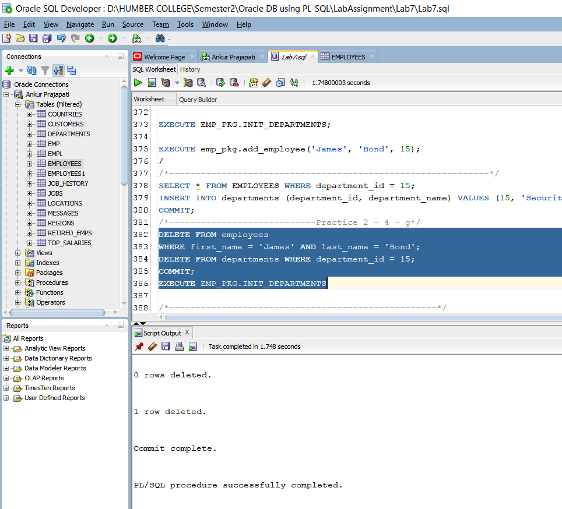

Now here we are deleting from employees where first name is ‘James’ and last name is ‘Bond’.

We are also deleting record from departments also where department id is 15.

After that commit is used to save changes.

After that we are calling init_departments again to store the data changes in database.