Question 1:

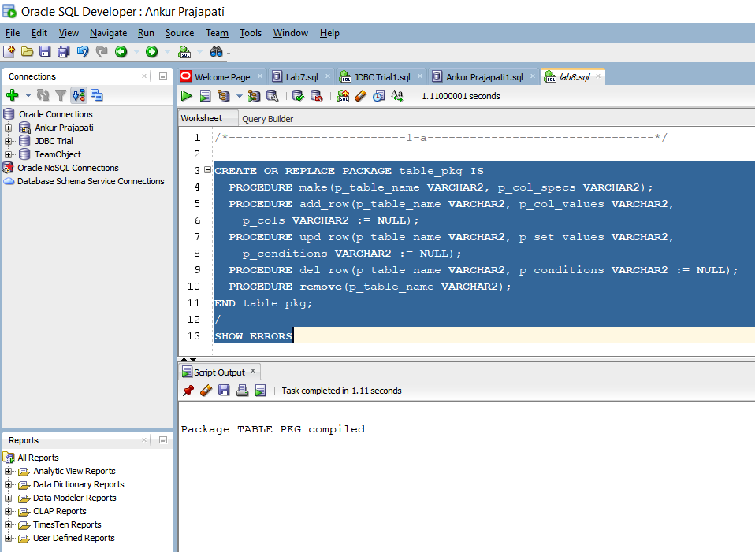

* table_pkg specification is compiled.
* Basically, we are adding 5 different procedures here.

1. make (p_table_name, p_col_specs) 🡪 to make new table with table name and column specification
2. add_row(p_table_name, p_col_values, p_cols) 🡪 to insert new records inside table. Basically, it takes table name, values for given columns and column names
3. upd_row(p_table_name, p_set_valuess, p_conditions) 🡪 to update inserted rows. Basically, it takes table name, updated values and condition for updating conditions
4. del_row() 🡪 to delete rows from table name using condition
5. remove 🡪 to drop table name

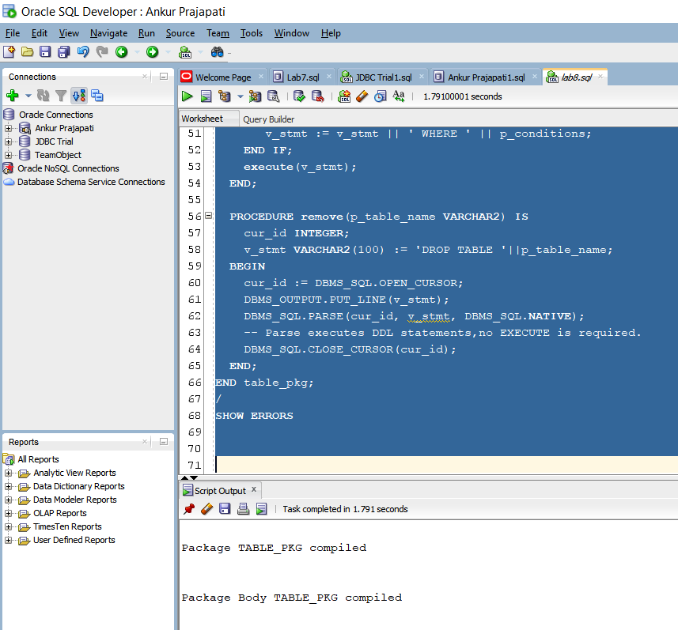

* table_PKG body is compiled with above mentioned procedures with specifications.
* Implementation is done properly.

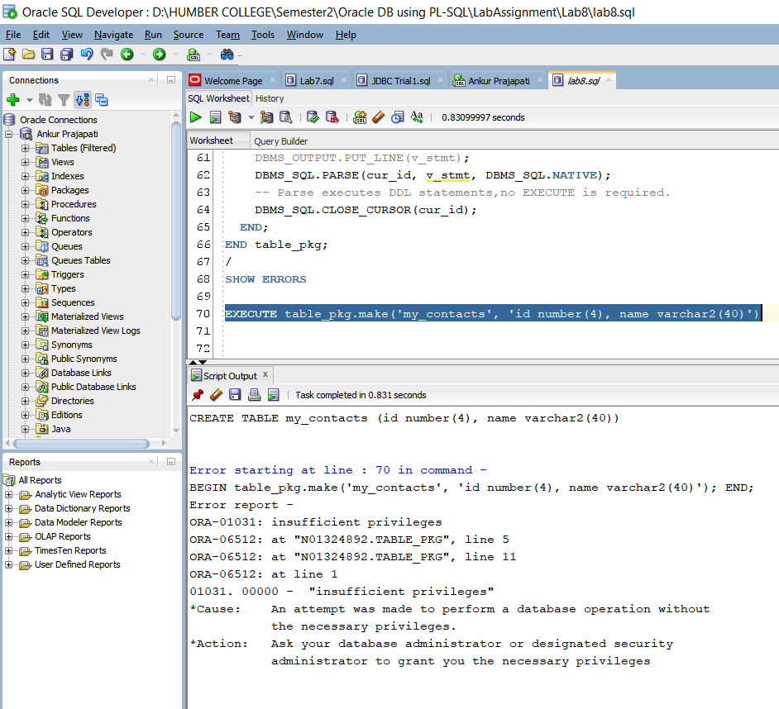

* Here we have tried to create new table with make procedure named my_contacts having id of type number and name of type varchar2.
* On compiling this statement, it given an error notifying that we don’t have insufficient privileges. That’s why we cannot create this table or perform a database operation without privilages.

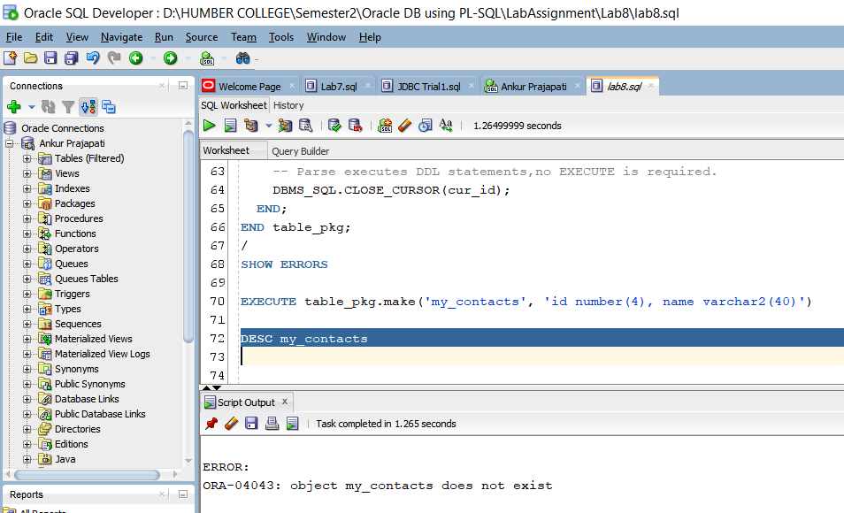

* Here we are describing my_contacts but due to insufficient privileges we cannot create table and that’s why it says that object does not exists.

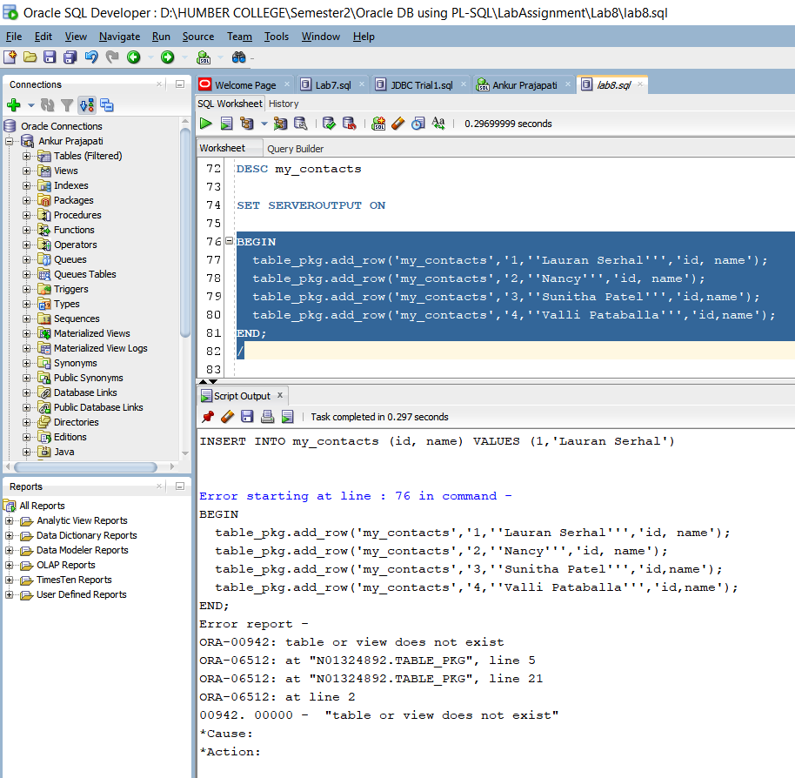

* Here we are trying to add/Insert new rows in my_contacts but it doesn’t exist that’s why we cannot insert into table.
* We can find error table or view does not exists.

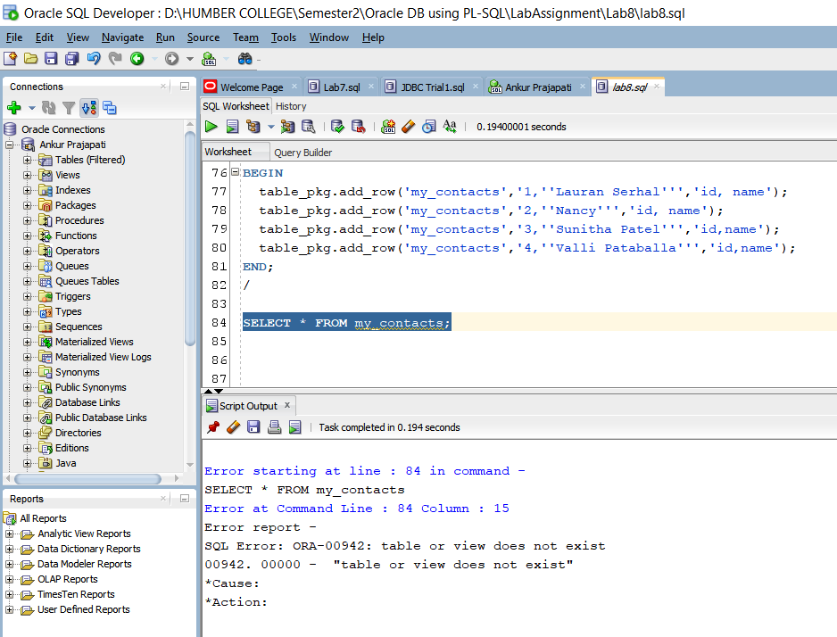

* We are using SELECT query to see the record inside table my_contacts, but table is not there so its not possible for us.

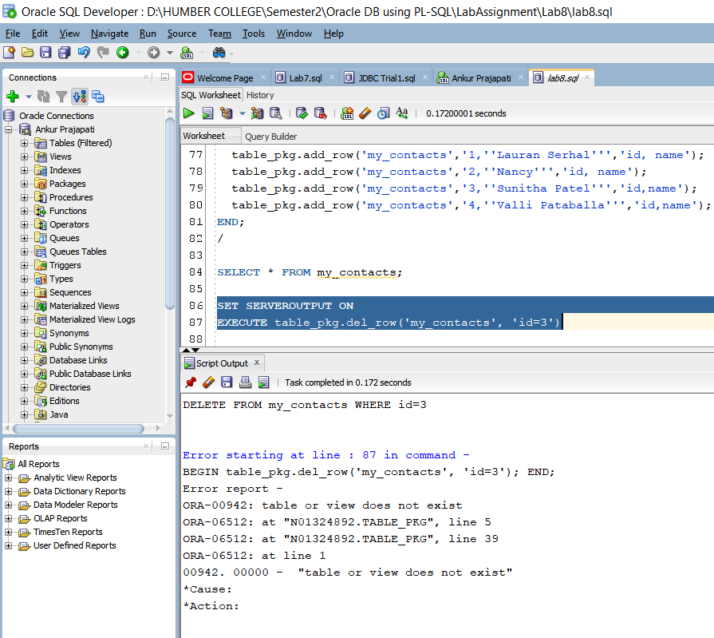

* We are trying to delete row from table my_contacts having id 3.
* For that we have used SET SERVEROUTPUT ON to print the output
* But due to table is not available there it’s not possible to delete record.

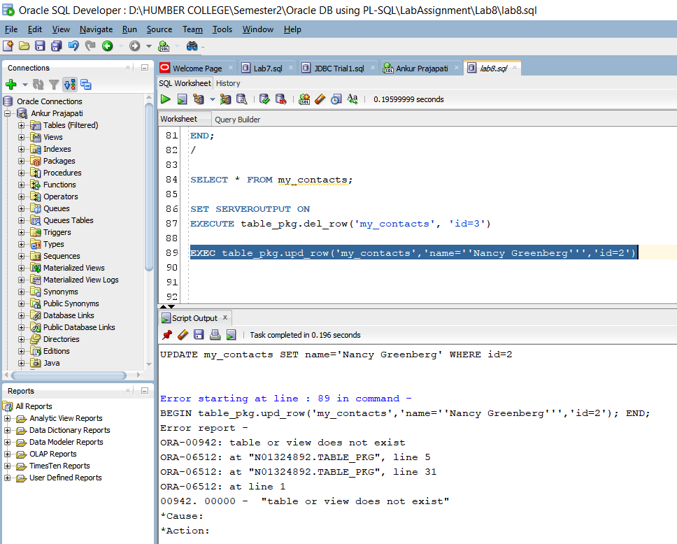

* Here we are trying to update row from table my_contacts having name as Nancy Greenberg and having id 2.
* But due to table does not exist updating fails.

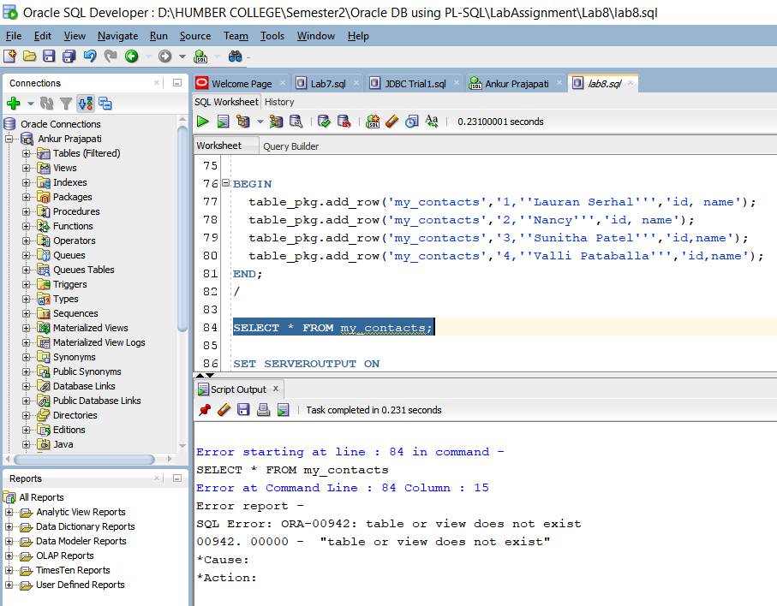

* We are using SELECT query to see the record inside table my_contacts, but table is not there so it’s not possible for us.

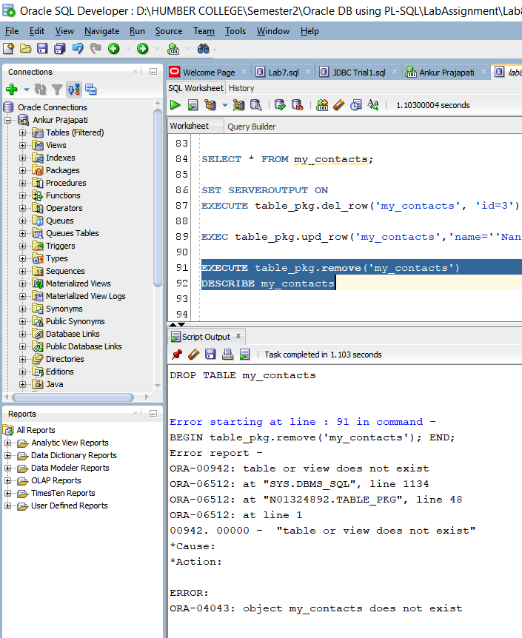

* We are trying to remove my_contacts from database but it says table or view does not exist. That’s why this database operation is not possible.

Question 2:

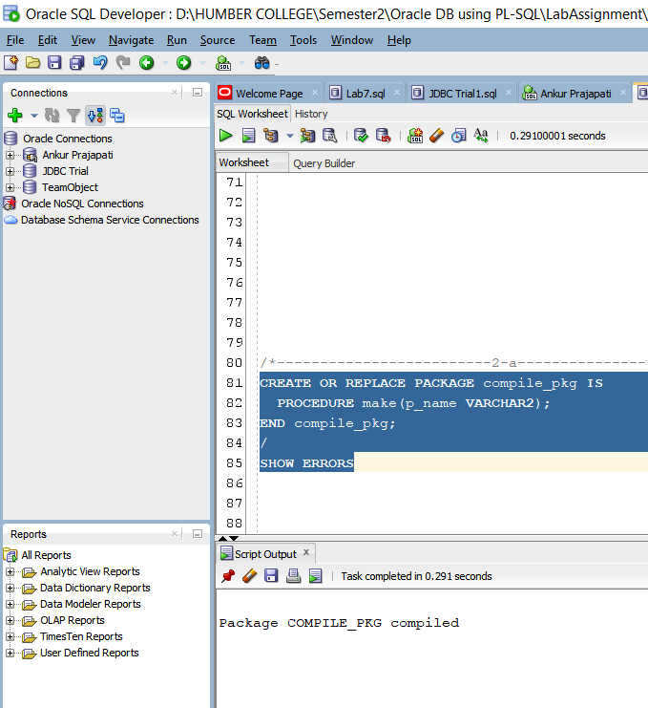

* Creation of complie_pkg using make procedure.
* Note that this procedure basically creates new table using given name.
* Compile_pkg is compiled successfully.

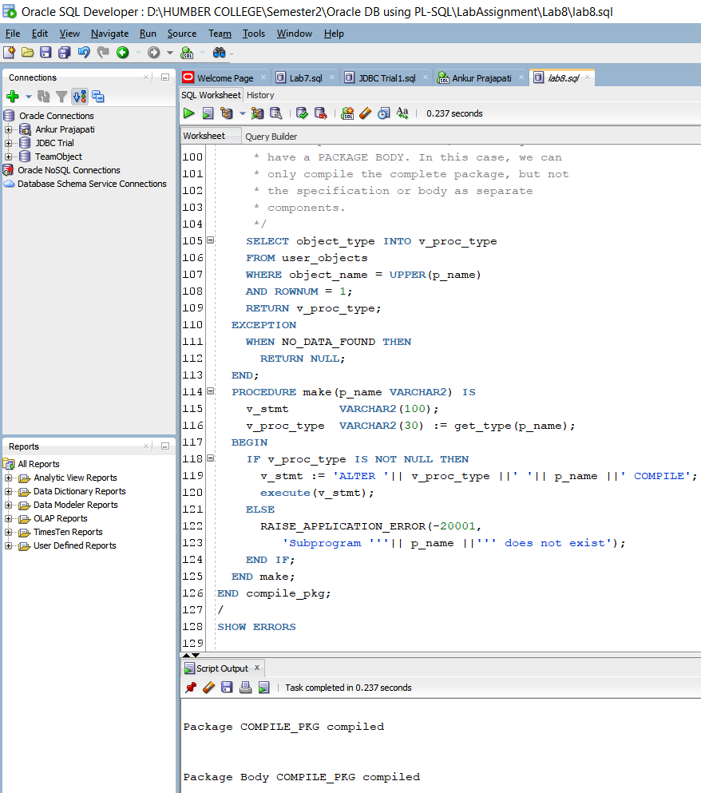

* Here we are taking screen shot of package specification and package body compilation.
* Both the compilation is done successfully.
* We have included get_type function to determine object type from the PL/SQL data dictionary. It will return package type if it exists otherwise it will return NULL.
* This function returns only one line so you can only compile whole package with specification and body. Note that you cannot compile stand alone package specification or body.
* We have implemented make procedure which accepts one argument called name which represents object name and it will call get_type function.

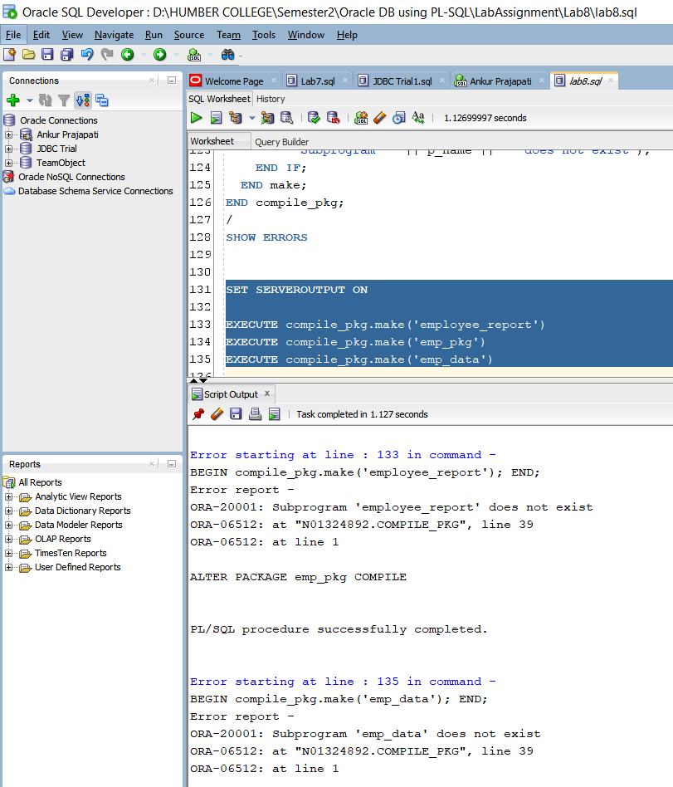

* We are calling make procedure of compile_pkg with employee_report, emp_pkg, emp_data
* As we don’t have employee_report package we can not alter it using this procedure.
* emp_pkg is already there so we can actually alter package and it says it’s compiled successfully.
* Same we don’t have emp_data object that’s why it says that emp_data does not exist.

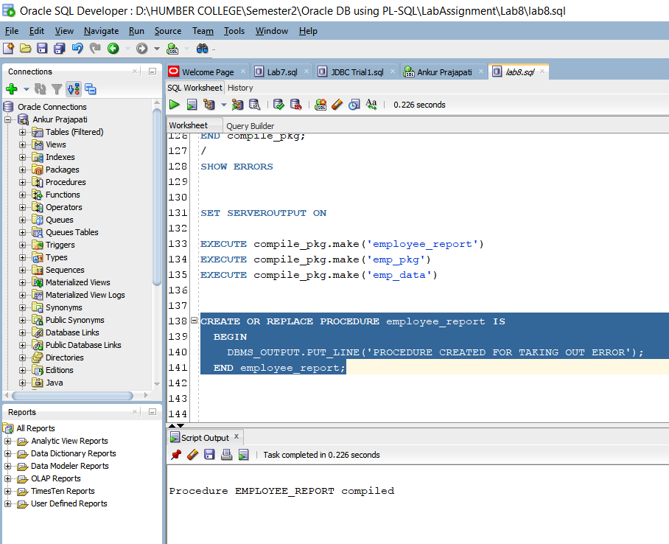

Let’s do one thing we will create employee_report procedure to remove this error and find out if it works or not.

Employee_report compiled

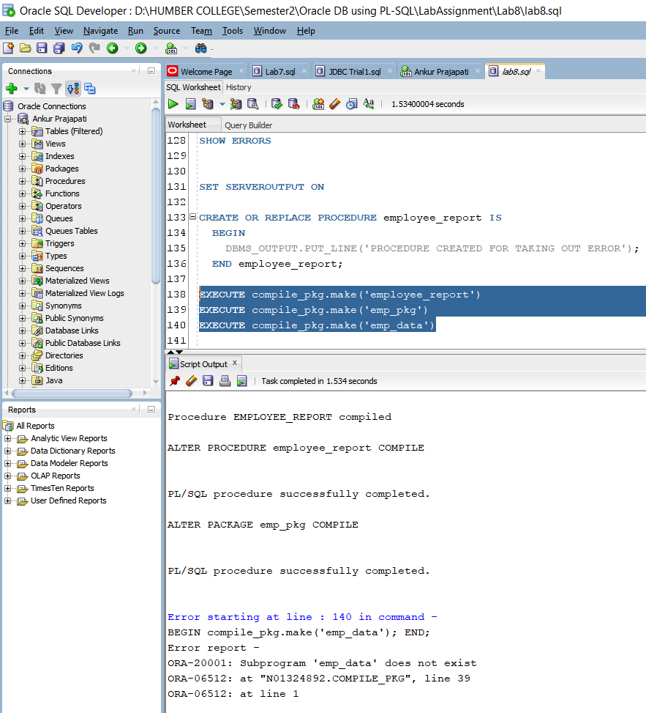

After creating procedure employee_report it actually alters employee_report procedure.

As we do not have emp_pkg it will give an error.