• Install Power BI Desktop and share the final screenshot of the report view page which appears when power desktop starts.

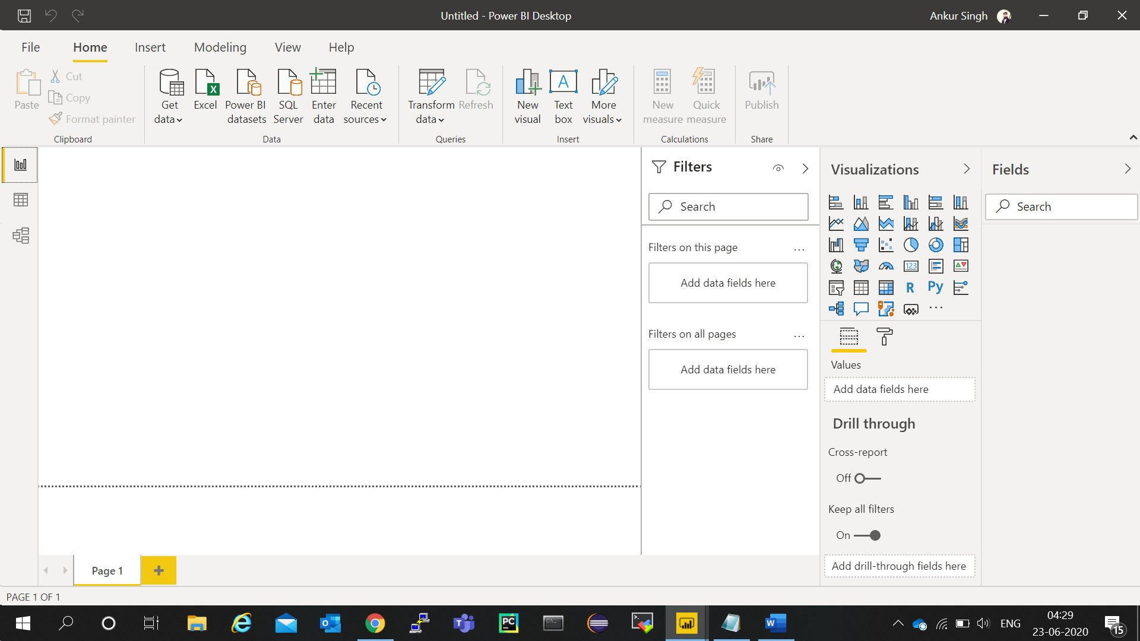

**• Prepare a document and with the following screenshot**

− Report View

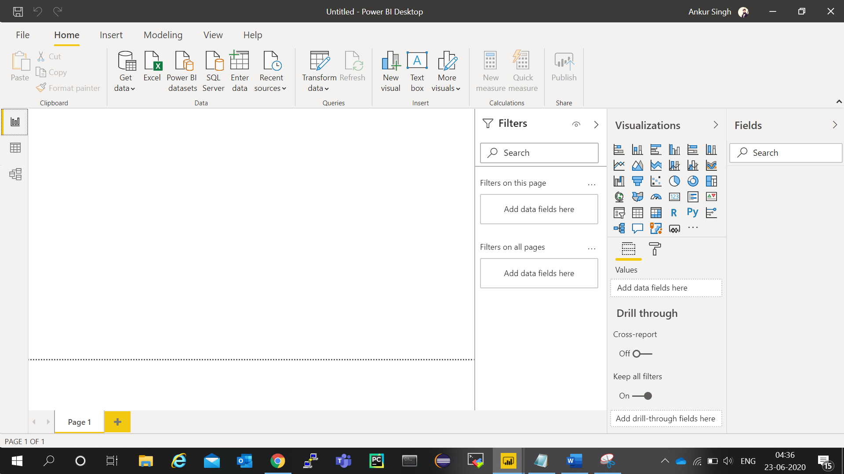

− Data View

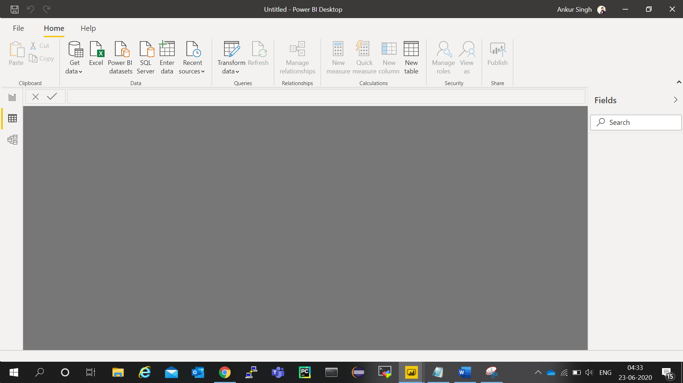

− Model View

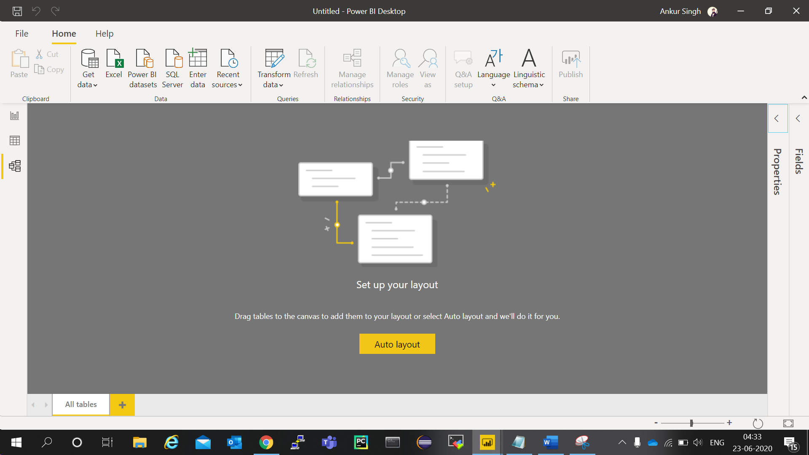

− Power Query Editor

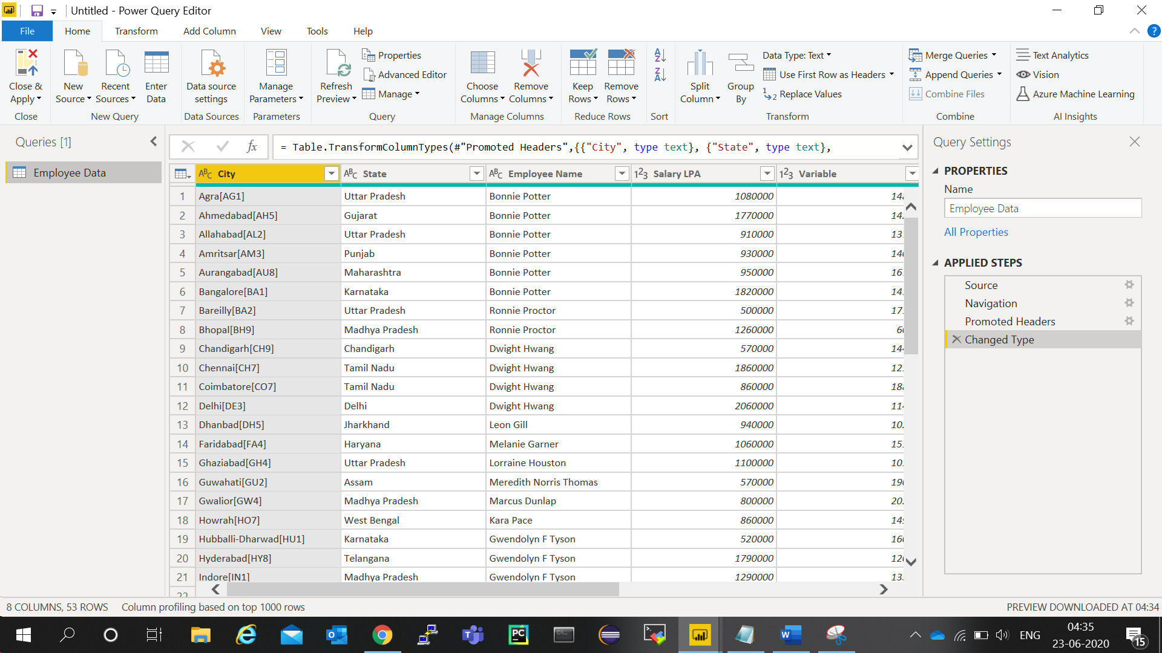

− Advance Editor

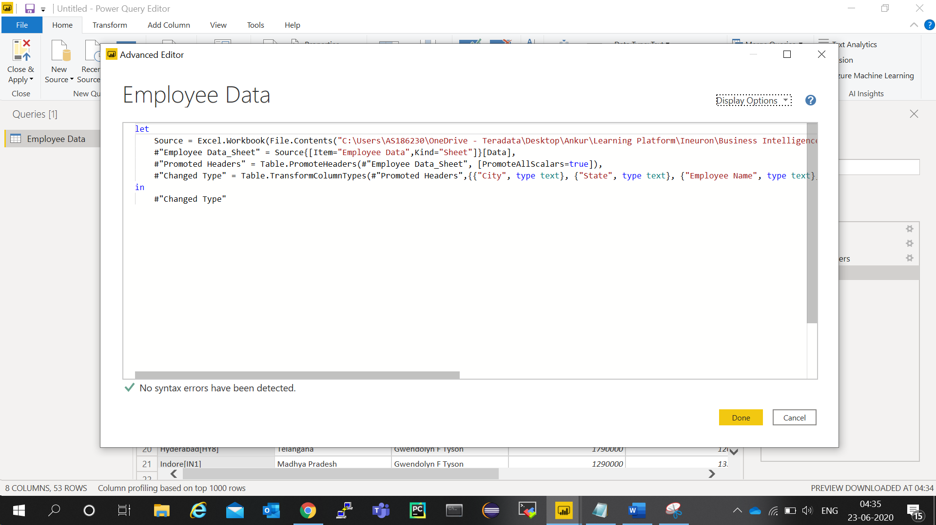

**• Prepare a document with details of the following along with their price**

− Power BI Desktop

− Power BI Premium

− Power BI Pro

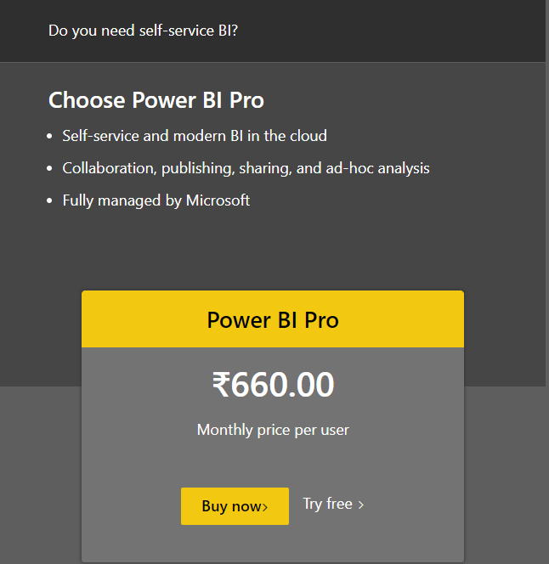

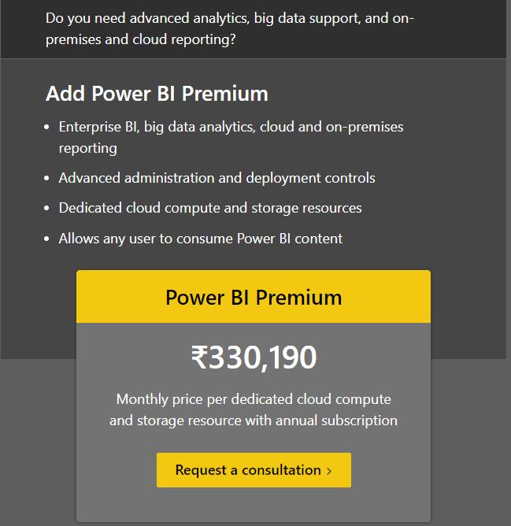

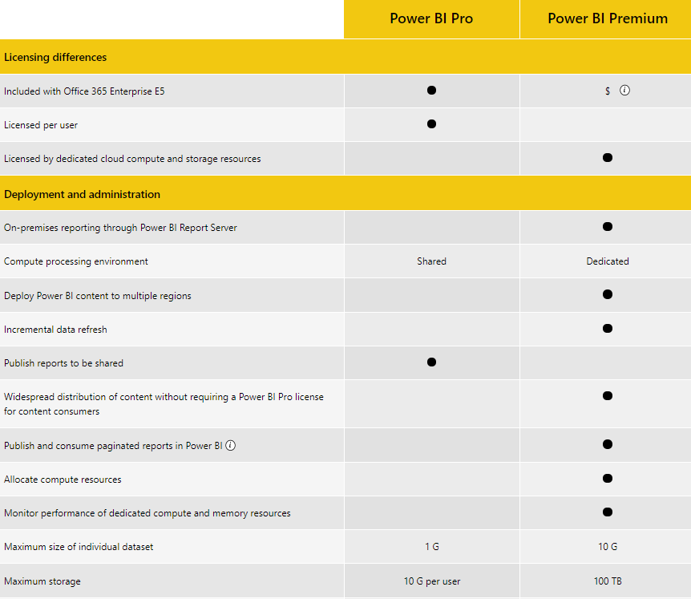

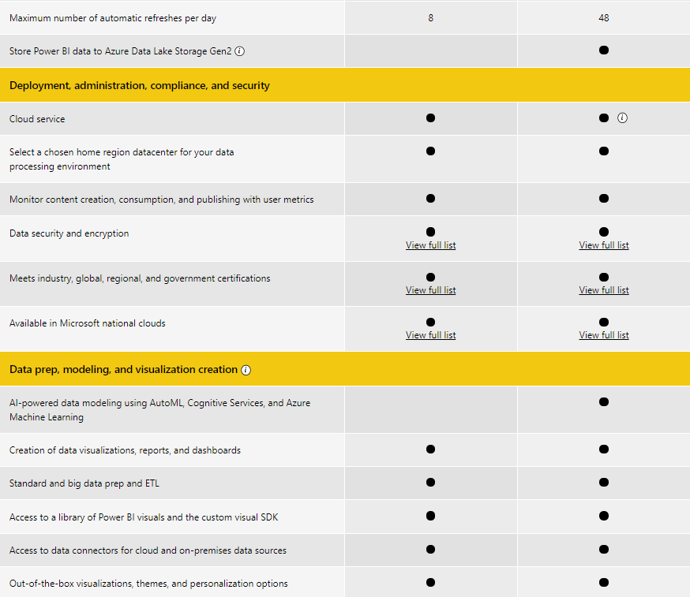

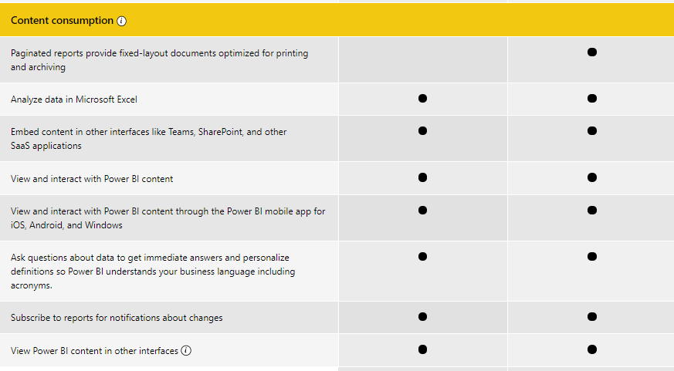

What is Power BI Desktop?

Power BI Desktop is the free version of Power BI that you can install on your local computer as a program, and acts as a companion desktop application to the full version of Power BI. If you need to consolidate your data sources, create your own reports and conduct your own analysis or test it’s capabilities, it’s the perfect version to start with for all skill levels - whether you’re non-IT and want to make your reports more interactive, or analysts seeking richer detail, it's one of the best business analytics tools to use.

Despite its free nature, you may be surprised at what Microsoft has included with Power BI Desktop:

* You can connect and import data from over 70 cloud-based and on-premises sources
* The same rich visualisations and filters from Power BI Pro
* Auto-detect that finds and creates data relationships between tables and formats
* Export your reports to CSV, Microsoft Excel, Microsoft PowerPoint and PDF
* Python support
* Save, upload and publish your reports to the Web and the full Power BI service
* Storage limit of 10 GB per user

Naturally, there are some feature limitations with the free Power BI Desktop that give further incentive to upgrade.

* Can’t share created reports with non-Power BI Pro users
* No App Workspaces
* No API embedding
* No email subscriptions
* No peer-to-peer-sharing
* No support to analyse in Excel within Power BI Desktop

To be very clear: All of Power BI’s basic features - cleaning and preparing data, connectors to data sources, custom reports, visualisations and exports to Microsoft apps are included in Power BI Desktop. Thus, whatever core functionality or features are available in Power BI Desktop are also standard in the higher-tier, paid versions.