yogitachittoria@cdac.in

Write Java programs to:

1. Calculate average of numbers using Array

2. Reverse an array

3. Sort an array in ascending order

4. Add two Matrix using Multi-dimensional Arrays

5. Find out the highest and second highest numbers in an array

6. Concatenate two arrays

7. create triangular array(ladder)

8. create varag arguments method

9. copy one array to other

1:

class average{

public static void main(String args[]){

int a[]={10,20,30,40,50,60,70,80,90,100};

System.out.println("array elements are: ");

for(int i=0;i<a.length;i++){

System.out.print(" "+a[i]);

}

int s=0;

for(int i=0;i<a.length;i++){

s=s+a[i];

}

double avg=s/a.length;

System.out.println();

System.out.println("average of array is : "+avg);

}

}

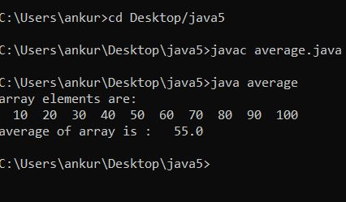

2:

class rev{

public static void main(String args[]){

int a[]={1,2,3,4,5,6,7,8,9,10};

System.out.println("befor reverse array elements are: ");

for(int i=0;i<a.length;i++){

System.out.print(" "+a[i]);

}

System.out.println();

System.out.println("after reverse array elements are: ");

for(int i=a.length-1;i>=0;i--){

System.out.print(" "+a[i]);

}

}

}

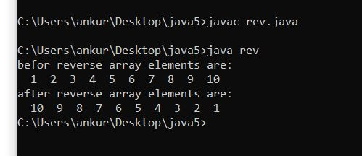

3:

class ascending{

public static void main(String args[]){

int a[]={357,122,985632,15,36,15,9856,98,9,25};

System.out.println("befor ascending array elements are: ");

for(int i=0;i<a.length;i++){

System.out.print(" "+a[i]);

}

for(int i=0;i<a.length;i++){

for(int j=i+1;j<a.length;j++){

if(a[i]>a[j]){

int b=a[i];

a[i]=a[j];

a[j]=b;

}}}

System.out.println();

System.out.println("after ascending array elements are: ");

for(int i=0;i<a.length;i++){

System.out.print(" "+a[i]);

}

}

}

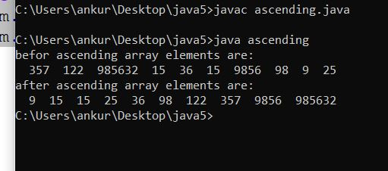

4:

class addm{

public static void main(String args[]){

int a[][]={{05,06,85},{15,20,32},{56,25,05}};

int b[][]={{06,154,25,78},{06,58,21},{95,62,34}};

int c[][]=new int[3][3];

System.out.println("array matrix 1 is: ");

for(int i=0;i<3;i++){

for(int j=0;j<3;j++){

System.out.print(a[i][j]+" ");

}

System.out.println();

}

System.out.println("array matrix 2 is : ");

for(int i=0;i<3;i++){

for(int j=0;j<3;j++){

System.out.print(b[i][j]+" ");

}

System.out.println();

}

for(int i=0;i<3;i++){

for(int j=0;j<3;j++){

c[i][j]=a[i][j]+b[i][j];

}

}

System.out.println(" addition of matrix is : ");

System.out.println();

for(int i=0;i<3;i++){

for(int j=0;j<3;j++){

System.out.print(c[i][j]+" ");

}

System.out.println();

}

}

}

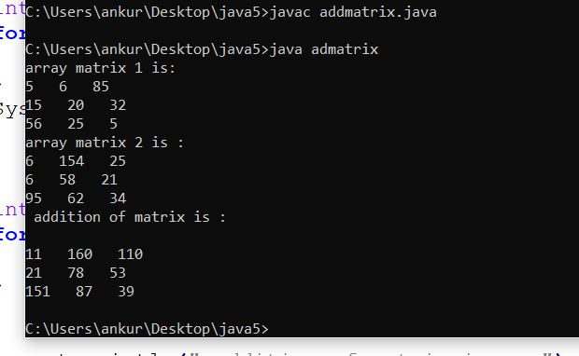

5:

class highest{

public static void main(String args[]){

int a[]={357,122,985632,15,36,15,9856,98,9,25};

System.out.println("array elements are: ");

for(int i=0;i<a.length;i++){

System.out.print(" "+a[i]);

}

for(int i=0;i<a.length;i++){

for(int j=i+1;j<a.length;j++){

if(a[i]<a[j]){

int b=a[i];

a[i]=a[j];

a[j]=b;

}

}

}

System.out.println();

System.out.println("highest element is : "+a[0]);

System.out.println("second highest element is : "+a[1]);

}

}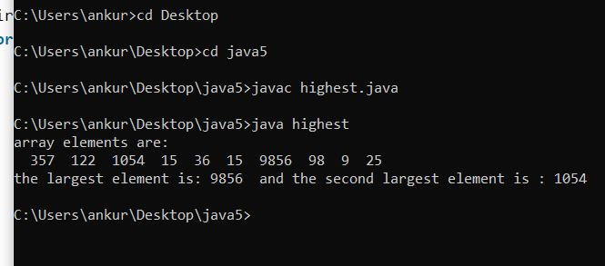

6:

class concatarr{

public static void main(String args[]){

int a[]={05,06,85,36,15};

int b[]={06,154,25,78,45};

int c[]=new int[10];

System.out.println("array 1 is: ");

for(int i=0;i<5;i++){

System.out.print(a[i]+" ");

}

System.out.println("array 2 is : ");

for(int i=0;i<5;i++){

System.out.print(b[i]+" ");

}

for(int i=0;i<10;i++){

if(i<5)

c[i]=a[i];

else

c[i]=b[i-5];

}

System.out.println(" concat of array is : ");

System.out.println();

for(int i=0;i<10;i++){

System.out.print(c[i]+" ");

}}

}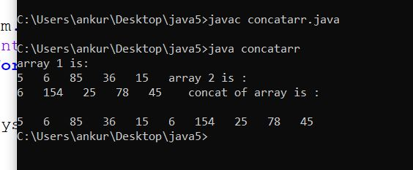

7: import java.util.Scanner;

class demo1{

public static void main(String args[]){

Scanner sc=new Scanner(System.in);

int[][] a=new int[5][];

for(int i=0;i<a.length;i++){

a[i]=new int[i+1];

}

for(int i=0;i<a.length;i++){

for(int j=0;j<a[i].length;j++){

System.out.print("enter the element no a["+i+"]["+j+"]: ");

a[i][j]=sc.nextInt();

System.out.println();

}

}

for(int i=0;i<a.length;i++){

for(int j=0;j<a[i].length;j++){

System.out.print(a[i][j]+" ");

}

System.out.println();

}

}

}

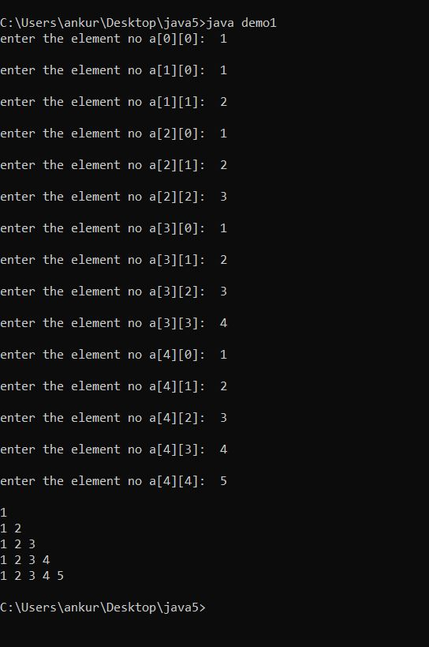

8:

import java.util.Scanner;

class demo1{

public static void main(String args[]){

Scanner sc=new Scanner(System.in);

int[][] a=new int[5][];

for(int i=0;i<a.length;i++){

a[i]=new int[i+1];

}

for(int i=0;i<a.length;i++){

for(int j=0;j<a[i].length;i++){

System.out.print("enter the element no a["+i+"]["+j+"]: " );

a[i][j]=sc.nextInt();

System.out.println();

}

}

for(int i=0;i<a.length;i++){

for(int j=0;j<a[i].length;i++){

System.out.print(a[i][j]+" ");

}

System.out.println();

}

}

}

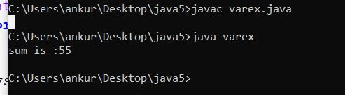

9:

class q9{

public static void main(String args[]){

int a[]={05,06,85,36,15};

int b[]=new int[5];

System.out.println("array 1 is: ");

for(int i=0;i<5;i++){

System.out.print(a[i]+" ");

}

for(int i=0;i<5;i++){

b[i]=a[i];

}

System.out.println();

System.out.println(" copied array is : ");

for(int i=0;i<5;i++){

System.out.print(b[i]+" ");

}

}

}

