A Guide to Building Docker Images
Sources:
https://seqera.io/blog/building-containers-for-scientific-workflows/
https://pythonspeed.com/articles/base-image-python-docker-images/
https://docs.docker.com/reference/dockerfile#maintainer-deprecated
https://seqera.io/containers/

What is Docker?
Docker is a software platform that packages your software into isolated units called containers, which includes everything your software needs to run — libraries, system tools, code, and runtime (OS, and binaries).
Advantages of using Docker:
- Offers a highly portable, OS-level process isolation, allowing programs to run in lightweight packages across different operating environments.
- Once built, a container runs identically anywhere — laptop, workstation, HPC, cloud platforms.
- No dependency management required — everything is already encapsulated in the image.
- Docker images are constructed in multiple layers where each layer corresponds to an instruction in the Dockerfile that was used to build the image.
- When a new image version is built, only the changed layers need to be downloaded rather than the entire image, saving space.
- Common layers shared across images derived from the same base are stored only once on the host OS, avoiding redundant duplication.
- Cpu and memory usage of a container can be capped.
Disadvantages of Docker:
Docker requires root privileges and therefore cannot run on HPC/cluster environments. However, Docker images can be pulled directly into Singularity, which runs containers without root.
Alternatives to Docker: Singularity, Shifter, and Podman.

How to build a Docker image?
Building a Docker image requires:
- Dockerfile – a text document that contains the set of commands used to build a Docker image. It has a reference to base image and the commands to construct upon it.
- Environment specifications in a .yaml or .yml file (special files used to specify and share configurations/application settings)
Users can either build their own image in their system using these files or can download (pull) a pre-build image form platforms like Docker Hub where people publish images for free.
The images are built upon a base image. Smaller base images are better as they load faster. https://pythonspeed.com/articles/base-image-python-docker-images/
Commands in a Dockerfile - https://docs.docker.com/reference/dockerfile#maintainer-deprecated
Simplest way to create a Dockerfile would be to use Seqera’s container building tool https://seqera.io/containers/ View build details section to see the Conda environment file and Docker definition file. These files can be used to build image locally.
Conda is a package and virtual environment manager. Conda has several distributions (variants):
- Miniconda – conda with limited essential packages
- Anaconda – conda with extensive pre-installed packages
- Mamba – lighter, ultra-fast replacement of the Conda

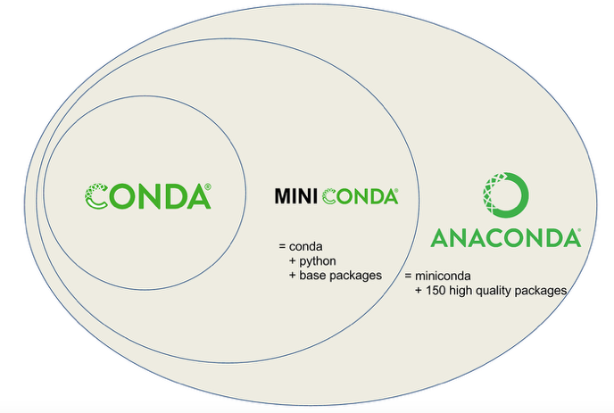
Source: https://medium.com/data-science/managing-project-specific-environments-with-conda-b8b50aa8be0e

Conda installs programs from repositories that are called channels. These are remote locations from where conda can fetch the packages.
Bioconda is a channel dedicated to bioinformatics tools/packages.
Environments in conda can be exported in a .yaml file format that can be shared with others who want to recreate the same environment.
$ conda env export > environment.yaml

Build containers using Dockerfile and environment.yml with the following command:
~$ docker build -t name:tag .
-t specify an image name:tag (e.g. cnv-robot:v4.2)
To download (pull) a container from Docker Hub:
~$ docker pull ankurtchuzy/cnv-robot-docker-dev:v4.2
To see the list of images built/pulled from Docker Hub:
~$ docker images
To see how a container was constructed:
~$ docker history <container_name>

Using a container interactively:
~$ docker run -it <image name> bash
-i run the container interactively
-t allocate a tty to interact with the container from command line
bash start a bash shell inside the container
Type exit from the shell to exit the container.

Publishing a container to registry
Follow these steps to build and publish a container on Docker Hub:
- Create a profile on Docker Hub - https://hub.docker.com
- Install Docker on your system
Mac: https://docs.docker.com/desktop/setup/install/mac-install/
Linux: https://docs.docker.com/desktop/setup/install/linux/
- Login to Docker Hub on command line
~$ docker login
- Build image
~$ docker build -t user_name/repository_name:v0.0 .
(Dockerfile and environment.yml should be in the same directory)
- Push to Docker Hub
~$ docker push user_name/repository_name:v0.0

