Conda is a package and virtual environment manager. Conda has several distributions (variants):
- Mamba –
- Miniconda – limited essential packages
- Anaconda – extensive pre-installed packages
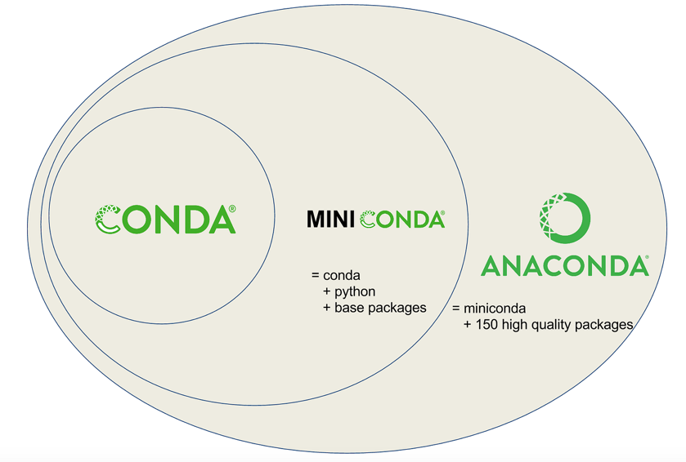
Conda installs programs from repositories that are called channels. These are remote locations from where conda can fetch the packages.
Bioconda is a channel dedicated to bioinformatics tools/packages.
Environments in conda can be exported in a YAML file format that can be shared with others who want to recreate the same environment.

