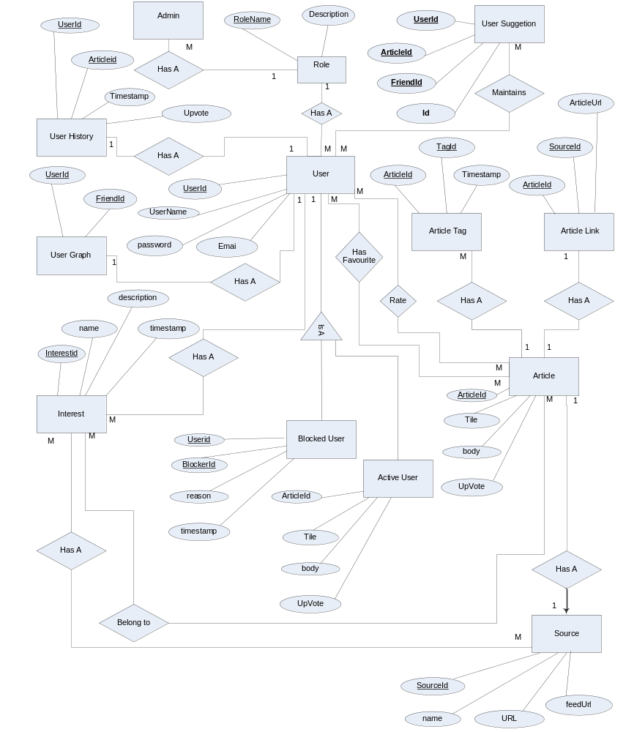
Author: Rinku Dhola and Sanki Shah

