SDLC Model

Project Title : Pattern based RSS Searching

Selected Model : Prototyping Model.

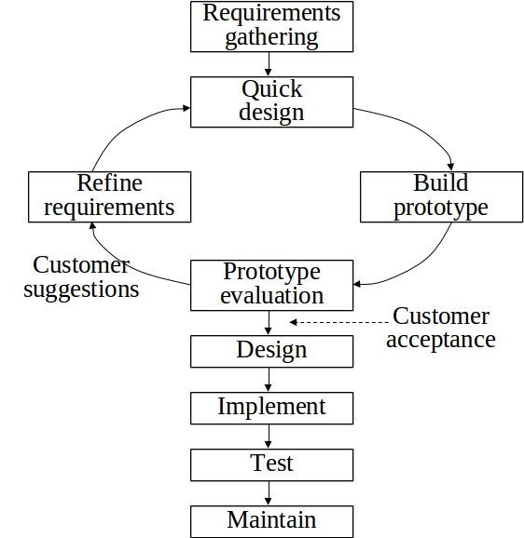

Prototyping model suggests building a functional prototype before developing the actual software.

A prototype is a toy implementation of a system; usually exhibiting limited functional capabilities, low reliability, and inefficient performance. There are several reasons for developing a prototype. An important purpose is to illustrate the input data formats, messages, reports and the interactive dialogs to the customer. This a valuable mechanism for gaining better understanding of the customer’s needs. Another important use of the prototyping model is that it helps critically examine the technical issues associated with the product development.

Prototyping may involve several iterations because at the end of the development of each prototype it has to be discussed with the client and if it is not according to the requirement then it has to be redeveloped.

Once all the prototypes of the system are developed and verified against the requirements, the development process can proceed further. The further development can be done using simple waterfall model.

## Outline of the prototyping process

The process of prototyping involves the following steps

1. Identify basic requirements

Determine basic requirements including the input and output information desired. Details, such as security, can typically be ignored.

1. Develop Initial Prototype

The initial prototype is developed that includes only user interfaces but it can depend on the requirements. Review the customers, including end-users, examine the prototype and provide feedback on additions or changes.

1. Revise and Enhance the Prototype

Using the feedback both the specifications and the prototype can be improved. Negotiation about what is within the scope of the contract/product may be necessary. If changes are introduced then a repeat of steps #3 and #4 may be needed.

Reasons for the selection :

1) Technical Challenges

As prototype model is suitable for the situations where technical aspects are not clearly understood, we have chosen it.

The technical aspects that are not clear to us are web data crawling and information retrieval part which also includes XML data mining. We are not well versed with the data mining techniques and tools. So before we start our development we have to ensure that the requirements that our project is going to address are achievable. For that we need to make various prototypes of our requirements. We need to study that prototypes and have to refine them according to our requirements. If we find that prototype is a simulation of our requirements then we can easily move further in the development process. Thus, it is a strong reason for selection prototyping model as our development model.

Another reason being it reduces risk of failure, as potential risks can be identified early and mitigation steps can be taken. So that further development process can proceed without any major known/unknown problems.

Here time required to complete the project after getting final the SRS reduces, since the developer has a better idea about how he should approach the project.

Users are actively involved in the development

Errors can be detected much earlier as the system is mode side by side.

Quicker user feedback is available leading to better solutions.

**Reasons for not selecting other models.**

**1 ) The Waterfall Model**

**All requirements must be known upfront**

**Deliverables created for each phase are considered frozen – inhibits flexibility**

**2) Incremental Model**

**Requires early definition of a complete and fully functional system to allow for the definition of increments**

**3) Spiral Model**

**Time spent on planning, re-setting objectives, doing risk analysis and prototyping may be excessive.**

**Risk assessment expertise is required.**

**May be hard to define objective, verifiable milestones that indicate readiness to proceed through the next iteration.**