PayUmoney BOLT plugin for

For Magento 2.2

**Installation Steps (Via FTP)**

1. Extract the zip file and upload ‘PayUM’ folder to Magento <root>/app/code. If ‘PayUM’ folder already exists, then copy the ‘Pumbolt’ folder from inside.
2. Run the magento commands –

php bin/magento setup:upgrade

php bin/magento setup:static-content:deploy

1. Follow the configuration section to configure the module in Magento Admin panel**.**

# Configuring the Payment Method

1. Login and Navigate to Store->Configuration->Sales->Payment Methods. Expand the tab named ‘PayUmoney BOLT’.

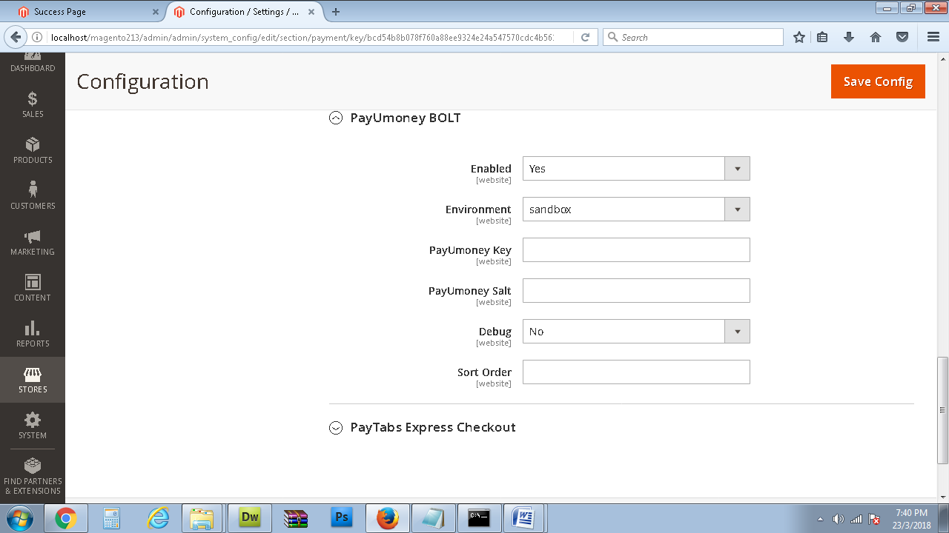

You should see the page as shown in above pic.

If not, clear Cache, then repeat this step.

1. Fill up the configuration details as you received.

Brief description of the info fields….

1. **Enabled:** ‘Yes’ to enable the module.
2. **Environment:**

This field determines the gateway environment your payment will be redirected to.

This field can have three values :

1. **sandbox –** This is a test environment. No actual fund transfer will take place.
2. **Production –** This is the live environment. Use this value only for your website in production. Payments sent in production environment will actually get processed.

For testing purposes we suggest only use sandbox.

1. **PayU Money Key:** If you have received PayUmoney credentials then enter this info.
2. **PayU Money Salt:** If you have received PayUmoney credentials then enter this info.
3. After your have setup information in step 2, click on **Save Config** and you can have your customers make payment via the payment method.
4. Select PayUmony BOLT in checkout for payment.