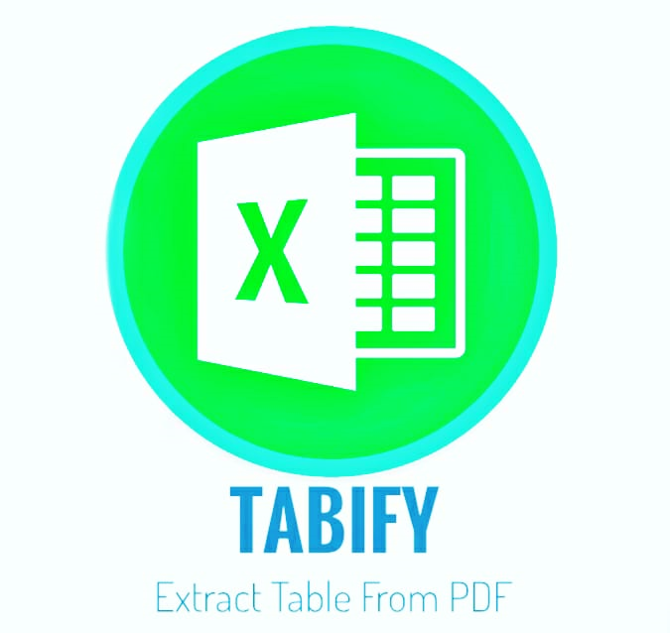

  - Programming lab Documentation
Aztec | Python Lab | 20 Nov 19

Python Mini Project Aim :
- To create new datasheets of tables by extracting from portable document formats.

Advantages of Python
The diverse application of the Python language is a result of the combination of features which give this language an edge over others. Some of the benefits of programming in Python include:

1. Presence of Third Party Modules:
The Python Package Index (PyPI) contains numerous third-party modules that make Python capable of interacting with most of the other languages and platforms.

2. Extensive Support Libraries:
Python provides a large standard library which includes areas like internet protocols, string operations, web services tools and operating system interfaces. Many high use programming tasks have already been scripted into the standard library which reduces length of code to be written significantly.

3. Open Source and Community Development:
Python language is developed under an OSI-approved open source license, which makes it free to use and distribute, including for commercial purposes.
Further, its development is driven by the community which collaborates for its code through hosting conferences and mailing lists, and provides for its numerous modules.

4. Learning Ease and Support Available:
Python offers excellent readability and uncluttered simple-to-learn syntax which helps beginners to utilize this programming language. The code style guidelines, PEP 8, provide a set of rules to facilitate the formatting of code. Additionally, the wide base of users and active developers has resulted in a rich internet resource bank to encourage development and the continued adoption of the language.

5. User-friendly Data Structures:
Python has built-in list and dictionary data structures which can be used to construct fast runtime data structures. Further, Python also provides the option of dynamic high-level data typing which reduces the length of support code that is needed.

6. Productivity and Speed:
Python has clean object-oriented design, provides enhanced process control capabilities, and possesses strong integration and text processing capabilities and its own unit testing framework, all of which contribute to the increase in its speed and productivity. Python is considered a viable option for building complex multi-protocol network applications.

Disadvantages of Python
As an interpreted language, Python has a slow speed of execution. It is slower than C and C++ because it works with an interpreter, not the compiler.
The language is seen as less suitable for mobile development and game development. It is often used on desktop and server, but there are only several mobile applications that were developed with Python. Another disadvantage Python has is the runtime error. The language has a lot of design limits and needs more testing time. The programmer has the possibility to see bugs only during run time.
Python has high memory consumption and is not used in web browsers because it is not secure. Language flexibility is considered among both advantages and disadvantages of Python.
Developers like Python for its simplicity in learning and coding, so much that it might be difficult for some of them to learn and use other languages.
In spite of all the disadvantages of Python programming language, it has a lot more pros than cons.

Domain :
- Tkinter is a Python binding to the TK GUI toolkit. It is the standard Python interface to the Tk GUI toolkit,^{[1]} and is Python's de facto standard GUI.^{[2]} Tkinter is included with standard Linux, Microsoft Windows and Mac OS X installs of Python.
- As with most other modern Tk bindings, Tkinter is implemented as a Python wrapper around a complete Tcl interpreter embedded in the Python interpreter. Tkinter calls are translated into Tcl commands which are fed to this embedded interpreter, thus making it possible to mix Python and Tcl in a single application.
- Python 2.7 and Python 3.1 incorporate the "themed Tk" ("ttk") functionality of Tk 8.5. This allows Tk widgets to be easily themed to look like the native desktop environment in which the application is running, thereby addressing a long-standing criticism of Tk (and hence of Tkinter).
- There are several popular GUI library alternatives available, such as wxPython, PyQt (PySide), Pygame, Pyglet, and PyGTK.

- The Modules and packages used are:
- Tkinter
- Camelot
- Numpy
- Pandas

Some definitions

Window
This term has different meanings in different contexts, but in general it refers to a rectangular area somewhere on the user's display screen.

Top Level Window
A window that exists independently on the screen. It will be decorated with the standard frame and controls for the desktop manager. It can be moved around the desktop, and can usually be resized.

Widget
The generic term for any of the building blocks that make up an application in a graphical user interface.
- Core widgets: The containers:frame, toplevel, paned window. The buttons: button, radiobutton, checkbutton (checkbox), menubutton (combobox). The text widgets: label, labelframe, message, text. The entry widgets: scale, scroll, listbox, slider, spinbox, entry (singleline), text (multiline), and canvas (vector and pixel graphics).
- There are the extension widgets:tk_optionMenu, tk_dialog, tk_messageBox, tk_getOpenFile, tk_getSaveFile, tk_chooseColor, tk_chooseDirectory.
- The ttk widgets: The ttk widgets coexist with other widgets which they can replace.^{[7]} There are ttk::button, ttk::checkbutton, ttk::combobox, ttk::entry, ttk::frame, ttk::label, ttk::labelframe, ttk::menubutton, ttk::notebook, ttk::panedwindow, ttk::progressbar, ttk::radiobutton, ttk::scale, ttk::scrollbar, ttk::separator, ttk::sizegrip, ttk::spinbox, ttk::treeview.^{[8][9]}

Frame
In Tkinter, the Frame widget is the basic unit of organization for complex layouts. A frame is a rectangular area that can contain other widgets.

Child and parent
When any widget is created, a parent-child relationship is created. For example, if you place a text label inside a frame, the frame is the parent of the label.

A good start to know about modules :
Pandas :
pandas is a Python package providing fast, flexible, and expressive data structures designed to make working with “relational” or “labeled” data both easy and intuitive. It aims to be the fundamental high-level building block for doing practical, real world data analysis in Python.
Camelot : Camelot is the python gui module help us in making read pdf buffers. And by using the streams and third party- python modules , we can read the tables in datasheets form .Also , tabule can also be used to make this things happen but it is hectic . Also, it donot have ease in buffers to convert dataframe objects into other formats.

Problem statement :
On daily basis we download many pdfs that are safe in terms of data losing concepts. Also, it is portable format .It is non –editable(mostly) . It contains some data in forms of tables , and we wish to extract only table data. Here comes TABIFY .
Solution :
To solve above problem our team have made great efforts to save time and do tasks with ease. Tabify not only extracts the tables in document but also can make copy of table datasheets in csv or excel format . There only table data are concerned .

Implementation of TABIFY :
Algorithm :
Step 1 : Start
Step2 : Enter the pdf name without extension, password if protected , total number of pages to read, table number in pdf.
Step 3: check if all the entries are valid else go to step 2 :
Step 4 : Get the user event trigger for
4.1 submit go to step 5
4.2 get excel sheet go to step 6
4.3 cancel or exit the program go to step 7
Step 5 :
5.1 Check if all entries are valid else raise error in messagebox
5.2 calculate valid page number range
5.3read pdf until valid pages
5.4 view data objects in terminal
Go to step 2 :

Step 6 :
6.1 validate all the entries else raise error in messagebox
6.2 read pdf till valid pages
6.3create data objects
6.4 export as csv file
6.5 clear all entries in entries in tkinter widgets
6.6 calculate the absolute path of exported file
6.7 request OS to open excel .exe with exported filename
6.8 go to step 2

Step7 :
Close the program
Step 8:
END

Working :
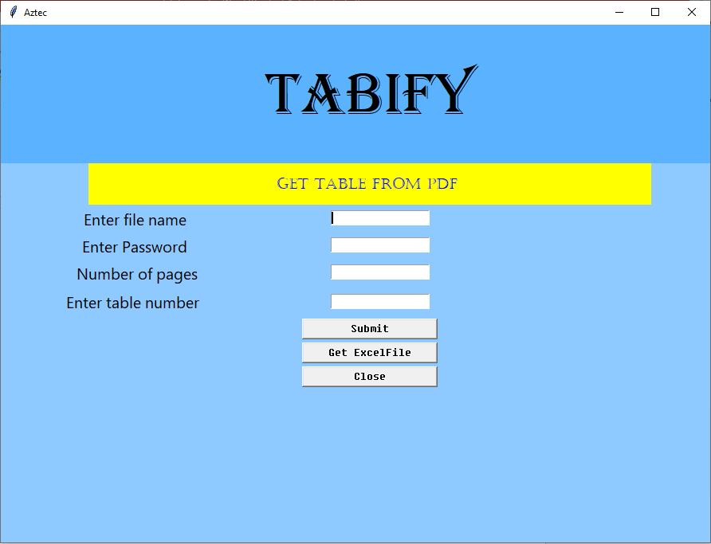
The preface of program is given below .

2. Error prompt dialogbox for invalid entries .
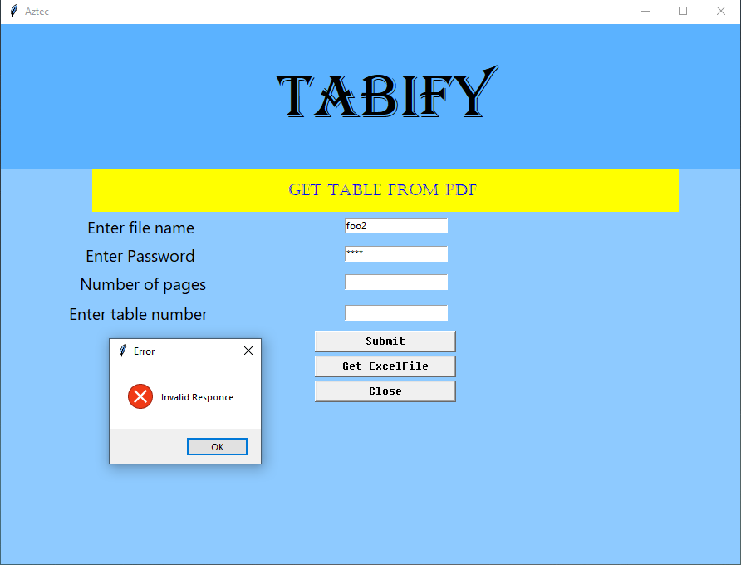

3. Successful fetching of table .
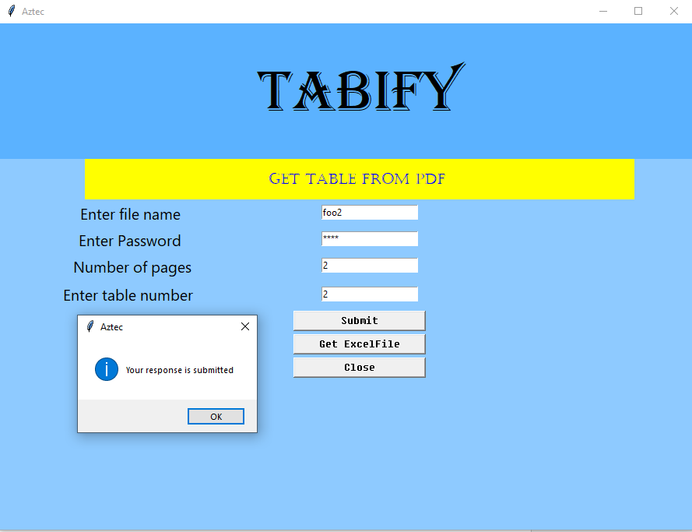
Terminal output :
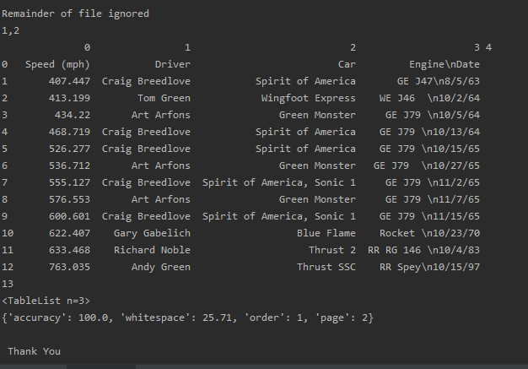

4. Get excel file of fetched table
4.1 Tabify interface :
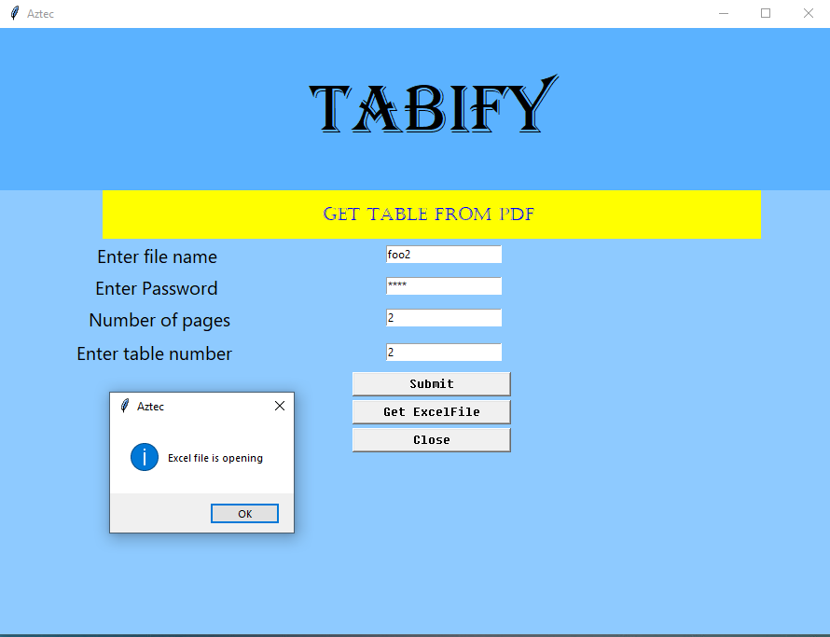

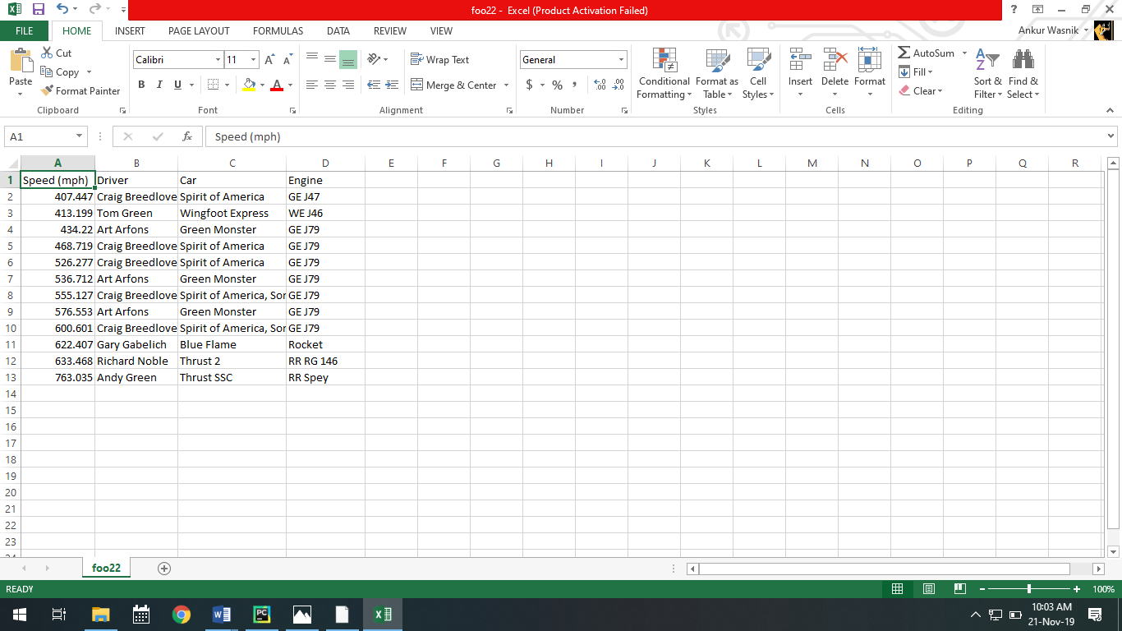
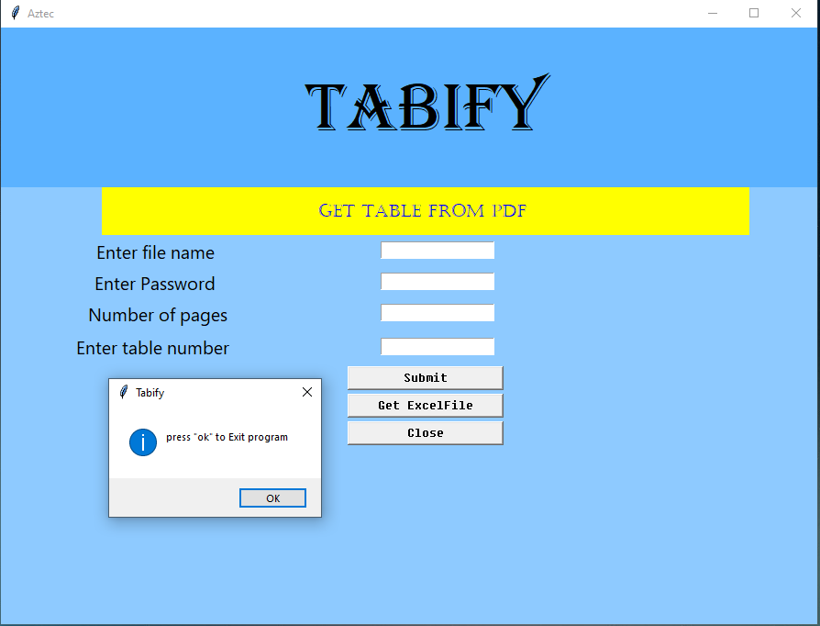
5 exit program

Conclusion :
Thus, we have developed desktop application using GUI programming in python viz. tkinter module.
Future Scope of Tabify :
This desktop application can be redefined to not only extract tables from pdf but also graphics such as images, gifs, cliparts ,etc. Also, It can be used convert available formats to any formats. Also data visualization can be implemented live thereby of tables selected in pdf.

