- A police officer from Vancouver Police Department wanted to find out the percentage of drivers who were distracted (defined as using their phone while driving or waiting at the traffic lights) during the day (0800-1600). The officer took a random sample of 80 drivers to investigate this. The results can be found in “Distracted Driving - Day” worksheet of the file “STAT1123_HW2_Data.xlsx” on BrightSpace.
  - Use Excel to provide a Pivot Table showing “column percentages”. [2 marks]
Note: Please make sure you have the “Yes” category goes above the “No” category.
Row Labels | Count of Distracted
Yes | 55%
No | 45%
Grand Total | 100%

  - Use Excel to produce a “2-D Pie” graph (i.e. a pie chart). Provide a description of the graph. [2+1 marks]
Note: A graph directly copied from Excel without any annotation will get a zero.
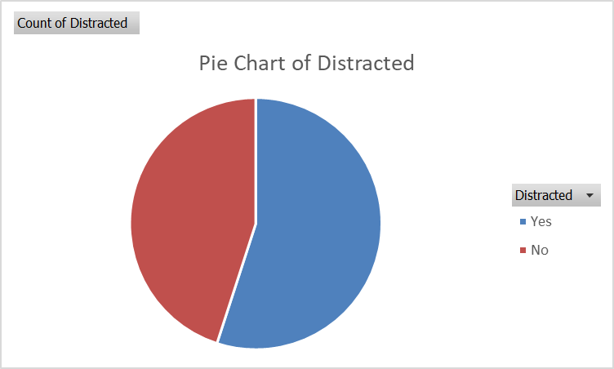[2]
Description: Majority of the drivers are distracted in the sample of 80 drivers. [1]
Note: Any reasonable answers are fine, but it has to be describing the graph.

  - Use Excel to produce a “2-D Column” graph (i.e. a vertical bar graph). Provide a description of the graph. [2+1 marks]
Note: A graph directly copied from Excel without any annotation will get a zero.
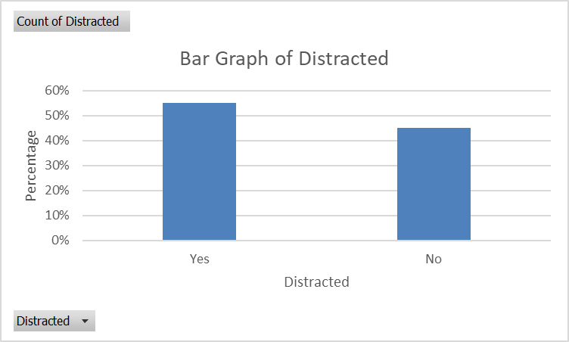 [2]
Description: Majority of the drivers are distracted in the sample of 80 drivers. [1]
Note: Any reasonable answers are fine, but it has to be describing the graph.

  - Which graph is better to use here? Briefly justify your answer using statistical reasoning. [0+1 mark]
Either graph is fine because the data is in nominal scale. [1]

  - Provide a description of the parameter of interest. [2 marks]
Note that the objective is to find the percentage of drivers who are distracted. Therefore, the answer here should be:
The proportion (or percentage) of all drivers who are distracted when driving during the day. [2]

  - Provide a description of the corresponding statistic. [2 marks]
The proportion (or percentage) of the 80 randomly selected drivers who are distracted when driving during the day. [2]

  - Calculate the value of the most appropriate statistic. [1 mark]
$\overline{p}=\frac{p}{n}=\frac{44}{80}=0.55$ or 55%

- Whenever there is a major concert in a city, the hotel rate during that time normally go up. A random sample of 20 hotels in downtown Vancouver was drawn during the time of major concert and the rate of a hotel room per night (based on two double-bed rooms) was recorded.
286 | 378 | 245 | 292 | 244 | 314 | 298 | 282 | 281 | 317
319 | 237 | 289 | 275 | 285 | 227 | 270 | 322 | 274 | 293
  - Identify the subjects of interest. [1 mark]
Subjects: hotels in downtown Vancouver during major concert time

  - Calculate the average hotel room rate manually. Please show all work. [2 marks]
$\overline{X}=286.4$ or $286.4 [2]
Note: Work is not shown here but feel free to let me know if you have trouble doing it.

  - Provide a description of the answer in part (b). [2 marks]
The average hotel room rate per night of the 20 randomly selected hotels in downtown Vancouver during major concert time. [2]

  - Find the median hotel room rate manually. Please show all work. [2 marks]
First, the observed values have to be arranged in ascending order.
227 | 237 | 244 | 245 | 270 | 274 | 275 | 281 | 282 | 285
286 | 289 | 292 | 293 | 298 | 314 | 317 | 319 | 322 | 378
There are 20 observed values. Therefore, the location of median is $i=\frac{20+1}{2}=10.5$. In other words, median $=\frac{285+286}{2}=285.5$. [2]

  - Use the method in our notes to find the first quartile and the third quartile. Then find the interquartile range. [1+1+1 marks]
$Q_{1}$ is the median to the left of the overall median 285.5. In other words, it is the midpoint between 270 and 274. Therefore, $Q_{1}=\frac{270+274}{2}=272$. [1]
$Q_{3}$ is the median to the right of the overall median 285.5. In other words, it is the midpoint between 298 and 314. Therefore, $Q_{3}=\frac{298+314}{2}=306$. [1]
Interquartile range = 306 – 272 = 34. [1]

  - Determine if there is/are any outlier(s), using IQR. [3 marks]
$LL=272-1.5×34=272-51=221$ [0.5]
There is no outlier on the left-hand side because the minimum (227) is not less than the lower limit of 221. [1]
$UL=306+1.5×34=306+51=357$ [0.5]
There is one outlier on the right-hand side because maximum (378) is larger than the upper limit of 357. [1]

- A first-year Langara student wanted to know the weekly expenses (in CAD$) of typical Langara students. To investigate this, she got a random sample of 100 students this term. The data set is in “Expense” worksheet of the file “STAT1123_HW2_Data.xlsx” on BrightSpace.
- Use Excel Data Analysis Toolpak (or individual Excel functions) to produce a Summary Statistics table that contains Mean, Median, Standard Deviation, Minimum, Maximum, and Count. Please also include the First Quartile, and Third Quartile using the method in the notes. [3 marks]
Note: Leave all values in one decimal place.
Expense
Mean | 29.9
Median | 29.5
Standard Deviation | 10.7
Minimum | 3
Maximum | 58
First Quartile | 23.5
Third Quartile | 36.5
Count | 100

- Use Excel to produce a histogram and provide a description of it. Please make sure there are 6 bars (1-10, 11-20, …, 51-60), chart title included and axes labelled properly. [4+2 marks]
Note: Make sure you label your graph and axes appropriately.
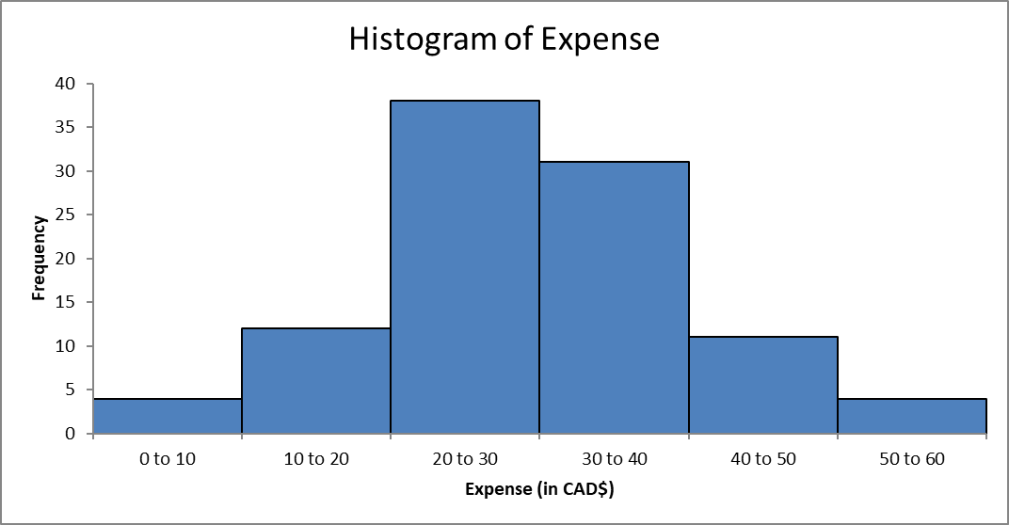 [2]
Description:
Centre: between $20 and $30
Spread: $0 to $60
Shape: slightly skewed to the right
Outlier: No obvious outliers

- Use Excel to produce a (vertical) boxplot. [2 marks]
Note: Make sure you label your graph and axes appropriately.
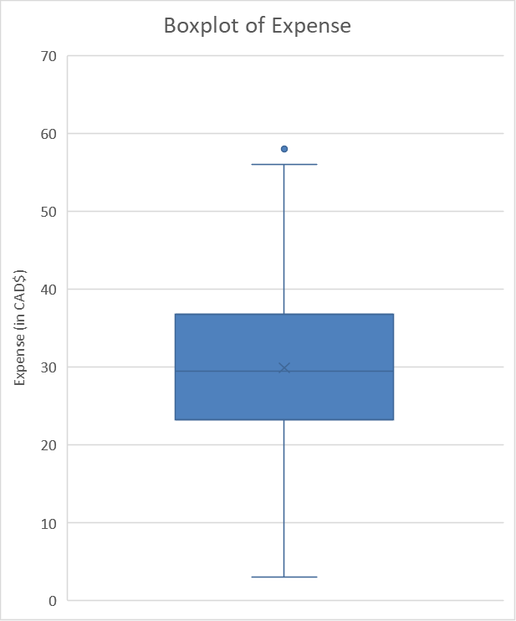 [2]

- Use the weighted average method to compute the following.
Note: This question is particularly handy later in the semester.
  - Suppose there are four different assessments: 10% homework, 20% midterm 1, 20% midterm 2 and 50% final exam. You have 90% in the homework, 70% in midterm 1, 50% in midterm 2, and 60% in the final. What overall percentage do you get? [3 marks]
Item | Weight | Weight Factor ($w$) | Mark ($X$) | Contribution ($w×X$)
Homework | 10% | 0.10 | 90% | $$0.10×90\%=9\%$$
Midterm 1 | 20% | 0.20 | 70% | $$0.20×70\%=14\%$$
Midterm 2 | 20% | 0.20 | 50% | $$0.20×50\%=10\%$$
Final Exam | 50% | 0.50 | 60% | $$0.50×60\%=30\%$$
Total | 100% | 1.00 |  | Total = 63%
You will get an overall percentage of 63.0%.

  - Suppose there are four different assessments: 10% homework, 20% midterm 1, 20% midterm 2 and 50% final exam. What final exam score (in percentage) do you need in order to get an overall percentage of 68% (at least a B) if you have 80% in the homework, 75% in midterm 1, 80% in midterm 2? [3 marks]
Item | Weight | Weight Factor ($w$) | Mark ($X$) | Contribution ($w×X$)
Homework | 10% | 0.10 | 80% | $$0.10×80\%=8\%$$
Midterm 1 | 20% | 0.20 | 75% | $$0.20×75\%=15\%$$
Midterm 2 | 20% | 0.20 | 80% | $$0.20×80\%=16\%$$
Final Exam | 50% | 0.50 | Y% | $$0.50×Y\%=(0.5×Y)\%$$
Total | 100% | 1.00 |  | Total = 68%
Removing all % in the last column, we have:
$8+15+16+\left(0.5×Y\right)=68$ $Y=58$.
In other words, you will have to score 58% or higher in the final exam to get a “B” grade.

- Suppose SAT Math score follows a Normal distribution with an average of 500 and a standard deviation of 100. Suppose also that ACT MATH score follows a Normal distribution with an average of 18 and a standard deviation of 5. Ana scores 680 in the SAT MATH while Bernice gets a score of 28 in the ACT MATH.
  - Find the Z-scores (or standardized scores) for both Ana and Bernice. Assuming that both tests measure the same kind of ability, who is better in math? Briefly explain why? [2+2 marks]
Ana:
Given: $μ=500$ and $σ=100$; Ana gets 680.
The Z-score of Ana is $Z=\frac{680-500}{100}=+1.80$. [1]

For Bernice:
Given: $μ=18$ and $σ=5$; Bernice gets 28.
The Z-score of Bernice is $\frac{28-18}{5}=+2.00$. [1]

They both have positive Z-scores, meaning that they are both better than their respective average. However, Bernice has a larger magnitude (the number without the sign) than Ana, therefore Bernice has a higher relative score. Hence, Bernice performs better in Math. [2]

  - Use the Z-table (or Excel) to find the percentage of SAT and ACT test-takers who score a higher score than Ana and Bernice, respectively. How do the two percentages agree with the conclusion from part (a)? [2+2 marks]
Note: There are two sets of calculations here.
Ana: Using Z-table, the area to the right of +1.80 is 0.0359 (1 – 0.9641). In other words, 3.59% of the SAT test takers score higher than her. [1]
Note: Using Excel function =1-NORM.DIST(680,500,100,TRUE) gives 0.0359.

Bernice: Using Z-table, the area to the right of +2.00 is 0.0228 (1 – 0.9772). In other words, only 2.28% of the ACT test takers score higher than her. [1]
Note: Using Excel function =1-NORM.DIST(28,18,5,TRUE) gives 0.0228.

There are about 3.6% of SAT test takers that are better than Ana while there are 2.3% of ACT test takers that are better than Bernice. Bernice is better in Math because there are smaller percentages of test takers that have a better score. [2]

- Many states have programs for assessing the skills of students in various grades. The Indiana Statewide Testing for Educational Progress (ISTEP) is one such program. In a recent year, all tenth-grade Indiana students took the English/language arts exam. The average score was 550 and the standard deviation was 40. Assuming the ISTEP score follows a Normal distribution, answer the following questions.
Subjects: Indiana tenth-grade students
# of variable: 1
Variable: ISTEP score (no units)
Type: numerical variable
  - Use the 68–95–99.7% Rule (or the Empirical Rule) to give a range of scores (i.e. two scores), within which it contains the middle-most 68% of the tenth-grade students. [2 marks]
Given: $μ=550$ and $σ=40$;.
Using 68-95-99.7% Rule, 68% of the values are within one standard deviation from the mean. In other words, $\left(550-40,550+40\right)=(510,590)$. [2]

  - Find the percentage of tenth-grade students who have an ISTEP score over 500. [2 marks]
$Z_{1}=\frac{500-550}{40}=-1.25$
Using the Z-table, the cumulative area is 0.1056.
Hence, the answer is 1 – 0.1056 = 0.8944.
Note: Use Excel function =1-NORM.DIST(500,550,40,TRUE) = 0.8944

  - Use the Z-table to find the percentage of tenth-grade students who have an ISTEP score between 600 and 630. [2 marks]
Using Z-table:
$Z_{1}=\frac{600-550}{40}=+1.25$ and $Z_{2}=\frac{630-550}{40}=+2.00$
The two cumulative areas are 0.8944 and 0.9772 respectively.
Hence, the answer is the difference of the two = 0.9772 – 0.8944 = 0.0828.
Note: Use Excel function =NORM.DIST(630,550,40,TRUE)-NORM.DIST(600,550,40,TRUE) = 0.0829.

  - Suppose 36% of the Indiana tenth-grade students score below Y on the ISTEP exam. Find the value of Y. [2 marks]
Using Z-table:
The closest cumulative area to 0.36 is 0.3594 which has the corresponding Z-score of -0.36.
$Y=550-0.36×40=535.6$
Note: Use Excel function =NORM.INV(0.36,550,40) and it gives Y = 535.66.

