- A dietician wanted to find out how the total fat content (Fat; measured in grams per serving) is dependent on the amount of calories (Calories; measured in calories) among chicken burgers made from different fast food chains in Canada. A random sample of 20 chicken burgers was collected from different fast food chains (one burger per fast food chain) and the information was recorded. The data set is in the “Burgers” worksheet of “STAT4800_HW3_Data.xlsx” on BrightSpace.
Subjects: chicken burgers
# of variables: 2
Variable 1 desc. & type: fat content (in grams per serving); numerical variable
Variable 2 desc. & type: amount of calories (in calories); numerical variable
  - Identify the role (or use) of the two variables. [2 marks]
Dependent variable: Fat
Independent variable: Calories

  - Use Excel to produce a scatter diagram. Provide a description of the scatter diagram. [2+2 marks]
Note: Please make sure the title and axes are properly labeled.
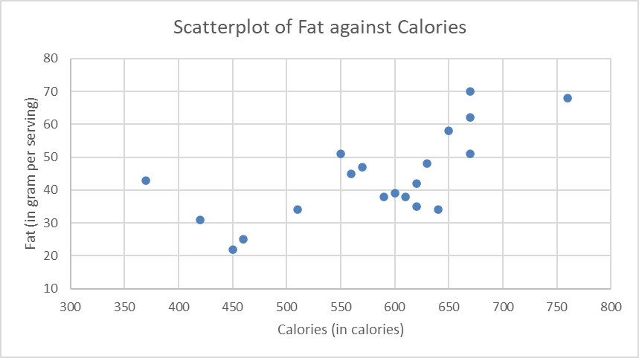[2]
Description [0.5 marks each]:
Direction: the relation between calories and fat content has a positive relation.
Strength: Hard to tell from the plot, but it seems to show a strong relation.
Outliers: There is an outlier on the top right - 760 calories with 68 grams of fat. (Other answers are acceptable too.)
Form: It seems the relation has a linear form.

  - Use two methods in Excel to find the value of the correlation coefficient. Method 1 is the built-in =CORREL() function and Method 2 is the Data Analysis ToolPak. [2 marks]
Method 1:
Method 2:

  - Use Excel “Data Analysis ToolPak” to produce a Regression Output. Identify (highlight or circle it) the correlation coefficient in this output. [2+1 marks]
[2]

  - Provide the description the above correlation coefficient (or most appropriate statistic in this situation). [2 marks]
The correlation coefficient between Calories and Fat among 20 randomly selected chicken burgers. [2]

  - Do we have enough evidence to conclude that the total fat and the amount of calories are significantly correlated? Make sure you use the three-step process and an appropriate decision point to answer this question. [2+1+2 marks]
1) Set up the null hypothesis and alternative hypothesis:
Null: Fat and Calories do not have a linear correlation among all chicken burgers.
Alternative: Fat and Calories have a linear correlation among all chicken burgers. [2]

2) Find correlation coefficient and the decision point:
$r=+0.68$
n = 20 D.P. = 0.444 [1]

3) Make a conclusion:
Since the magnitude of correlation coefficient is larger than the decision point, we (have enough statistical evidence to reject the null hypothesis and conclude) that Fat and Calories have a significantly linear correlation among all chicken burgers. [2]

- Trying to accurately allocate labour hours in a moving job, the manager of a moving company would like to develop a method of predicting the labour hours (Hours; measured in hours) based on the size of the high-rise apartment (Size; measured in cubic feet). A random sample of 25 high-rise apartment moves was randomly selected in downtown Vancouver in the previous calendar year. The data set is in “Moving” worksheet of “STAT4800_HW3_Data.xlsx” on BrightSpace.
Subjects: high-rise apartment moves
# of variables: 2
Variable 1 desc. & type: labour hours (in hours); numerical variable
Variable 2 desc. & type: size of the apartment (in cubic feet); numerical variable
  - Identify the role (or use) of the two variables. [2 marks]
Dependent variable: Labour Hours
Independent variable: Apartment Size

  - Identify the subjects of interest. [1 mark]
Subjects: high-rise apartment moves in downtown Vancouver

  - Use Excel to provide a scatterplot. Provide a description of the scatter diagram. [2+2 marks]
Note: Make sure you label your graph and axes appropriately.
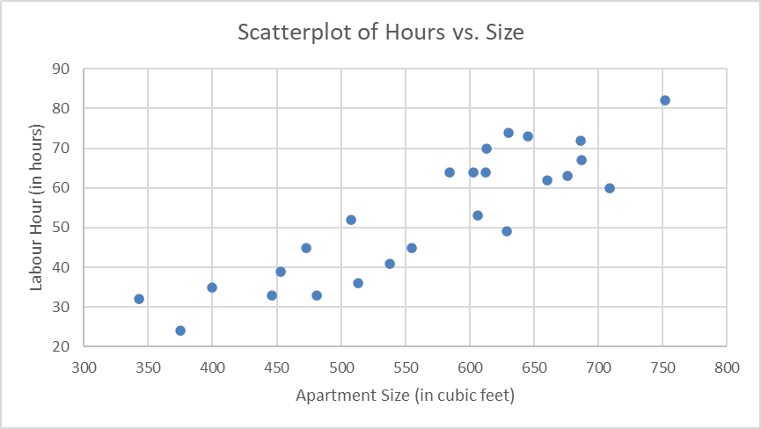
Descriptions [0.5 marks each]
Direction: the relation between Labour Hour and Apartment Size has a positive relation.
Strength: the scatterplot shows a strong relation between Labour Hour and Apartment Size.
Outliers: There is potentially one outlier on the upper right corner - 750 cubic feet and takes about 80 hours to complete. Otherwise, it is not too bad.
Form: The relation has a linear form.

  - Use Excel to produce a Regression output. Highlight the correlation coefficient. [2+1 marks]
[2]

  - Can we conclude that there is a significant correlation between the moving hours and apartment size of all high-rise apartment moves in downtown Vancouver? Make sure you use the three-step process and an appropriate decision point to answer this question. [2+1+2 marks]
1) Set up the null hypothesis and alternative hypothesis:
Null: Labour hours and Apartment Size do not have a linear correlation among all high-rise apartment moves in downtown Vancouver.
Alternative: Labour hours and Apartment Size have a linear correlation among all high-rise apartment moves in downtown Vancouver. [2]

2) Find correlation coefficient and the decision point:
$r=+0.8857$
n = 25 D.P. = 0.396 [1]

3) Make a conclusion:
Since the magnitude of correlation coefficient is larger than the decision point, we (have enough statistical evidence to reject the null hypothesis and conclude) that Labour hours and Apartment Size have a significantly strong linear correlation among all high-rise apartment moves in downtown Vancouver. [2]

  - Use the Regression Output you produced in one of the previous part and write down the least square regression line. [2 bonus marks]
Predicted value of the Hours = -20.64 + 0.13*Size

  - Provide an interpretation of the slope estimate of the regression line. [2 bonus marks]
When the size of a high-rise apartment in downtown Vancouver goes up by 100 cubit foot, it is expected the labour hour will go up by about 13 hours.

  - Provide an interval estimate when the apartment size is 575 cubic feet, with 95% confidence level. [2 bonus marks]
Note: In case you didn’t get the Excel Regression output, use RMSE = 7.68.
$\hat{y}=-20.64+0.13*575=54.11$ [1]
RMSE = 7.68
Answer = $54.11± 2×7.68=54.11±15.36$ [1]

