- The PopularKids data set (from PopularKids worksheet in STAT4800_HW4_Data.xlsx) was about opinions of a group of primary school students, who were stratified by their origin (rural, suburban and urban). More information about the data set can be in the following link: https://www.openml.org/search?type=data&sort=runs&id=1100&status=active
Note: In this question, let us only use Gender (boy and girl) as the row variable and Goals (Grades, Popular, and Sports) as the column variable. Every subsequent mentioning of “row” and “column” refer to this definition.
- Use Excel Pivot Table to produce a two-way table. Please make sure Gender is used as the row variable and Goals as the column variable. [2 marks]
Count of Gender
 | Grades | Popular | Sports | Grand Total
boy | 117 | 50 | 60 | 227
girl | 130 | 91 | 30 | 251
Grand Total | 247 | 141 | 90 | 478

- Find the percentage of students who are boys and their main goal is being popular. [1 mark]
Ans = 50/478 or 0.1046 or 10.46%

- Find the percentage of boys whose main goal is being popular. [1 mark]
Ans = 50/227 or 0.2203 or 22.03%

- Among the students whose main goal is being popular, find the percentage of them who are boys. [1 mark]
Ans = 50/141 or 0.3546 or 34.46%

- Use Excel to produce a side-by-side bar graph with Goals on the x-axis and column percentage (or percentage with each goal) on the y-axis. Make sure you have a proper title, labels of axes, and no gaps between bars of the same group.[3 marks]
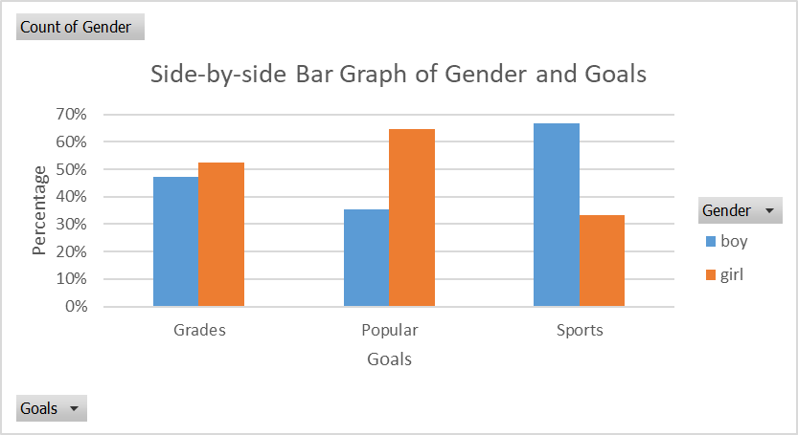 [3]

- Provide a description of the graph. [1 mark]
Description: The three groups of bars do not look alike. (We could make a conclude that the two categorical variables are not independent to each other.)

- Provide a description of the most appropriate statistic. [2 marks]
The chi-square statistic between Gender and Goals among all grade school (Grades 4-6) students.

- Calculate the expected frequency of the cell with “Girl and Sports”. Provide an interpretation of its value. [1+2 marks]
$e=251×\frac{90}{478}=47.3$ [1]
Interpretation: It represents the number of grade school kids (Grade 4-6) who are girls and with sports as the primary goal, when the two variables Gender and Goals are assumed to be independent to each other.

- Use the frequency table from part (a), calculate and enter expected frequencies in the following table. Please keep one decimal place in all entries. [2 marks]
 |  | Goals
 |  | Grade | Popular | Sports
Gender | Boy | 117 (117.3) | 50 (67.0) | 60 (42.7) | 227
 | Girl | 130 (129.7) | 91 (74.0) | 30 (47.3) | 251
 |  | 247 | 141 | 90 | 478

- Manually calculate the $χ^{2}$-statistic. [3 marks]
Calculation of $χ^{2}$ is not shown here, but its value is 21.46.

- With the above $χ^{2}$-statistic (it is 21.46, in case you did not get it correctly), can we conclude that students with different gender have different primary goals? Make sure you use the three-step process and an appropriate decision point to answer this question. [2+1+2 marks]
1) Set up the null hypothesis and alternative hypothesis:
Null hypothesis: Gender and Goals are independent to each other among all grade school students (Grade 4-6)
Alternative hypothesis: Gender and Goals are not independent to each other among all grade school students (Grade 4-6) [2]

2) Calculate the $χ^{2}$-statistic and find the decision point:
$χ^{2}=21.46$ (given)
$DF=\left(r-1\right)×\left(c-1\right)=\left(2-1\right)\left(3-1\right)=2$ Decision point = 5.991 [1]

3) Make a conclusion:
Since $χ^{2}$-statistic is bigger than the decision point, we have enough statistical evidence to reject the null hypothesis and conclude that Gender and Goals are not significantly independent to each other among all grade school students (Grade 4-6). [2]

- In a local high school, 25% of all Grade 11 students play basketball and 20% of all Grade 11 students play volleyball. It is also estimated that 5% of all Grade 11 students play both sports. Use a two-way table, or otherwise any other method, to find the following probabilities.
Subjects: Grade 11 students
# of variables: 2
Variable 1 desc. & type: whether a Grade 11 student plays basketball (class: Yes, No); categorical variable
Variable 2 desc. & type: whether a Grade 11 student plays volleyball (class: Yes, No); categorical variable
  - When a Grade 11 student is randomly selected, what is the probability that one is playing either basketball or volleyball? Provide an interpretation of the answer. [2+2 marks]
Define event A as Grade 11 students playing basketball and event B as Grade 11 students playing volleyball. Given: P(A) = 0.25, P(B) = 0.20 and P(A and B) = 0.05.
 |  | Play Basketball
 |  | Yes (A) | No (A^{c})
Play Volleyball | Yes (B) | 5 | 15 | 20
 | No (B^{c}) | 20 | 60 | 80
 |  | 25 | 75 | 100
Both the two-way table method and formula method are presented in this answer key.
Note: Work of how to get this two-way table is not shown here. Please ask if you are not sure how to do it.

Two-way table method: (5+15+20)/100 = 40/100
Formula method: P(A or B) = P(A) + P(B) – P(A and B) = 0.25 + 0.20 – 0.05 = 0.40 [2]
Interpretation: When the experiment of “selecting a random Grade 11 student” is repeated infinite number of times, 45% of them play either basketball or volleyball. [2]

  - When a Grade 11 student is randomly selected, what is the probability that one is playing neither basketball nor volleyball? [1 mark]
Two-way table method: 60/100
Formula method: P(neither A nor B) = 1 – P(A or B) = 1 – 0.40 = 0.60 [1]

  - When a Grade 11 student who is playing volleyball is randomly selected, what is the probability that one is also playing basketball? [2 marks]
Two-way table method: 5/20 = 0.25
Formula method: $P\left(A \right| B)=\frac{P(A and B)}{P(B)}=\frac{0.05}{0.20}=0.25$ [2]

  - When a Grade 11 student who is playing basketball is randomly selected, what is the probability that one is also playing volleyball? [2 marks]
Two-way table method: 5/25 = 0.20
Formula method: $P\left(B \right| A)=\frac{P(A and B)}{P(A)}=\frac{0.05}{0.25}=0.20$ [2]

  - Define event A as Grade 11 students playing basketball and event B as Grade 11 students playing volleyball. Are the two events A and B mutually exclusive? Briefly justify your answer. [0+3 bonus marks]
1) If the two events are mutually exclusive, then P(A and B) = 0 [1]
2) P(A and B) = 0.05 (from the two-way table) [1]
3) Since P(A and B) is not zero, the two events A and B are not mutually exclusive. [1]
Heuristically, you can see that there are 5% of students playing both sports.
Note: The presentation and pattern are more important than the content/numbers.

  - Define event A as Grade 11 students playing basketball and event B as Grade 11 students playing volleyball. Are the two events A and B independent? Justify your answer by providing some probability calculation using the three-step process. [0+3 bonus marks]
1) If the two events are independent, then P(A and B) = P(A)*P(B). [1]
2) LHS = P(A and B) = 0.05
RHS = P(A)*P(B) = 0.25*0.20 = 0.05
3) Since LHS is the same as RHS, the two events A and B are independent to each other. [1]
Note: The presentation and pattern are more important than the content/numbers.

- Suppose that 85% of shoppers buy coffee at this local café, 65% of shoppers buy baked goods (like muffins and cookies etc.) at this local café, and 90% of shoppers buy either coffee or baked goods.
  - Construct a two-way table of the situation above. [2 marks]
 |  | Buy Coffee
 |  | Yes (A) | No (A^{c})
Buy Baked Goods | Yes (B) | 60 | 5 | 65
 | No (B^{c}) | 25 | 10 | 35
 |  | 85 | 15 | 100
Please try to use the two-way table method to do the following 3 parts.
  - When a shopper visiting this local café is randomly selected, what is the probability that one is buying coffee and baked goods? [1 mark]
Answer = 60/100 [1]

  - Given a shopper visiting this local café is buying baked goods, what is the probability that one is also buying coffee? [1 mark]
Answer = 60/65 = 0.923 [1]

  - Given a shopper visiting this local café is buying coffee, what is the probability that one is also buying baked goods? [1 mark]
Answer = 60/85 = 0.706 [1]

