Module 03 – Data Summary for One Categorical Variable
- The manager of a local company wanted to find out the number of their employees have a valid passport, a criterion needed to send them to overseas conference. From a random sample of 140 employees, 98 of them have a valid passport.
Subjects = employees with subjects, we can define the population or sample
Variable = whether or not the employees have valid passport just need to pick one class
Type = categorical variable -> with type, we know that single value to use
- Provide a description of the parameter of interest. [2 marks]
The proportion (or percentage) of all employees who have valid passport.
Note that this value is unknown.
- Provide a description of the most appropriate statistic. [2 marks]
The proportion (or percentage) of the 140 randomly selected employees who have valid passport.
Note that this value is generally known (see below).
- Report the value of the most appropriate statistic. [2 marks]
$\overline{p}=\frac{X}{n}=\frac{98}{140}=0.70$ (corresponding to the answer in part b)
Note: You could also use the group of employees who do not have valid passport as long as parts (b) and (c) are consistent.

- The data set “S1123_Practice2_Data.xlsx” is available on BrightSpace. Make use of the variable “MAJOR” and answer the following questions.
- Use Excel to produce a Pivot Table of the variable “MAJOR”. Make sure it is expressed in percentage (instead of frequency). [2 marks]
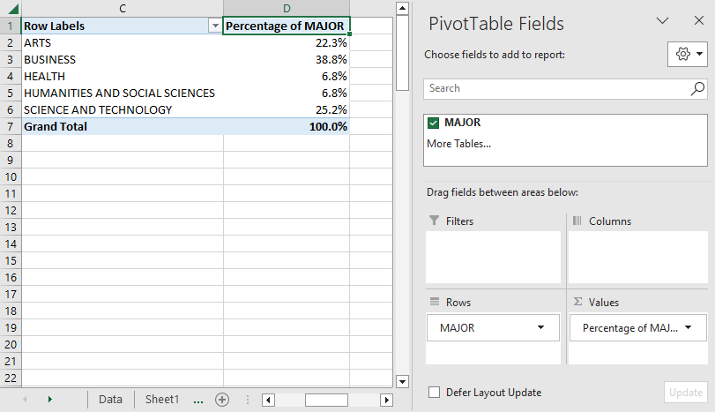
- Use Excel to produce a “2-D Pie” graph (i.e. a pie chart). Please make sure you provide a proper title for the graph. Provide a description of the graph. [2+1 marks]
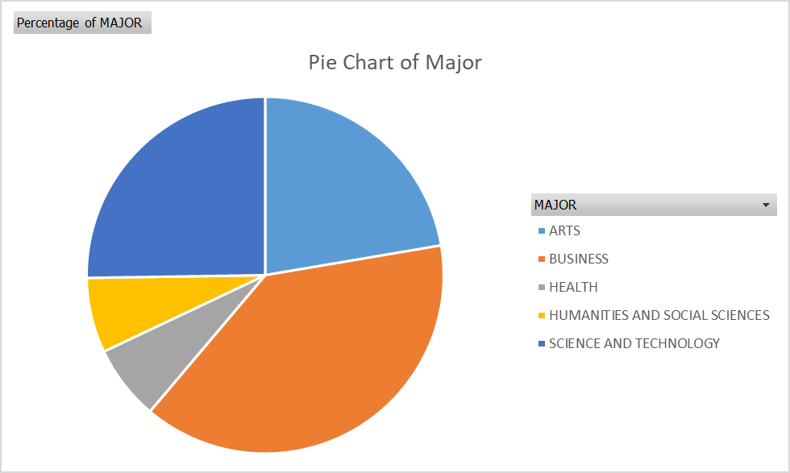
There are five different “slices” with about 40% of the sampled students from Business.
- Use Excel to produce a “2-D Column” graph (i.e. a vertical bar graph). Please make sure you provide a proper title of the graph and remove the Legend. Provide a description of the graph. [2+1 marks]
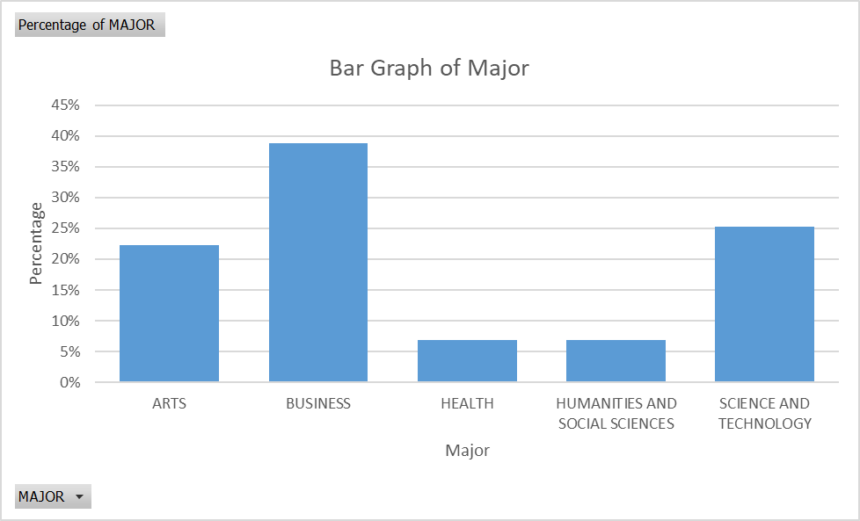
There are five different bars with about 40% of the sampled students from Business.
- Which graph is better to use here. Briefly justify your answer. [0+1 mark]
Since the variable Major is in nominal scale, either one is fine.

- The data set “S1123_Practice2_Data.xlsx” is available on BrightSpace. Make use of the variable “COURSE LOAD” and answer the following questions.
- Use Excel to produce a Pivot Table of the variable “COURSE LOAD”. Make sure it is expressed in percentage (instead of frequency). [2 marks]
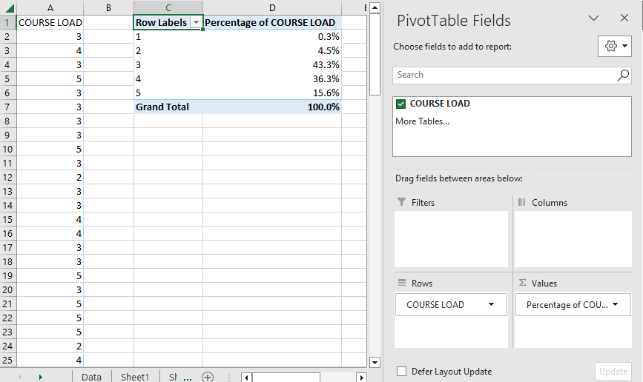
- Use Excel to produce a “2-D Pie” graph (i.e. a pie chart). Please make sure you provide a proper title of the graph. Provide a description of the graph. [2+1 marks]
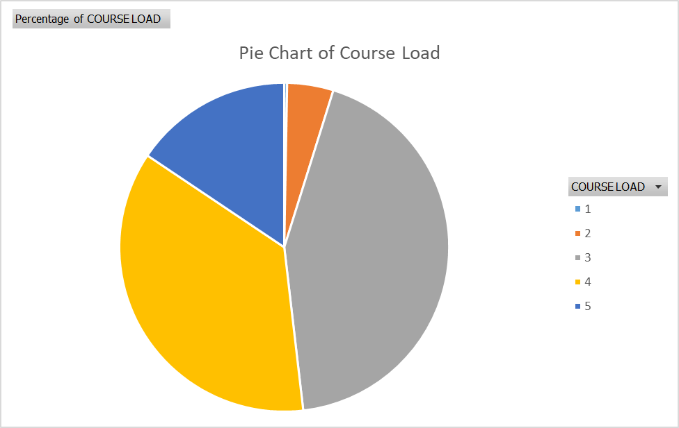
There are five different “slices” with about 50% of the sampled students taking 3 courses.
- Use Excel to produce a “2-D Column” graph (i.e. a vertical bar graph). Please make sure you provide a proper title of the graph and remove the Legend. Provide a description of the graph. [2+1 marks]
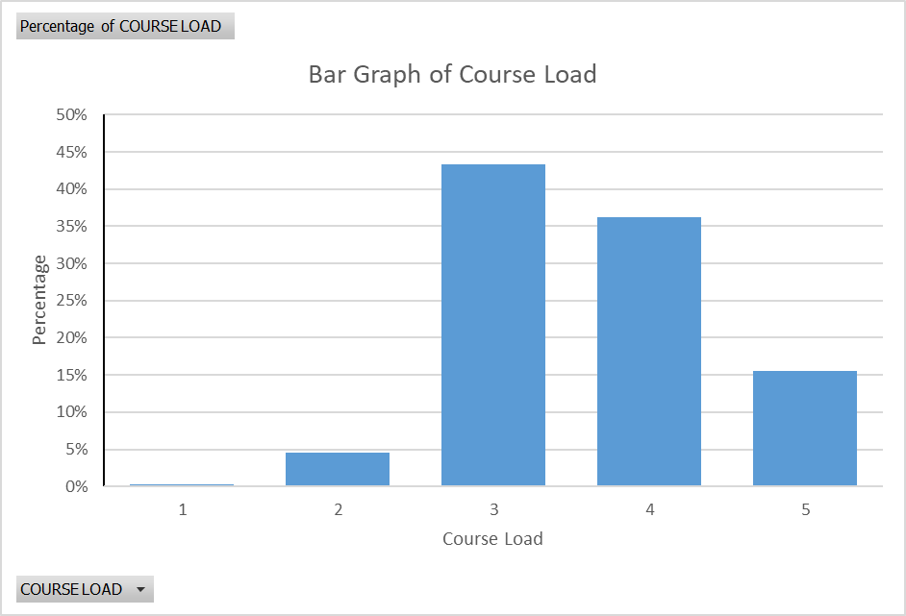
There are five different bars with about 50% of the sampled students taking 3 courses. Also, you can see a mountain (going up on the left and going down on the right)
- Which graph is better to use here. Briefly justify your answer. [0+1 mark]
Since the variable Course Load is in ordinal scale, bar graph is better to use.

M04 Data Summary for One Numerical Variable
- Suppose you want to know about the selling price of detached houses in the city of Vancouver in September 2015. The selling price of 15 randomly selected detached houses was recorded. Note: The numbers are expressed in CD$100,000. In other words, a number 7.8 means CD$780,000.
7.8 | 8.2 | 8.3 | 8.4 | 8.8 | 8.9 | 9.2 | 9.6 | 9.8 | 9.9 | 10.2 | 10.4 | 10.5 | 10.7 | 11.8
- Calculate the mean and find the median. [1+1 marks]
Mean:
$$\overline{X}=\frac{7.8+8.2+8.3+…+11.8}{15}=9.5$$
Median:
Note that the numbers are already in ascending order. The location index of median is
$i=\frac{n+1}{2}=\frac{15+1}{2}=8$.
The 8th location of the ordered list has 9.6. Therefore, median is 9.6.
- Find the first quartile and third quartile. [1+1 marks]
The first quartile is the median of all numbers strictly to the left of the “overall median” (i.e. 9.6). Therefore, the first quartile is 8.4 (by eyeballing).
The third quartile is the median of all numbers strictly to the right of the “overall median” (i.e. 9.6). The location index is $i=\frac{7+1}{2}=4$ (since there are 7 values to the right of 9.6). In other words, the third quartile is 10.4.
- Find the range, inter-quartile range and calculate standard deviation. [1+1+3 marks]
Range: range = maximum – minimum = 11.8 – 7.8 = 3.0
Interquartile range:
Since $Q_{1}=8.4$ and $Q_{3}=10.4$, $IQR=Q_{3}-Q_{1}=10.4-8.4=2.0$.
Standard deviation:
Since , we have

Obs. Values | 7.8 | 8.2 | 8.3 | 8.4 | 8.8 | 8.9 | 9.2 | 9.6 | 9.8 | 9.9 | 10.2 | 10.4 | 10.5 | 10.7 | 11.8
 | -1.7 | -1.3 | -1.2 | -1.1 | -0.7 | -0.6 | -0.3 | 0.1 | 0.3 | 0.4 | 0.7 | 0.9 | 1.0 | 1.2 | 2.3
 | 2.89 | 1.69 | 1.44 | 1.21 | 0.49 | 0.36 | 0.09 | 0.01 | 0.09 | 0.16 | 0.49 | 0.81 | 1.00 | 1.44 | 5.29
$∑{\left(X-\overline{X}\right)}^{2}=17.46$, $\frac{∑{\left(X-\overline{X}\right)}^{2}}{n-1}=\frac{17.46}{15-1}=\frac{17.46}{14}=1.247$
$s=\sqrt{\frac{∑{\left(X-\overline{X}\right)}^{2}}{n-1}}=\sqrt{1.247}=1.117$.
- Report the five-number summary. [1 mark]
Min | $$Q_{1}$$ | Median | $$Q_{3}$$ | Max
7.8 | 8.4 | 9.6 | 10.4 | 11.8
- Is/Are there any outlier(s)? Justify your answer by providing some calculation. [2 marks]
Lower limit and upper limit:
$LL=Q_{1}-1.5×IQR=8.4-1.5×2.0=5.4$,
$UL=Q_{3}+1.5×IQR=10.4+1.5×2.0=13.4$,
To determine if there are outliers, it’s sufficient to check the minimum and maximum. Since the minimum is not less than the lower limit and the maximum is not larger than the upper limit, there are no outliers in the data set.

- Suppose you want to know about the selling price of detached houses in the city of Vancouver in September 2015. The selling price of 15 randomly selected detached houses was recorded. Note: The numbers are expressed in CD$100,000. In other words, a number 7.8 means CD$780,000.
7.8 | 8.2 | 8.3 | 8.4 | 8.8 | 8.9 | 9.2 | 9.6 | 9.8 | 9.9 | 10.2 | 10.4 | 10.5 | 10.7 | 11.8
- Provide a description of the sample mean. [2 marks]
The mean (or average) selling price of the 15 randomly selected detached houses in Vancouver of Sept 2015.
- Provide a description of the sample median. [2 marks]
The median selling price of the 15 randomly selected detached houses in Vancouver of Sept 2015.
- The first quartile and third quartile of the selling price are 8.4 and 10.4 respectively. Provide an interpretation of these values. [2+2 marks]
The first quartile tells us that 25% of the sample (or about 4 houses in the sample) has selling price below CD$840,000 and 75% of them above CD$840,000.
The third quartile tells us that 75% of the sample (or about 12 houses in the sample) has selling price below CD$1,040,000 and 25% of them above CD$1,040,000.
- The range, inter-quartile range and standard deviation of the selling price are 3.0, 2.0 and 1.1 respectively. Provide an interpretation of them. [2+2+2 marks]
Range: The difference between the most expensive house and least expensive house of the sample is CD$300,000.
IQR: The price range (or price difference) of the middlemost 50% of the sample is CD$200,000.
SD: The typical distance between each selling house price from the mean selling house price is about CD$110,000.

- MUST READ: Answer the following weighted average questions.
- Suppose there are four different assessments: 10% homework, 20% midterm 1, 20% midterm 2 and 50% final exam. What overall percentage would you get if you got 90% in the homework, 68% in midterm 1, 80% in midterm 2 and 75% in the final exam? [2 marks]
Item | Weight | Weight Factor ($w$) | Mark ($X$) | Contribution ($w×X$)
Homework | 10% | 0.10 | 90% | $$0.10×90\%=9\%$$
Midterm 1 | 20% | 0.20 | 68% | $$0.20×68\%=13.6\%$$
Midterm 2 | 20% | 0.20 | 80% | $$0.20×80\%=16\%$$
Final Exam | 50% | 0.50 | 75% | $$0.50×75\%=37.5\%$$
Total | 100% | 1.00 |  | Total = 76.1%

- Suppose there are four different assessments: 10% homework, 25% midterm 1, 25% midterm 2 and 40% final exam. What final exam score (in percentage) do you need to get an overall percentage of 80% (“A” grade) if you have 90% in the homework, 70% in midterm 1, 66% in midterm 2? [3 marks]
Item | Weight | Weight Factor ($w$) | Mark ($X$) | Contribution ($w×X$)
Homework | 10% | 0.10 | 90% | $$0.10×90\%=9\%$$
Midterm 1 | 25% | 0.25 | 70% | $$0.25×70\%=17.5\%$$
Midterm 2 | 25% | 0.25 | 66% | $$0.25×66\%=16.5\%$$
Final Exam | 40% | 0.40 | Y% | $$0.40×Y\%=(0.4×Y)\%$$
Total | 100% | 1.00 |  | Total = 80%
Removing all % in the last column, we have:
$9+17.5+16.5+\left(0.4×Y\right)=80$ $Y=92.5$.
In other words, you will have to score 92.5% or higher to secure an “A” grade.

- The data set “S1123_Practice2_Data.xlsx” is available on BrightSpace. Make use of the variable “STUDY HRS/WEEK” and answer the following questions.
- Use Excel to produce a boxplot. [2 marks]
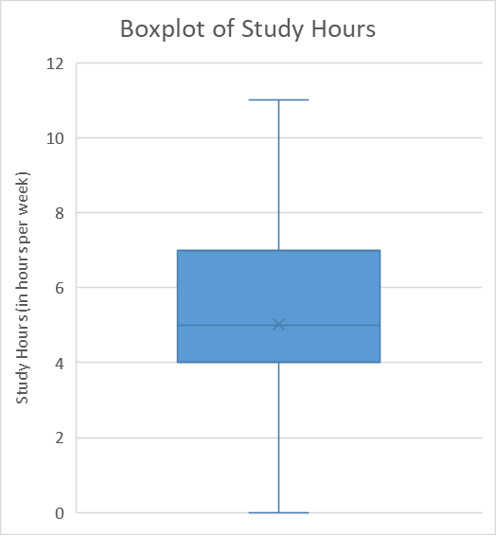
- Use Excel to produce a histogram, with percentage on y-axis. Provide a description of the histogram. [2 marks]
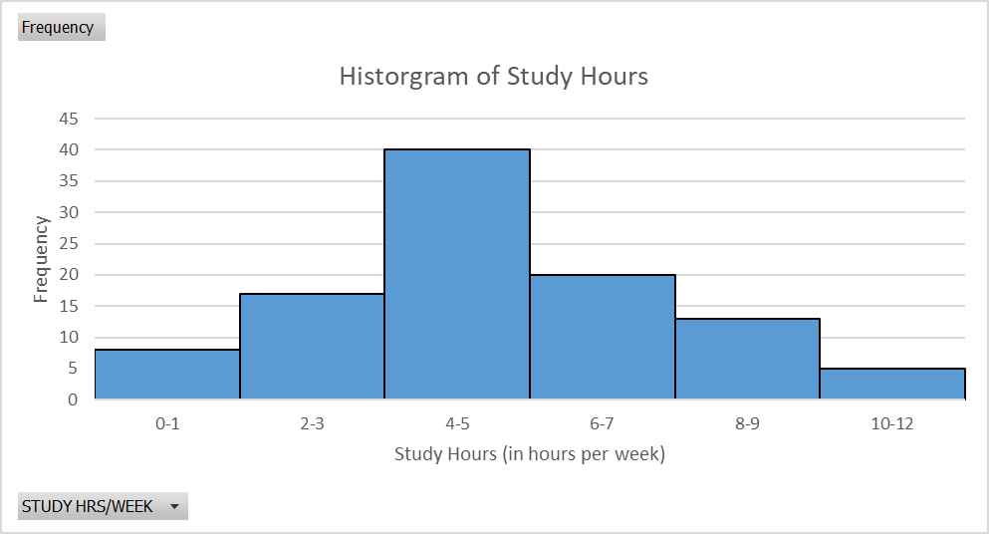
- Provide a description of the histogram. [4 marks]
Centre: around 4-5 hours
Spread: from about zero to 12 hours
Shape: Slightly right-skewed
Outliers: No obvious outliers
- Would histogram or boxplot be more appropriate to use in this question? Briefly justify your answer. [1+1 marks]
Because the sample size is over 30 (and there is only one sample to display), histogram is a better graph to use here.

- Suppose you want to know about the selling price of detached houses in the city of Vancouver in September 2015. The selling price of 15 randomly selected detached houses was recorded. Note: The numbers are expressed in CD$100,000. In other words, a number 7.8 means CD$780,000. Perform a Data Summary of the situation by following the questions below.
7.8 | 8.2 | 8.3 | 8.4 | 8.8 | 8.9 | 9.2 | 9.6 | 9.8 | 9.9 | 10.2 | 10.4 | 10.5 | 10.7 | 11.8
- Use Excel to produce a Summary Statistics table that contains Mean, Median, Standard Deviation, Minimum, Maximum, First Quartile, and Third Quartile. [2 marks]
Note: This is not a standard Excel function. That means you will have to create your own table.
Summary Statistics
Mean | 9.5
Median | 9.6
Standard Deviation | 1.12
Minimum | 7.8
Maximum | 11.8
First Quartile | 8.4
Third Quartile | 10.4

- Use Excel to produce a numerical graph and see if it is skewed. Briefly justify your choice. [2+1 marks]
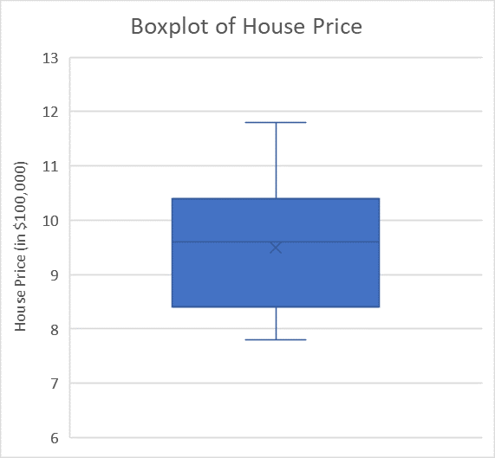
It is not too skewed.
We will use boxplot because the sample size is less than 30.
- Determine if there are outliers in the data set. Make sure you show all calculations. [2 marks]
First, we need to calculate the $LL$ and $UL$:
$LL=Q_{1}-1.5×IQR=8.4-1.5×2.0=5.4$,
$UL=Q_{3}+1.5×IQR=10.4+1.5×2.0=13.4$,
Since the minimum is not less than the lower limit and the maximum is not larger than the upper limit, there are no outliers in the data set.
- Provide the most appropriate graph and statistics set to summarize the variable of interest. Briefly justify your answer. [2+1+1 marks]
Graph: Boxplot with reasons explained above (sample size is less than 30). [1]
Statistics: Use the mean and SD pair. [1]
It is because there are no outliers and the boxplot does not show much skewness. [1]
Answer: From the sample of 15 randomly selected detached houses in Vancouver in Sept 2015, the average selling price is CD$960,000 with a standard deviation about CD$117,000. [1]

M03 & M04 Combined
- In each of the following situations, (1) identify the most appropriate graph to display the data, (2) briefly justify your answer.
- Suppose we want to find out what percentage (or proportion) of all Langara students purchase lunch at the Langara cafeteria in the Fall semester. [1+1 marks]
Variable: whether or not Langara students purchase lunch at cafeteria in the Fall semester
Type: Categorical variable
Scale: Nominal scale
Graph: Bar Graph (or pie chart)
Justification: 1) one variable, 2) categorical variable, and 3) nominal scale of measurement
- To investigate if more funding was required to have more new medical clinics in the area, the Health Ministry randomly selected 200 patients and their waiting times (in minutes) at the clinic were recorded in the last month. [1+1 marks]
Variable: wait time (in minutes)
Type: Numerical variable
Sample size? 200
Graph: histogram
Justification: 1) one variable, 2) numerical variable, and 3) sample size bigger than 30
- A smartphone retailer wanted to find out about the popularity of Apple iPhones, compared to Samsung Galaxy, among Vancouverites. A sample of 150 shoppers in a nearby mall was drawn and they were asked about the smartphone preference. They are given five options: (1) Like iPhone very much, (2) Somewhat like iPhone, (3) Neutral, (4) Somewhat like Galaxy, and (5) Like Galaxy very much. [1+1 marks]
Variable: the smartphone preference (given the 5 options)
Type: Categorical variable
Scale: Ordinal scale
Graph: Bar Graph
Justification: 1) one variable, 2) categorical variable, and 3) ordinal scale of measurement

M08 Normal Distributions
- Tom and Lisa are friends and they are arguing who has a better Math understanding by comparing their Math 12 final percentage. However, Tom is from British Columbia and Lisa is from Alberta and it is hard to compare two education systems. Tom got 87%, and the mean and standard deviation in BC are 80% and 10% respectively. Lisa got 84%, but the mean and standard deviation in AB are 81% and 3% respectively. Use Z-score to find out who has a better score, in relation to their respective province? [2 marks]
Tom has a Z-score of +0.7 while Lisa has a Z-score of +1.0. So, Lisa has a better in relation to their respective province.
Here is a typical school of thoughts when thinking about this type of comparison.
First, we compare the standalone score. In this regard, Tom wins (87% to Lisa’s 84%).
Then, we look at the absolute difference from the mean. Using this criteria, Tom still wins (he is 7% over the mean, while Lisa is only 3% over the mean.
But neither one is accurate because it did not take into consideration the standard deviation (the Math 12 score variation among all students in their respective province). Now, we compare the Z-score and it turns out that Lisa wins as she has a bigger Z-score. Bigger Z-score means she is farther away from mean in standard units.

- Suppose the height of a very big group of professional basketball players (or simply players) has a Normal shape or Normal distribution with an average of 200cm and a standard deviation of 10cm. Use the empirical rule to answer the following questions.
- Find the percentage of professional basketball players who are taller than 200cm. [1 mark]
About 50%
- Find the percentage of professional basketball players who are between the height of 190cm and 210cm. [1 mark]
About 68%
- Find the percentage of professional basketball players who are between the height of 190cm and 220cm. [1 mark]
The area between 190cm and 200cm is half of 68% 68%/2 = 34%.
The area between 200cm and 220 is half of 95% 95%/2 = 47.5%
Hence, the answer is the sum of the two 34% + 47.5% = 81.5%.
- Find the percentage of professional basketball players who are taller than 220cm. [1 mark]
The area between 200cm and 220 is half of 95% 95%/2 = 47.5%.
But the area from 200cm to far right (or positive infinity) is 50%.
Therefore, the area beyond 220cm is the difference of the two 50% - 47.5% = 2.5%.

- Answer the following questions using the Z-table.
- Find the left-hand area with $Z=+1.35$. [1 mark]
The Z-score is broken down in to two parts: +1.3 as the row and 0.05 as the column. The cumulative area shown in the Z-table is 0.9115. This is also the answer because we want the cumulative area (or the left-hand area).
Using Excel function: NORM.DIST(1.35,0,1,TRUE)
- Find the right-hand area with $Z=+2.84$. [1 mark]
The Z-score is broken down in to two parts: +2.80 as the row and 0.04 as the column. The cumulative area shown in the Z-table is 0.9977. Because we want the right-hand area, the answer is 1 – 0.9977 = 0.0023.
Using Excel function: 1-NORM.DIST(2.84,0,1,TRUE)
- Find the right-hand area with $Z=+6.30$. [1 mark]
The Z-score is broken down in to two parts: +6.30 as the row and 0.00 as the column. However, we cannot find the corresponding cumulative area in the Z-table. But intuitively, the right-hand area of a very big positive Z-score should be very small. The answer here is either zero or approximately zero.
Using Excel function: 1-NORM.DIST(6.30,0,1,TRUE)
- Suppose the area to the left of an unknown point Z is 0.0643. Find Z. [1 mark]
With cumulative area (or left-hand area) given as 0.0643, we could use this to look up the Z-table right away, it is at the intersection between the row of -1.5 and column of 0.02. In other words, the corresponding Z-score is -1.52.
Using Excel function: NORM.INV(0.0643,0,1)
- Suppose the area to the right of an unknown point Z is 0.0250. Find Z. [1 mark]
The area given is the right-hand area. To use the Z-table, we will have to use the left-hand area. In other words, the cumulative area of the unknown Z is 1 – 0.0250 = 0.9750. The cumulative area is at the intersection between the row of +1.9 and column of 0.06. In other words, the corresponding Z-score is +1.96.
Using Excel function: NORM.INV(1-0.0250,0,1)

- Suppose the height of all professional basketball players (or simply players) follows a Normal distribution with an average of 200cm and a standard deviation of 10cm. Use the Z-table to answer the following questions.
  - Find the percentage of professional basketball players who are taller than 196cm. [2 marks]
Given $μ=200$ and $σ=10$.
First, we want to standardize 196cm in to a Z-score, namely $Z=\frac{X-μ}{σ}=\frac{196-200}{10}=-0.40$.
Using the Z-score of -0.40, we get a cumulative area of 0.3446. To get the area to the right-hand side (because it wants “taller than”), we use the total area (1 or 100%) minus the cumulative area. In other words, it is 1 – 0.3446 = 0.6554.
In other words, 65.54% of the professional basketball players are taller than 196cm.
Using Excel function: 1-NORM.DIST(196,200,10,TRUE)
  - Find the percentage of professional basketball players who are between 167cm and 207cm. [2 marks]
The two Z-scores are -3.30 and +0.70 respectively.
Using them, the corresponding cumulative areas are 0.0005 and 0.7580, respectively.
Therefore, the area between the two heights would be the difference of the above two areas, or 0.7580 – 0.0005 = 0.7575.
In other words, 75.75% of the professional basketball players are between 167cm and 207cm.
Using Excel function: NORM.DIST(207,200,10,TRUE) -NORM.DIST(167,200,10,TRUE)
  - Suppose a professional basketball player was told that he was taller than 85% of all his peers (i.e. professional basketball players). Find his height. [2 marks]
To be taller than 85% of his peers means that 85% of his peers are shorter. Or, there is a cumulative area of 0.85.
Using this, we will try to match 0.8500 in the Z-table. However, 0.8500 are not available.
As a general rule of thumb, we will pick the closest one. In this case, there are two adjacent numbers – 0.8485(which is 0.0015 away) and 0.8508 (which is 0.0008 away). The latter is closer, so we will use 0.8508 to find the corresponding Z-score.
We get +1.0 on the left edge of the row and 0.04 on the top of the column. Adding them up gives you the Z-score. In this case, the Z-score of cumulative area of 0.8508 is Z=+1.04.
Now, the second step is to use the Z-score to find the X-value. Hence, $X=200+1.04×10$ 210.4.
Therefore, this player’s height is 210.4cm.
Using Excel function: NORM.INV(0.85,200,10)

- Consider a large class of introductory statistics course. The professor has a grading scheme. The best 15% gets A grade (suppose there is no difference in A+, A and A-), the next 30% gets B grade, the next 20% gets C grade. And the rest of the class fail the course. Suppose the mean and standard deviation of the overall grade in this large introductory class has been 70% and 8% respectively. What are the three cut-off points of the four grades? In other words, what are the minimum percentage a student needs in order to get C, B and A respectively? [3 marks]
For A cut-off:
The top 15% of students gets A, that means 85% below. The corresponding Z-score is +1.04.
Using Excel function: =NORM.INV(0.85,70,8)
Therefore, $X=70+1.04×8=78.32$.
For B cut-off:
Besides the top 15% for A, the next 30% gets B. In other words, the cumulative area is 55% (100% - 15% - 30%), the corresponding Z-score is +0.13 (using cumulative area of 0.5517).
Using Excel function: =NORM.INV(0.55,70,8)
Therefore, $X=70+0.13×8=71.04$.
For C cut-off:
There are 35% of the class gets a failing grade, that means if you are on or above the lowest 35% mark, you will get a C grade.
So, using the cumulative area of 0.35, the corresponding Z-score is $Z=-0.39$.
Using Excel function: =NORM.INV(0.35,70,8)
Therefore, $X=70-0.39×8=66.88$.
Therefore, the three cut-off points are 66.88%, 71.04% and 78.32%.

