M12 Correlation Analysis
- To investigate if time spent preparing for an introductory statistics final exam (Study; measured in hours) is linearly related to the final exam score (Exam; measured in percentage), a random sample of 60 introductory statistics students was drawn. The data set can be found in the “Exam” tab in “S1123_Practice2_Data.xlsx” on BrightSpace.
- Identify the role or use of the two variables. [2 marks]
Dependent variable: final exam score
Independent variable: study time
- Use Excel to produce a scatter diagram with Exam on the y-axis and Study on the x-axis. Provide a description of the scatter diagram. [2+4 marks]
Note: Make sure the title and axes are properly labeled.
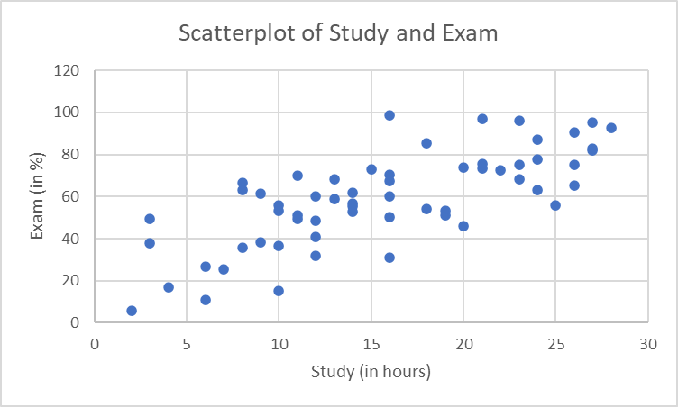
Descriptions:
- The direction of the relation is positive; [1]
- The strength of the relation is rather to tell, but relatively strong (based on the given scatter diagram); [1]
- There are no obvious outliers; [1]
- The form seems to be rather linear. [1]
Note: Even though there weren’t any outliers, we still have to mention it.
- Provide a description of the most appropriate statistic. [2 marks]
Since there are two numerical variables, the most appropriate statistic is the correlation coefficient.
Description: The correlation coefficient between the final exam score (in percentage) and Study Time (in hours) of the 60 randomly selected introductory statistics students. [2]
Note: Recall it is a statistic so the description will have the three main requirements. [2]
- Use Excel to find the correlation coefficient. [2 marks]
Method 1: Using formula
CORREL(A2:A61,B2:B61) | 0.735837
Method 2: Using Excel Data Analysis ToolPak
 | Study | Exam
Study | 1
Exam | 0.735837 | 1
- Note that the correlation coefficient has a value of about 0.74. Does spending more time studying the final exam alone lead to better final exam score? Provide a brief justification of your answer. [0+2 marks]
The key point here is that “correlation doesn’t imply causation”. Although the study time and final exam score are highly (positively) correlated, one doesn’t cause the other alone. There are other factors that will play a big role in the exam score too.
- Do we have enough statistical evidence to conclude that students’ study time and their final exam mark are significantly correlated? Make sure you use the three-step process and an appropriate decision point to do this. The data set can be found on BrightSpace. [2+1+2 marks]
Step 1:
$H_{0}$: The study time and their final exam mark do not have a linear correlation among all Langara students.
$H_{a}$: The study time and their final exam mark have a linear correlation among all Langara students. [2]
Step 2:
From the Excel output: $r=0.7358$.
Because $n=60$ $D.P.=0.254$ (from the supplementary notes or decision table tables, both are available from D2L). [1]
Step 3:
Since the magnitude of r is bigger than D.P., we have enough statistical evidence to reject the null hypothesis and conclude that the study time and final exam mark have a significantly strong linear correlation among all Langara students. [2]

M13 Regression Analysis
- To investigate if time spent preparing for an introductory statistics final exam (Study; measured in hours) is linearly related to the final exam score (Exam; measured in percentage), a random sample of 60 introductory statistics students was drawn. We have previously shown that the two variables Study and Exam are significantly correlated (in the previous module). Make use of the following Excel outputs and answer the questions below. The data set can be found in the “Exam” tab in “S1123_Practice2_Data.xlsx” on BrightSpace.
 | 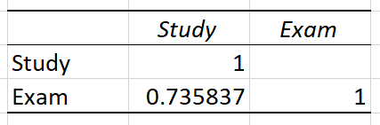

- Use Excel Data Analysis ToolPak and produce the Regression Output. [2 marks]
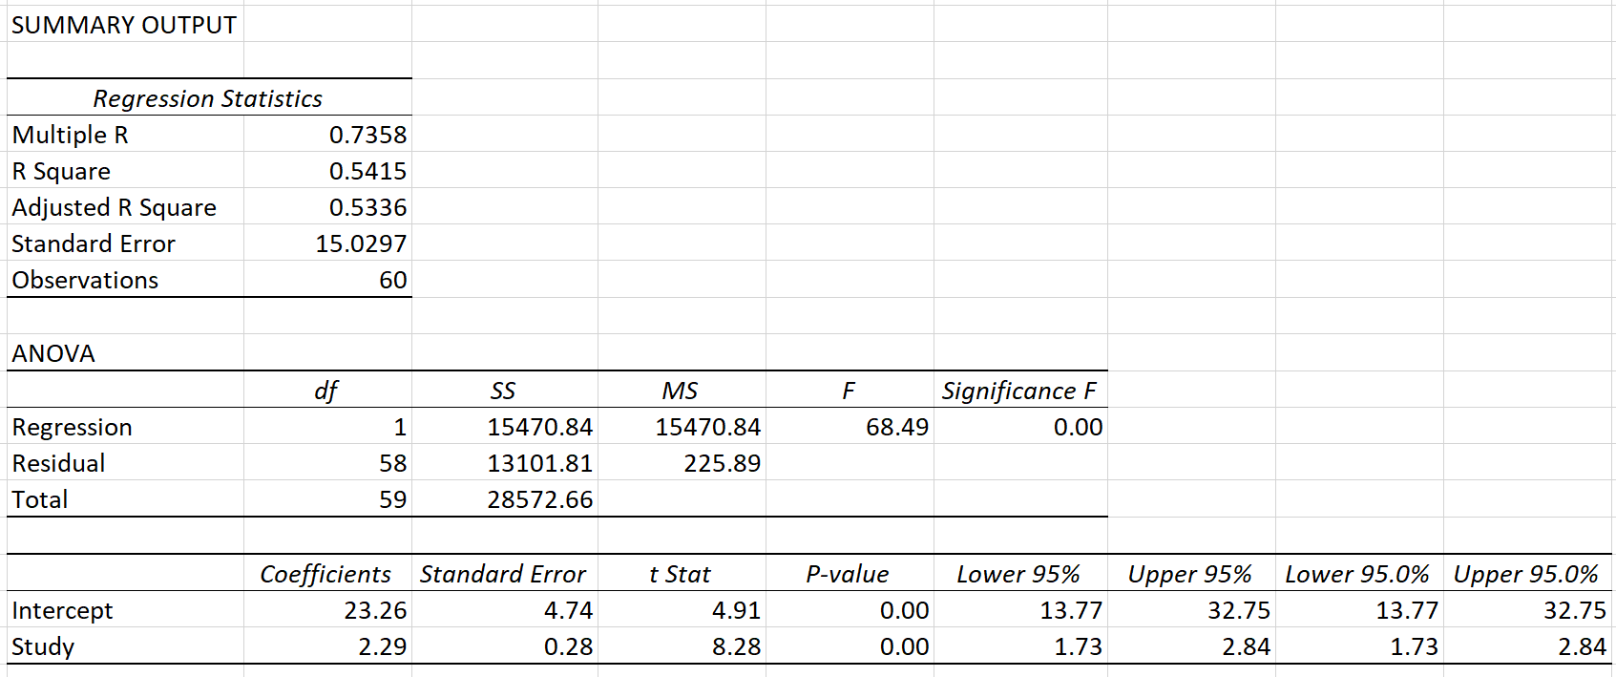
Or you could also use =SLOPE() or =INTERCEPT() Excel functions to find the two values.
- Write out the least regression line. [1 mark]
Predicted value of Exam Score = 23.26 + 2.29*(Study Time)
Note: Full marks will not be given if the answer is presented as “$\hat{y}=23.26+2.29x$”. In other words, the letter “x” and “y” have to be replaced by the actual variable names.
- Provide an interpretation of the slope estimate. [2 marks]
b = 2.29(%)
For every extra hours of study, students are expected to gain an additional 2.29% in the final exam.
Note: Please pay special attention to the unit of measurements. And please note that the unit might not always be %!
- Provide an interpretation of the intercept estimate. [2 marks]
a = 23.26(%)
Students are expected to get a final exam score of 23.26% when they did not study for the exam at all (i.e. 0 hours studying).
Note: The intercept estimate may not be interpreted if “x=0” does not make sense to begin with.
- Missing the final exam due to personal reason, a student went to the instructor after and told her that he did study for 20 hours. Not promising anything, the instructor plugged “X=20” in to the least square regression line obtained from the class. What final exam score he would get, if he wrote the final exam? Provide an interpretation of the answer. [1+2 marks]
$\hat{y}=23.26+2.29×20=69.06$
When students study 20 hours (for the exam), they are expected to get 69.06% in the final exam.
- Another student who has similar situation, but he claimed that he studied for 70 hours for the final exam. What final exam score should the instructor give this student? [2 marks]
We should not start with calculation first. We shall look at the scatterplot (or the data) and see if the given value (70 in this case) falls outside the range of all observed values (which go from about 2 hours to about 28 hours; from the scatterplot). Therefore, we could tell students because his value falls outside the range of the observed values, we cannot do extrapolation in statistics!
- Missing the final exam due to personal reason, a student went to the instructor after and told her that he did study for 20 hours. Not promising anything, the instructor plugged “X=20” in to the least square regression line obtained from the class. What final exam score he would get, if he wrote the final exam? Provide the answer in such a way that it is accurate 95% of the time. [3 marks]
From the Excel output, the Mean Square Error is 225.89. Taking the square root gives you the RMSE, i.e. RMSE = $\sqrt{225.89}$ = 15.03
With 95% confidence level, it means we would extend two “standard deviations” on either side of $\hat{y}$. In other words, the answer is:
$\hat{y}±2×RMSE=69.06±2×15.03=69.06±30.06$ or (39.00, 99.12)
Note: You could also use 1.96 to replace 2 in this calculation.

