M14 Chi-Square Analysis
- Are male and female shoppers different regarding reading labels of packaged food? A random sample of 100 shoppers was drawn in a nearby supermarket during a three-day period. They were asked about their gender and if they regularly read the labels in packaged food or not. The data set can be found in the “Labels” tab in “S1123_Practice4_Data.xlsx” on BrightSpace. Results are summarized in the following two-way table.
 |  | Gender
 |  | Male | Female
Reading Labels | Yes | 10 | 36 | 46
 | No | 30 | 24 | 54
 |  | 40 | 60 | 100
- Identify the role or use of the two variables. [2 marks]
Dependent variable: Reading Labels
Independent variable: Gender
- Use Excel to draw a side-by-side bar graph with Gender on the x-axis and percentage on the y-axis. Provide a description of it. [2+1 marks]
Note: It takes a bit of playing around to get this graph.
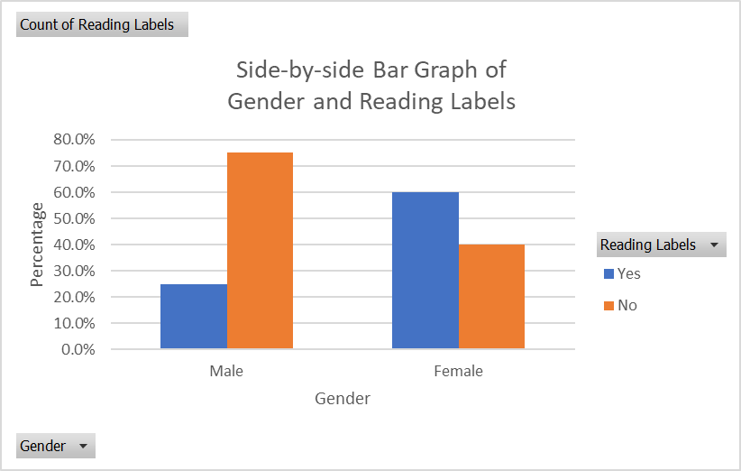
Description: The two groups of bars do not look similar. In other words, the two variables (Gender and Reading Labels) are not (likely) to be independent.
- Find the percentage of shoppers who are both female and reading labels regularly. [1 mark]
Note: the subjects are shoppers or consumers
Answer: 36/100*100% = 36% (this is an example of table percentage)
- Find the percentage of male shoppers who read labels regularly. [1 mark]
Answer: 10/40*100% = 25% (this is an example of column percentage)
- Find the percentage of female shoppers who read labels regularly. [1 mark]
Answer: 36/60*100% = 60% (this is another example of column percentage)
- Among all shoppers who do not read labels regularly, find the percentage of them who are male shoppers. [1 mark]
Answer: 30/54*100% = 55.6% (this is an example of row percentage)

- Use Excel Pivot Table to reproduce the above two-way table. [2 marks]
Count of Reading Labels | Column Labels
Row Labels | Male | Female | Grand Total
Yes | 10 | 36 | 46
No | 30 | 24 | 54
Grand Total | 40 | 60 | 100
- Change the entries in the above Excel Pivot Table to “Row Percentage”. [2 marks]
Steps: Right-click on the Pivot Table, choose “Show Values as” and then select “% of Row Total”.
Count of Reading Labels | Column Labels
Row Labels | Male | Female | Grand Total
Yes | 21.7% | 78.3% | 100.0%
No | 55.6% | 44.4% | 100.0%
Grand Total | 40.0% | 60.0% | 100.0%
- Find the expected frequency of the cell “Male and Yes”. Provide an interpretation of the value. [1+2 marks]
$e=\frac{40×46}{100}=18.4$ [1]
It is the number of shoppers (from the random sample of 100 shoppers) who are male and reading labels regularly, when it is assumed that the two variables Gender and Reading Labels are independent to each other. [2]
- Calculate the $χ^{2}$-statistic. And provide a description of it. [2+2 marks]
$χ^{2}=\frac{{\left(10-18.4\right)}^{2}}{18.4}+\frac{{\left(36-27.6\right)}^{2}}{27.6}+\frac{{\left(30-21.6\right)}^{2}}{21.6}\frac{{\left(24-32.4\right)}^{2}}{32.4}$
$=3.8+2.6+3.3+2.2=11.8$ [2]
Description: The $χ^{2}$-statistic between the gender and whether they read labels of packaged food of the 100 randomly selected shoppers in a nearby supermarket during a three-day period. [2]
- Using the $χ^{2}$ from the previous part, can we conclude that male and female shoppers are different, in terms of reading labels from the packaged food regularly? Make sure you use the three-step process and an appropriate decision point to answer this question. [2+2+2 marks]
Step 1:
$H_{0}$: Gender and Reading Labels are independent to each other among all shoppers.
$H_{a}$: Gender and Reading Labels are not independent to each other among all shoppers. [2]
Step 2:
$χ^{2}=11.8$
DF = (r-1)(c-1) = (2-1)(2-1) = 1 DP = 3.84 [1]
Step 3:
Since the chi-square statistic is bigger than the decision point, we have enough evidence to reject the null hypothesis and conclude that Gender and Reading Labels are not significantly independent to each other among all shoppers. [2]

M05 Probability
- From a recent study, 80% of first-year university students have taken introductory French and 60% of them have taken Calculus I. The study also showed that 50% them have done both.
  - When a first-year university student is randomly selected, what is the probability that one has taken either introductory French or Calculus I? [2 marks]
The following information is not really necessary to answer this question, but it would be nice to have them (just to get into a routine).
Subjects: first-year university students.
Variable #1: whether or not first-year university students have taken introductory French.
Variable #2: whether or not first-year university students have taken Calculus I.
Both are categorical variables.
Since we have two variables, we need two events.
Define event A as first-year university students having taken introductory French.
Define event B as first-year university students having taken Calculus I.
The question has provided three numbers.
P(A) = 0.80. To put this probability statement into words, it is “the probability of first-year university students having taken introductory French is 80%” or “80% of first-year university students have taken introductory French”.
P(B) = 0.60. It means “the probability of first-year university students having taken Calculus I is 60%.
P(A and B) = 0.50. Note that we don’t need to define a third event because we could always make use of “and” and “or” to put events together. Here, the keyword is “both”. Therefore, we know that it is an intersection.
Next, we need to recognize what the question wants. The key words are “either-or”. So, it must be $P(A or B)$. There are two methods you could use: (1) addition rule formula, and (2) two-way table together with fundamental probability equation. In the exam, you may be asked specifically to use one of them. So, make sure you’re comfortable with both methods.
Method #1 (equation):
$P\left(A or B\right)=P\left(A\right)+P\left(B\right)-P\left(A and B\right)=0.80+0.60-0.50=0.90$.
Method #2 (two-way table):
First, we need to fill in all 9 entries in the following two-way table. We always would like to start off with a nice round number (like 100) as the overall total. Once we are able to fill in the three entries (one from each numbers provided in the question), then the rest should be relatively straight-forward.
 |  | French
 |  | Yes ($A$) | No ($A^{c}$)
Calculus I | Yes ($B$) | 50 | 10 | 60
 | No ($B^{c}$) | 30 | 10 | 40
 |  | 80 | 20 | 100
Note: Red numbers represent the 100 and three other numbers provided in the question; whilst the blue numbers were obtained by subtraction. The answer is calculated from the grayed-out cells. Hence, $P\left(A or B\right)=\frac{50+10+30}{100}=0.90$.

  - Provide an interpretation of the above answer. [2 marks]
When a first-year university student is randomly selected, 90% of them have taken either introductory French or Calculus I, or both – of course it is the same as the question.
Or the following version will be used predominantly later in the course.
When the experiment of “randomly selecting one first-year university student” is repeated infinite number of times, 90% of them have taken either introductory French or Calculus I, or both.

- From a recent study, 80% of first-year university students have taken introductory French and 60% of them have taken Calculus I. The study also showed that 50% them have done both.
- When a first-year university student who has taken introductory French is randomly selected, what is the probability that one has also taken Calculus I? [2 marks]
Here, note that the “base” is different from the previous question. In the previous one, it only wanted the subjects of interest (first-year university students). But here, it wants a subgroup (those who has taken introductory French) of subjects. Therefore, it is a conditional probability.
Method 1 (equation):
Given that we now consider the group who has taken introductory French, that means we are conditioning on event A. As a result, the question asks for P(B | A).
$P\left(B \right| A)=\frac{P(A and B)}{P(A)}=\frac{0.50}{0.80}=0.625$.
The interpretation here is that among all first-year university students who have taken introductory French, 62.5% of them has also taken Calculus I.
Method #2 (two-way table):
 |  | French
 |  | Yes ($A$) | No ($A^{c}$)
Calculus I | Yes ($B$) | 50 | 10 | 60
 | No ($B^{c}$) | 30 | 10 | 40
 |  | 80 | 20 | 100
Like we have mentioned above, the “based” are the number of the first-year university students who have taken introductory French, which is 80. Among them, 50 of them have taken Calculus I. Therefore, the answer is 50/80 = 0.625.
- Provide an interpretation of the above answer. [2 marks]
When the experiment of “randomly selecting one first-year university student who has taken French” is repeated infinite number of times, 62.5% of them have (also) taken Calculus I.

- Suppose students would take only one of the following two elective courses (Introductory French and Introductory Spanish) because they will not get credits for both courses – therefore no one would take both. From a recent study, 60% of first-year university students choose to take introductory French and 20% of them take introductory Spanish. When a first-year university student is randomly selected, what is the probability that one has taken either introductory French or introductory Spanish? [2 marks]

Define event A as first year university students having taken introductory French.
Define event B as first year university students having taken introductory Spanish.
From the question: P(A) = 0.60 and P(B) = 0.20.
Because students don’t take both courses, P(A and B) = 0. In other words, from the description of the situation, the two events A and B are mutually exclusive or disjoint.
Method #1 (equation):
The question wants P(A or B) because of the combo “either-or”.
$P\left(A or B\right)=P\left(A\right)+P\left(B\right)-P\left(A and B\right)=0.60+0.20-0=0.80$.
Method #2 (two-way table):
Two-way table:
 |  | French
 |  | Yes ($A$) | No ($A^{c}$)
Spanish | Yes ($B$) | 0 | 20 | 20
 | No ($B^{c}$) | 60 | 20 | 80
 |  | 60 | 40 | 100
Note that the red zero represents the two events (A and B) are mutually exclusive.
Answer: $P\left(A or B\right)=\frac{0+20+60}{100}=0.80$.

- From a recent study, 80% of first-year university students have taken introductory French and 60% of them have taken Calculus I. The study also showed that 50% them have done both. Define event A as first year student taking introductory French and event B as first year student taking Calculus I. Are events A and B independent to each other? Justify your answer by providing some probability calculation using the three-step process. [3 marks]
1) Write out an identity (or Hypothesis):
Suppose the two events A and B are independent.
Therefore, the following identity is true: $P\left(A and B\right)=P(A)×P(B)$.
2) Calculation:
LHS = P(A and B) = 50/100 = 0.50; RHS = P(A)*P(B) = 0.80*0.60 = 0.48
3) Conclusion: Since LHS is not the same as RHS, the two events A and B are not independent.

- It is estimated that 40% of university students are international students. Among international students, 60% are working part-time. On the other hand, among the domestic students, 25% are working part-time.
- When a university student is randomly selected, what is the probability that one is an international student and working part-time? [2 marks]
 |  | International Student
 |  | Yes ($A$) | No ($A^{c}$)
Work  PT | Yes ($B$) | 24 | 15 | 39
 | No ($B^{c}$) | 16 | 45 | 61
 |  | 40 | 60 | 100

P(A) = 0.40 gives the three red numbers above.
Then using $P\left(B \right| A)=0.60$, we understand 60% of 40 (or 24) international students works part-time. The two blue numbers show this.
Then using $P\left(B \right| A^{c})=0.25$, we understand 25% of 60 (or 15) domestic students works part-time. The two green numbers show this.
Answer: $P\left(A and B\right)=\frac{24}{100}=0.24$.
- When a university student is randomly selected, what is the probability that one is working part-time but not an international student (i.e. domestic student)? [2 marks]
(From the two-way table in part a.) When a university student is randomly selected, what is the probability that one is working part-time but not an international student?
Answer: $P\left(A^{c} and B\right)=\frac{15}{100}=0.15$.
- When a student is randomly selected from the group of students who are working part-time, what is the probability that one is an international student? [2 marks]
$P\left(A \right| B)=\frac{P\left(A and B\right)}{P\left(B\right)}=\frac{0.24}{0.39}=0.615$.
- When a student is randomly selected from the group of students who are not working part-time, what is the probability that one is not an international student? [2 marks]
$P\left(A^{c} \right| B^{c})=\frac{P\left(A^{c} and B^{c}\right)}{P\left(B^{c}\right)}=\frac{0.45}{0.61}=0.738$.

