

**EC -Campus**

**Subject: Web Technology Subject Code: UE21CS242A**

**Name:**

**SRN:**

**Section: 3**

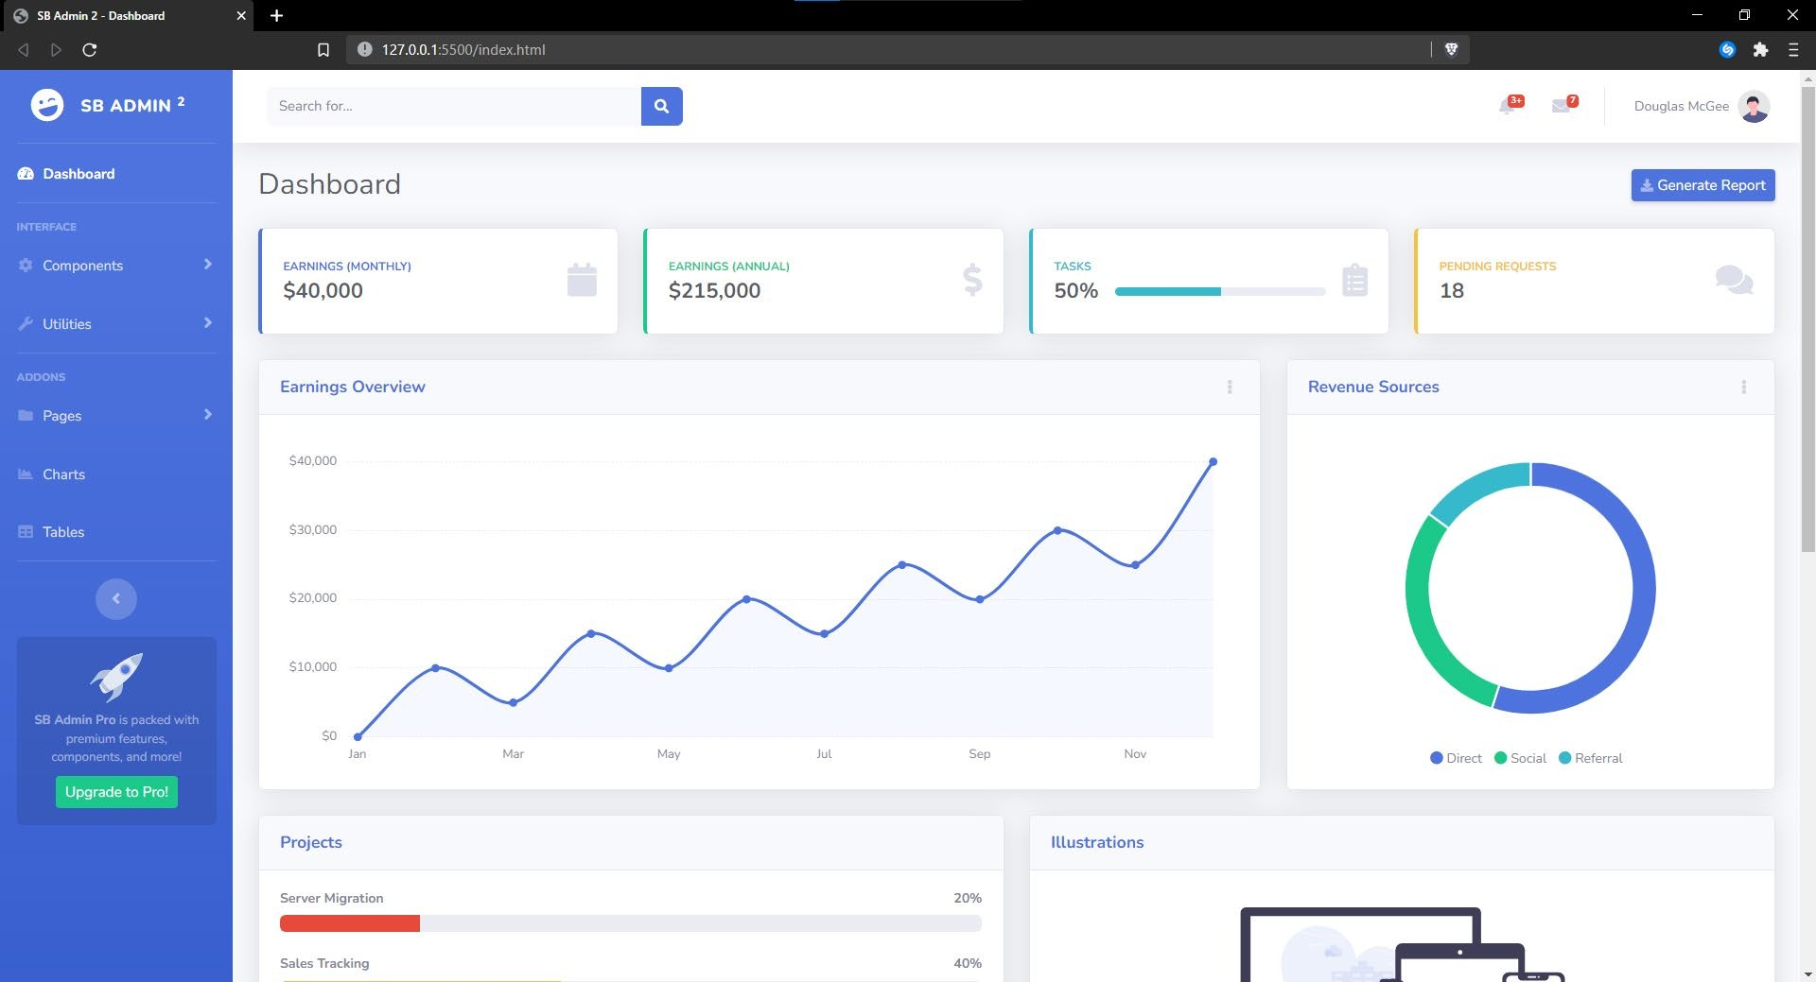**Before**

**After**

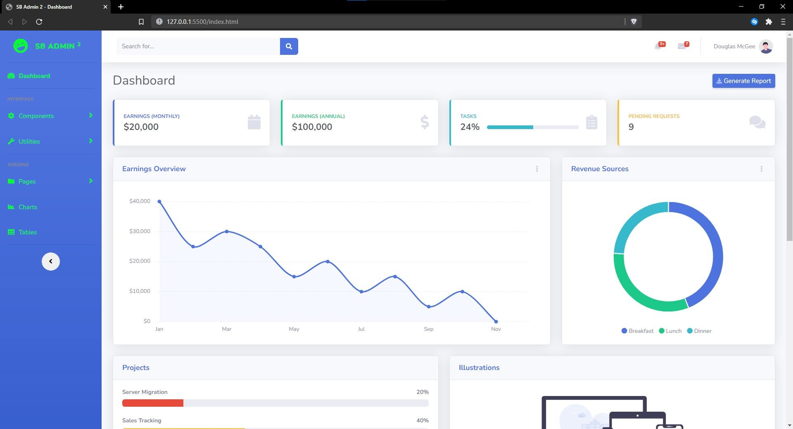**Changes:**

* **Values of line Graph/Area Graph**
* **Nav-Bar color**
* **Values of Pie Chart**
* **Monthly, Annual, Tasks, Pending requests values**
* **Removed the ad on the nav bar at the bottom**