**Project: Food Delivery Orders**

**This document contains SQL queries generated to perform ad-hoc analysis of food delivery orders.**

**Data Analyst: Ankush Shukla**

[**LinkedIn**](https://www.linkedin.com/in/ankush-shukla-514851226/)

**GitHub:** [**ankush0699 (github.com)**](mailto:ankush0699%20(github.com))

**E-mail:** [**ankushshukla0612@gmail.com**](mailto:ankushshukla0612@gmail.com)

**Q1: Top outlets by cuisine type (without using the limit and top functions).**

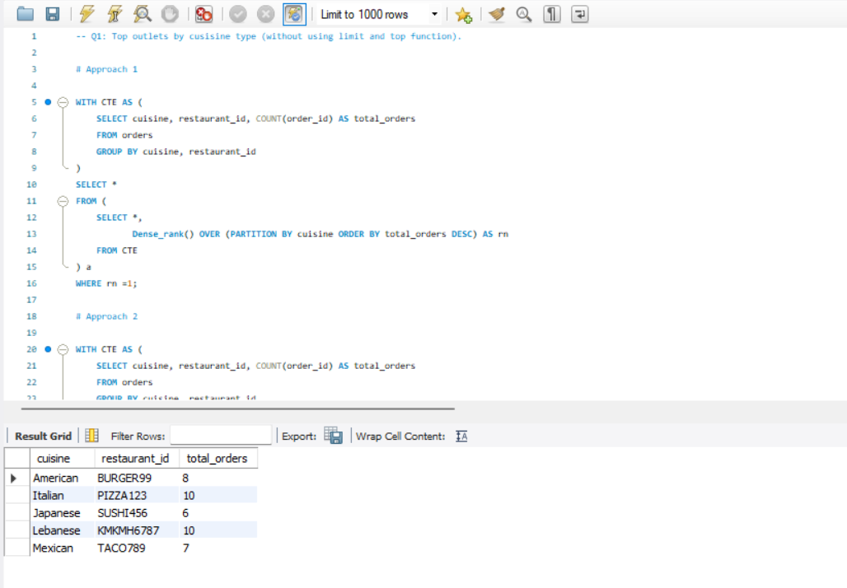

**Q2: Find the daily new customer count from the launch date (how many new customers are we acquiring?).**

**––**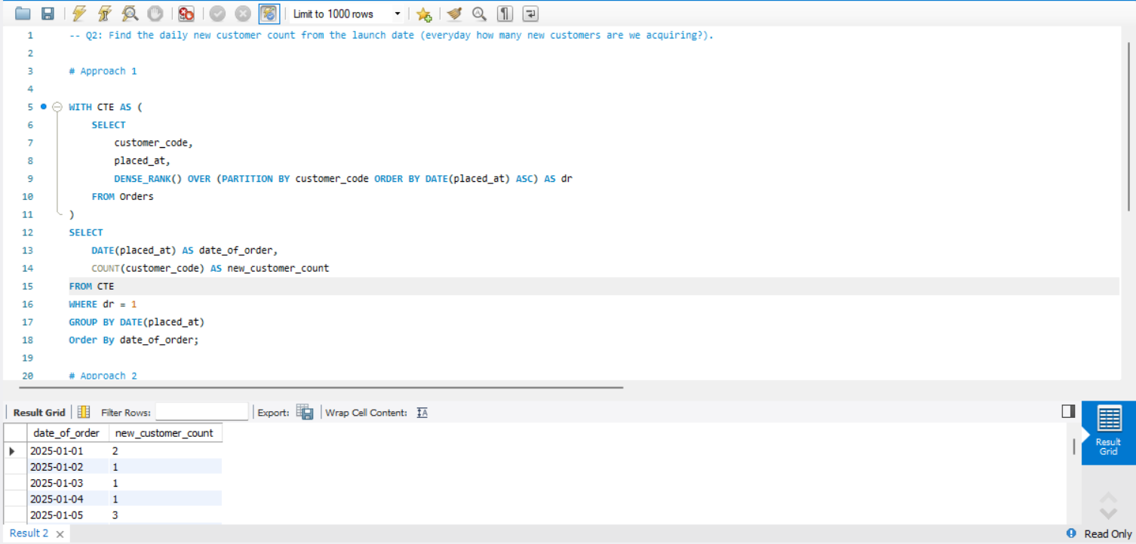

**Q3: Count of all the users who were acquired in Jan 2025 and only placed one order in Jan and did not place any other order after that.**

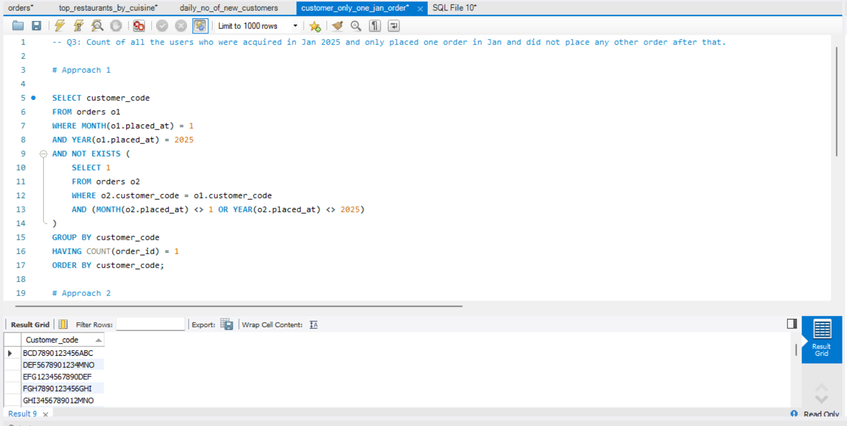

**Q4: List all customers with no orders in last 7 days but were acquired one month ago with their first order on promo.**

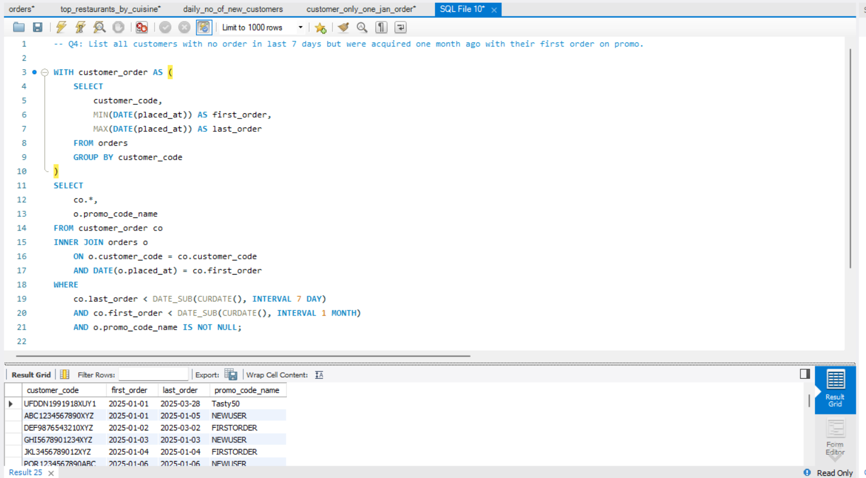

**Q5: The Growth team is planning to create a trigger that will target customers after their every third order with personalized communication, and they have asked you to create a query for this.**

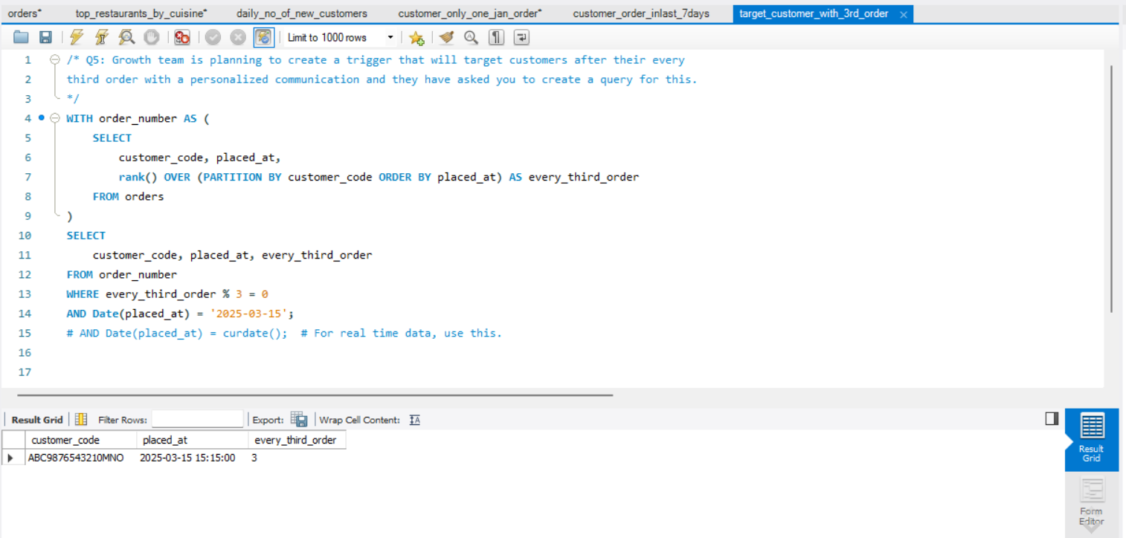

**Q6: List customers who placed more than 1 order and all their orders on a promo only.**

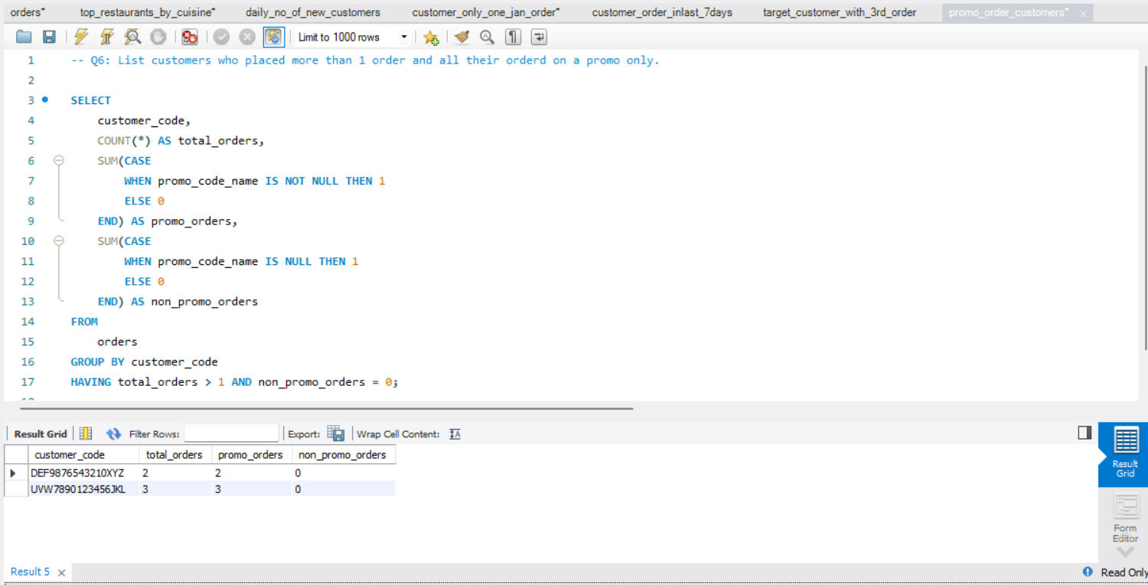

**Q7: What percent of customers were organically acquired in Jan 2025? (Placed their first order without promo)**

