The Silent Hand
Fund My Crazy — Build Night with Gemini | Education Category

The Problem
In large Indian classrooms of 50-60 students, one teacher cannot tell who's actually confused. Shy or slower students rarely raise their hand out of fear of looking foolish in front of peers, so their confusion goes unnoticed until it's too late — often surfacing only as poor exam results.

The Practical Solution
- 1-Tap "I'm Lost" Button: Every student has access to a simple shared screen or basic device with a prominent "I'm Lost" button next to a text input — no typing required, fully anonymous.
- Gemini Real-Time Confusion Clustering: Gemini reads every anonymous tap/input in real time and clusters similar confusions into clear, actionable patterns (e.g., "18 students are stuck on Matrix Multiplication, Step 2") displayed on the teacher's screen alongside the lesson timeline.
- Instant Pivot Suggestions: The moment a cluster is detected, Gemini generates a 30-second alternative explanation or visual analogy the teacher can use immediately to re-explain — without breaking the class's flow.

Why It Is Highly Feasible
It uses only a basic shared screen or low-cost tablets already found in many schools, plus Gemini's existing text-clustering and generation capabilities — no new hardware, sensors, or physical infrastructure required. It integrates directly into any existing classroom teaching flow.

Sample Pitch
"In a classroom of 60 students, the quietest room is often the most confused. The kids who need help most are almost always the ones too afraid to raise their hand. Meet The Silent Hand — an anonymous, real-time feedback layer built for high-density Indian classrooms. Instead of raising a hand, a confused student just taps 'I'm Lost.' Gemini instantly clusters these anonymous signals into clear patterns — like '18 students are stuck on this exact step' — and generates a 30-second alternative explanation the teacher can use immediately, so they pivot without missing a beat. We're not asking kids to be braver. We're building a classroom where they don't have to be. Would you fund a room where silence stops meaning confusion?"

Sample Poster
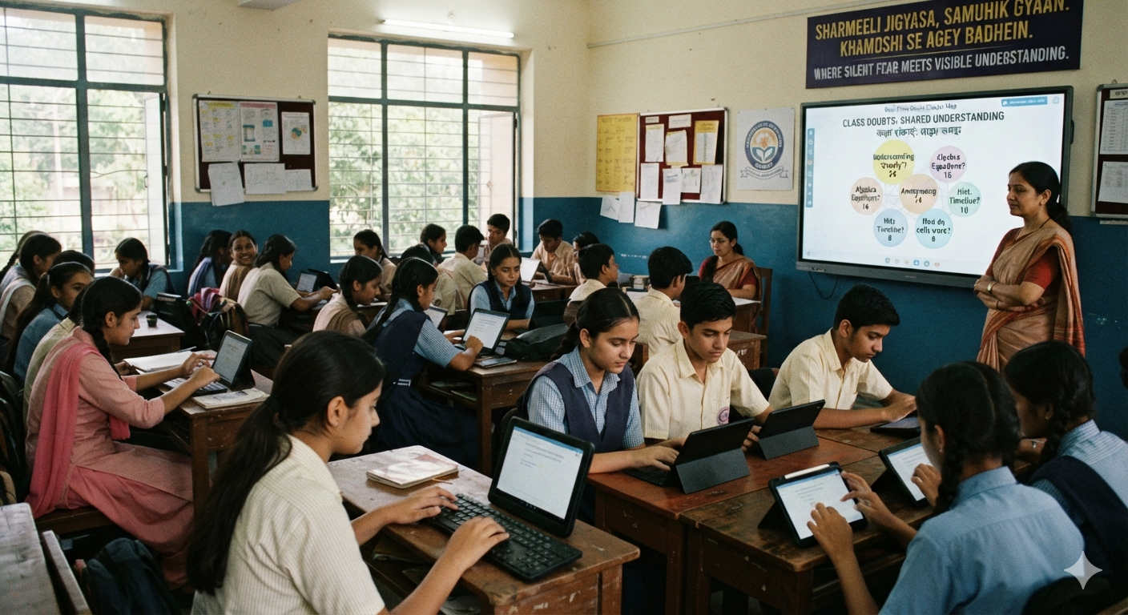
Best Of Luck

