***THIS CODE HAS BEEN TESTED OUT ON GOOGLE CHROME***

**192.168.56.101/main.php**

**Picture1**



If the student does not enter Student ID and Presses Enter on key board then:

Picture2



If the student enters a non-numeric Student ID then:

Picture3



If the student enters nothing and Presses the Button “ENTER” then:

Picture4



If the student enters a numeric student ID (Success):

Picture5

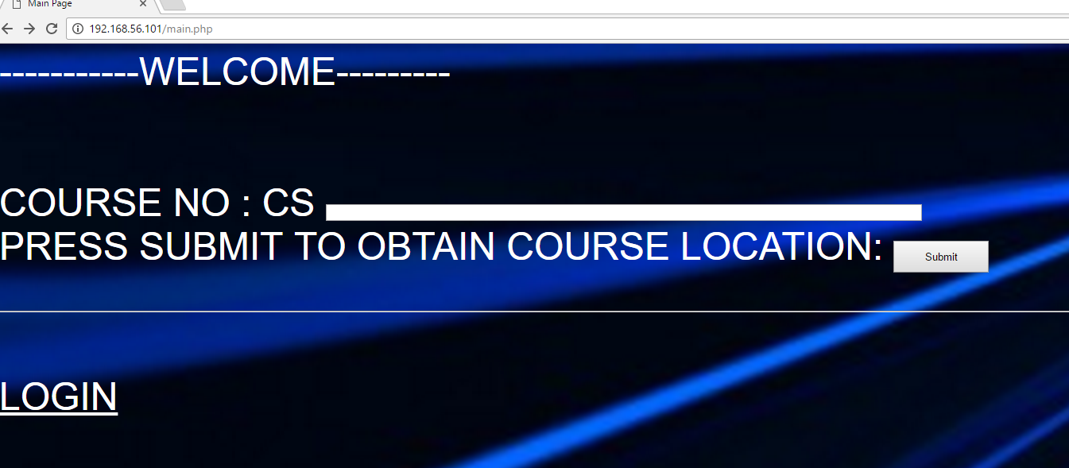

How to Enter Course Number AND press submit:

Picture6

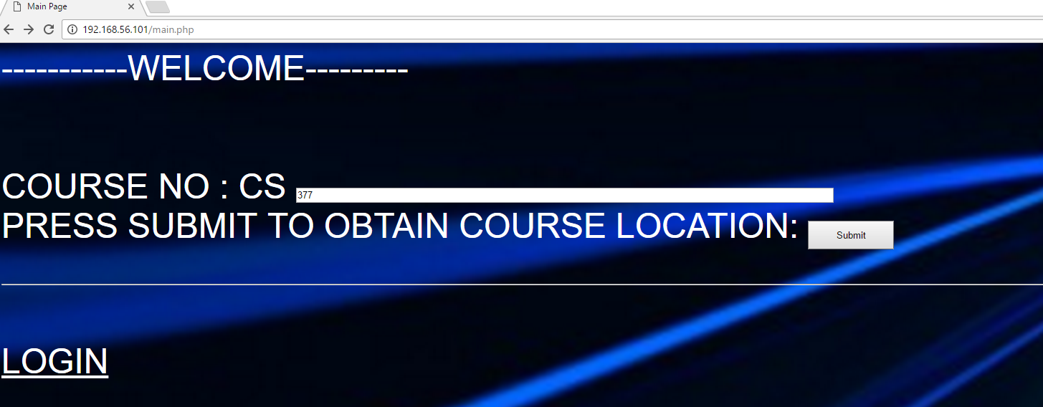

IF THE STUDENT ID WAS INDEED VALID | **retrieve.php**:

Picture7

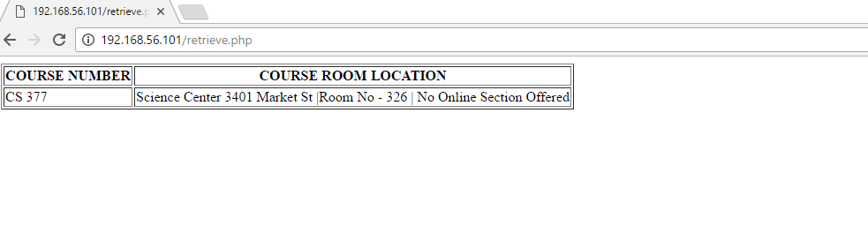

IN CASE OF INVALID STUDENT ID:

Picture8



IN CASE OF INVALID NUMERIC COURSE NUMBER:

Picture9

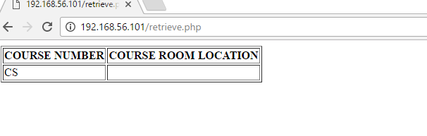

IN CASE OF INVALID COURSE NUMBER (DUE TO NON-NUMERIC ENTRY FOR COURSE NUMBER):

*NO DISPLAY/UNSUCCESSFUL QUERY*

Picture10



**SQL INJECTION (ANSWER-KEY)**

**Picture11**

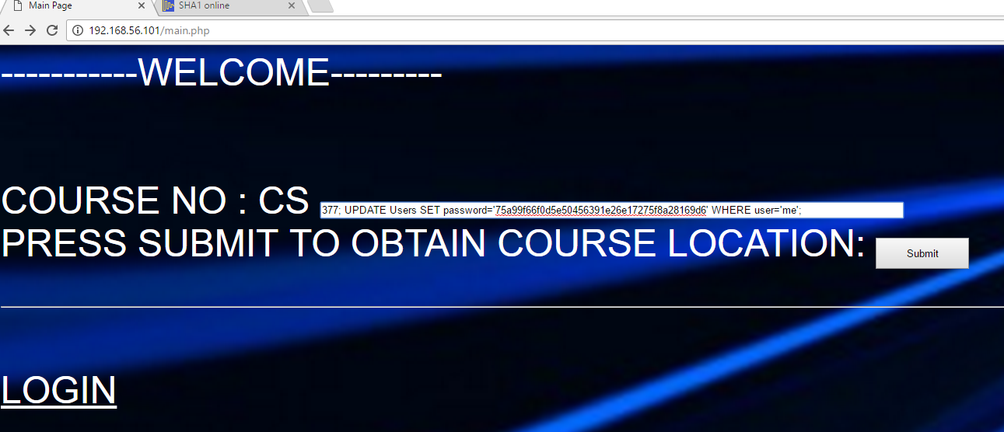

**Picture12**

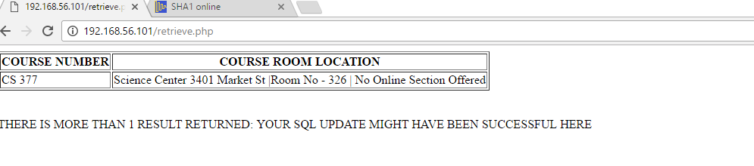

**AFTER CLICKING ON LOGIN ON main.php (login.php):**

**Student ID will be automatically fed in (readonly field)**

**Picture13**

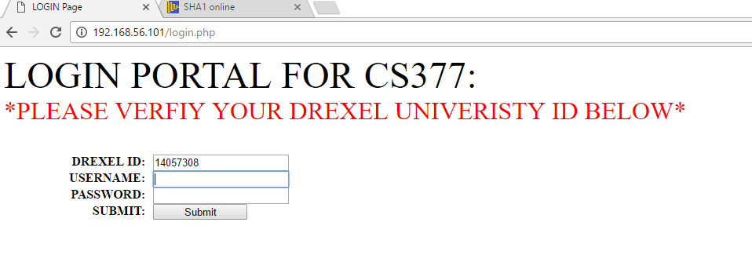

**IF USERNAME IS EMPTY:**

**Picture14**

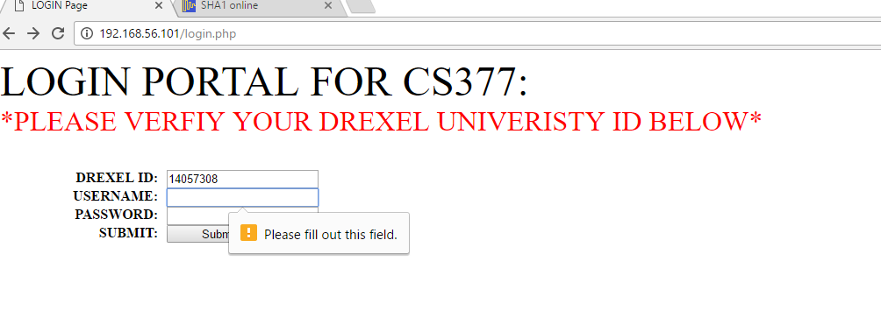

**IF PASSWORD IS EMPTY:**

**Picture15**

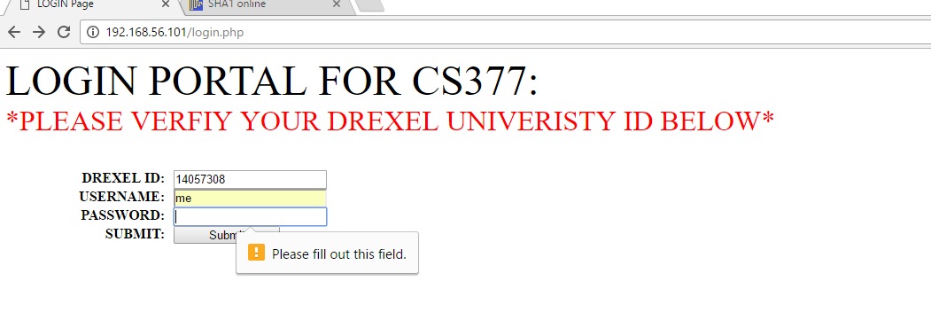

**IF USERNAME IS NOT ‘me’ (calculate.php):**

**Picture16**

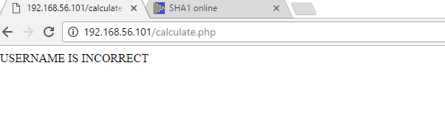

**IF PASSWORD IS NOT CORRECT (calculate.php):**

**Picture17**

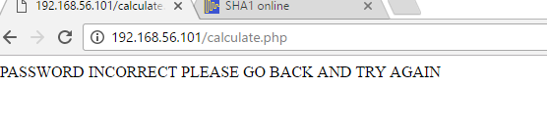

**IF STUDENT ID WAS NOT VALID (same as in ‘retrieve.php’)**

**SUCCESSFUL TO VERIFY CREDENTIALS (calculate.php):**

**Picture18**

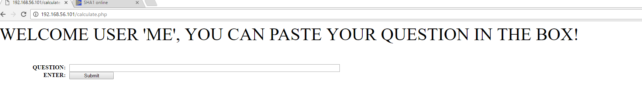

**ENTER QUESTION PLUS SUBMIT (answer.php):**

**Picture19**

