Que. 1 What are the most explicative variables indicating churn?
Ans.
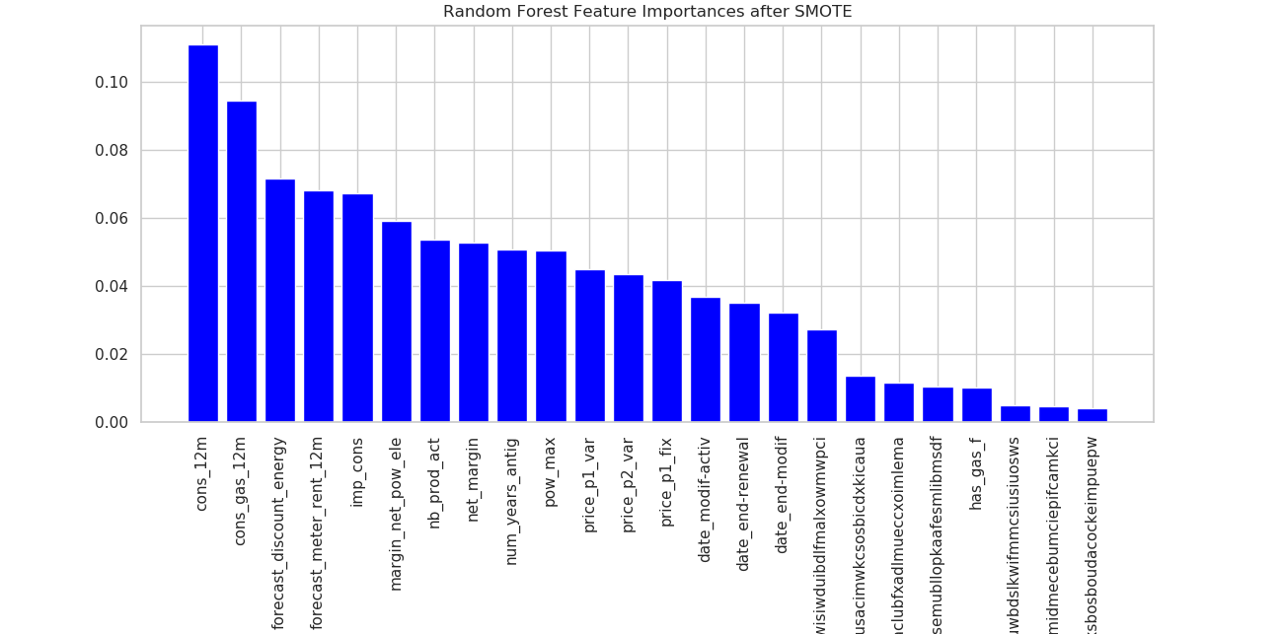
Random forest feature importance after SMOTE

All features with their impact on churn analysis has been represented by above histogram. cons_12m has highest impact on churning, then cons_gas_12m and so on.
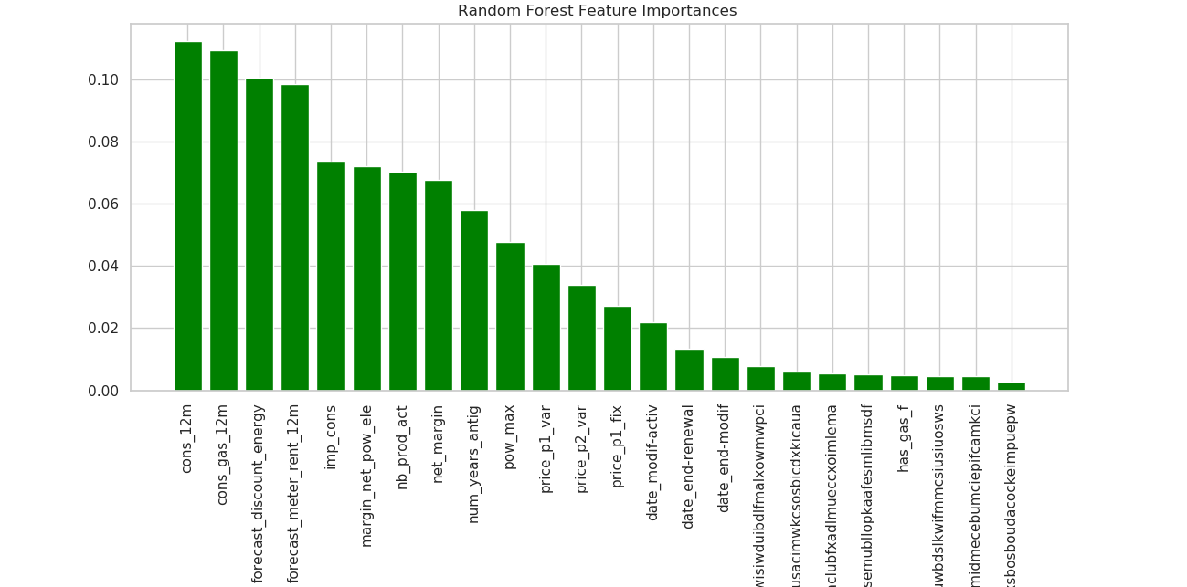

Random Forest Feature importance without SMOTE

Que. 2 Is there a correlation between subscribed power and consumption?
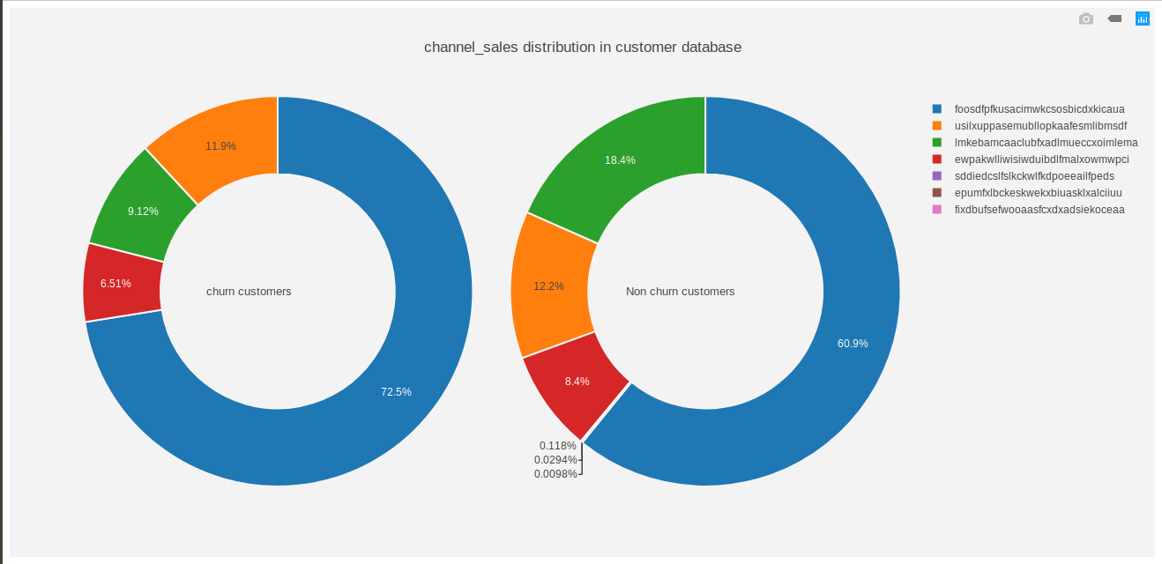
Ans.
Churned customer and non-churned customers are segregated on the basis of sales channel id.
72.5% of churned customers belong to foosdfpfkusacimwkcsosbicdxkicaua.
60.9% of non-churned customers belong to foosdfpfkusacimwkcsosbicdxkicaua.
Following three companies have neglible contribution to churn analysis.
1. epumfxlbckeskwekxbiuasklxalciiuu
2. sddiedcslfslkckwlfkdpoeeailfpeds
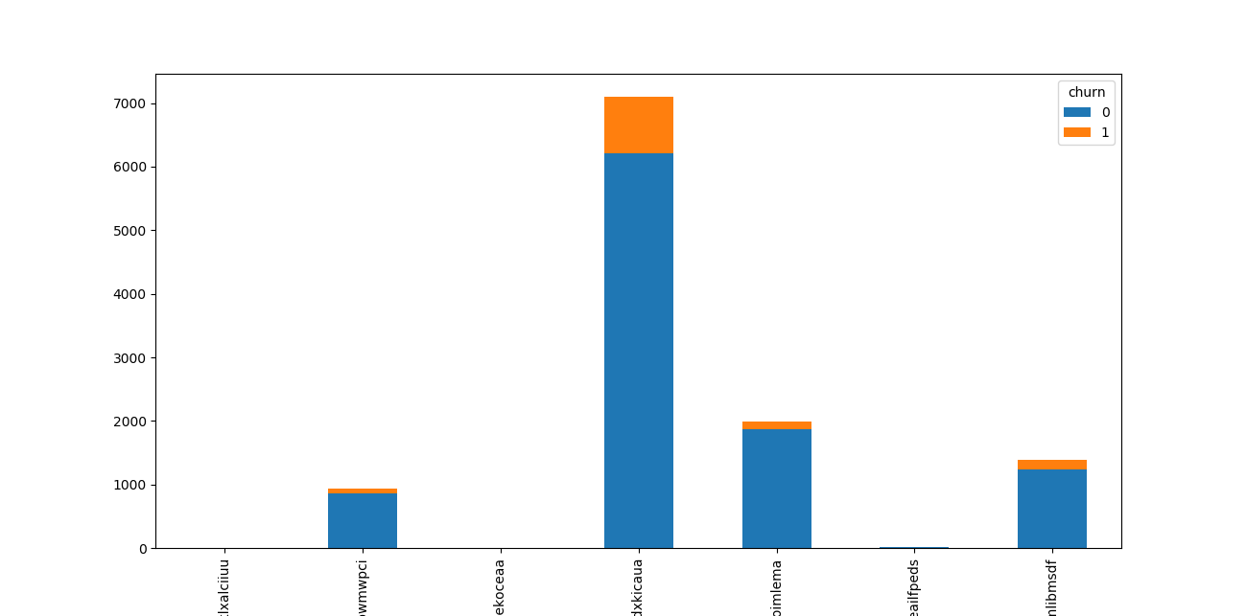
3. fixdbufsefwooaasfcxdxadsiekoceaa

Que. 3 Is there a correlation between subscribed power and consumption?
Ans.
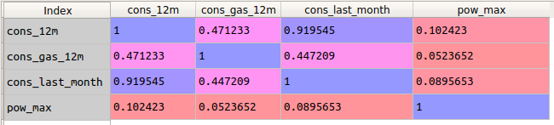
The correlation coefficient is a statistical measure that calculates the strength of the relationship between the relative movements of the two variables.
If cofficient corrrelation is positive, it indicates that value of one variable increases or decreases with increase or decrease in value of other variable.
If cofficient corrrelation is negative, it indicates that value of one variable increases or decreases with decrease or increase in value of other variable.

Yes, there is positive correlation between subscribed power and consumption but very insignificant. Genrally, cofficient in range (-0.8 , 0.8) is not considered as strong correlation.

Que. Build a machine learning model that can predict the customers with high probability of churn.
Ans.
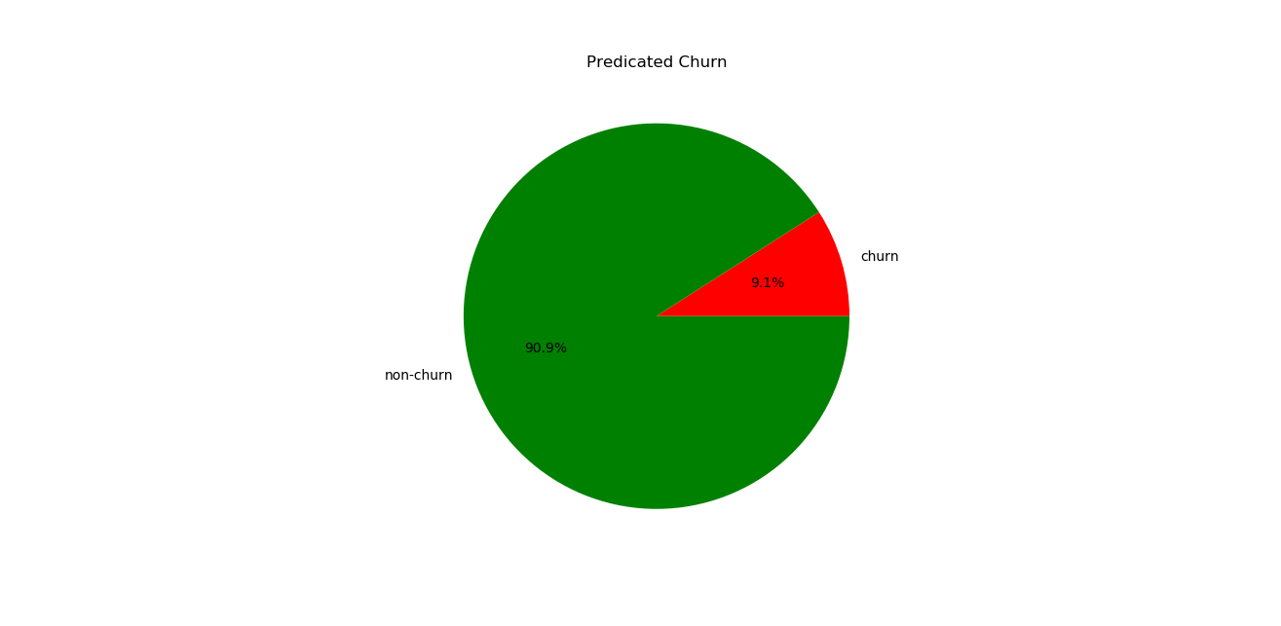
Accuracy = 90%
Precison = 7%
Recall = 51%
auc = 93%
auc_roc = 70%

Accuracy, Not always true parameter of measure. Why?: Our algorithm provided following table for churn analysis.
Actual
Number: 1000 | Churned | Non Churned
Chruned | TP: 20 | FP: 10
Non Churned | FN: 30 | TN: 940
Accuracy = (TP +TN)/ total = 960/1000 = 96%

Now, Let us create a dumb algorithm which always predicts that an employee will not churn.
Actual
Number: 1000 | Churned | Non Churned
Chruned | TP: 00 | FP: 00
Non Churned | FN: 50 | TN: 950
Now, Accuracy = (TP+TN) / Total = 950/1000 = 95%
Still believe accuracy is always true parameter for analysis ?
: This happened because we had class imbalanced dataset.

Precision or Recall :
Actual
Number: 1000 | Churned | Non Churned
Chruned | TP: 20 | FP: 10
Non Churned | FN: 30 | TN: 940
Precision = TP / (TP + FP) = 20/30
Recall = TP / (TP + FN) = 20 / 50
High Precision Low Recall
Actual
Number: 1000 | Churned | Non Churned
Chruned | TP: 20 | FP: 30
Non Churned | FN: 10 | TN: 940
Precision = TP / (TP + FP) = 20/50
Recall = TP / (TP + FN) = 20 / 30
Low Precision High Recall
You are HR Manager of company and employee are leaving organization. In first example, you predicted 30 persons will leave and 20 of them actually left. Overall, 50 people left the organization.
In second example, you predicted 50 persons will leave and 20 of them actually left. Overall, 30 people left the organization.
Which scenario would you favour ? 20 unnoticed people left organization and you had to talk to only 30 people or 10 unnoticed people left organization and you had to talk to 50 persons ?
Second scenario is more preferred. Even if an employee is falsely predicted to be churning, showing your concern will make them feel special and boost their loyalty towards organization.
Hence in churning scenario, Recall is better measure than precision.

## Model used to predict: AdaBoostClassifier with ExtraTreeClassifier as base
estimator
As this is churn analysis problem, we have assumed that if probability
of churning of customer is greater than 0.3, then they are most probably to shift.
By this assumption, 54 of 596 customers are to be churned and 542 customers are to be non-churned.

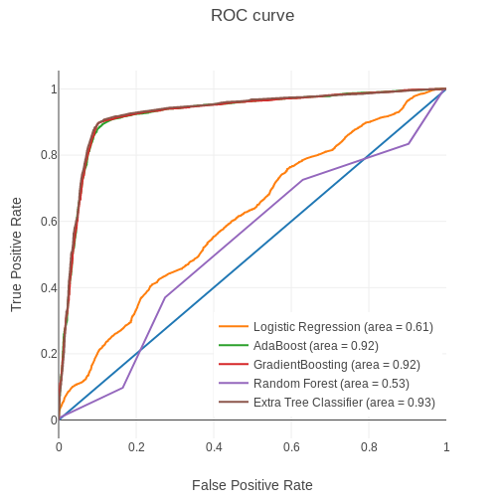

One way to retain customers is to provide perks to them like reduced price rate, increasing allowed power subscription and seasonal discounts like in festival seasons.

Exploratory Data Analysis :
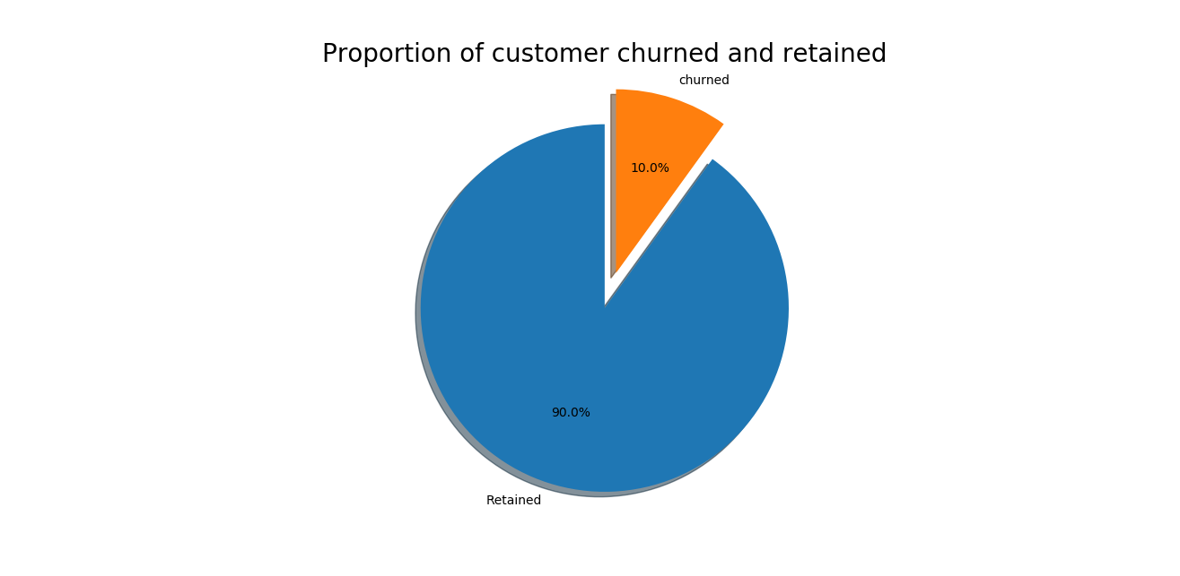

As represented by the piechart plotted above, it can be observed that 90.0% of total customers are non-churned and 10.0% of total customers are churned which implies that 90% of customers are still retained by their supplying company and 10% of customers have shifted from their previous suppliers.

HeatMap of pairwise correlations of features:
In a nutshell, this is heatmap of pairwise correlation of features.
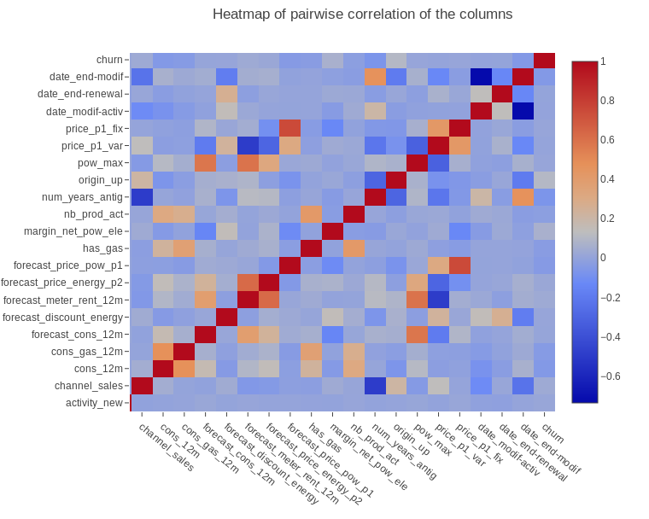
More warm color indicates more correlated features and more cold color indicates less correlated features.
Missing Values :
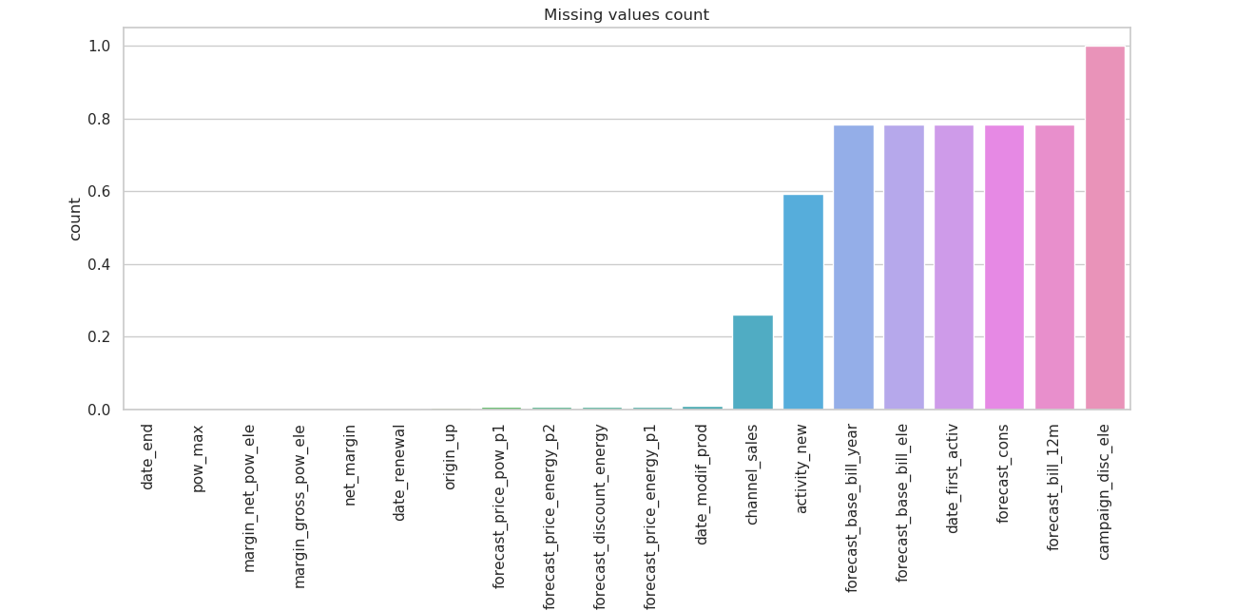
Above plot shows fraction of total data missing from particular columns in training dataset so we have liberty to ommit them.

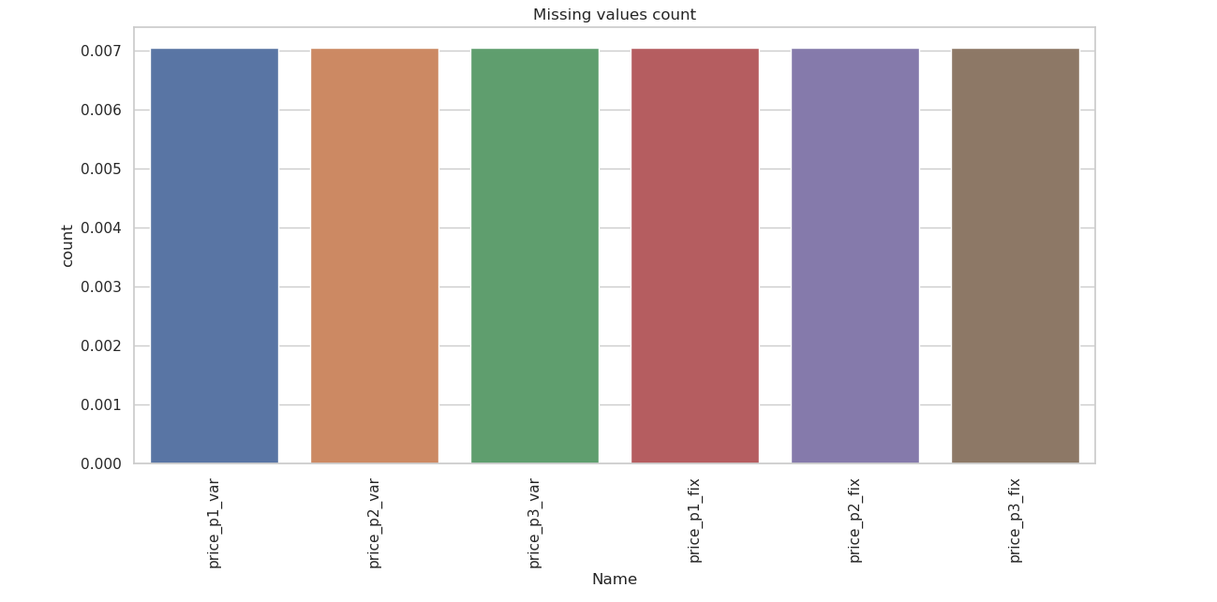
Missing values count in price dataset
Above plot shows fraction of missing values from price datset of each column. As percentage of each column is very very low so we cannot ommit them. Ommiting them can affect our model to be biased.

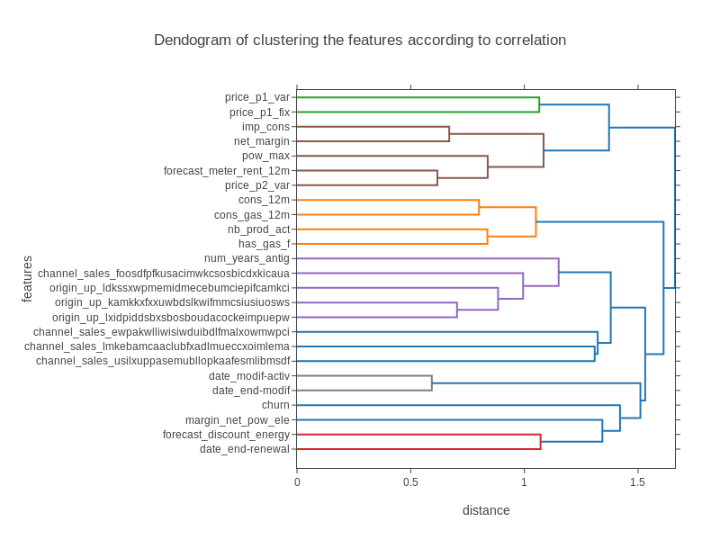

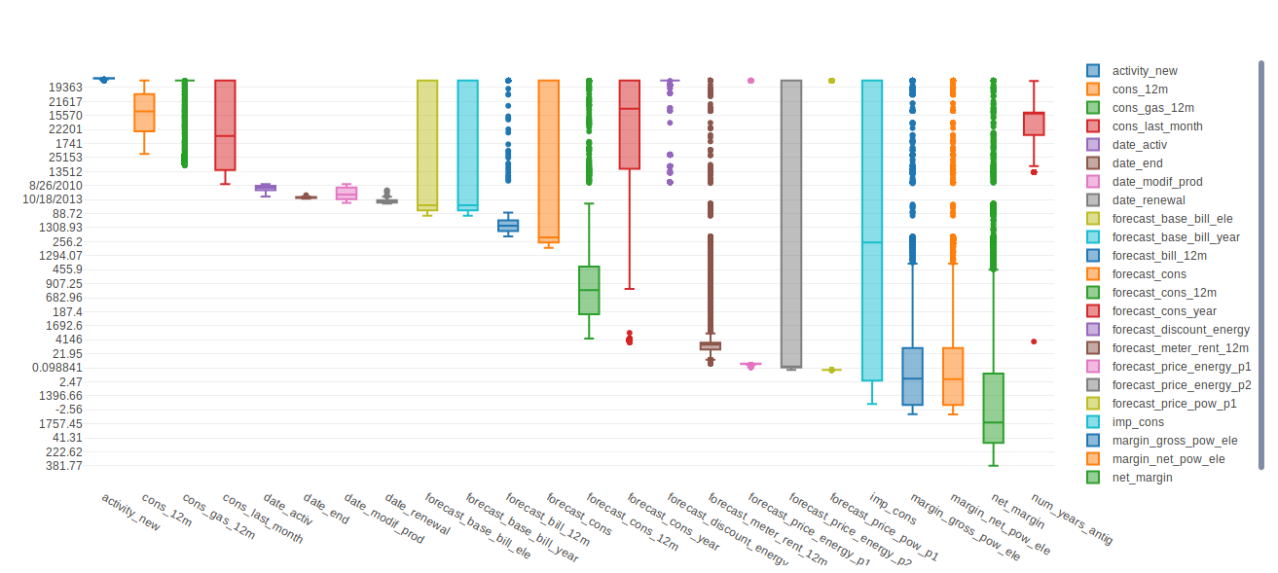
BoxPlot of all features with churn
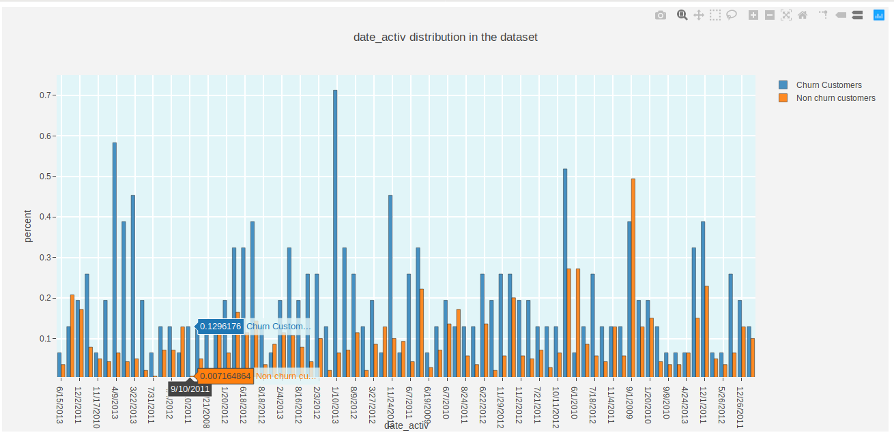

date of activation of the contract

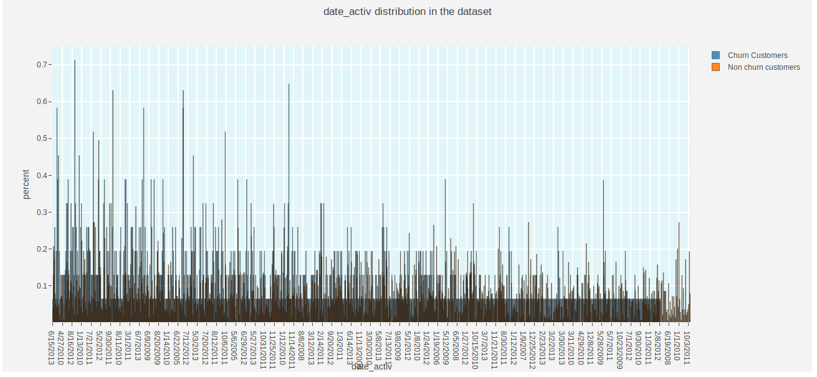
date of activation of the contract

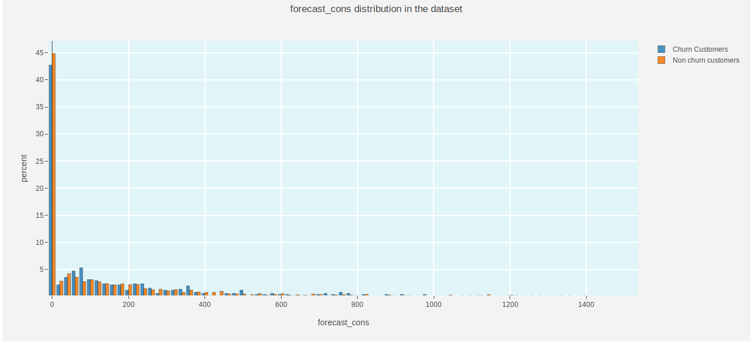
forecasted electricity consumption for next month
( Right skewed)

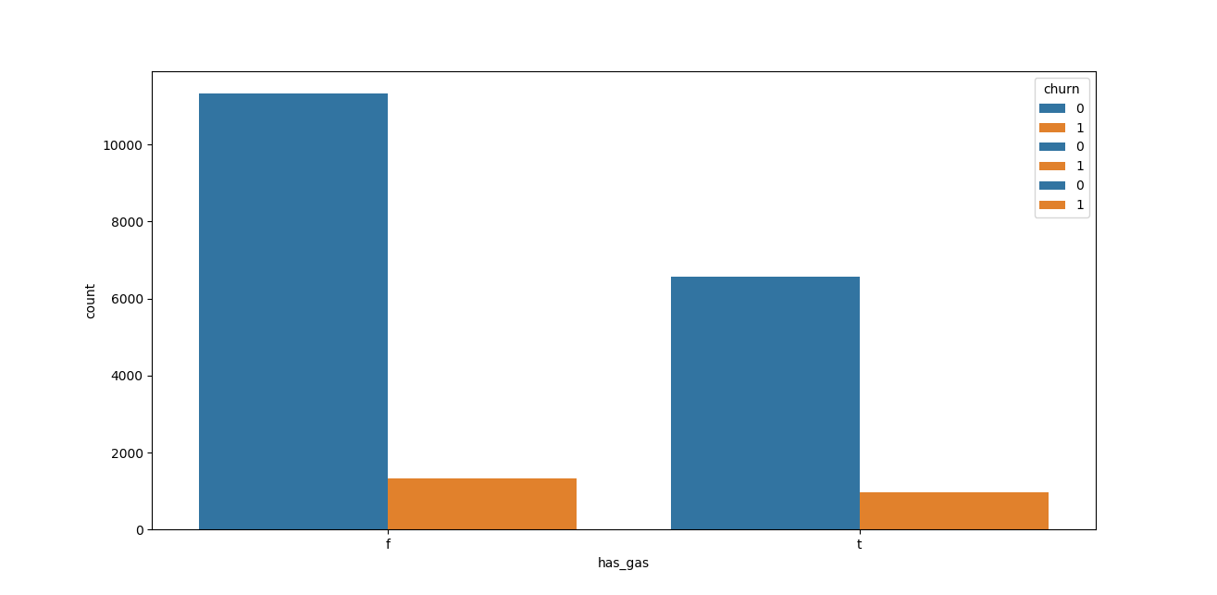

Has_gas in dataset - indicated if client is also a gas client

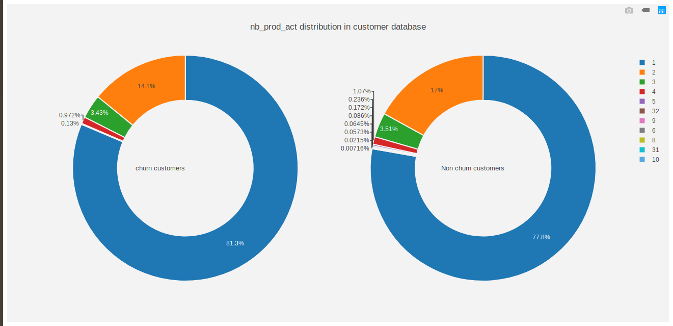

number of active products and services

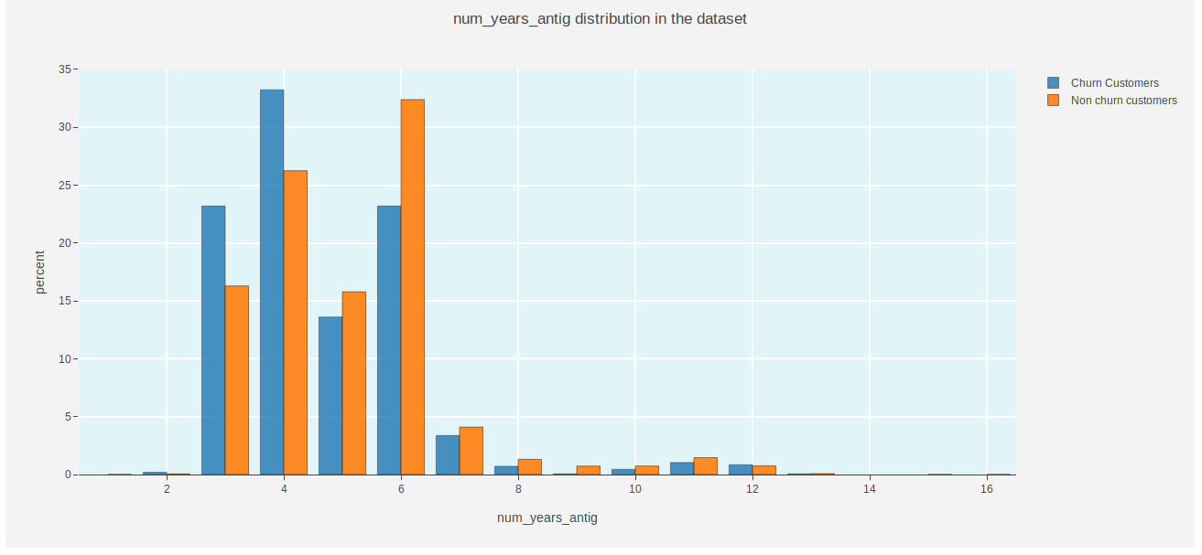
antiquity of the client (in number of years)

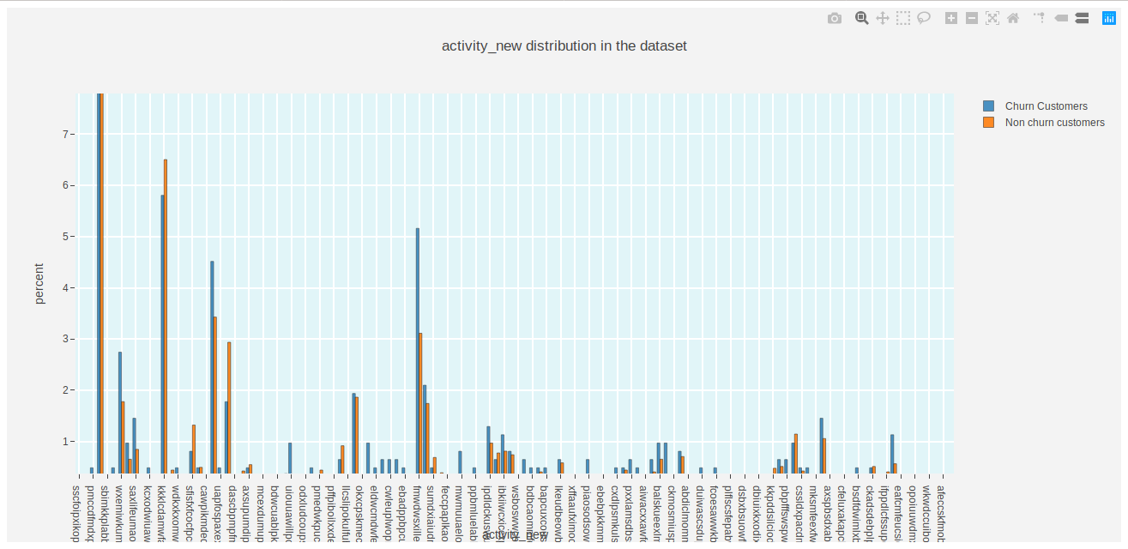
category of the company's activity

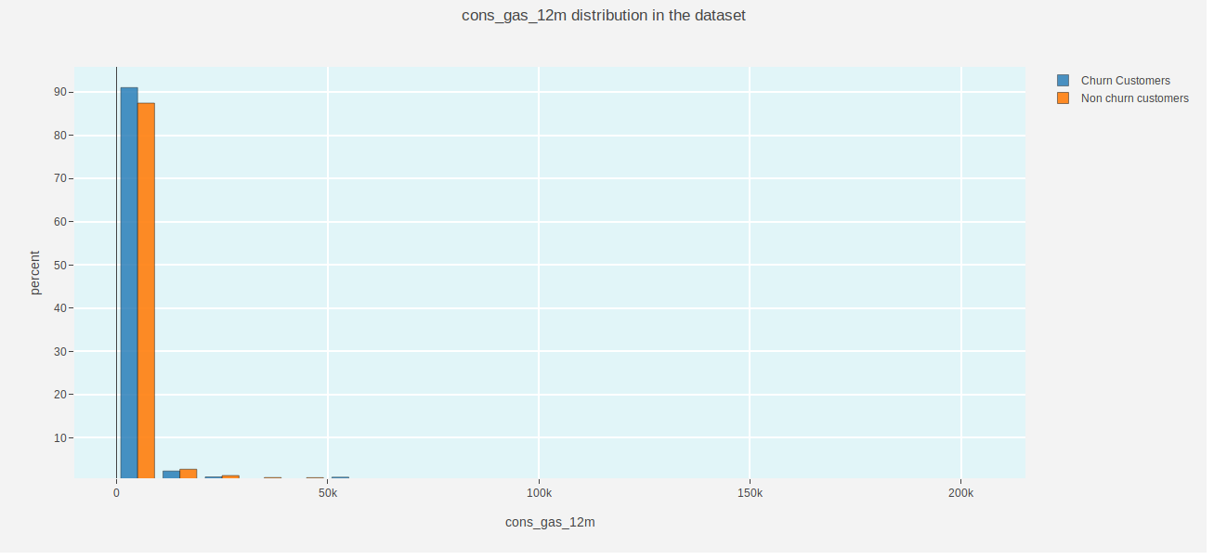
gas consumption of the past 12 months

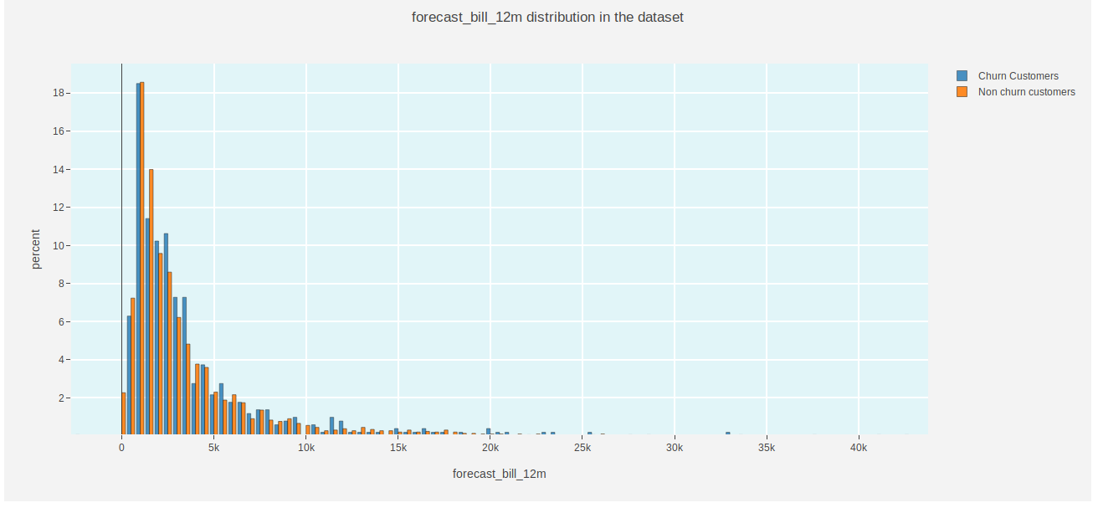
forecasted electricity bill baseline for 12 months ( Right skewed)

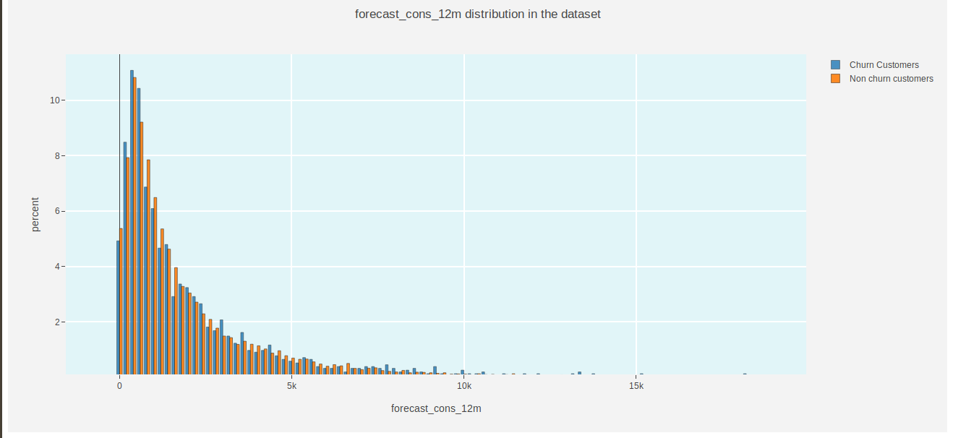
forecasted electricity consumption for next 12 months ( Right skewed)

forecasted electricity consumption for next month

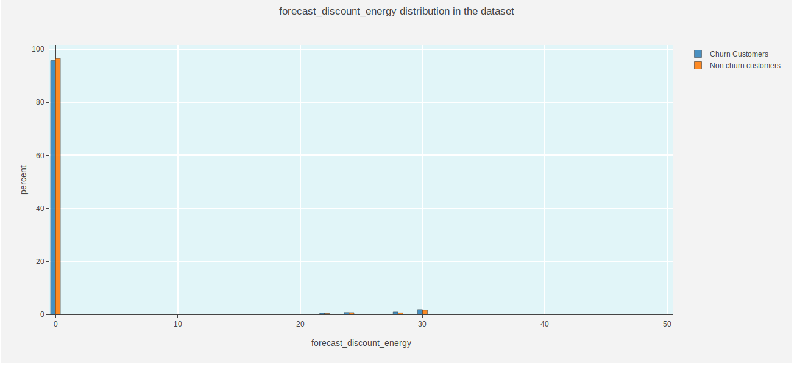
forecasted value of current discount

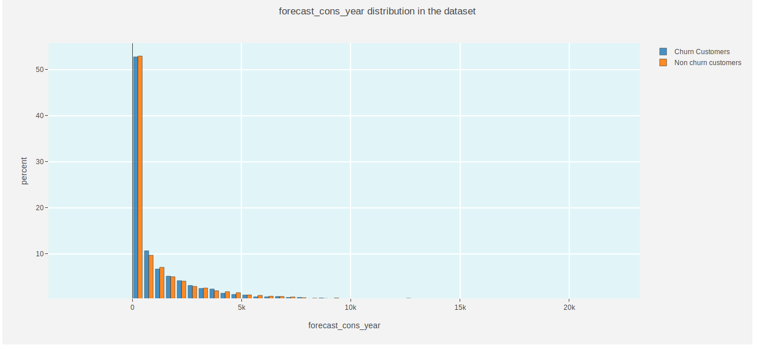
forecasted electricity consumption for next calendar year ( Right skewed)

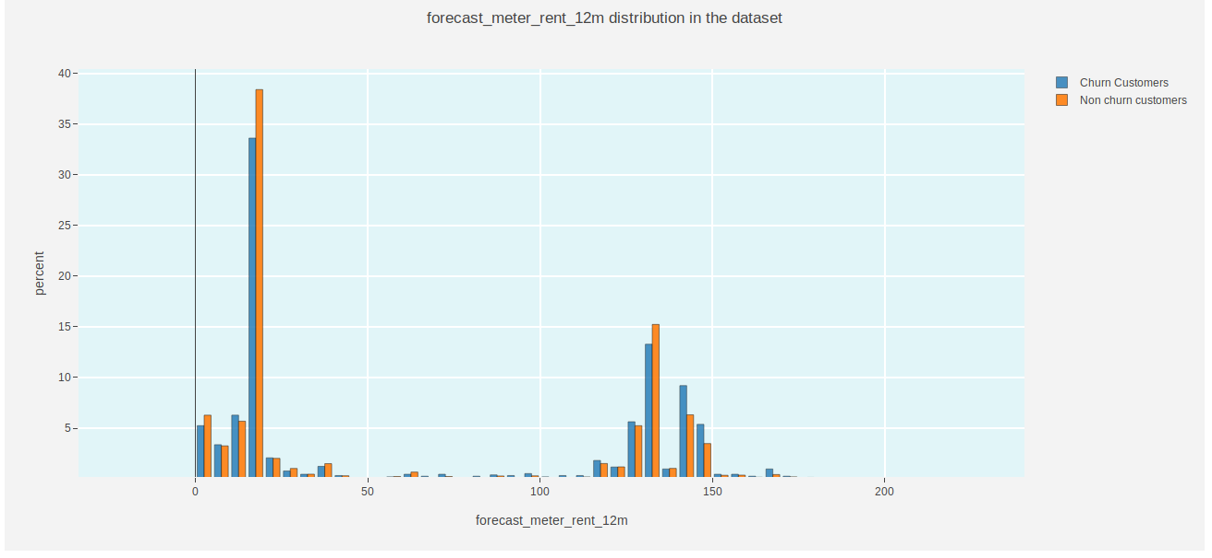
forecasted bill of meter rental for the next 12 months

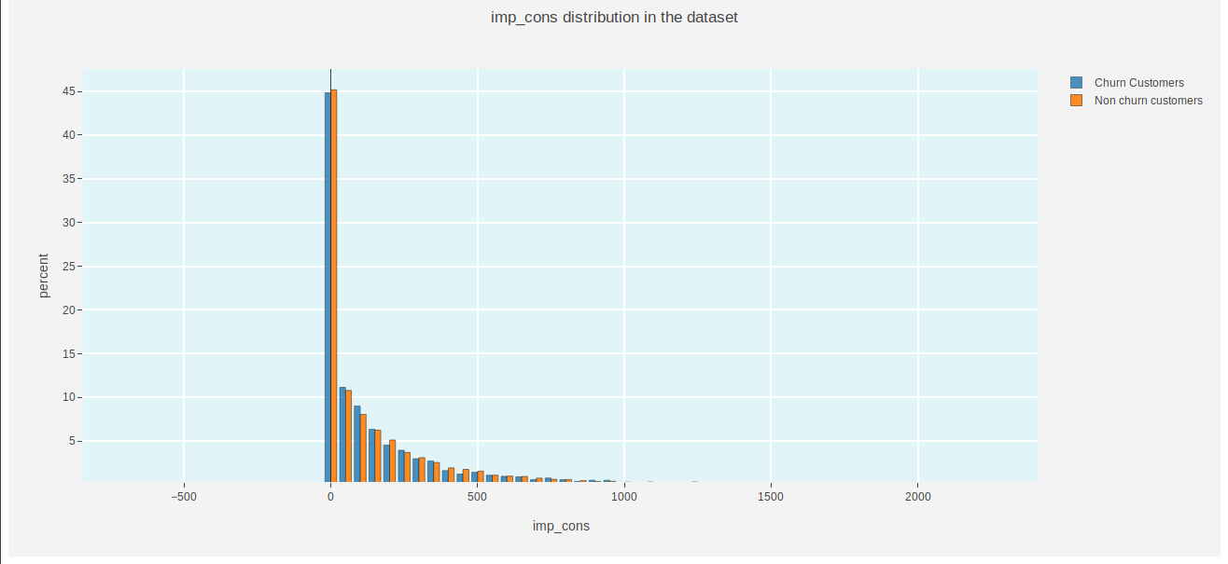
current paid consumption

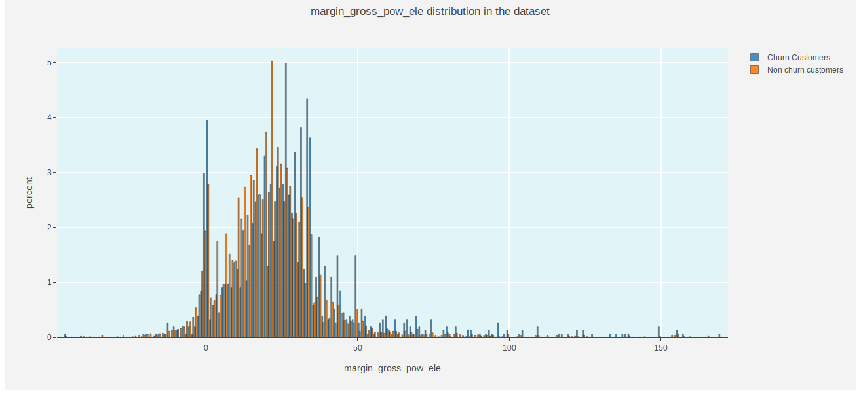
gross margin on power subscription
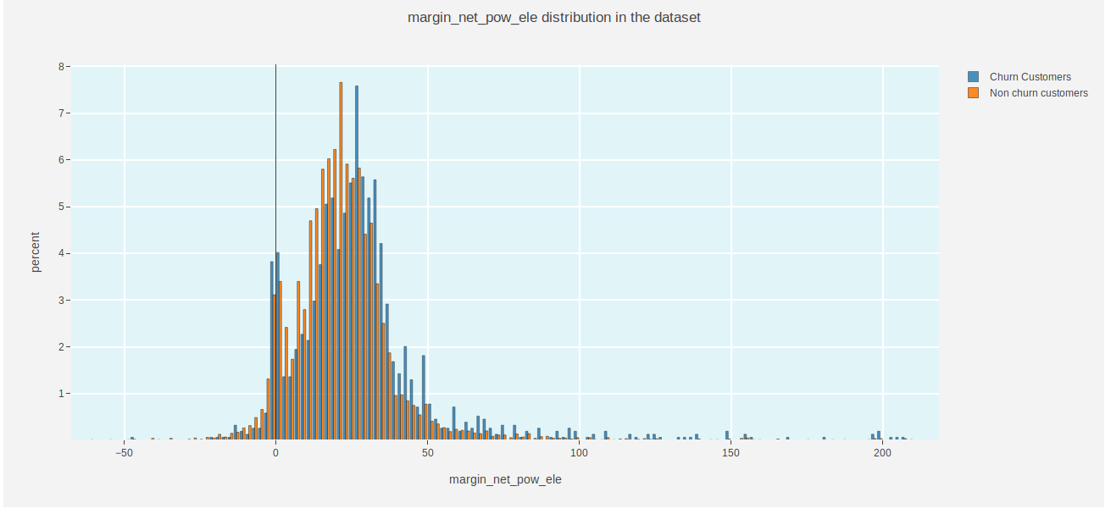

net margin on power subscription

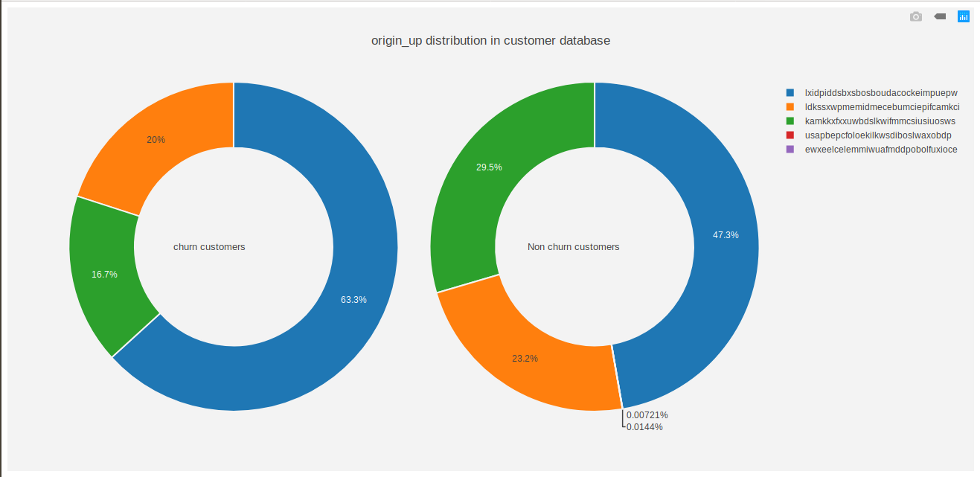
code of the electricity campaign the customer first subscribed to

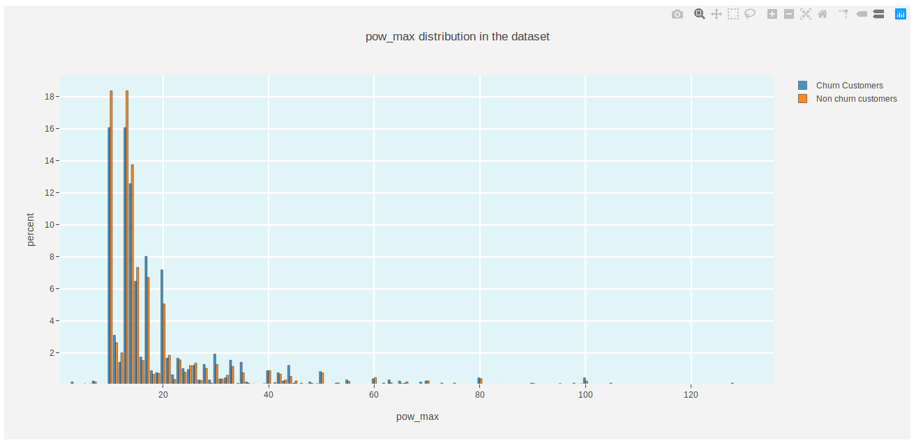
subscribed power

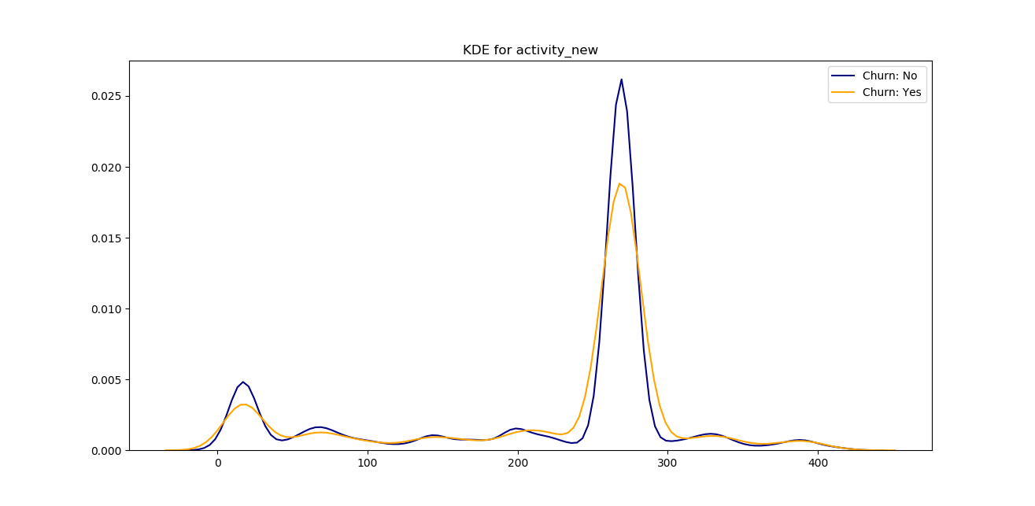
KDE for activity_new
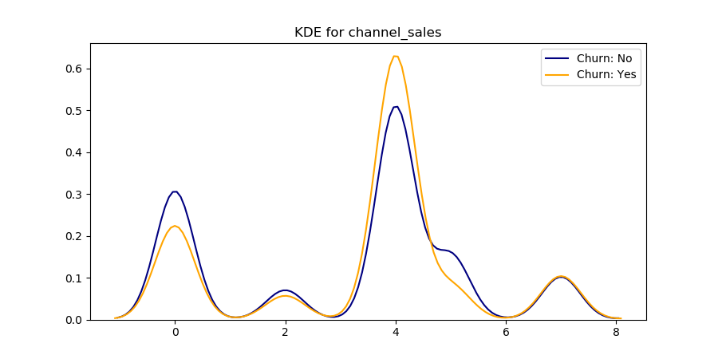
KDE for channel_sales

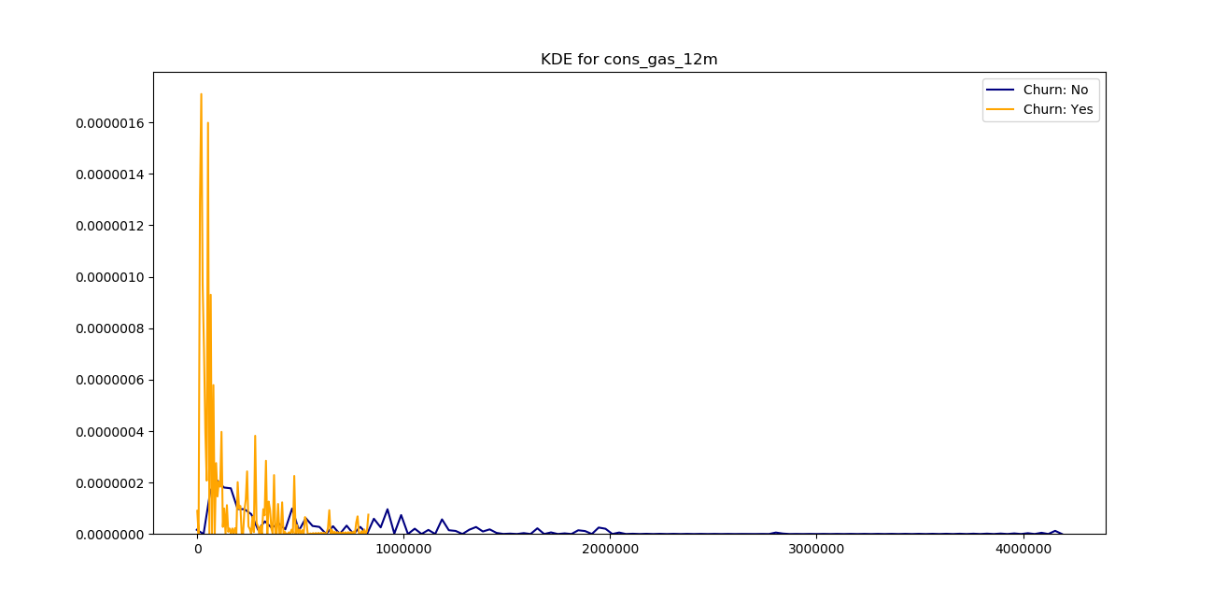
KDE for cons_gas_12m

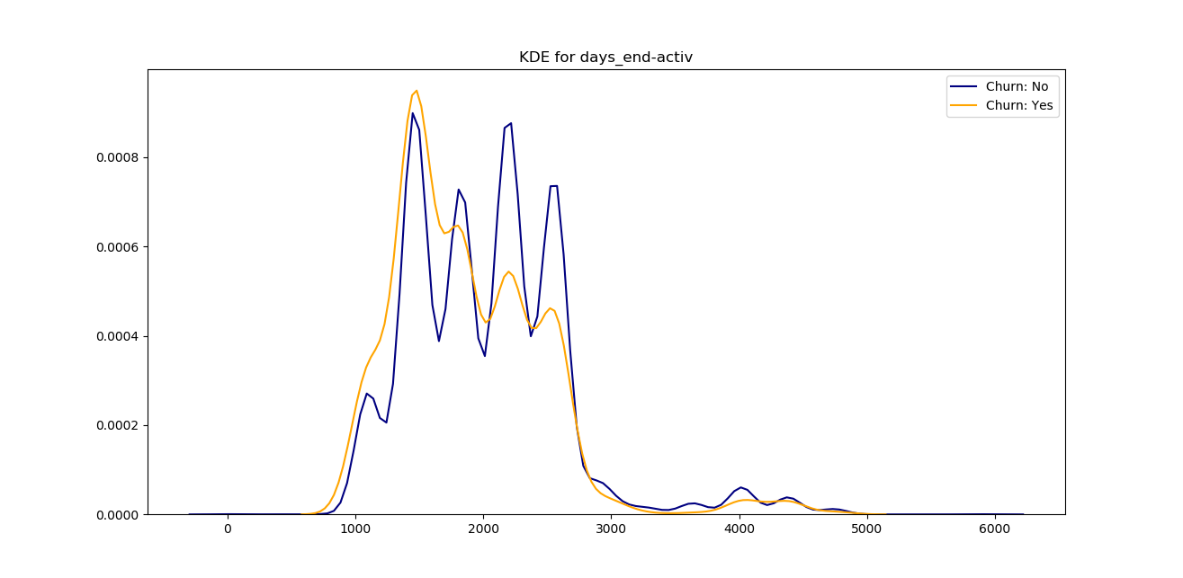
KDE for days_end_active

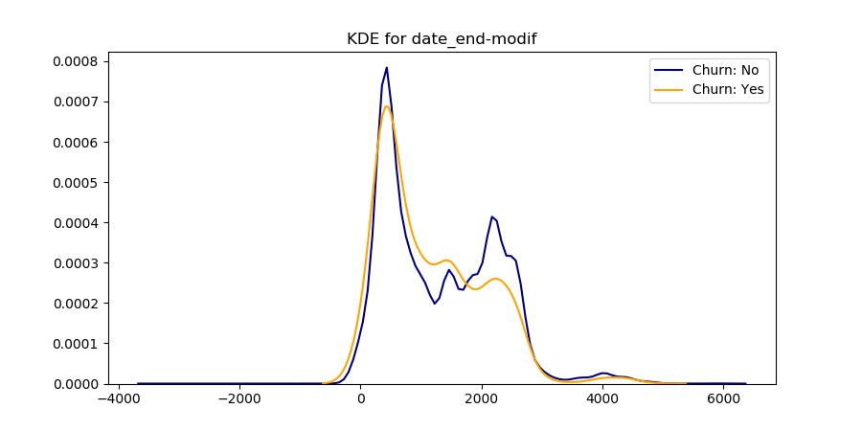
KDE for date_end_modif

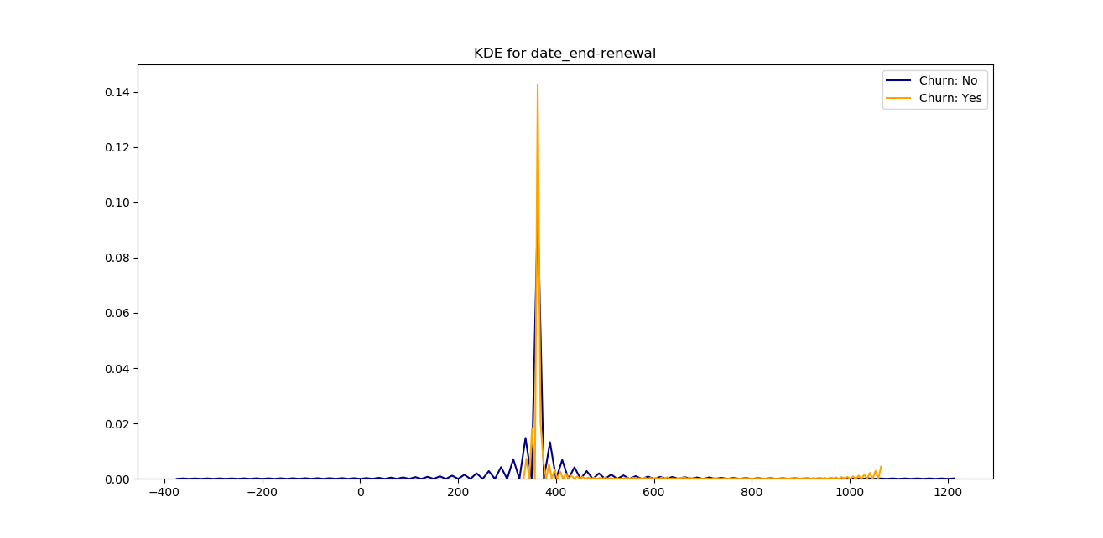
KDE for date_end_renewal

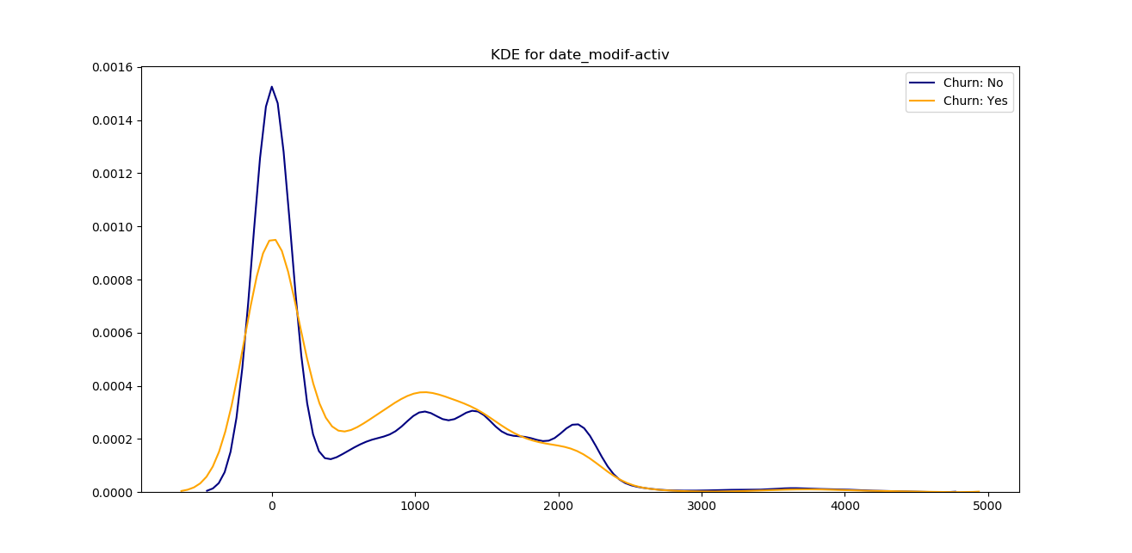
KDE for date_modif_activ

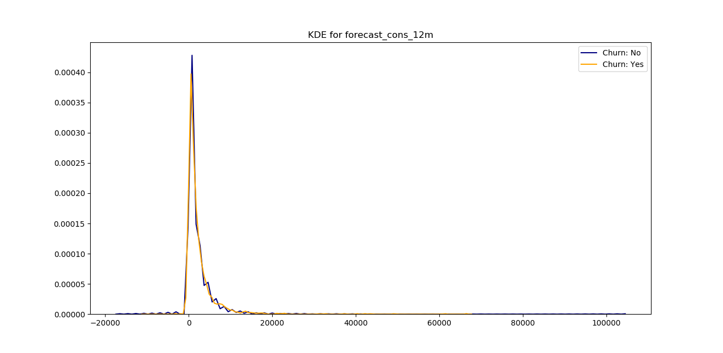
KDE for forecast_cons_12m
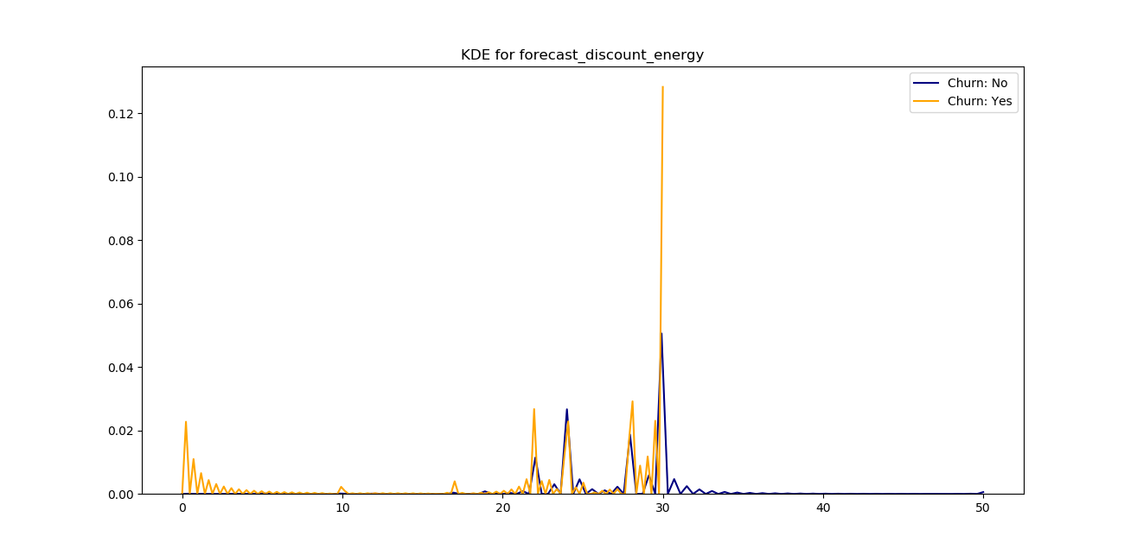
KDE for forecast_discount_energy

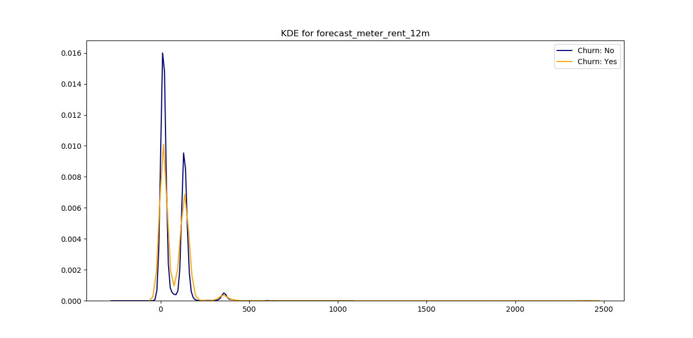
KDE for forecast_meter_rent_12m

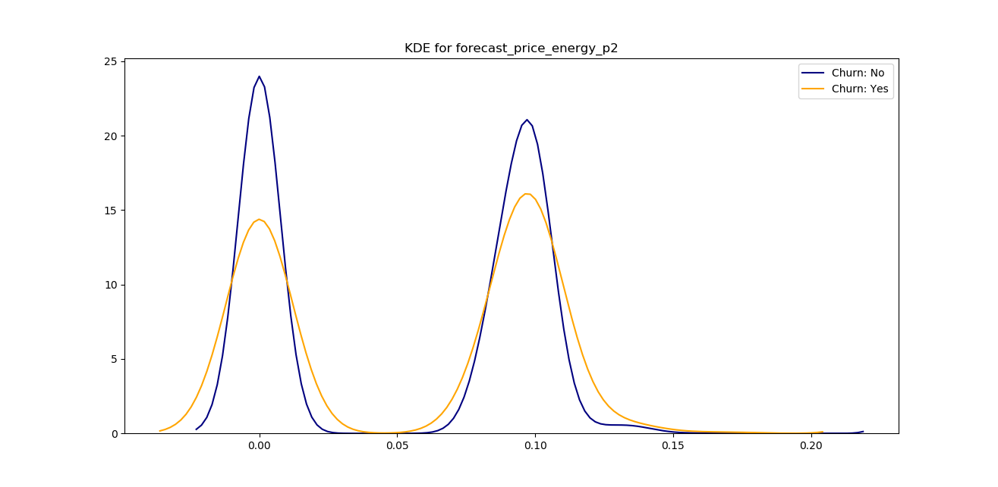
KDE for forecast_price_energy_p2

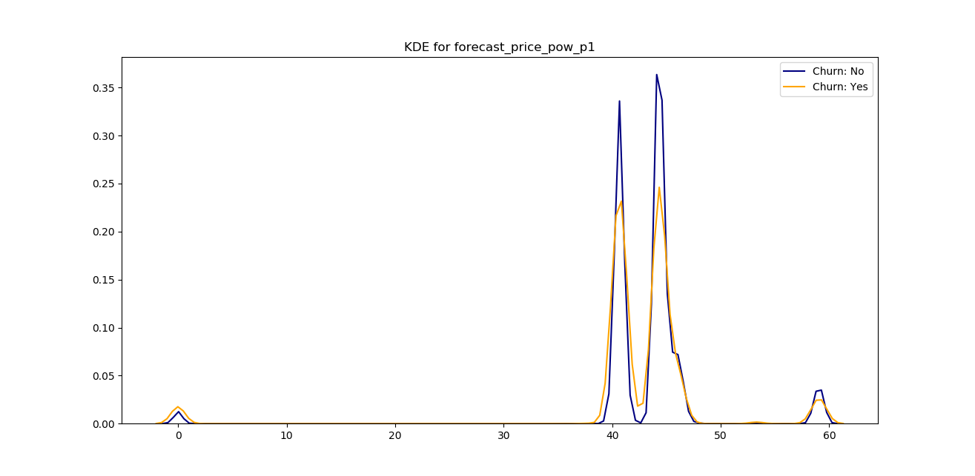
KDE for forecast_price_low_p1

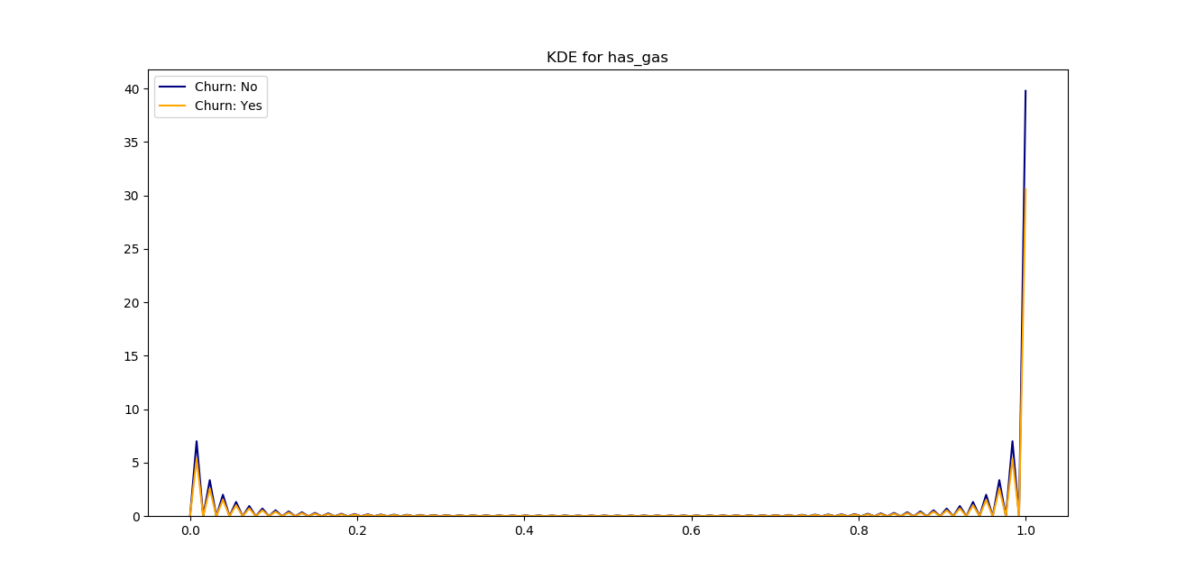
KDE for has_gas

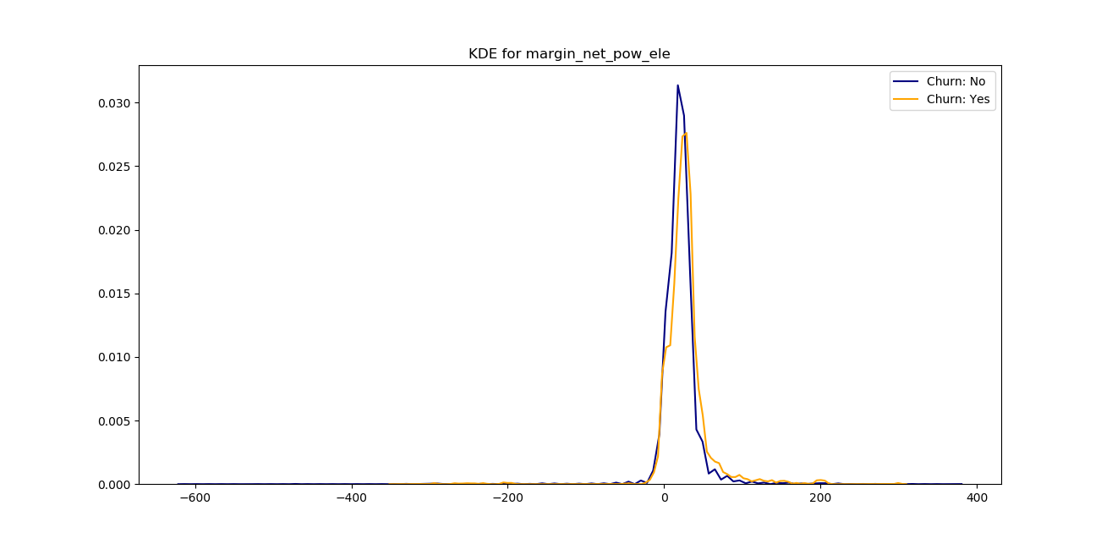
KDE for margin_new_pow_ele

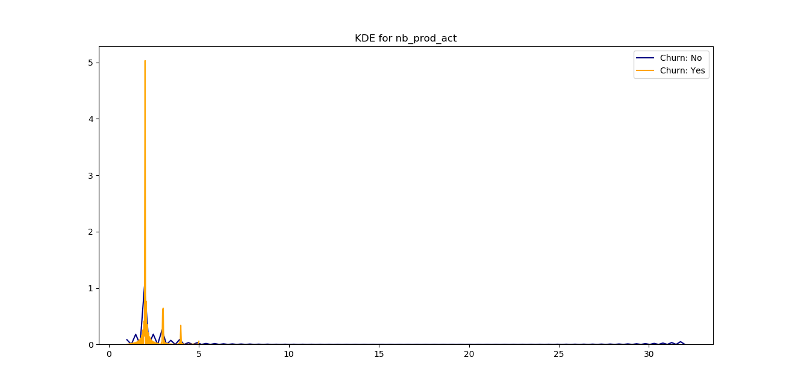

KDE for nb_prod_act

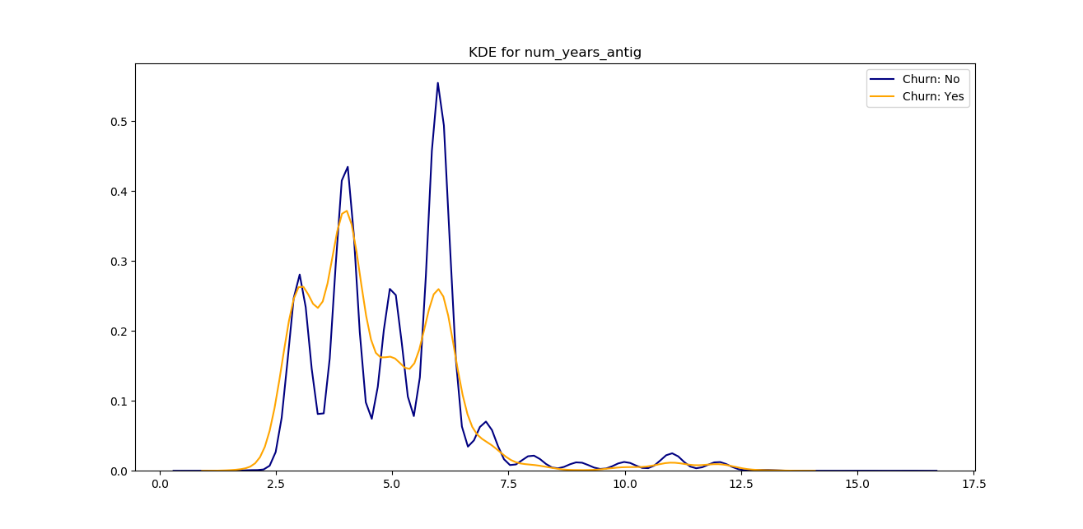
KDE for num_year_antig

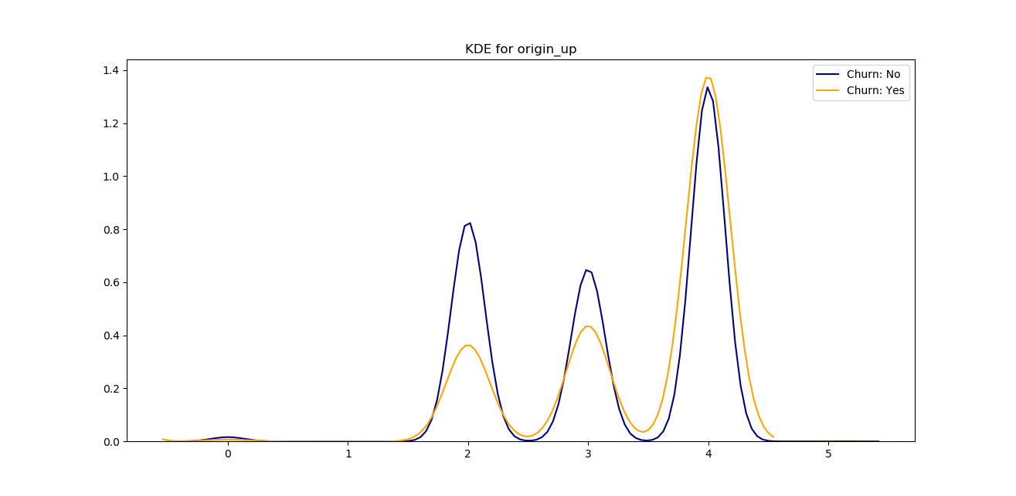
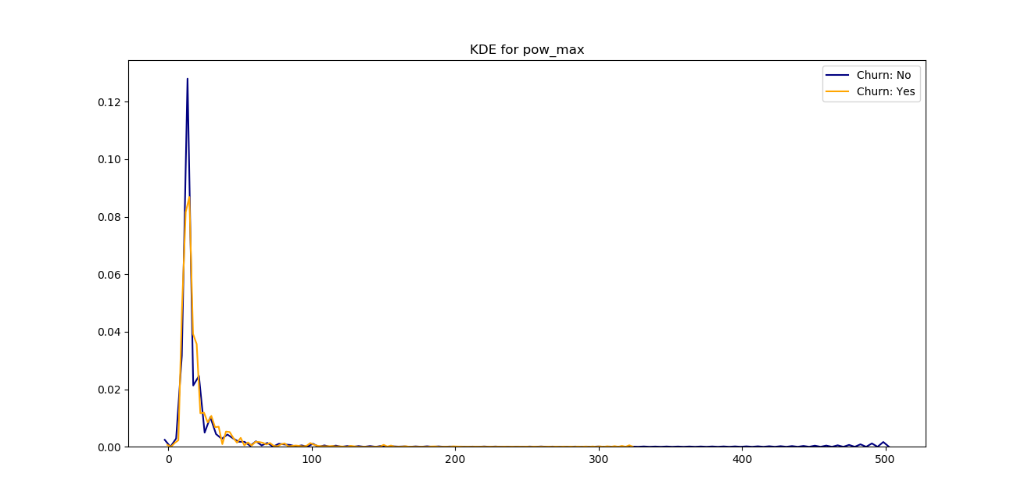
KDE for origin_up

KDE for pow_max
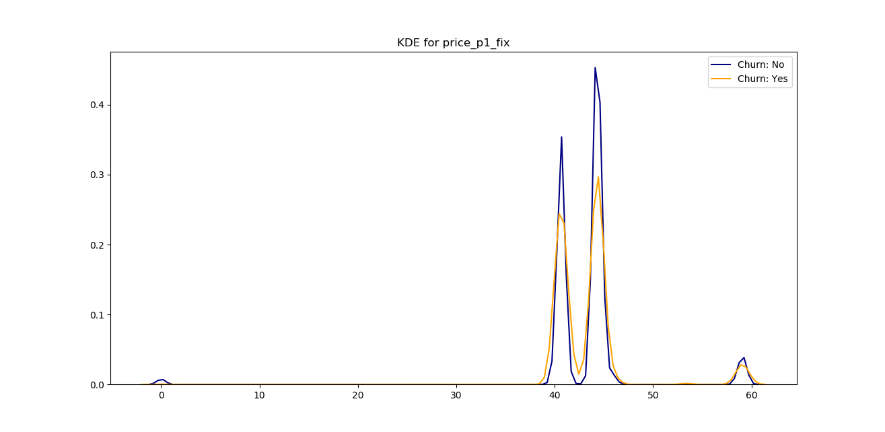
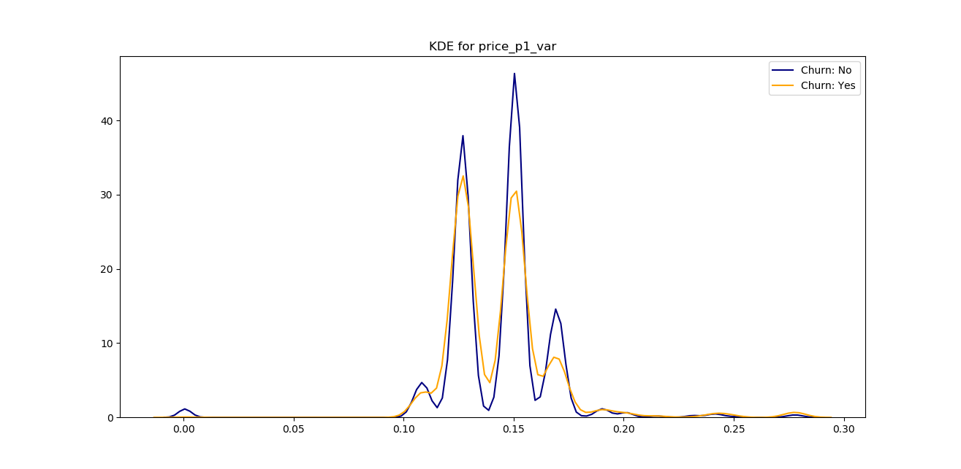
KDE for price_p1_fix

KDE for Price_p1_var

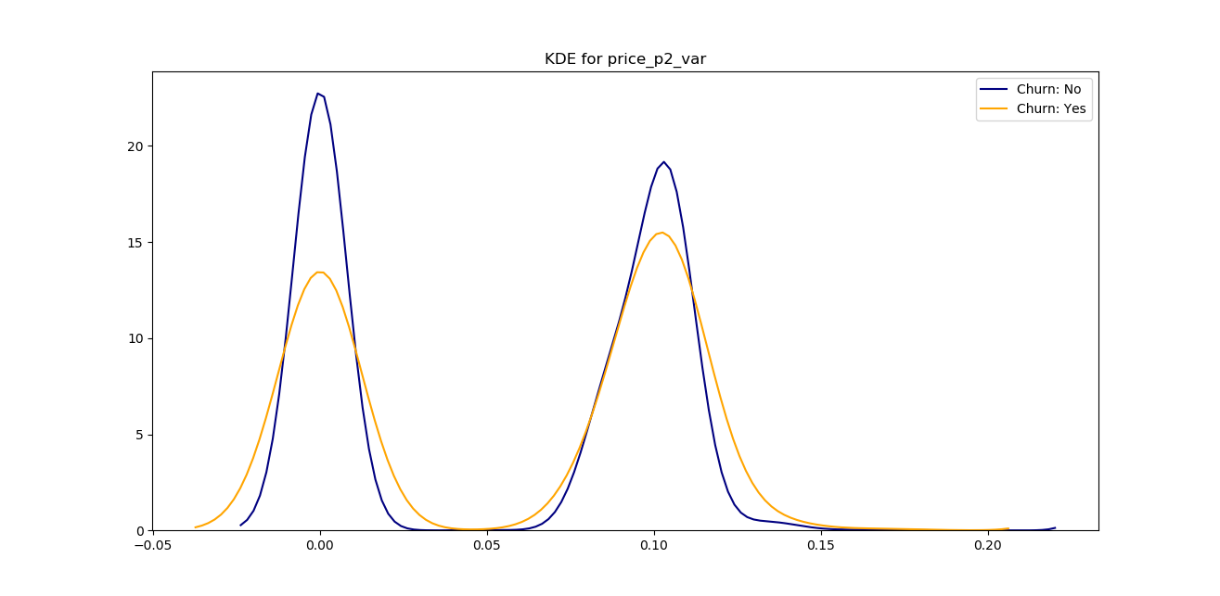
KDE for price_p2_var

