**Task 1 Report**

* **Task – 1 : Responsive Company Member Team Page-**
* **Project Description:**

Your first project task is to develop a responsive web page for the Company Member Team Page. The design reference is provided in the attached file named "designed-1." Utilize HTML and CSS to bring this design to life, ensuring responsiveness across various devices. This project allows you to showcase your coding skills and creativity while adhering to the design reference.

* **Project Details:**

• Design Reference: Please refer to "Designed-1" (attached the bellow) for the layout and styling inspiration.

• Development Tools: Use HTML and CSS for the implementation.

• Creativity: Feel free to add your creative touch and ideas while maintaining the overall design structure.

* **Project Timeline:**

• Start Date: May 20th, 2024.

• Deadline: May 23rd, 2024.

* **Steps Taken:**
* Created a folder given name is – Task1
* Opened Task1 folder in Code Editor like VS Code
* Created a HTML file which name is – index.HTML
* Created a CSS file which name is – styles.css
* Created Folder name is assets and inserted the images.
* Started Creating Web app using HTML, CSS
* Checked Code by clicking Run Button.
* On browser seen the Output.
* **Challenges Faced:**
  + defining the page size and making the content in center.
  + to place a team in one line.
  + creating a Flag symbol and its orientation.
* **Solution Implemented**

For defining page size and making content in center I used the following css in for this div tag

*display*: flex;

*flex-direction*: column;

*align-items*: center;

*justify-content*: center;

*width*: 100%;

*max-width*: 1000px;

*padding*: 20px;

*box-sizing*: border-box;

*border*: 1px solid;

*margin-top*: 10px;

to Place team in one Line I created html file like

        <div class="team">

            <div class="team-container">

                <div class="team-member">

                    <img src="assets/aiim.png" alt="Member 1">

                    <h3>Soft Tech</h3>

                    <p>Founder/ CEO</p>

                </div>

                <div class="team-member">

                    <img src="assets/aiim.png" alt="Member 1">

                    <h3>Soft Tech</h3>

                    <p>Founder/ CEO</p>

                </div>

            </div>

        </div>

applied css on make team in one line

.team {

*display*: flex;

*flex-direction*: row;

*align-items*: center;

*justify-content*: center;

*-ms-flex-order*: unset;

*padding* :10px;

}

.team-container {

*display*: flex;

*gap*: 40px;

*align-items*: center;

*justify-content*: center;

*flex-wrap*: wrap;

}

.team-member {

*text-align*: center;

*padding*: 10px;

}

.team-member img {

*width*: 150px;

*height*: 150px;

*border-radius*: 50%;

*flex-wrap*: wrap;

*justify-content*: center;

*object-fit*: cover;

*border*: 3px solid rgb(157, 7, 203);

*box-shadow*: 0 0 10px rgba(0, 0, 0, 0.2);

}

.team-member h3 {

*margin*: 10px 0 5px;

*font-size*: 18px;

}

.team-member p {

*margin*: 0;

*font-size*: 14px;

*color*: #666;

}

Creating flag symbol

        <br>

        <div class="team-header">

                <div class="bookmarkRibbon"></div>

                <div class="team-name">

                    <h3>Leadership/ Management Team</h3>

                </div>

        </div>

        <br>

.team-header{

*display*: flex;

*width*: 100%;

*align-items*: center;

*justify-content*: center;

*margin-bottom*: 20px;

*position*: relative;

}

.team-name{

*padding-left*:20px;

*padding-right*:20px;

*background-color*: rgb(195, 99, 224);

*align-items*: center;

*justify-content*: center;

*border*: 1px solid rgb(157, 7, 203);

*border-radius*: 10px;

}

.bookmarkRibbon {

*position*: absolute;

*left*: 0;

*top*: 50%;

*transform*: translateY(-50%);

*width*: 80px;

*height*: 70px;

*background*: rgb(195, 99, 224);

*border*: 1px solid rgb(157, 7, 203);

*clip-path*: polygon(0% 0%, 100% 0%, calc(100% - 20px) 50%, 100% 100%, 0% 100%);

  }

* **Output :**

Visit this Website to see the Output- <https://employee-teamlist.netlify.app/>

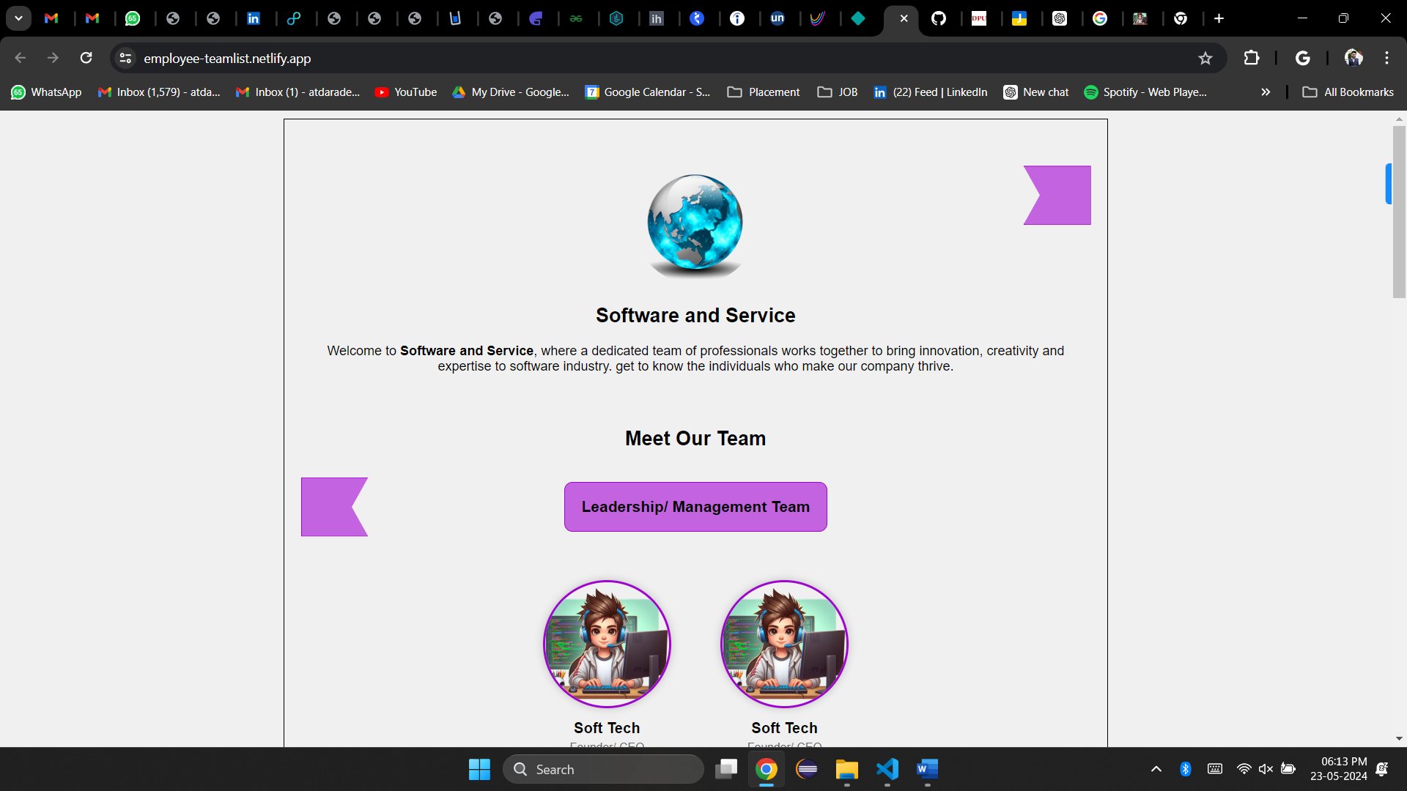

* **Learnings:**

How to use the html tags.

how to make alignment in inner tags.

how set content position in anywhere in tag.

how to make objects in HTML using CSS.

how to make responsive web page for any device size support.

* **Task1 Planning and Progress Structure:**

|  |  |  |  |
| --- | --- | --- | --- |
| **Task- 1 Planning and Progress Report** | | | |
| **Sr. No.** | **Activity** | **Status** | **Due** |
| 1 | Task assigned +start building project | **On Track** | 20/05/2024 |
| 2 | Create a Page a mention | **On Track** | 21/05/2024 |
| 3 | Finishing the Project | **On Track** | 22/05/0204 |
| 4 | Submitting the Project | **On Track** | 23/05/2023 |