**Task 4 Report**

* **Task – 4 : OTT Platform Website Clone.**
* **Project Description:**

Task 4 - OTT Platform Website Clone! In this project, you'll be challenged to recreate the design and functionality of any OTT (Over-The-Top) platform website like Netflix, Amazon Prime, Zee 5, etc. using HTML, CSS, and JavaScript. This task aims to test your skills infront-end development and user interface design

* **Project Details:**

• HTML: Structure your web pages.

• CSS: Style your website for a visually appealing look.

• JavaScript: Add dynamic and interactive functionalities

1. Homepage:

Recreate the layout and design of the OTT platform's homepage.

Include sectionssuch astrending movies, series, and recommended content.

1. Content Details Page:

Design a page that displays detailed information about a movie orseries when clicked.

1. Search Functionality:

Implement a search feature that allows usersto find content easily.

1. User Authentication (Optional):

If you're up for an extra challenge, include user authentication functionality.

* **Project Timeline:**

• Start Date: June 9th, 2024.

• Deadline: June 17th, 2024.

* **Steps Taken:**
* Created a folder given name is – Task4
* Opened Task4 folder in Code Editor like VS Code
* Created a HTML file which name is – index.HTML
* Created a CSS file which name is – styles.css
* Inserted the image for logo
* Started Creating Web app using HTML, CSS, JavaScript
* Checked Code by clicking Run Button.
* On browser seen the Output.
* **Challenges Faced:**
  + Create a Image Tag
  + Js File to show poster of movies
* **Solution Implemented**

Create a HTML Tag

    <header>

        <nav>

            <div class="nav-container">

                <button class="nav-toggle" aria-label="toggle navigation">

                    <span class="hamburger"></span>

                </button>

                <div class="logo">

                    <img src="./assets/image.png" alt="logo">

                </div>

                <ul class="nav-links">

                    <li class="nav-item"><a href="#">Home</a></li>

                    <li class="nav-item"><a href="#">Movies</a></li>

                    <li class="nav-item"><a href="#">TV Shows</a></li>

                    <li class="nav-item"><a href="#">My List</a></li>

                    <li class="nav-item auth-buttons">

                        <button id="login" class="auth-button">Login</button>

                        <button id="signup" class="auth-button">Sign Up</button>

                    </li>

                </ul>

            </div>

        </nav>

    </header>

    <main>

        <section class="hero">

            <h1>Welcome to OTT Clone</h1>

            <p>Stream your favorite movies and TV shows</p>

        </section>

        <section class="content">

            <!-- Dynamic content like movies/series will go here -->

        </section>

        <section>

Script for Display images

document.addEventListener("DOMContentLoaded", () *=>* {

    loadContent();

    // Event listeners for authentication buttons

    document.getElementById('login').addEventListener('click', showLoginForm);

    // document.getElementById('signup').addEventListener('click', showSignupForm);

    // Event listener for nav toggle

*const* navToggle = document.querySelector('.nav-toggle');

*const* navLinks = document.querySelector('.nav-links');

    navToggle.addEventListener('click', () *=>* {

        navLinks.classList.toggle('active');

    });

});

*function* loadContent() {

    fetch('assets/movie.json')

        .then(*response* *=>* *response*.json())

        .then(*data* *=>* {

*const* contentSection = document.querySelector('.content');

            contentSection.innerHTML = '';

*data*.forEach(*item* *=>* {

*const* movieCard = document.createElement('div');

                movieCard.classList.add('movie-card');

                movieCard.innerHTML = `

                    <img src="${*item*.image}" alt="${*item*.title}">

                    <h3>${*item*.title}</h3>

                    <p>${*item*.description}</p>

                `;

                contentSection.appendChild(movieCard);

            });

        })

        .catch(*error* *=>* console.error('Error fetching data:', *error*));

}

*function* showLoginForm() {

*const* modal = document.getElementById('loginModal');

    modal.style.display = 'block';

*const* closeBtn = modal.querySelector('.close');

    closeBtn.onclick = () *=>* {

        modal.style.display = 'none';

    };

    window.onclick = (*event*) *=>* {

        if (*event*.target == modal) {

            modal.style.display = 'none';

        }

    };

}

* **Output :**

Visit this Website to see the Output- <https://ott-platfom.netlify.app/>

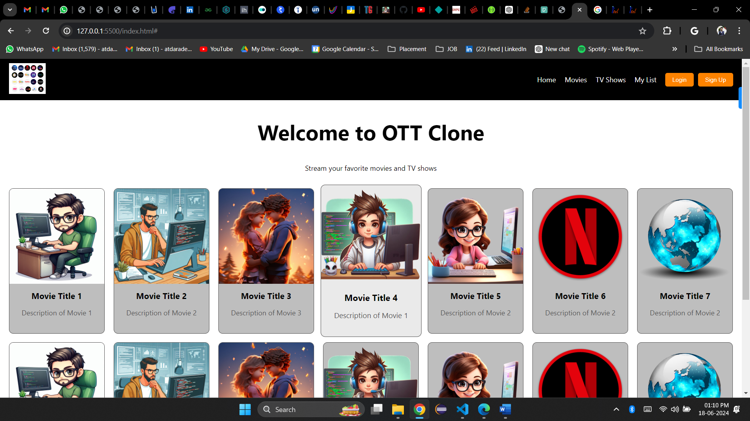

* **Learnings:**

How to make objects in HTML using CSS and JavaScript.

How to call Json data in html.

* **Task4 Planning and Progress Structure:**

|  |  |  |  |
| --- | --- | --- | --- |
| **Task- 4 Planning and Progress Report** | | | |
| **Sr. No.** | **Activity** | **Status** | **Due** |
| 1 | Task assigned | **On Track** | 09/06/2024 |
| 2 | Create a folder and files and thinking topic | **On Track** | 10/06/2024 |
| 3 | Create a HTML Page | **On Track** | 11/06/2024 |
| 4 | Apply CSS for HTML page | **On Track** | 12/06/2024 |
| 5 | Tages inserts | **On Track** | 13/06/2024 |
| 6 | Function Building and Implementation | **On Track** | 14/06/2024 |
| 7 | Checking and testing | **On Track** | 15/06/2024 |
| 8 | Adding social Links | **On Track** | 16/06/2024 |
| 9 | Git Upload and Submission | **On Track** | 17/06/2024 |