**Task 2 Report**

* **Task – 2 : Landing Page -**
* **Project Description:**

Your second project task involves creating a compelling Landing Page. The goal is to choose a design and theme that resonates with you, and develop a landing page for an event or launch. This could be related to a car launch, product unveiling, course introduction, university promotion, or any other topic of your choice.

* **Project Details:**
  + Choose a design and theme that aligns with the concept of your landing page.
  + Ensure that the design is visually appealing and complements the purpose of the landing page
  + Include relevant content such as an introduction, features, and a call-to-action.
  + Use engaging visuals and appropriate multimedia elements.
* **Project Timeline:**

• Start Date: May 24th, 2024.

• Deadline: May 30th, 2024.

* **Steps Taken:**
* Created a folder given name is – Task2
* Opened Task2 folder in Code Editor like VS Code
* Created a HTML file which name is – index.HTML
* Created a CSS file which name is – styles.css
* Created a JavaScript File name is – script.js
* Created Folder name is assets and inserted the images.
* Started Creating Web app using HTML, CSS, JavaScript
* Checked Code by clicking Run Button.
* On browser seen the Output.
* **Challenges Faced:**
  + Using Bootstrap CSS.
  + Getting Map in HTML
  + Join two containers in one div
  + Set a Timmer counter
  + Responsive page
* **Solution Implemented**

Uses of Bootstrap CSS in html file imported using ling tag

    <link href="https://cdnjs.cloudflare.com/ajax/libs/themify-icons/0.1.2/css/themify-icons.css" rel="stylesheet">

    <link href="https://cdnjs.cloudflare.com/ajax/libs/flaticon/2.1.0/css/flaticon.css" rel="stylesheet">

    <!-- Latest compiled and minified CSS -->

<link rel="stylesheet" href="https://maxcdn.bootstrapcdn.com/bootstrap/3.3.7/css/bootstrap.min.css" integrity="sha384-BVYiiSIFeK1dGmJRAkycuHAHRg32OmUcww7on3RYdg4Va+PmSTsz/K68vbdEjh4u" crossorigin="anonymous">

<!-- Optional theme -->

<link rel="stylesheet" href="https://maxcdn.bootstrapcdn.com/bootstrap/3.3.7/css/bootstrap-theme.min.css" integrity="sha384-rHyoN1iRsVXV4nD0JutlnGaslCJuC7uwjduW9SVrLvRYooPp2bWYgmgJQIXwl/Sp" crossorigin="anonymous">

    <link href="https://cdnjs.cloudflare.com/ajax/libs/animate.css/4.1.1/animate.min.css" rel="stylesheet">

    <link href="https://cdnjs.cloudflare.com/ajax/libs/owl-carousel/1.3.3/owl.carousel.min.css" rel="stylesheet">

    <link href="https://cdnjs.cloudflare.com/ajax/libs/owl-carousel/1.3.3/owl.theme.min.css" rel="stylesheet">

    <link href="https://cdnjs.cloudflare.com/ajax/libs/slick-carousel/1.8.1/slick.min.css" rel="stylesheet">

    <link href="https://cdnjs.cloudflare.com/ajax/libs/slick-carousel/1.8.1/slick-theme.min.css" rel="stylesheet">

    <link href="https://cdnjs.cloudflare.com/ajax/libs/Swiper/5.4.5/css/swiper.min.css" rel="stylesheet">

    <link href="https://cdnjs.cloudflare.com/ajax/libs/OwlCarousel2/2.3.4/assets/owl.transitions.min.css" rel="stylesheet">

    <link href="https://cdnjs.cloudflare.com/ajax/libs/fancybox/3.5.7/jquery.fancybox.min.css" rel="stylesheet">

    <link href="https://cdnjs.cloudflare.com/ajax/libs/magnific-popup.js/1.1.0/magnific-popup.min.css" rel="stylesheet">

    <link rel="stylesheet" href="https://fonts.googleapis.com/icon?family=Material+Icons">

    <link rel="stylesheet" href="https://cdnjs.cloudflare.com/ajax/libs/font-awesome/4.7.0/css/font-awesome.min.css">

    <link rel="stylesheet" href="https://cdn.jsdelivr.net/npm/@icon/themify-icons@1.0.1-alpha.3/themify-icons.min.css">

Getting Map in HTML

<iframe src="https://www.google.com/maps/embed?pb=!1m18!1m12!1m3!1d3755.5671753472375!2d74.12887891470845!3d19.731043186715464!2m3!1f0!2f0!3f0!3m2!1i1024!2i768!4f13.1!3m3!1m2!1s0x3bddadfc6df0c125%3A0x8db15979f7f45100!2sISHWAR%20RATNA%20LAWNS!5e0!3m2!1sen!2sin!4v1672914693304!5m2!1sen!2sin" width="300" height="200" style="border:0;" allowfullscreen="" loading="lazy"

          referrerpolicy="no-referrer-when-downgrade"></iframe>

Join two containers in one div

.wedding-location-section {

*padding-bottom*: 0px;

}

.wedding-location-section .location-grids {

*margin*: 0 -15px;

}

.wedding-location-section .location-grids .grid {

*width*: calc(50% - 30px);

*float*: left;

*margin*: 0 15px 50px;

*position*: relative;

}

Set a Timmer counter

 <div id="clock">

                                <div class="box">

                                    <div>

                                        <div class="time" id="days"></div> <span>Days</span>

                                    </div>

                                </div>

                                <div class="box">

                                    <div>

                                        <div class="time" id="hours"></div> <span>Hours</span>

                                    </div>

                                </div>

                                <div class="box">

                                    <div>

                                        <div class="time" id="minutes"></div> <span>Minutes</span>

                                    </div>

                                </div>

                                <div class="box">

                                    <div>

                                        <div class="time" id="seconds"></div> <span>Seconds</span>

                                    </div>

                                </div>

                            </div>

  // Set the date we're counting down to script code

*var* countDownDate = new *Date*("July 27, 2024 00:00:00").getTime();

// Update the count down every 1 second

*var* x = setInterval(*function*() {

        // Get the current date and time

*var* now = new *Date*().getTime();

        // Calculate the distance between now and the count down date

*var* distance = countDownDate - now;

        // Calculate days, hours, minutes and seconds remaining

*var* days = Math.floor(distance / (1000 * 60 * 60 * 24));

*var* hours = Math.floor((distance % (1000 * 60 * 60 * 24)) / (1000 * 60 * 60));

*var* minutes = Math.floor((distance % (1000 * 60 * 60)) / (1000 * 60));

*var* seconds = Math.floor((distance % (1000 * 60)) / 1000);

        // Display the result in the elements with class="box"

        document.getElementById("days").innerHTML = days;

        document.getElementById("hours").innerHTML = hours;

        document.getElementById("minutes").innerHTML = minutes;

        document.getElementById("seconds").innerHTML = seconds;

        // If the count down is finished, display some text

        if (distance < 0) {

            clearInterval(x);

            document.getElementById("clock").innerHTML = "EXPIRED";

        }

    }, 1000);

Toggle Button Function

    $(document).ready(*function*() {

        // Toggle mobile navigation

*function* toggleMobileNavigation() {

*var* navbar = $(".navigation-holder");

*var* openBtn = $(".navbar-header .open-btn");

*var* closeBtn = $(".navigation-holder .close-navbar");

*var* body = $(".page-wrapper");

            openBtn.on("click", *function*() {

                if (!navbar.hasClass("slideInn")) {

                    navbar.addClass("slideInn");

                    body.addClass("body-overlay");

                }

                return false;

            });

            closeBtn.on("click", *function*() {

                if (navbar.hasClass("slideInn")) {

                    navbar.removeClass("slideInn");

                }

                body.removeClass("body-overlay");

                return false;

            });

            // Close navigation on list item click

            $("#navbar > ul > li > a[href^='#']").on("click", *function*() {

                if (navbar.hasClass("slideInn")) {

                    navbar.removeClass("slideInn");

                    body.removeClass("body-overlay");

                }

            });

        }

        toggleMobileNavigation();

    });

* **Output :**

Visit this Website to see the Output- <https://employee-teamlist.netlify.app/>

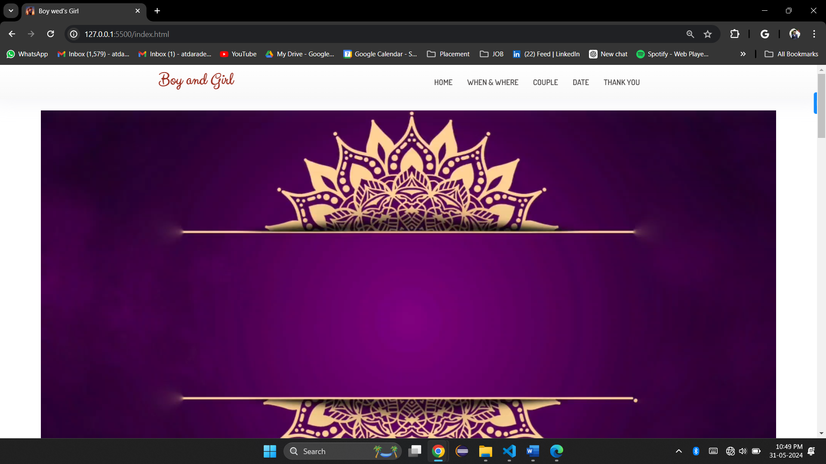

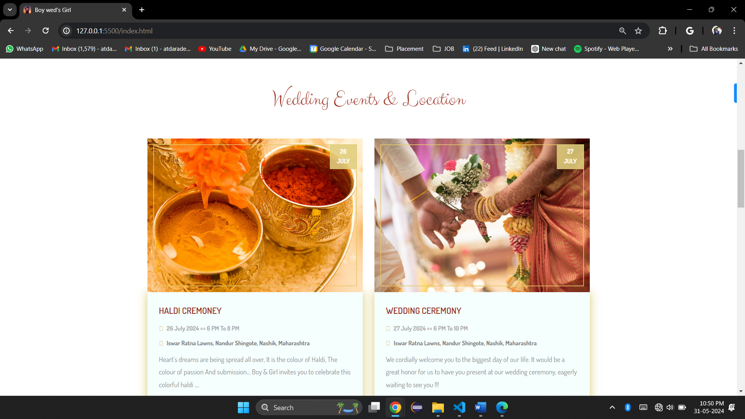

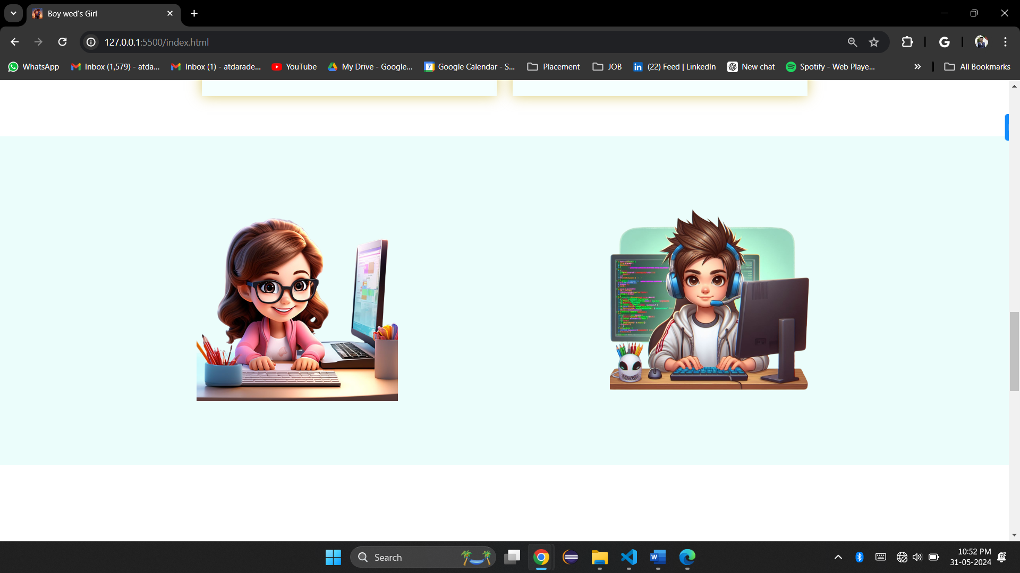

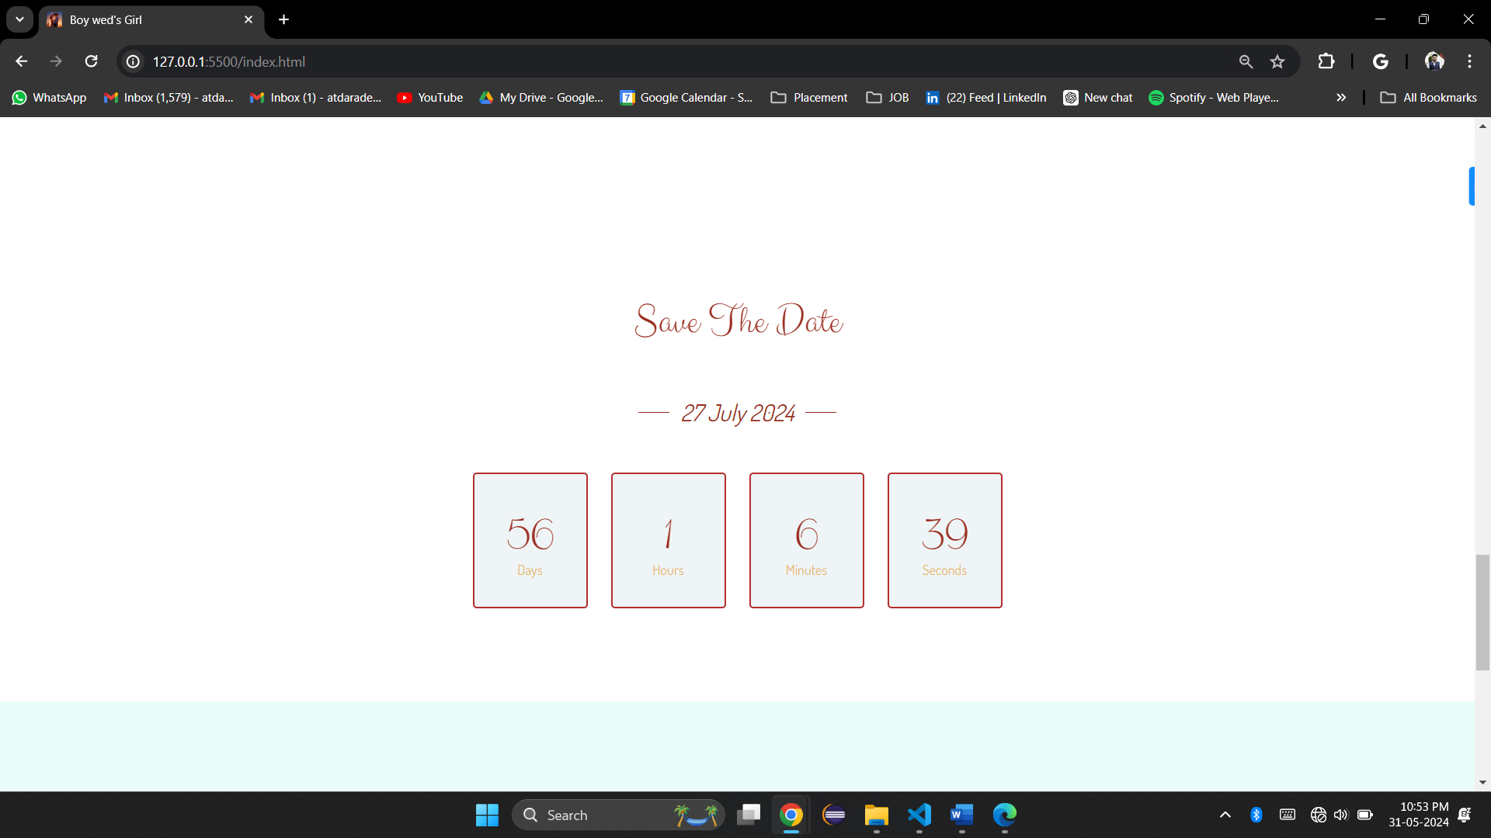

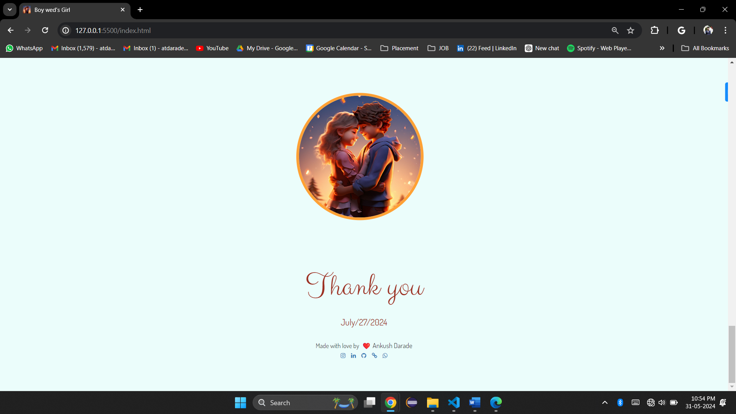

* **Learnings:**

How to use the html tags.

how to make alignment in inner tags.

how set content position in anywhere in tag.

how to make objects in HTML using CSS.

how to make responsive web page for any device size support.

how to add Counter Timmer in HTML.

how to add maps in html.

how to use toggle button.

* **Task2 Planning and Progress Structure:**

|  |  |  |  |
| --- | --- | --- | --- |
| **Task- 2 Planning and Progress Report** | | | |
| **Sr. No.** | **Activity** | **Status** | **Due** |
| 1 | Task assigned | **On Track** | 24/05/2024 |
| 2 | Create a folder and files and thinking topic | **On Track** | 25/05/2024 |
| 3 | Create a couple window for marriage | **On Track** | 26/05/2024 |
| 4 | Create a Timmer Counter for count the date | **On Track** | 27/05/2024 |
| 5 | Create location and details in one div | **Delayed** | 28/05/2024 |
| 6 | Adding maps in location | **On Track** | 29/05/2024 |
| 7 | Creating Navbar for navigation | **Delayed** | 30/05/2024 |
| 8 | Git Upload and Submission | **On Track** | 31/05/2024 |
|  |  |  |  |