**ASSIGNMENT-1**

1. Create a new folder called Shopping

2. Initialize a new git repo inside of the Shopping folder (make sure you're not already inside of a Git repo!)

Make a new file called yard.txt

Make another new file called groceries.txt

3. Make a commit that includes both empty files. The message should be "create yard and groceries lists"

4. In the yard.txt file, add the following changes:

- 2 bags of potting soil

- 1 bag of worm castings

5. In the groceries.txt file, add the following:

- 4 tomatoes

- 6 shallots

- 1 fennel bulb

6. Make a new commit, including **ONLY the changes from the groceries.txt file.** The commit message should be "add ingredients for tomato soup"

7. Make a second commit including **ONLY the changes to the yard.txt file.** It should have the commit message "add items needed for garden box"

8. Next up, add the following line to the end of groceries.txt

- couple of seed potatos

9. In the yard.txt file, change the first line so that it says "**3** bags of potting soil" instead of "2 bags of potting soil"

- 3 bags of potting soil

- 1 bag of worm castings

10. **Make a commit that includes the changes to BOTH files.** The message should read "add items needed to grow potatoes"

**ASSIGNMENT -1 ANSWERS**

1.Create a new folder called Shopping

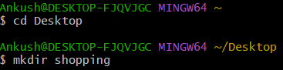

$ mkdir shopping

2. Initialize a new git repo inside of the Shopping folder (make sure you're not already inside of a Git repo!)

Make a new file called yard.txt

Make another new file called groceries.txt

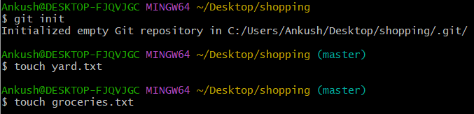

$ git init

$ touch yard.txt

$ touch groceries.txt

3.Make a commit that includes both empty files. The message should be "create yard and groceries lists"

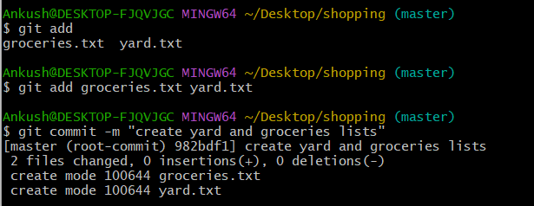

$ git add groceries.txt yard.txt

$ git commit -m "create yard and groceries lists"

4. In the yard.txt file, add the following changes:

- 2 bags of potting soil

- 1 bag of worm castings

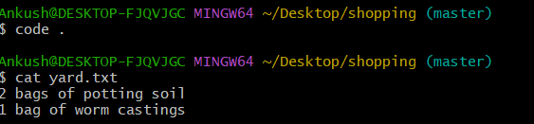

5. In the groceries.txt file, add the following:

- 4 tomatoes

- 6 shallots

- 1 fennel bulb

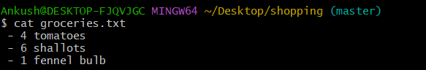

6. Make a new commit, including **ONLY the changes from the groceries.txt file.** The commit message should be "add ingredients for tomato soup"

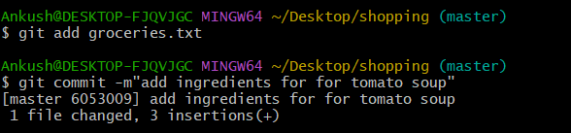

$ git add groceries.txt

$ git commit -m"add ingredients for for tomato soup"

7. Make a second commit including **ONLY the changes to the yard.txt file.** It should have the commit message "add items needed for garden box"

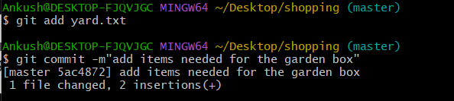

$ git add yard.txt

$ git commit -m"add items needed for the garden box"

8. Next up, add the following line to the end of groceries.txt

- couple of seed potatos

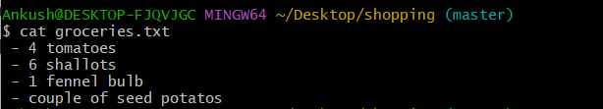

9. In the yard.txt file, change the first line so that it says "**3** bags of potting soil" instead of "2 bags of potting soil"

- 3 bags of potting soil

- 1 bag of worm castings

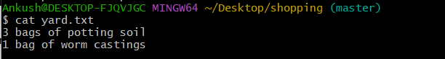

10. **Make a commit that includes the changes to BOTH files.** The message should read "add items needed to grow potatoes"

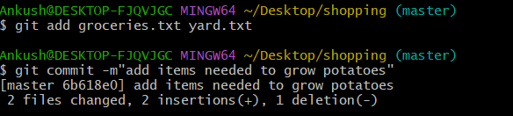

$ git add groceries.txt yard.txt

$ git commit -m"add items needed to grow potatoes"