LOCAL LLM IMPLEMENTATION PLAN

Developer Productivity, Code RAG, and Microsoft Teams Support
Laptop-first proof of concept using Ollama, Continue, NVIDIA OpenShell, and OpenCode

Version 1.0 | July 29, 2026

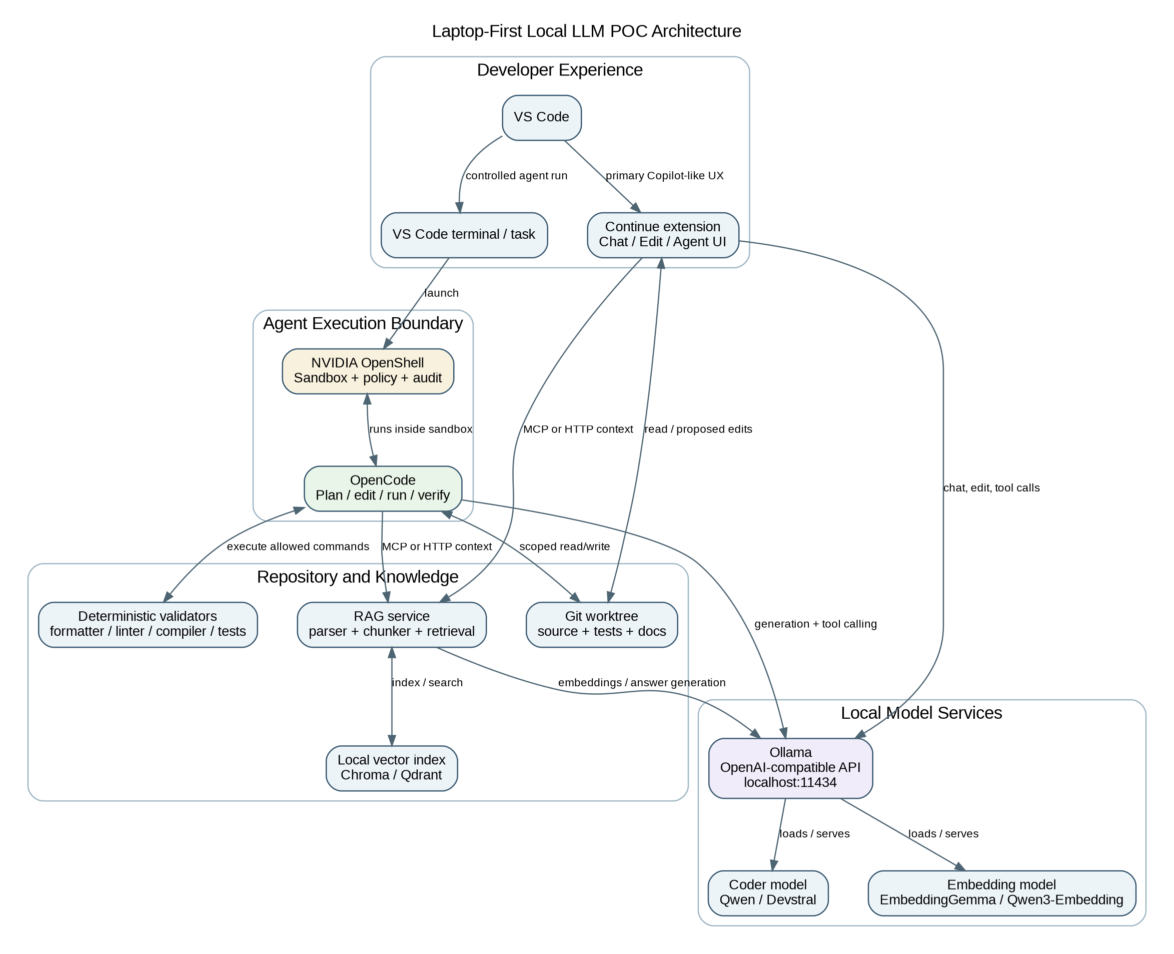
Authoritative architecture: Continue and OpenCode are parallel clients; OpenShell is the execution sandbox; Ollama is the model server.

Executive Recommendation
Recommended topology
Use Continue as the primary Copilot-like VS Code experience. Use OpenCode for longer autonomous tasks and run it inside NVIDIA OpenShell. Continue and OpenCode call Ollama directly and share the repository and RAG service. Do not chain Continue into OpenCode for the first POC.

Ollama is the local model server. Continue is the in-IDE chat/edit/agent client. OpenCode is a terminal coding agent. NVIDIA OpenShell is the sandbox, policy, and audit boundary for command-executing agents; it is not a reasoning engine or model.
The fastest credible path is prompting, repository rules, deterministic validators, and RAG first. Fine-tune only when the baseline reveals a repeatable behavior gap that RAG or tools cannot solve.
Because the laptop specification includes 64 GB of system RAM but not GPU VRAM, the plan includes hardware branches. A 14B coder is the safe baseline. Qwen3-Coder 30B-A3B or Devstral Small 2 24B becomes the preferred agentic comparison when the laptop has about 24 GB VRAM; otherwise use AWS G6e or a similar approved 48 GB GPU instance.

Document Map
1. Objectives and scope
2. How the four tools communicate
3. Target operating model
4. Laptop and AWS hardware plan
5. Model selection
6. Phased implementation
7. Use-case test plan
8. RAG design
9. Microsoft Teams support
10. Training and adaptation
11. Artifactory supply chain
12. Configuration examples
13. Developer adoption
14. Security and governance
15. Go/no-go criteria

1. Objectives and Scope
The POC evaluates local/open-weight LLM support for eight developer and support use cases while preserving human control, deterministic validation, and enterprise security boundaries.
1. Code formatting and lint fixes
2. Test scaffolding and basic test generation
3. Code summarization (advisory only)
4. Mechanical refactoring (rename, split, and reorganization)
5. Bug-fix suggestions validated before use
6. Documentation and code comments
7. Boilerplate and template generation
8. RAG-based Q&A over code and support knowledge, including Microsoft Teams

Non-goals for the first POC
- Autonomous merging or production deployment.
- Full pretraining or continued pretraining over the enterprise code estate.
- Direct production exposure of a developer laptop to Microsoft Teams or the public internet.
- Immediate replacement of GitHub Copilot without measured quality, latency, trust, and workflow evidence.

2. How the Four Tools Communicate
Tool | Primary role | Calls / is called by | POC boundary
Ollama | Local inference server for chat, code, tool calls, and embeddings | Called directly by Continue, OpenCode, and the RAG service | Bind to localhost for laptop POC; approved private endpoint for shared use
Continue | VS Code chat/edit/agent experience | Calls Ollama and optional RAG/MCP tools | Primary engineer-facing UI; advisory and bounded edits first
OpenCode | Terminal coding agent for plan/edit/run/verify loops | Calls Ollama and local tools; shares worktree and RAG | Run inside OpenShell for write/execute tasks
NVIDIA OpenShell | Sandbox, filesystem/network/process policy, audit | Hosts OpenCode or another agent process | Default-deny; scoped worktree; explicit inference and package endpoints

2.1 Continue flow
1. Engineer asks a question or requests an edit in Continue.
2. Continue gathers selected code, open files, repository rules, and optional RAG context.
3. Continue sends the request directly to Ollama.
4. Ollama returns text, patch content, or tool calls supported by the model/provider.
5. Continue presents the answer or proposed diff. The engineer approves and runs deterministic checks.

2.2 OpenCode inside OpenShell
1. Engineer launches an OpenCode Plan or Build task from the VS Code terminal.
2. OpenCode runs inside an OpenShell sandbox with a disposable or isolated Git worktree.
3. OpenCode calls Ollama through the allowed endpoint.
4. OpenCode requests scoped read, grep, edit, formatter, compiler, and test tools.
5. OpenShell permits or blocks operations according to filesystem, process, and network policy and records decisions.
6. OpenCode iterates until validators pass or the configured step/error threshold is reached.
7. Engineer reviews the final diff and validation report before accepting changes.
Important architecture decision
Continue and OpenCode are both clients/orchestrators. Chaining them would duplicate planning, context, and permissions. Keep them parallel and connect them through the same Ollama endpoint, repository, RAG service, prompts, and evaluation standards.

2.3 RAG communication
Expose a code/support RAG service through MCP or authenticated HTTP. The service parses code by symbol, performs hybrid retrieval, filters by access metadata, and returns compact evidence with source identifiers. Continue, OpenCode, and the Teams support service can call the same retrieval API.

3. Target Operating Model
Work type | Preferred interface | Execution policy | Human control
Summaries, Q&A, documentation drafts | Continue Chat/Edit | Read-only or proposed diff | Review before apply
Formatting/lint | Continue Edit or OpenCode | Approved formatter/linter only | Auto-apply only after deterministic pass
Tests and mechanical refactors | OpenCode inside OpenShell | Scoped write and approved commands | Review diff and tests
Bug-fix suggestions | OpenCode Plan then Build | Reproducer and regression required | Never auto-merge
Teams support Q&A | Hosted Teams agent + RAG | Read-only knowledge access | Citations and abstention required

4. Laptop and AWS Hardware Plan
First hardware check
Run nvidia-smi. System RAM alone does not determine model speed or fit. Record GPU model, VRAM, driver, CUDA compatibility, storage, and whether Docker/WSL GPU passthrough is permitted.

4.1 Laptop branches
- No NVIDIA GPU or 8 GB VRAM: 7B Q4 coder; possibly 14B with CPU offload, but do not judge agent UX on multi-minute turns.
- 12-16 GB VRAM: 14B Q4 as primary baseline; 24B/30B only as an offload experiment.
- 24 GB VRAM: Qwen3-Coder 30B-A3B and Devstral Small 2 24B become practical primary candidates.
- 48 GB+ VRAM: higher precision 24B/30B inference and larger QLoRA experiments.

4.2 Recommended Windows layout
- Ollama native on Windows, initially bound to localhost.
- Continue in native VS Code.
- OpenShell in WSL 2 + Docker Desktop; Windows support is currently experimental, so retain a Linux EC2 fallback.
- OpenCode inside the OpenShell sandbox.
- Encrypted local workspace and vector index excluded from Git.

4.3 AWS escalation path
AWS tier | Typical GPU memory | Use in this plan
G5/G6 | 24 GB per GPU | 7B/14B tuning and inference; entry agent tests
G6e | 48 GB L40S per GPU | Preferred single-GPU 24B/30B inference and QLoRA step
P4de | 80 GB A100 per GPU | 70B/80B-class experiments and larger fine-tunes
P5/P5e/P5en | H100/H200 multi-GPU | Large-scale comparison and frontier open-weight evaluation

5. Model Selection Strategy
Select models using internal golden tasks under identical prompts, context budgets, quantization, and hardware. Public benchmarks are screening signals, not acceptance evidence.
Candidate | Approx. runtime memory* | Practical target | Best POC use | Notes
Qwen2.5-Coder 7B Instruct (Q4) | ~5-7 GB | CPU or 8 GB VRAM | Formatting, docs, boilerplate, small refactors | Fast baseline; weaker long-horizon agent behavior
Qwen2.5-Coder 14B Instruct (Q4) | ~9-12 GB | 12-16 GB VRAM preferred | Primary low-risk POC baseline | Good balance when GPU is unknown or modest
Qwen3-Coder 30B-A3B (Q4) | ~19-24 GB | 24 GB VRAM ideal; 64 GB RAM offload possible | Agentic coding, repo navigation, multi-file work | 30B total weights even though ~3.3B are active
Devstral Small 2 24B (Q4/FP8) | ~16-24 GB | 24 GB VRAM preferred | Tool use, multi-file editing, coding agents | Strong second candidate; Apache 2.0
Qwen3 8B Instruct (Q4) | ~6-8 GB | 8 GB VRAM or CPU | Documentation, summaries, support answers | Use as a fast non-coding/general model
EmbeddingGemma or Qwen3-Embedding | <2-5 GB | CPU/GPU | RAG embeddings | Benchmark on internal vocabulary; do not assume one embedding model wins
Qwen3-Coder-Next 80B (Q4) | ~50-60 GB | 48-80 GB GPU; not a comfortable laptop target | Higher-end agentic coding | 80B total weights despite only ~3B active
Devstral 2 123B / Mistral Medium 3.5 128B | ~75-100+ GB | 80 GB+ GPU or multi-GPU | Production-quality agent comparison | Cloud/EC2 evaluation only; verify license terms
Qwen3-Coder 480B-A35B | ~280-330+ GB | Multi-GPU H100/H200 class | Frontier open-weight comparison | Not a laptop or single-GPU POC model

* Planning estimate only. Context KV cache, concurrent requests, backend, and quantization implementation add memory.

5.1 First model comparison
- Baseline A: Qwen2.5-Coder 14B Instruct Q4.
- Baseline B: Qwen3-Coder 30B-A3B Q4 when 24 GB VRAM is available; otherwise run on G6e.
- Alternative B: Devstral Small 2 24B if procurement, license review, or model behavior favors it.
- Fast advisory/support model: Qwen3 8B or the winning coder model.
- Embedding candidates: EmbeddingGemma and Qwen3-Embedding; choose by internal retrieval recall and latency.

5.2 Approval card for every model
- Source and immutable revision
- License and commercial-use conditions
- Parameter count and architecture
- Tool-call and chat-template requirements
- Context and memory assumptions
- Quantization source and checksum
- Security/model-risk review
- Known limitations and approved use cases

6. Phased Implementation Plan
Phase | Typical duration | Deliverables | Exit gate
0. Governance and benchmark corpus | 3-5 days | Approved data boundary, package/model allowlist, 25-50 golden tasks per use case, secrets scan | No production code sent outside approved boundary
1. Runtime and developer UX | 3-5 days | Ollama, Continue, OpenCode, OpenShell smoke tests; two local models; baseline latency | Continue chat/edit and OpenCode plan/build both work
2. Low-risk use cases | 1 week | Formatting, summarization, docs, boilerplate experiments | At least two use cases meet initial gates
3. Agentic use cases | 1 week | Test scaffolding, refactoring, bug-fix suggestion harness inside OpenShell | No unauthorized writes/network; deterministic validation executes
4. RAG and Teams support | 1-2 weeks | Code/document index, citation-aware answers, Teams bot/agent pilot | Grounded-answer and abstention gates met
5. Model adaptation | 1-2 weeks | QLoRA/SFT experiment only if prompt+RAG baseline leaves a measurable gap | Fine-tuned model beats baseline on held-out tasks without regressions
6. Team pilot and decision | 1 week | 5-10 engineers, telemetry, feedback, operating playbook | Go/no-go based on quality, security, latency, and adoption

6.1 Phase 0 - Governance and benchmark corpus
- Define allowed repositories, branches, data classes, and use cases.
- Approve tools, models, package repositories, container images, and network routes.
- Create 25-50 golden tasks per use case and clean immutable repository snapshots.
- Create baseline prompts, validators, logging schema, and security tests before model selection.

6.2 Phase 1 - Runtime and smoke tests
- Test Ollama API, Continue, OpenCode, OpenShell restrictions, deterministic commands, and telemetry independently.
- Run end-to-end tasks only after each layer passes its own smoke test.
- Record latency, memory, tool-call conformance, and failures for two models.

6.3 Phase 2 - Low-risk use cases
- Formatting/lint, summaries, documentation, and boilerplate first.
- Use exact project commands, approved templates, and repository rules.
- Measure accepted-without-edit rate and time saved.

6.4 Phase 3 - Agentic use cases
- Run test generation, mechanical refactoring, and bug-fix suggestions inside isolated worktrees.
- Require Plan before Build, file-scope confirmation, step limits, changed-line limits, and deterministic validation.
- Stop on repeated failures or scope expansion.

6.5 Phase 4 - RAG and Teams
- Index one repository and one support knowledge collection first.
- Pass standalone RAG tests before building the Teams surface.
- Add access controls, citations, abstention, feedback, and escalation.

6.6 Phase 5 - Adaptation
- Fine-tune only for a documented recurring behavior gap.
- Compare the adapter against the unchanged prompt+RAG baseline on held-out data.
- Reject the adapter if it harms general coding, safety, or latency.

7. Detailed POC Test Plan
Use case | Test input | Required output | Core metrics | Initial control
1. Formatting and lint fixes | Dirty but compiling files with known formatter/linter violations | All target violations fixed; no new violations; semantic tests unchanged | lint-clean rate, new-issue count, diff size, runtime | Can auto-apply only after deterministic formatter/linter confirms
2. Test scaffolding and basic tests | Public APIs/functions with missing tests | Tests compile, pass, assert meaningful behavior, and follow framework conventions | compile rate, pass rate, coverage delta, mutation score, flaky rate | Human review required until quality is stable
3. Code summarization | Files/modules with a symbol and dependency checklist | Accurate purpose, inputs, outputs, side effects, risks, dependencies | claim accuracy, symbol coverage, unsupported-claim count | Advisory only; no repository changes
4. Mechanical refactoring | Rename/split/reorganization tasks with contract tests | Build and tests pass; APIs preserved; changes remain within requested scope | build rate, regression pass, AST scope adherence, diff churn | OpenShell sandbox plus explicit file allowlist
5. Bug-fix suggestions | Known bug with reproducer and hidden regression cases | Explains root cause, proposes minimal patch, passes reproducer and regression suite | reproducer pass, regression pass, patch precision, false-fix rate | Never auto-merge; validate before use
6. Documentation/comments | Stale or missing docs with API truth set | Technically accurate, useful, non-obvious, project style compliant | factual accuracy, doc build, stale-link count, reviewer acceptance | Low-risk auto-apply after doc checks
7. Boilerplate/templates | Approved templates and interface contracts | Generated files compile and match approved structure/security defaults | template conformity, build pass, security scan, manual edits required | Use retrieval of approved templates rather than model memory
8. Code/support RAG Q&A | Questions with known supporting passages and unanswerable controls | Correct answer with source citations or explicit abstention | retrieval recall@k, answer correctness, citation precision, abstention accuracy, latency | No uncited operational answer in Teams

7.1 Golden task design
- 25-50 tasks per use case per major language, stratified by difficulty.
- Negative cases where the correct action is no change or abstention.
- Hidden tests and contract checks for refactors and bug fixes.
- Prompt-injection and malicious repository content.
- Time/repository-separated holdout set that is not used for prompt iteration or training.

7.2 Initial acceptance thresholds
Use case | Starting gate
Formatting/lint | At least 95% target violations fixed; zero new violations; all relevant tests pass
Generated tests | 100% compile/pass; >=80% reviewer-rated meaningful; no flaky/network/time dependence
Summaries | >=90% claim accuracy; zero invented APIs or side effects
Mechanical refactors | 100% build/regression pass; requested scope and public contracts preserved
Bug fixes | Reproducer fails before and passes after; full regression passes; human approval
Documentation | Doc build passes; >=90% accepted without factual correction
Boilerplate | 100% build and approved security checks; exact template conformity
RAG | >=90% citation precision; >=85% answer correctness; >=90% correct abstention

7.3 Experiment controls and telemetry
- Fix temperature, context budget, prompt, step limit, and model revision.
- Repeat stochastic tasks at least three times.
- Record tokens/second, time to first token, total latency, memory, tool calls, command outputs, diff, and validator results.
- Compare with a no-LLM baseline and the current Copilot workflow where policy permits.
- Store metrics by model and task, not as individual engineer performance rankings.

8. RAG Design for Code and Support

8.1 Ingestion
- Parse code by AST/symbol boundaries rather than arbitrary text windows.
- Attach repository, path, branch/tag, commit, language, symbol, owner, ACL tag, and update timestamp.
- Index tests, API schemas, architecture decisions, runbooks, known errors, and authoritative support resolutions.
- Exclude secrets, generated output, vendored code, binaries, and unapproved content.
- Use incremental Git/document ingestion and retain deletion/tombstone handling.

8.2 Retrieval
- Hybrid BM25/exact retrieval for identifiers and errors plus vectors for semantic questions.
- Metadata filtering for repository, version, environment, ownership, and access.
- Optional reranking after baseline measurements.
- Return coherent symbol-level chunks with neighboring definitions and tests.
- Prefer current authoritative sources over old chats.

8.3 Answer policy
- Cite file path, symbol, revision, document title/section, and updated date as applicable.
- Separate observed facts from recommendations.
- Abstain when evidence is missing, stale, conflicting, or inaccessible.
- Do not execute code or operational commands from Teams Q&A.
- Log evidence IDs and answer hash for audit without retaining unnecessary sensitive text.

8.4 RAG evaluation
- Retrieval recall@k and mean reciprocal rank
- Answer correctness
- Citation precision and completeness
- Unsupported-claim rate
- Abstention accuracy
- Freshness
- ACL leakage
- Latency and resource use

9. Microsoft Teams Support Method
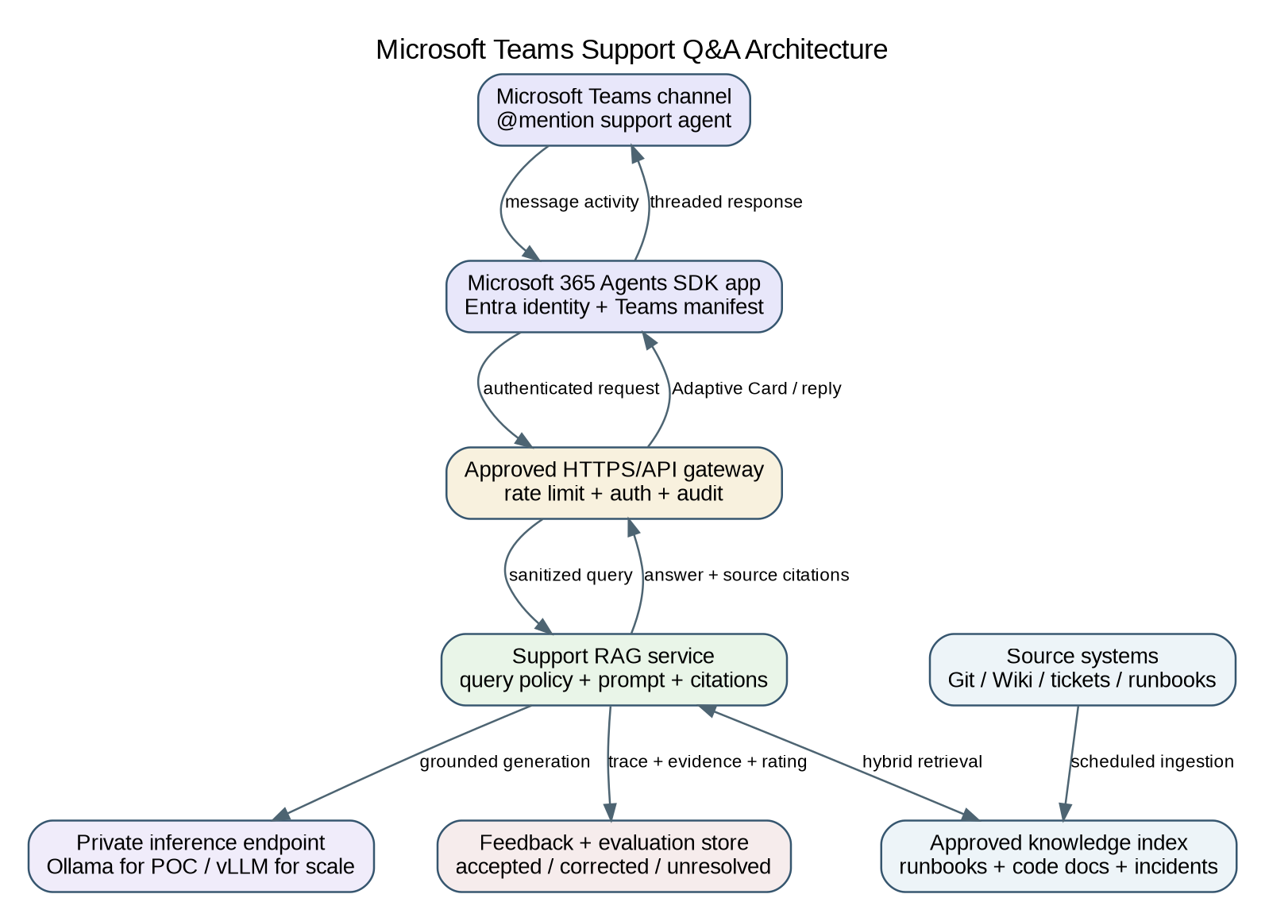

9.1 Interactive Q&A
Use a Microsoft 365 Agents SDK application (or current Teams SDK path) with Entra identity and a Teams manifest. In channels, the normal interaction is an @mention. The Teams app sends an authenticated request to a hosted support RAG API and returns a threaded answer or Adaptive Card with citations, evidence coverage, feedback, and escalation actions.
Do not use the laptop as the production Teams endpoint
Teams requires a reachable, approved HTTPS endpoint. Use the laptop only for local development or an explicitly approved tunnel. Production should run on internal compute or private AWS networking with an API gateway, identity, audit, and rate limits.

9.2 Notification-only path
Use a Teams incoming webhook or Workflow for outbound POC reports, evaluation summaries, or unresolved-question notifications. This does not replace a conversational bot/agent.

9.3 Teams controls
- Authenticate and authorize before retrieval.
- Apply source ACLs at retrieval time.
- Require citations and last-updated metadata.
- Escalate low-evidence/high-risk questions.
- Redact secrets in logs.
- Never expose arbitrary shell or repository write tools to Teams users.

10. Training and Adaptation on the Company Codebase
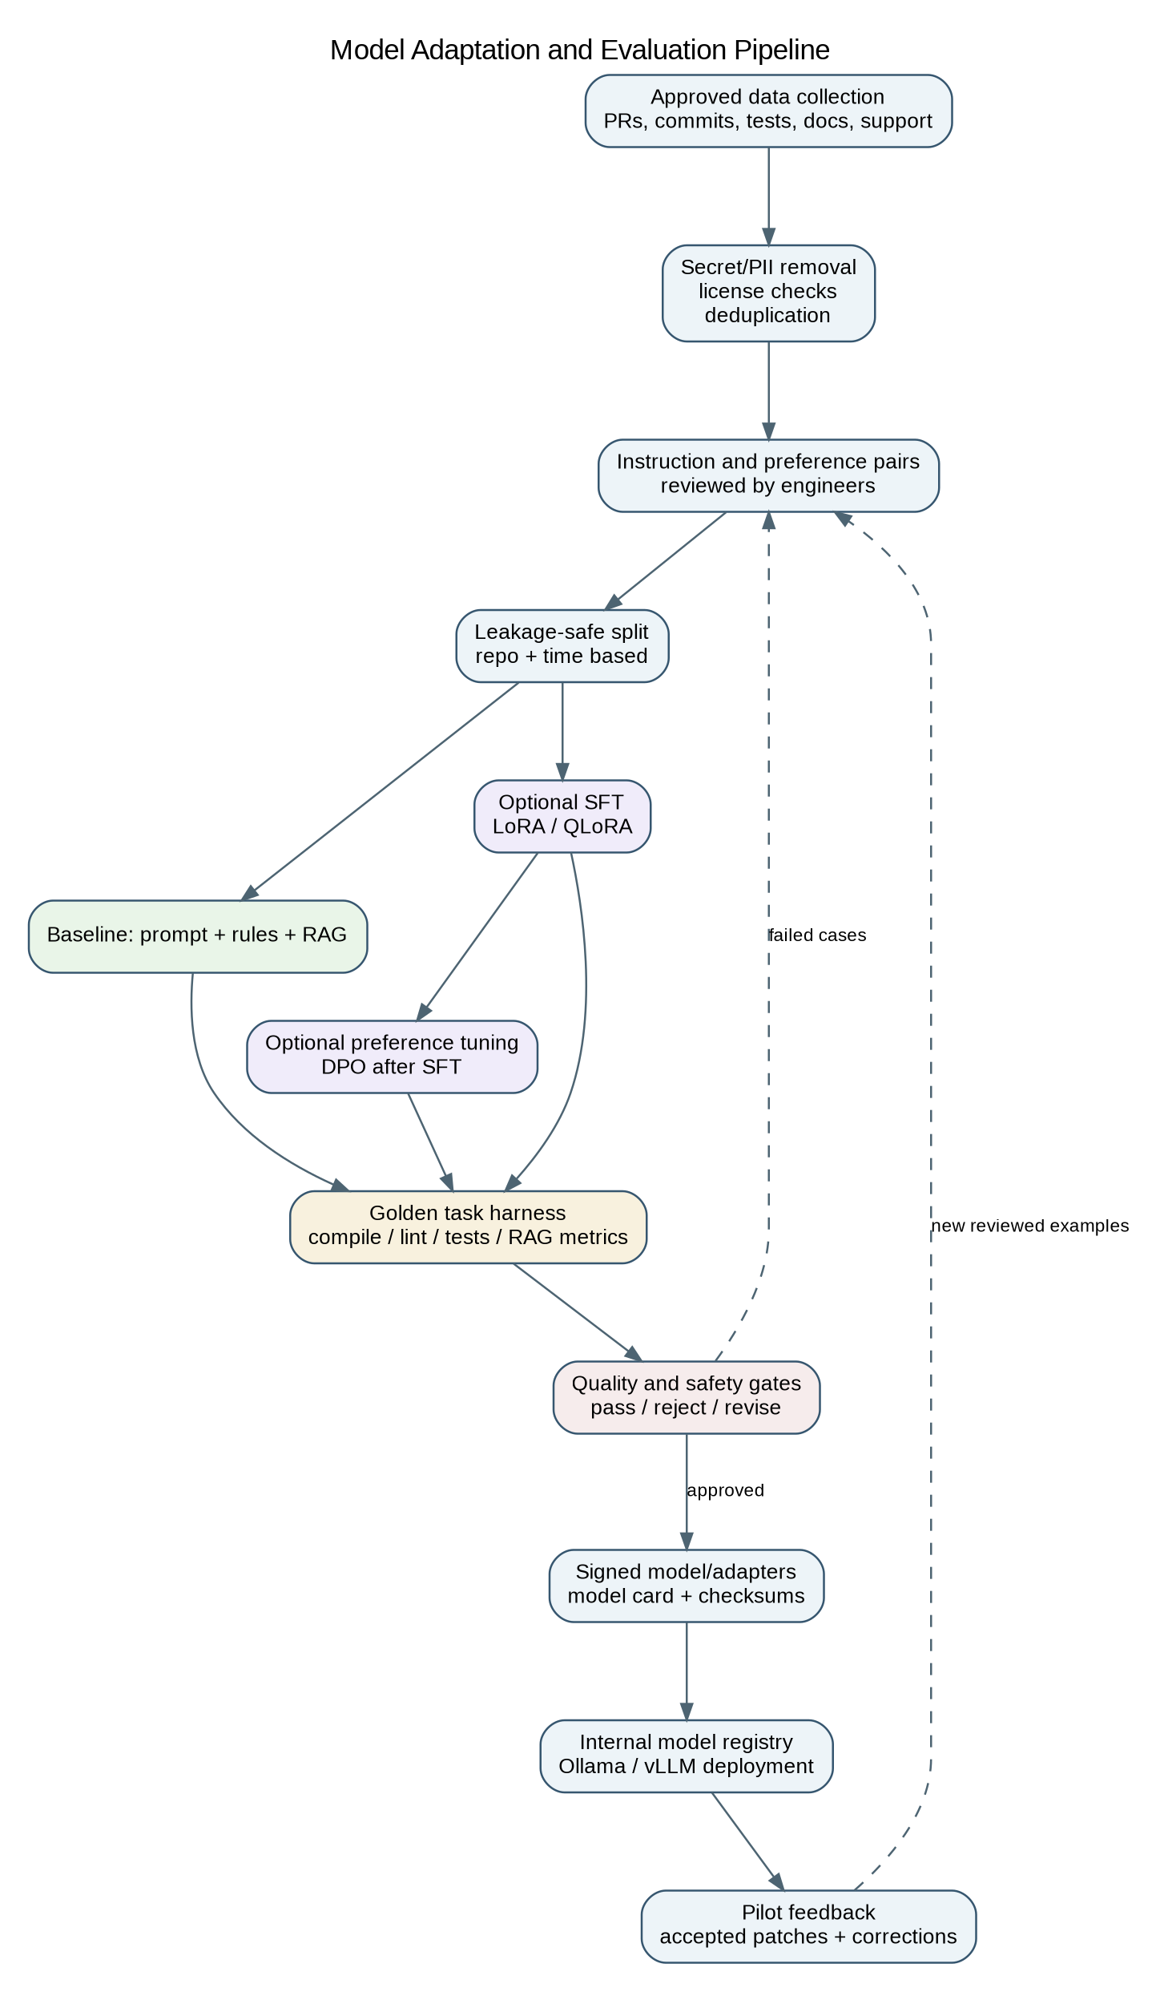

10.1 Adaptation ladder
1. Prompts, repository rules, examples, and deterministic tools.
2. RAG for current code, documentation, templates, and internal terminology.
3. SFT with LoRA/QLoRA for recurring behavior, style, or tool-use gaps.
4. Preference tuning such as DPO after reviewed chosen/rejected examples exist.
5. Continued pretraining only as a separate large-compute research effort.

10.2 Data collection and curation
- Merged PRs with clean issue/description context and passing CI.
- Bugs paired with final fixes and tests.
- Accepted review comments and final code.
- Approved templates and support runbooks.
- Support questions paired with authoritative answers.
- Exclude intermediate mistakes, reverted commits, secrets, and unreviewed chat output.

10.3 Dataset record shape
{
"task_type": "bug_fix",
"repository": "repo-a",
"language": "python",
"input_context": "...approved minimal context...",
"instruction": "Fix the defect and add a reproducing test",
"expected_response": "root-cause explanation",
"expected_patch": "unified diff or structured edit",
"validators": ["ruff check", "pytest tests/unit/test_x.py"],
"data_classification": "internal"
}

10.4 Split and leakage prevention
- Split by subsystem and time, not random lines.
- Keep issue/patch/tests/docs together in one split.
- Hold out the newest period and at least one subsystem.
- Deduplicate exact and near-duplicate code before splitting.
- Never use the held-out set for prompt tuning or data selection.

10.5 Fine-tuning method
Use PEFT LoRA or 4-bit QLoRA with Transformers, TRL, PEFT, Accelerate, bitsandbytes, or Unsloth. Begin with a 7B/14B model and 500-5,000 highly reviewed examples. A 24 GB GPU is a realistic laptop target for 7B/14B QLoRA; use 48 GB+ for larger models. Evaluate every checkpoint and stop when held-out performance stops improving.

10.6 Packaging and deployment
- Retain base model revision, adapter, config, tokenizer, training manifest, evaluation report, checksums, and model card.
- Serve adapters separately where supported, or merge/quantize a reviewed build and import it into Ollama.
- Store weights and adapters only in approved internal repositories.
- Reject a fine-tune that does not beat prompt+RAG or that degrades general coding/safety.

11. Artifactory-Backed Open-Source Supply Chain
Artifact type | Repository pattern | Contents
Python packages | PyPI virtual + local | Approved wheels/sdists; internally built packages; lock files
Containers | OCI virtual/local | OpenShell, training, evaluation, inference images
Model artifacts | Hugging Face ML / Generic / approved model repo | Weights, GGUF, tokenizers, adapters, model cards, checksums
Reports and manifests | Generic/local | SBOMs, evaluation reports, signed manifests, audit exports

11.1 pip configuration
[global]
index-url = https://ARTIFACTORY_HOST/artifactory/api/pypi/pypi-virtual/simple
trusted-host = ARTIFACTORY_HOST
require-virtualenv = true
Use a pinned lock file with hashes, corporate CA bundle, service tokens, SCA scanning, build-info/SBOM capture, and an offline wheelhouse for restricted networks. Block direct public PyPI and model downloads at the network layer.

Inference and service
ollama (Python client, optional), fastapi, uvicorn, httpx, pydantic, tenacity.

RAG and parsing
llama-index-core or langchain-core (choose one primary framework), llama-index-llms-ollama / llama-index-embeddings-ollama or langchain-ollama, tree-sitter, tree-sitter-language-pack, qdrant-client or chromadb, rank-bm25, sentence-transformers (optional reranking/embedding experiments).

Training/adaptation
transformers, datasets, peft, trl, accelerate, bitsandbytes, unsloth, safetensors, sentencepiece.

Evaluation
pytest, pytest-cov, coverage, mutmut (where appropriate), ragas or deepeval, pandas, scikit-learn, mlflow (optional internal experiment tracking).

Security/quality
detect-secrets or the company's approved secret scanner, ruff, black, mypy, bandit, pip-audit or approved software-composition scanner.

12. Configuration Examples

12.1 Ollama
ollama pull qwen2.5-coder:14b
# If a 24 GB GPU is available:
ollama pull qwen3-coder:30b
ollama pull embeddinggemma
ollama list
Keep Ollama bound to localhost for the laptop POC. When OpenCode is in WSL/Docker, expose only the minimum host route required by policy.

12.2 Continue config.yaml
name: Local Coding POC
version: 1.0.0
schema: v1
models:
- name: Qwen 2.5 Coder 14B
provider: ollama
model: qwen2.5-coder:14b
roles: [chat, edit, apply]
- name: Qwen3 Coder 30B
provider: ollama
model: qwen3-coder:30b
roles: [chat, edit, apply]
capabilities: [tool_use]
- name: Local Embeddings
provider: ollama
model: embeddinggemma
roles: [embed]
rules:
- Never change files outside the requested scope.
- Run formatter, linter, compiler, and relevant tests before completion.
- For bug fixes, explain root cause and require a reproducing test.
Validate tool-call capability in your installed Continue version and model build. Good code generation does not guarantee reliable Agent mode.

12.3 OpenCode opencode.json
{
"$schema": "https://opencode.ai/config.json",
"provider": {
"ollama": {
"npm": "@ai-sdk/openai-compatible",
"name": "Ollama (local)",
"options": { "baseURL": "http://host.docker.internal:11434/v1" },
"models": {
"qwen2.5-coder:14b": { "name": "Qwen 2.5 Coder 14B" },
"qwen3-coder:30b": { "name": "Qwen3 Coder 30B" }
}
}
},
"permission": {
"read": "allow",
"glob": "allow",
"grep": "allow",
"edit": "ask",
"bash": "ask",
"webfetch": "deny",
"websearch": "deny"
}
}

12.4 OpenShell policy shape
version: 1
filesystem_policy:
include_workdir: true
read_only: [/usr, /lib, /etc]
read_write: [/sandbox, /tmp]
process:
run_as_user: sandbox
run_as_group: sandbox
network_policies:
local_ollama:
name: local-ollama-only
endpoints:
- host: host.docker.internal
port: 11434
protocol: rest
enforcement: enforce
access: read-write
binaries:
- { path: /usr/local/bin/opencode }
Policy warning
Validate exact binary paths, Docker/WSL host networking, inference protocol behavior, package endpoints, certificates, and deny logs. The example is an architecture starting point, not a drop-in production policy.

13. Suggested POC Repository Structure
.local-llm-poc/
configs/
continue/config.yaml
opencode/opencode.json
openshell/policy.yaml
prompts/
format.md
test-scaffold.md
summarize.md
refactor.md
bug-fix.md
documentation.md
boilerplate.md
rag-answer.md
rag/
ingest.py
service.py
access_policy.py
eval/
tasks/*.jsonl
runners/
validators/
reports/
training/
prepare_dataset.py
train_qlora.py
evaluate_adapter.py
docs/
model-cards/
decisions/
runbooks/

14. Developer Experience and Adoption
Keep Continue as the default UI so engineers retain the VS Code chat/edit workflow they know. Use OpenCode only when a task benefits from a plan-edit-run-verify loop. Provide one documented command/prompt catalog and one evaluation standard across both clients.
Command / workflow | Expected behavior
/format | Apply approved formatter/linter repairs and report commands
/tests | Generate basic tests, run the target, and report coverage/mutation evidence
/summarize | Advisory summary with cited files and symbols
/refactor | Plan and impact list first; execute only after approval
/bugfix | Require reproducer; return root cause, minimal patch, and validation
/docs | Update docs/comments and run documentation checks
/template | Retrieve approved template and fill only defined placeholders
/support | Grounded answer with sources or explicit abstention

14.1 Pilot metrics
- Activation and weekly active use
- Successful task rate
- Accepted-without-edit rate
- Time saved
- Revert/rollback rate
- Validation failure rate
- OpenShell policy denials
- Latency and resource consumption
- Engineer trust and reasons for rejection

15. Security and Governance Controls
- Approved model/package/image allowlists with immutable versions and checksums.
- No arbitrary public downloads from work devices.
- Secret/PII/regulatory scanning for prompts, retrieval, generated patches, and training data.
- Disposable Git worktrees or containers for agent writes.
- Default-deny network and explicit Artifactory, source-control, inference, and internal-service routes.
- Command allowlists; deny deployment, cloud CLIs, credential tools, package installation, destructive Git, and broad filesystem access by default.
- Normal code review, signed changes, and CI remain authoritative.
- Trace model/version, prompt template, evidence IDs, tool calls, policy decisions, validators, and output hashes.
- Red-team prompt injection in comments, docs, tickets, and Teams messages.
- Define retention and access for prompts, diffs, support questions, and feedback.

16. Risks and Mitigations
Risk | Mitigation
Unreliable tool calls | Separate tool-call conformance test; Plan mode; smaller action surface; stronger model on EC2
Model fits but is too slow | Smaller model, shorter context, GPU offload, G6e escalation; report quality and latency together
Excessive edit scope | OpenShell filesystem policy, worktree, file/line caps, plan approval
Unsupported RAG answers | Mandatory citations, evidence threshold, abstention, answer auditing
Training memorizes sensitive data | Curated data, secret/PII scan, private registry, memorization tests, restricted adapter distribution
Fine-tune harms general quality | Held-out multi-use-case regression suite and unchanged baseline comparison
Teams leaks restricted knowledge | Entra identity, retrieval-time ACLs, channel scope review, audit
Tool overlap confuses users | Continue default; OpenCode for approved autonomous tasks; shared prompts and metrics

17. Final Go/No-Go Criteria
1. At least four use cases meet quality gates, including one agentic use case and RAG Q&A.
2. No critical data leakage, unrestricted network, unauthorized file access, or destructive command path is found.
3. Interactive latency is acceptable on the target laptop or the EC2 operating model is justified.
4. Pilot adoption and accepted-output/revert metrics support productivity gains.
5. The package/model supply chain is reproducible through Artifactory and approved registries.
6. Any fine-tune beats prompt+RAG on held-out tasks without broad regressions.
7. Teams answers are access-controlled, cited, auditable, and can abstain/escalate.

18. First-Week Action List
1. Run nvidia-smi and capture hardware/driver facts.
2. Obtain approval for the four tools, initial models, PyPI/OCI/model repositories, and network routes.
3. Create smoke tasks across all eight use cases and a focused golden set for four priority cases.
4. Install Ollama and test the 14B baseline; add 24B/30B only if hardware permits.
5. Configure Continue and record Chat/Edit behavior and latency.
6. Install WSL 2, Docker Desktop, OpenShell, and OpenCode; prove default-deny and scoped-write behavior.
7. Build deterministic evaluation and telemetry before broad pilot use.
8. Create a small symbol-aware RAG index for one repository and one runbook set.
9. Defer fine-tuning until a stable baseline gap is documented.
10. Build Teams only after the RAG API passes standalone tests.

Official Reference Sources
The plan was grounded in current official documentation and official model cards. Revalidate versions, support status, model availability, and licenses during implementation.
- Continue: Agent model setup
- Continue: Using Ollama
- Continue: config.yaml reference
- Ollama: OpenAI compatibility
- Ollama: Tool calling
- Ollama: Embeddings
- OpenCode: Providers and Ollama
- OpenCode: Agents
- OpenCode: Permissions
- NVIDIA OpenShell overview
- NVIDIA OpenShell support matrix
- NVIDIA OpenShell policy schema
- Qwen3-Coder 30B model card
- Qwen3-Coder-Next model card
- Devstral Small 2 model card
- Hugging Face PEFT
- Hugging Face TRL
- Unsloth Windows installation
- JFrog Artifactory PyPI repositories
- Microsoft Teams channel/group agent conversations
- Microsoft 365 Agents SDK migration guidance
- AWS EC2 G6e instances
- AWS EC2 P5 instances
- AWS Deep Learning AMIs

