| **Test Name** | | | **Getting valid ticket** | | | |
| --- | --- | --- | --- | --- | --- | --- |
| **Use Case Tested:** | | | **Enter with car** | | | |
| **Test Description:** | | | **Customer trying to enter with car** | | | |
| **Pre-conditions** | | | **Car detected** | | | |
| **Post-conditions** | | | **Ticket registered** | | | |
| **Notes:** | |  | | | | |
| **Result (Pass/Fail/Warning/Incomplete)** | |  | | | | |
|  | **TEST STEP** | | | **EXPECTED TEST RESULTS** | P | F |
|  | A car is detected by the car sensor | | | Entry pillar state change from idle to waiting. | Pass |  |
|  | A season ticket is inserted | | | Entry controller verify the season ticket. Change status to validated. |  | Fail |
|  | The gate is raised and the car enter the car park. | | | Entry pillar detects car entering the car park.  Gate is lowered. Change status to idle. | Pass |  |

|  |  |  |  |
| --- | --- | --- | --- |
| Test Item |  | Description | Result |
| 1. | Carpark: Bathurst Chase  Entry Controller: IDLE  State: | This data is passed to the Entry controller to validate the season ticket and allow access to the car. | Fail |
| 2. | Carpark: Bathurst Chase | This data save the season usage. | Fail |

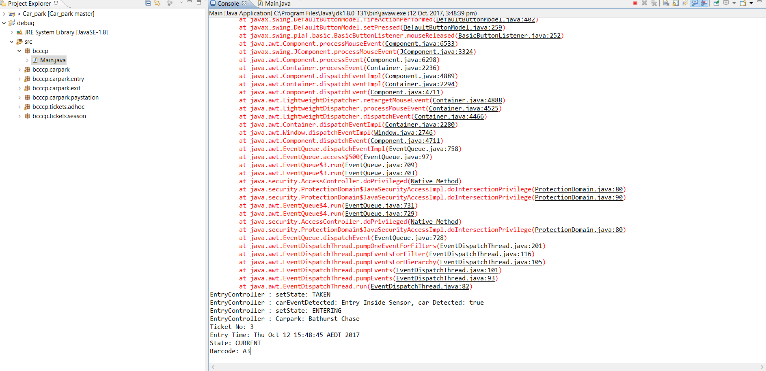

*Figure 1.1: Season ticket validate error*

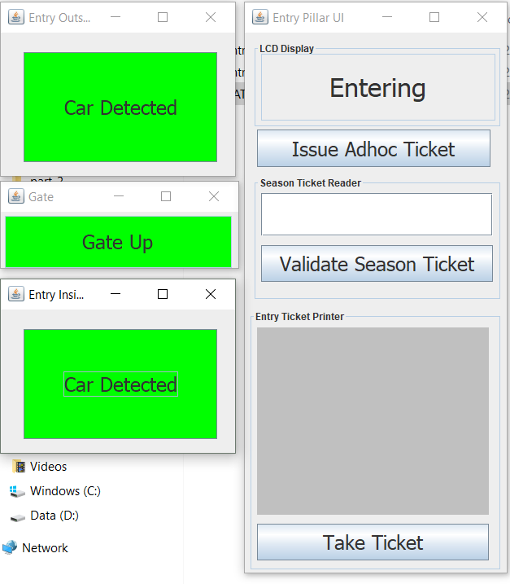

*Figure 1.2: Season ticket validate error*