|  |  |  |  |  |  |
| --- | --- | --- | --- | --- | --- |
| **Test Name** | | Invalid Adhoc Ticket | | | |
| **Use Case Tested:** | | Pay for Ticket | | | |
| **Test Description:** | | User trying to access with invalid ticket | | | |
| **Pre-conditions** | | Someone is coming to pay station | | | |
| **Post-conditions** | | Invalid ticket alert display in pillar | | | |
| **Notes:** | | **A3 ticket inserted** | | | |
| **Result**  **(Pass/Fail/Warning/Incomplete)** | |  | | | |
|  | **TEST STEP** | | **EXPECTED TEST RESULTS** | **P** | **F** |
| 1. | Ticket inserted by user | | Rejected ticket. | **Pass** |  |

|  |  |  |  |
| --- | --- | --- | --- |
| **Test Item** | **Ticket description** | **Description** | **Result** |
| 1. | Carpark: Bathurst Chase  Ticket No: 4  Entry Time: Thu Oct 12 16:54:09 AEDT 2017  State: ISSUED  Barcode: A4 | A3 ticket is Inserted by user into pay station. | Pass |

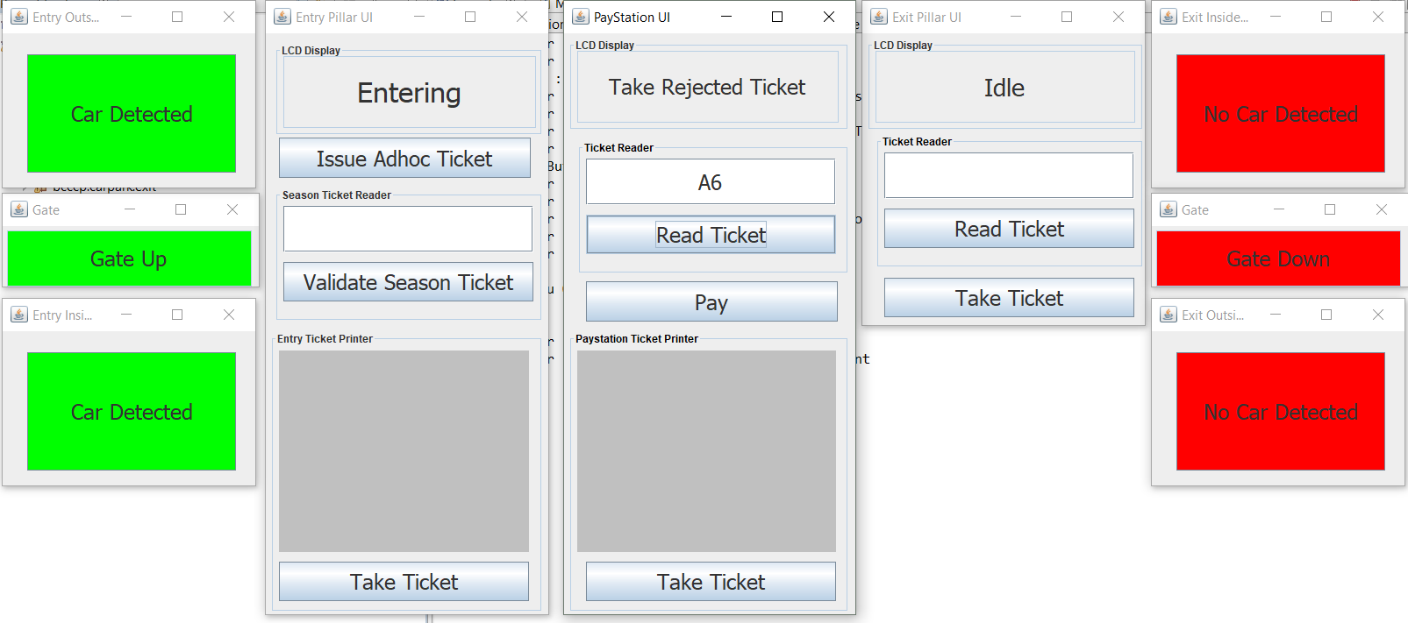

*Figure 2.1: car passed entry*