|  |  |  |  |  |  |
| --- | --- | --- | --- | --- | --- |
| **Test Name** | | Valid Adhoc Ticket | | | |
| **Use Case Tested:** | | Pay for ticket | | | |
| **Test Description:** | | The user pays for valid ticket | | | |
| **Pre-conditions** | | Someone is coming to pay station | | | |
| **Post-conditions** | | Valid ticket is paid by user | | | |
| **Notes:** | | **A3 ticket inserted** | | | |
| **Result**  **(Pass/Fail/Warning/Incomplete)** | |  | | | |
|  | **TEST STEP** | | **EXPECTED TEST RESULTS** | **P** | **F** |
| 1. | The valid ticket inserted by user | | System displays charge and pay command pass. | **Pass** |  |

|  |  |  |  |
| --- | --- | --- | --- |
| **Test Item** |  | **Description** | **Result** |
| 1. | Carpark : Bathurst Chase  Ticket No : 3  Entry Time : Thu Oct 12 16:59:34 AEDT 2017  Paid Time : Thu Oct 12 17:08:18 AEDT 2017  Charge : 3.00  Barcode : A3 | User paid for valid ticket and pillar displayed “paid” | Pass |

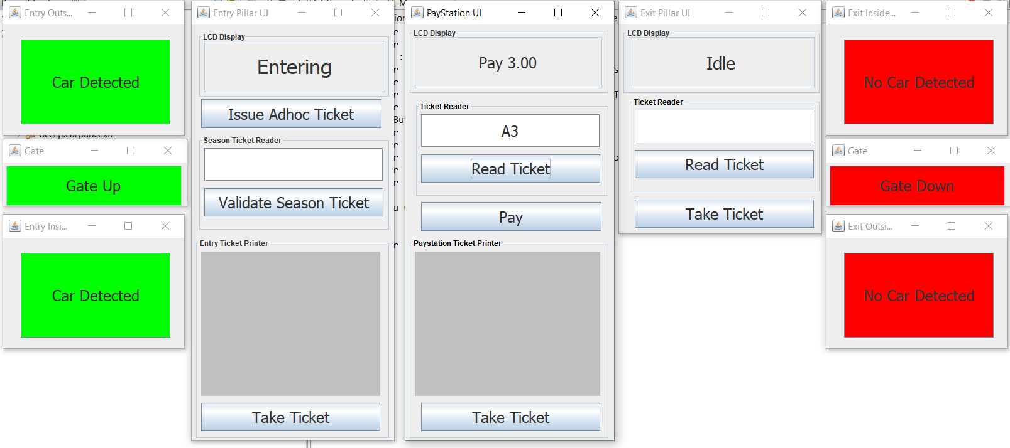

*Figure 2.1: Displaying amount for valid ticket*

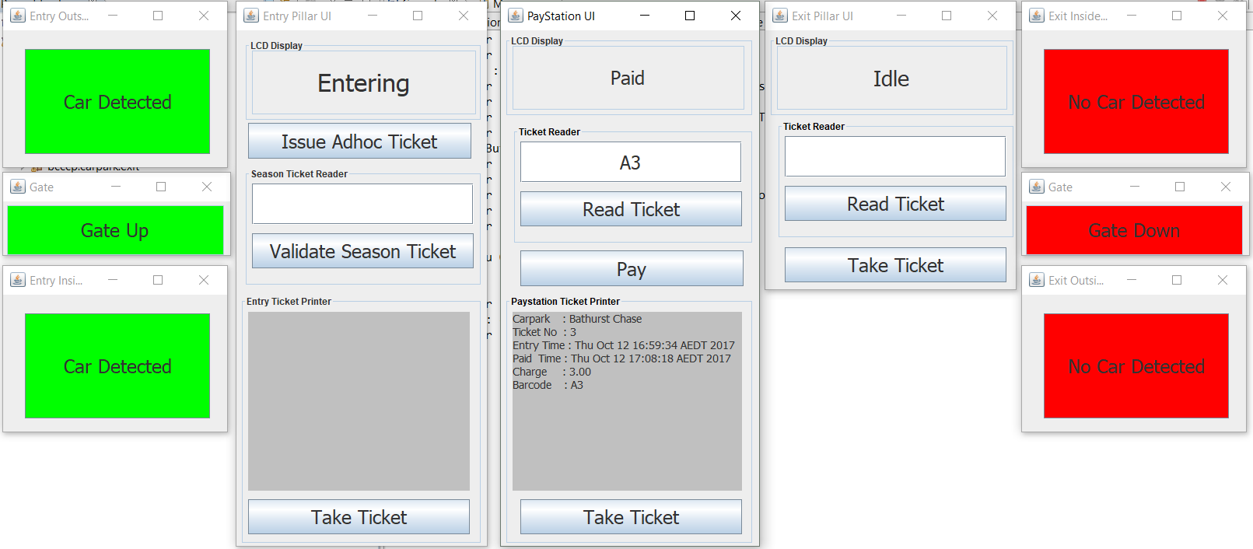

*Figure 2.2: Displaying paid valid ticket*