**Debugging Log**

**Bug #1:**

**Hypotheses:**

Winning variable don’t get proper value. Balance should have increased with winning variable, which is not assigned properly. When player lost on bet, then balance returned exact value, but on winning it is not increased the value.

**Bug Screenshot:**

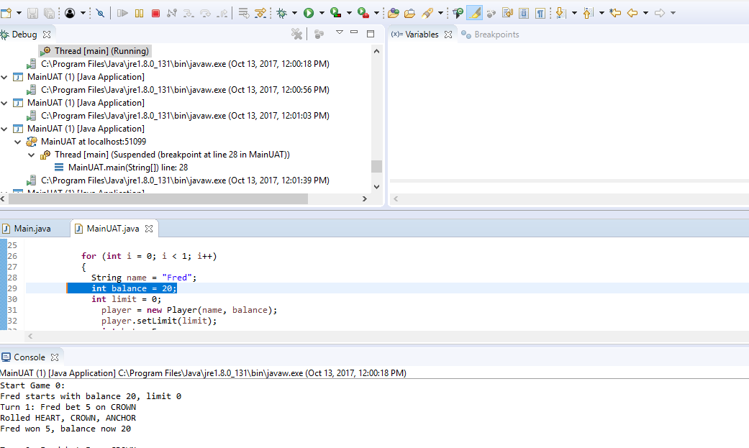

Above screenshot, When the player wins a bet, the balance does not increase. Fred wins the bit and balance should be 25. Balance still is showing 20. So, hypothesis one is false.

**Hypothesis Testing:**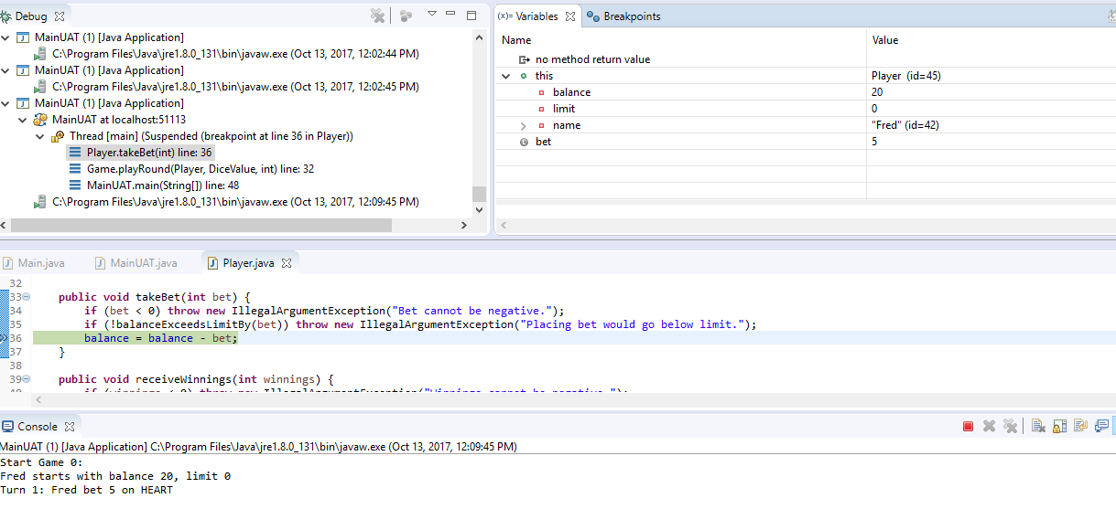

Fred begins the game with a balance of 20, and places a bet on 5.

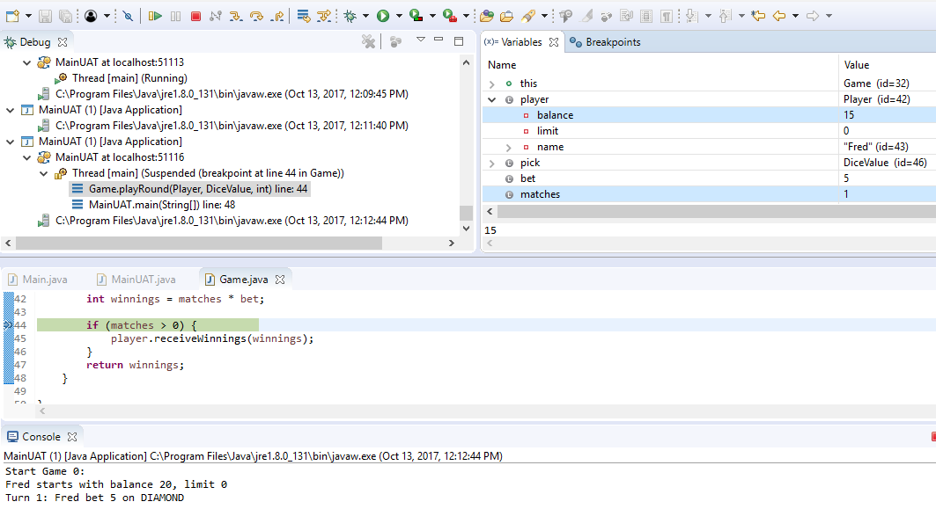

After lost the bet of $5, balance is deducted.

**Solved:**

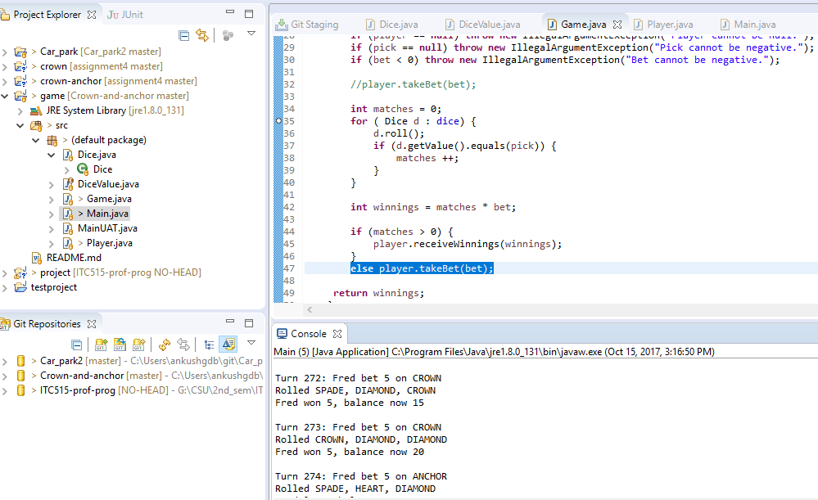

Bug #1 has been resolved by adjust statement **player.takeBet(bet)** in else part.

**Bug #2:**

**Screenshot:**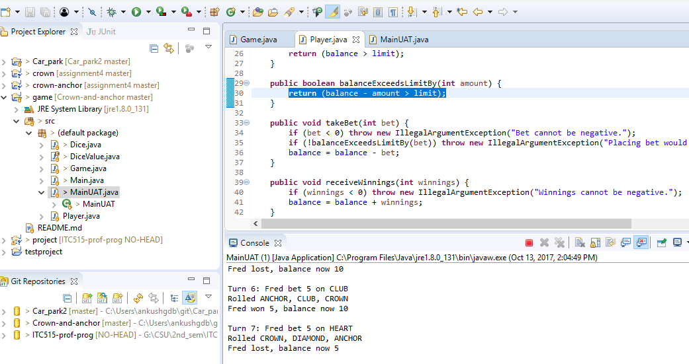

When the game reach on end, Balance is 5, while balance should be 0 on lost.

**Solved:**

Reported Bug #2 was successfully resolved.

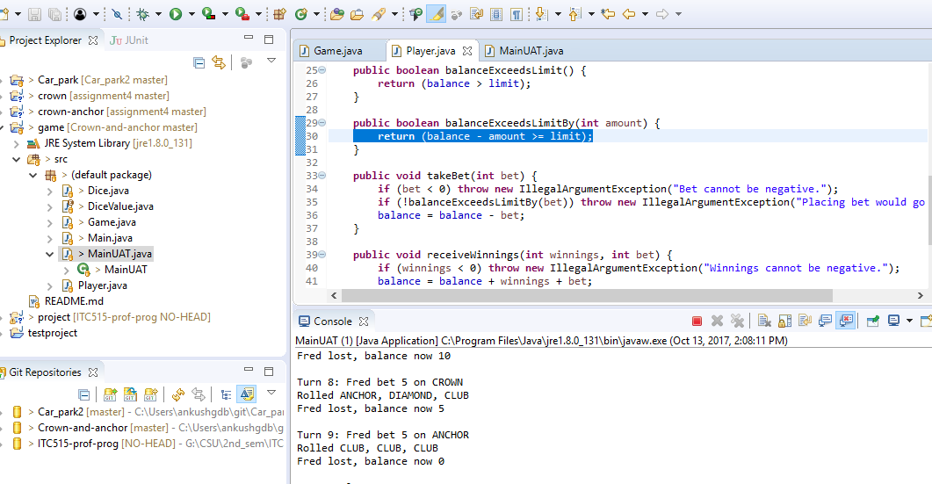

By changing this statement, **return** (balance - amount > limit); to **return** (balance - amount >= limit); problem is solved out at the end of game, the balance reaches zero.

**Reported Bug #3:**

**Hypothesis:**

Initial value of dice is randomly selected. So, bug is that, every subsequent roll is exactly the same as the first. When the method Dice.roll() is called, the returned value is neither used, nor assigned to the value of the dice.

**Bug Screenshot:**

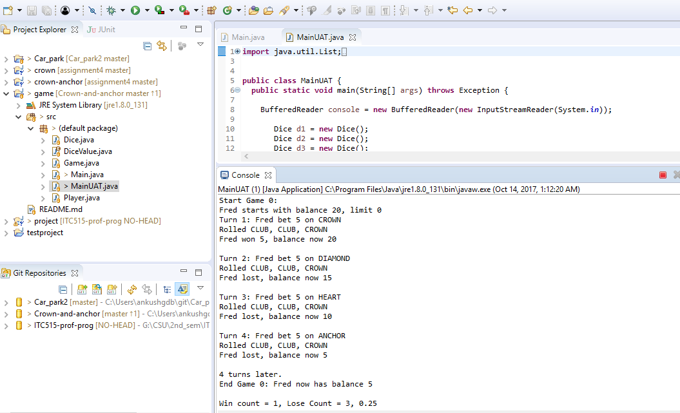

Above screenshot showing each subsequent set of dice rolls are same. Here, the winrate is 0.25, while it should be 0.42 for different dice value.

**Hypothesis Testing:**

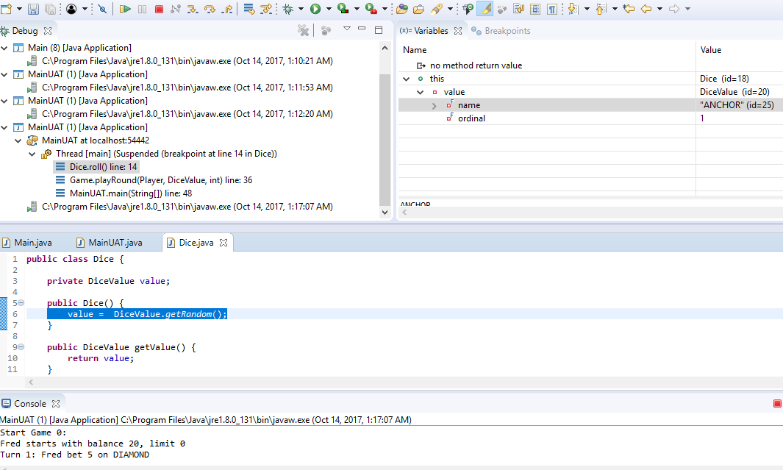

All dice values are showing randomly at starting. Here initial dice value is ‘Anchor’

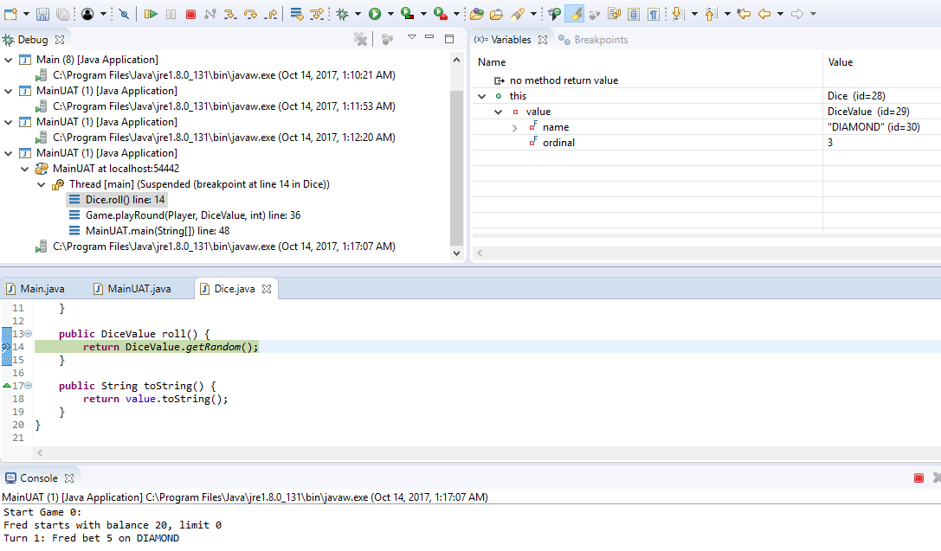

Randomly second dice value is ‘Diamond’.

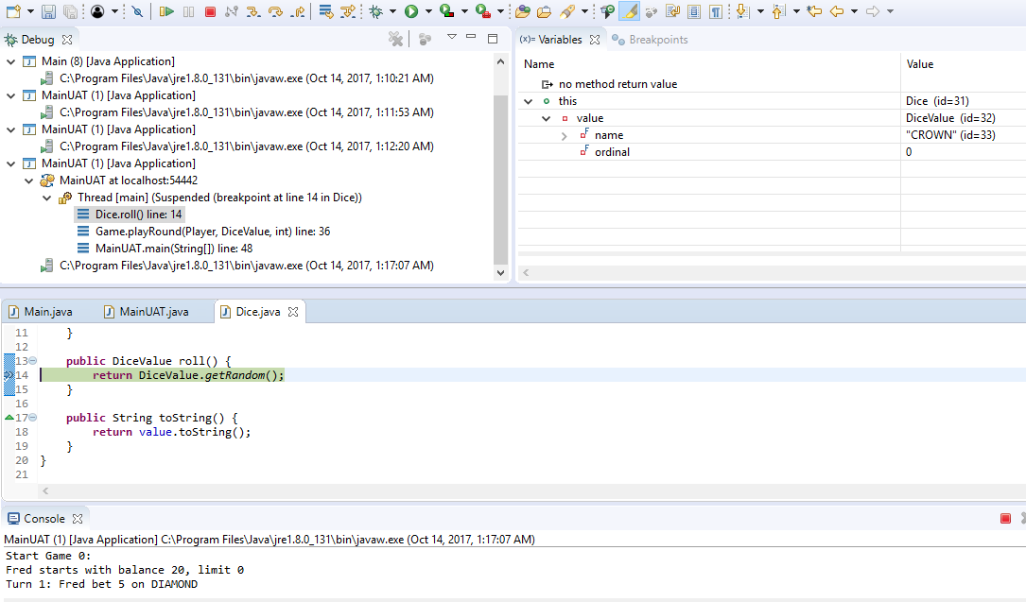

The third dice value is ‘Crown’.

So every time dice values are occuring ‘Anchor’, ‘Diamond’ , ‘Crown’ because Dice.Value in Dice.java file are not assigned to new value on call Dice.roll() function.

**Solved :**

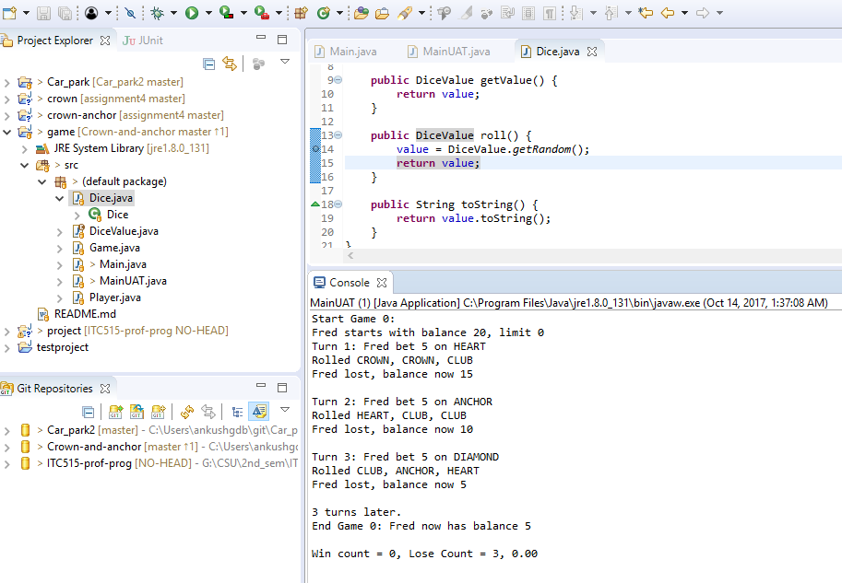

Passing DiceValue.getRandom(); to value variable to get differ value at randomly. This overcomes the repetition problem on each set of dice values.

**Bug #4:**

As per above all test, Single “SPADE” Dice value is not showing at all times in each game.

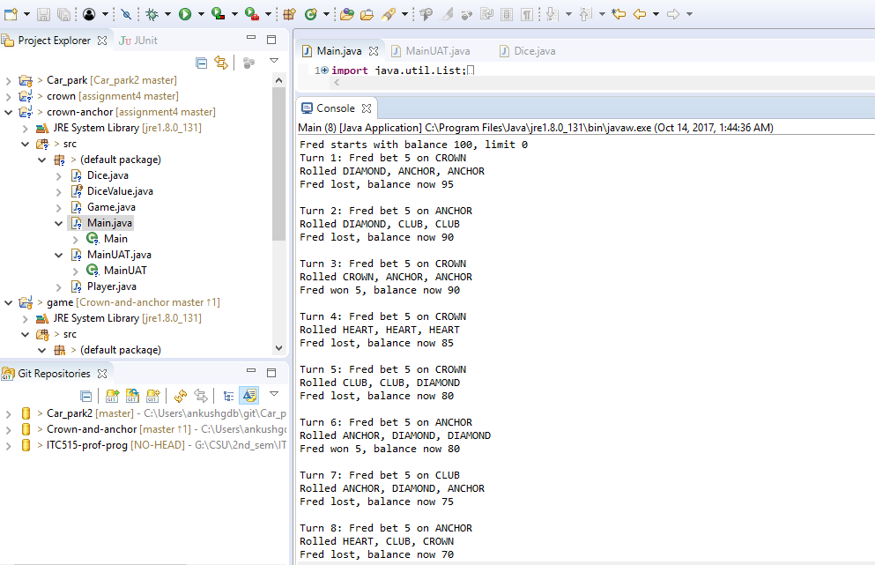

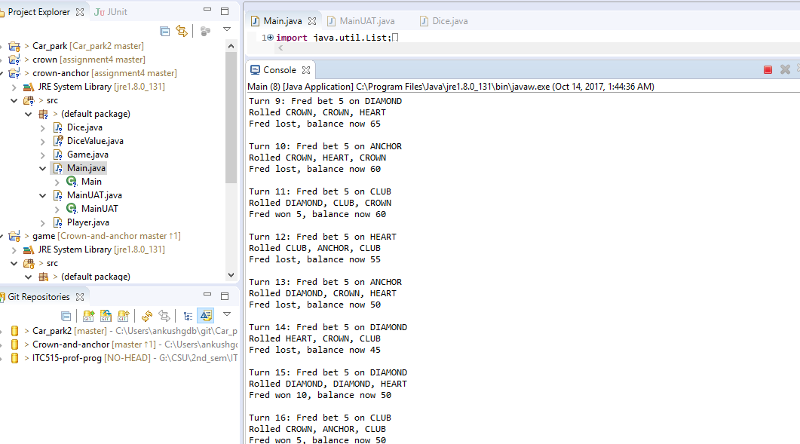

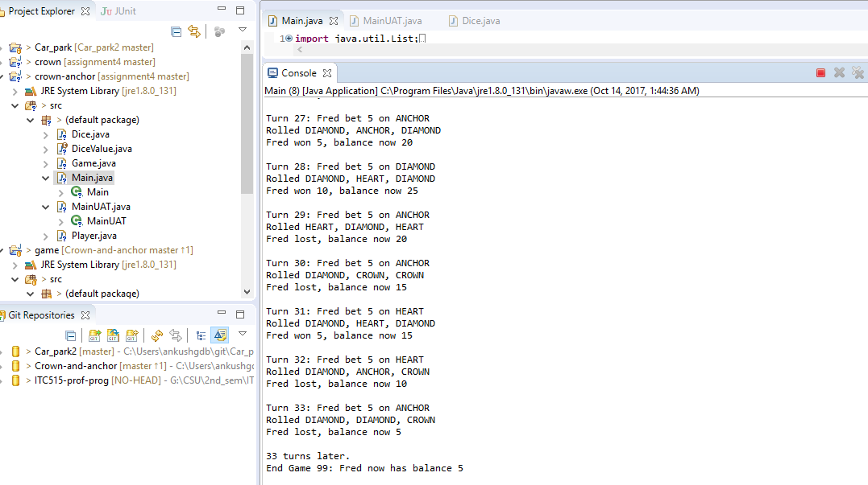

Above 3 screenshots showing the game’s output and turns of this game upto 33. ‘SPADE’ value of dice is not showing at all.

**Solved:**

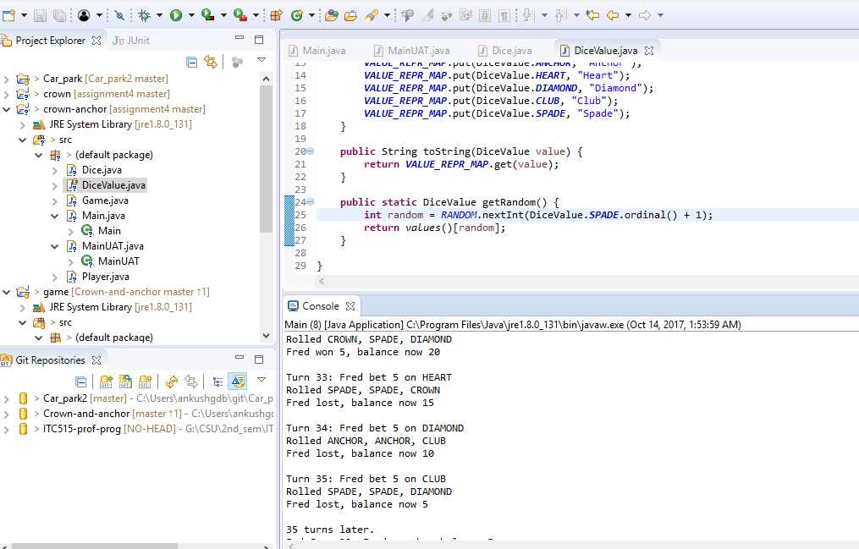

On line 25, just changed statement int random = RANDOM.nextInt(DiceValue.SPADE.ordinal() + 1); to get all possible values.