# **New National Biogas and Organic Manure Programme (NNBOMP) – 2020**

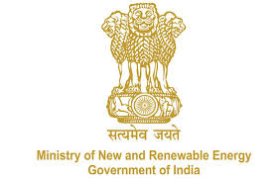

NNBOMP Information point (in case of doubts call us): 011-24360707; 24361920 Extn. 1047<https://mnre.gov.in/img/documents/uploads/dc65ef193ca9419f807441cfc193be3a.pdf>

**Demand Assessment Form**

*Form number: P2.S2.l (e) ver. 1 (2020.05.10)*

*This form is developed to capture the details of the demand aggregation work. Collected information will be submitted to the program implementing agency.*

To (name of your implementing Agency)

Name of the local body:

Contact person:

Telephone number:

Email address:

We would like to inform you that we have identified demand for installation of the biogas systems in the region of our operation. The identified demand has been assessed as of XX.XX.XXXX (date.month.year).

We have identified demand for installation of:

|  |  |  |  |
| --- | --- | --- | --- |
| **S.no.** | **Category** | **No. of plants (Total)** | **No. of plants (toilet linked)** |
| 1 | General |  |  |
| 2 | Scheduled caste |  |  |
| 3 | Scheduled tribe |  |  |
|  | **Total** |  |  |

Date:

Sign