**Front­end test**

**SpaceSwitcher component**

**Assignment:** Implement the component in JavaScript, using jQuery, HTML and CSS. You are free to choose the relevant frameworks and structure.

**Target browsers:** Chrome, Safari, and Firefox

**Case:** Users need to be able to switch between their Podio spaces from the global navigation. It should provide an overview of the spaces in relation to their organisation.

# Visuals:

Minimized:

Open Search/filter highlighting

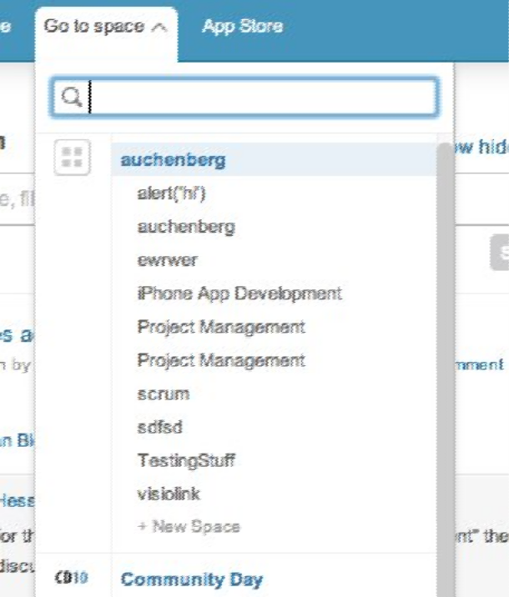 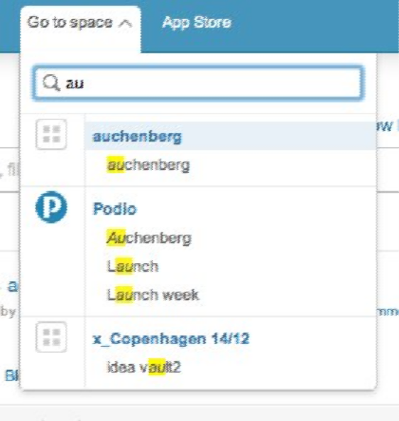



# Requirements:

1. Filtering
   1. Users with many spaces should be able to filter spaces by a search query they type into a text input field. Matching any string in space names and organisation.
   2. Search should ignore casing of space/organisation names.
   3. If user is clearing the search query, it should render all spaces and organisations
   4. If a **space name** is matching the search query, its parent **organization** should be visible, even if the query is not matching the organization name.
   5. After a search/filter has been completed, the first item (space or organisation) needs to be highlighted.
   6. The matching part of the search query in the organisation/space name should be highlighted with a yellow color (Google search style)
2. Keyboard navigation
   1. Up/Down arrows should navigate up and down in the list, and move the highlighting of the active item.
   2. Enter/Return should go to the link of the active element.
3. Scrolling behaviour (optional, bonus)
   1. The component is having a max height of 80% of the viewport.
   2. When viewport is resized space­switcher component should update its height
   3. If list of spaces/organisations is larger than the component height, a inline scrollbar is expected.
   4. When using keyboard navigation it is expected that scroll position (the scrolbar) is updated, so the active element is visible.

**JSON Data:**

**[**

**{**

**"id":736,**

**"org_id":736,**

**"name":"Podio",**

**"logo":3917,**

**"image":{**

**"perma_link":null,**

**"hosted_by":"podio",**

**"hosted_by_humanized_name":"Podio",**

**"thumbnail_link":"https://d3szoh0f46td6t.cloudfront.net/public/3917",**

**"link":"https://d3szoh0f46td6t.cloudfront.net/public/3917",**

**"file_id":3917**

**},**

**"spaces":[**

**{**

**"id":52456,**

**"space_id":52456,**

**"name":"Acceleration",**

**"url":"https://hoist.podio.com/acceleration/",**

**"url_label":"acceleration",**

**"org_id":736,**

**"contact_count":null,**

**"member_count":null,**

**"app_count":null,**

**"role":"regular",**

**"rights":[**

**"view_members",**

**"add_task",**

**"add_widget",**

**"subscribe",**

**"add_file",**

**"add_user_light",**

**"add_status",**

**"add_user",**

**"add_contact",**

**"view",**

**"add_app"**

**],**

**"post_on_new_app":null,**

**"post_on_new_member":null,**

**"subscribed":null,**

**"privacy":null,**

**"auto_join":null,**

**"type":"regular",**

**"premium":true,**

**"last_activity_on":null,**

**"created_on":null,**

**"is_overdue":null,**

**"push":{**

**"timestamp":1366359320,**

**"expires_in":20650,**

**"channel":"/space/52456",**

**"signature":"5b04f5c9e1c5984bb32e2986b863c75601b62296"**

**},**

**"rank":33**

**},**

**{**

**"id":11955,**

**"space_id":11955,**

**"name":"Agile",**

**"url":"https://hoist.podio.com/agile/",**

**"url_label":"agile",**

**"org_id":736,**

**"contact_count":null,**

**"member_count":null,**

**"app_count":null,**

**"role":"admin",**

**"rights":[**

**"view_members",**

**"add_task",**

**"add_widget",**

**"subscribe",**

**"delete",**

**"update",**

**"add_file",**

**"add_hook",**

**"add_user_light",**

**"add_status",**

**"add_user",**

**"share",**

**"add_contact",**

**"view",**

**"add_app"**

**],**

**"post_on_new_app":null,**

**"post_on_new_member":null,**

**"subscribed":null,**

**"privacy":null,**

**"auto_join":null,**

**"type":"regular",**

**"premium":true,**

**"last_activity_on":null,**

**"created_on":null,**

**"is_overdue":null,**

**"push":{**

**"timestamp":1366358596,**

**"expires_in":19926,**

**"channel":"/space/11955",**

**"signature":"9d36d2c3f2df587cd6127f3700b8030d866237c8"**

**},**

**"rank":41**

**},**

**{**

**"id":2168,**

**"space_id":2168,**

**"name":"API",**

**"url":"https://hoist.podio.com/api/",**

**"url_label":"api",**

**"org_id":736,**

**"contact_count":null,**

**"member_count":null,**

**"app_count":null,**

**"role":"admin",**

**"rights":[**

**"view_members",**

**"add_task",**

**"add_widget",**

**"subscribe",**

**"delete",**

**"update",**

**"add_file",**

**"add_hook",**

**"add_user_light",**

**"add_status",**

**"add_user",**

**"share",**

**"add_contact",**

**"view",**

**"add_app"**

**],**

**"post_on_new_app":null,**

**"post_on_new_member":null,**

**"subscribed":null,**

**"privacy":null,**

**"auto_join":null,**

**"type":"regular",**

**"premium":true,**

**"last_activity_on":null,**

**"created_on":null,**

**"is_overdue":null,**

**"push":{**

**"timestamp":1366359217,**

**"expires_in":20547,**

**"channel":"/space/2168",**

**"signature":"3dda35b0ac3b537cc80441bc38008c3155545889"**

**},**

**"rank":52**

**},**

**{**

**"id":3179,**

**"space_id":3179,**

**"name":"Design",**

**"url":"https://hoist.podio.com/design/",**

**"url_label":"design",**

**"org_id":736,**

**"contact_count":null,**

**"member_count":null,**

**"app_count":null,**

**"role":"regular",**

**"rights":[**

**"view_members",**

**"add_task",**

**"add_widget",**

**"subscribe",**

**"add_file",**

**"add_user_light",**

**"add_status",**

**"add_user",**

**"add_contact",**

**"view",**

**"add_app"**

**],**

**"post_on_new_app":null,**

**"post_on_new_member":null,**

**"subscribed":null,**

**"privacy":null,**

**"auto_join":null,**

**"type":"regular",**

**"premium":true,**

**"last_activity_on":null,**

**"created_on":null,**

**"is_overdue":null,**

**"push":{**

**"timestamp":1366359194,**

**"expires_in":20524,**

**"channel":"/space/3179",**

**"signature":"1841b644172e1078e7e9f81fcacd8ee28343f9fa"**

**},**

**"rank":6**

**},**

**{**

**"id":207,**

**"space_id":207,**

**"name":"Development",**

**"url":"https://hoist.podio.com/development/",**

**"url_label":"development",**

**"org_id":736,**

**"contact_count":null,**

**"member_count":null,**

**"app_count":null,**

**"role":"admin",**

**"rights":[**

**"view_members",**

**"add_task",**

**"add_widget",**

**"subscribe",**

**"delete",**

**"update",**

**"add_file",**

**"add_hook",**

**"add_user_light",**

**"add_status",**

**"add_user",**

**"share",**

**"add_contact",**

**"view",**

**"add_app"**

**],**

**"post_on_new_app":null,**

**"post_on_new_member":null,**

**"subscribed":null,**

**"privacy":null,**

**"auto_join":null,**

**"type":"regular",**

**"premium":true,**

**"last_activity_on":null,**

**"created_on":null,**

**"is_overdue":null,**

**"push":{**

**"timestamp":1366359164,**

**"expires_in":20494,**

**"channel":"/space/207",**

**"signature":"d02aff4711ed2f3f54a10218f2a9c303cd7d59c8"**

**},**

**"rank":1**

**},**

**{**

**"id":70,**

**"space_id":70,**

**"name":"Intranet",**

**"url":"https://hoist.podio.com/hoistaps/",**

**"url_label":"hoistaps",**

**"org_id":736,**

**"contact_count":null,**

**"member_count":null,**

**"app_count":null,**

**"role":"regular",**

**"rights":[**

**"view_members",**

**"add_task",**

**"add_widget",**

**"subscribe",**

**"add_file",**

**"add_user_light",**

**"add_status",**

**"add_user",**

**"add_contact",**

**"view",**

**"add_app"**

**],**

**"post_on_new_app":null,**

**"post_on_new_member":null,**

**"subscribed":null,**

**"privacy":null,**

**"auto_join":null,**

**"type":"regular",**

**"premium":true,**

**"last_activity_on":null,**

**"created_on":null,**

**"is_overdue":null,**

**"push":{**

**"timestamp":1366359194,**

**"expires_in":20524,**

**"channel":"/space/70",**

**"signature":"c17383959230989c1145b77c4a8b706ca679eb24"**

**},**

**"rank":11**

**}**

**],**

**"url":"https://hoist.podio.com/",**

**"url_label":"hoist",**

**"premium":true,**

**"role":"regular",**

**"status":"active",**

**"sales_agent_id":7156,**

**"created_on":null,**

**"user_limit":100,**

**"member_count":null,**

**"contact_count":null,**

**"billing_interval":null,**

**"rights":[**

**"add_conversation",**

**"update",**

**"add_contract",**

**"view_admins",**

**"statistics",**

**"add_space",**

**"view"**

**],**

**"verified_domain":null,**

**"domains":[**

**"hoisthq.com",**

**"podio.com"**

**],**

**"rank":1,**

**"contract_status":"full",**

**"type":"sponsored",**

**"segment":null,**

**"segment_size":null,**

**"grants_count":39,**

**"allow_add_space":null,**

**"child_orgs":[**

**],**

**"active?":true,**

**"admin?":false,**

**"upgradable?":true,**

**"not_upgraded?":false,**

**"partially_upgraded?":false,**

**"employee?":true,**

**"premium?":true,**

**"first_domain":"hoisthq.com"**

**},**

**{**

**"id":44315,**

**"org_id":44315,**

**"name":"CopenhagenJS",**

**"logo":20356965,**

**"image":{**

**"perma_link":null,**

**"hosted_by":"podio",**

**"hosted_by_humanized_name":"Podio",**

**"thumbnail_link":"https://d3szoh0f46td6t.cloudfront.net/public/20356965",**

**"link":"https://d3szoh0f46td6t.cloudfront.net/public/20356965",**

**"file_id":20356965**

**},**

**"spaces":[**

**{**

**"id":191599,**

**"space_id":191599,**

**"name":"ColdFront Conference",**

**"url":"https://copenhagenjs.podio.com/theconference/",**

**"url_label":"theconference",**

**"org_id":44315,**

**"contact_count":null,**

**"member_count":null,**

**"app_count":null,**

**"role":"admin",**

**"rights":[**

**"view_members",**

**"add_task",**

**"add_widget",**

**"subscribe",**

**"delete",**

**"update",**

**"add_file",**

**"add_hook",**

**"add_user_light",**

**"add_status",**

**"add_user",**

**"share",**

**"add_contact",**

**"view",**

**"add_app"**

**],**

**"post_on_new_app":null,**

**"post_on_new_member":null,**

**"subscribed":null,**

**"privacy":null,**

**"auto_join":null,**

**"type":"regular",**

**"premium":true,**

**"last_activity_on":null,**

**"created_on":null,**

**"is_overdue":null,**

**"push":{**

**"timestamp":1366358596,**

**"expires_in":19926,**

**"channel":"/space/191599",**

**"signature":"9acf84b5ff9684c7f93ff7a4415a05fcf4e8262e"**

**},**

**"rank":1**

**},**

**{**

**"id":86822,**

**"space_id":86822,**

**"name":"CopenhagenJS",**

**"url":"https://copenhagenjs.podio.com/copenhagenjs/",**

**"url_label":"copenhagenjs",**

**"org_id":44315,**

**"contact_count":null,**

**"member_count":null,**

**"app_count":null,**

**"role":"admin",**

**"rights":[**

**"view_members",**

**"add_task",**

**"add_widget",**

**"subscribe",**

**"delete",**

**"update",**

**"add_file",**

**"add_hook",**

**"add_user_light",**

**"add_status",**

**"add_user",**

**"share",**

**"add_contact",**

**"view",**

**"add_app"**

**],**

**"post_on_new_app":null,**

**"post_on_new_member":null,**

**"subscribed":null,**

**"privacy":null,**

**"auto_join":null,**

**"type":"regular",**

**"premium":true,**

**"last_activity_on":null,**

**"created_on":null,**

**"is_overdue":null,**

**"push":{**

**"timestamp":1366358596,**

**"expires_in":19926,**

**"channel":"/space/86822",**

**"signature":"28d541b1fb25c26f8ed790d5f324f69ac993ade6"**

**},**

**"rank":3**

**},**

**{**

**"id":131837,**

**"space_id":131837,**

**"name":"Employee Network",**

**"url":"https://copenhagenjs.podio.com/employeenetwork/",**

**"url_label":"employeenetwork",**

**"org_id":44315,**

**"contact_count":null,**

**"member_count":null,**

**"app_count":null,**

**"role":"admin",**

**"rights":[**

**"view_members",**

**"add_task",**

**"add_widget",**

**"subscribe",**

**"update",**

**"add_file",**

**"add_hook",**

**"add_status",**

**"add_user",**

**"add_contact",**

**"view"**

**],**

**"post_on_new_app":null,**

**"post_on_new_member":null,**

**"subscribed":null,**

**"privacy":null,**

**"auto_join":null,**

**"type":"emp_network",**

**"premium":false,**

**"last_activity_on":null,**

**"created_on":null,**

**"is_overdue":null,**

**"push":{**

**"timestamp":1366358596,**

**"expires_in":19926,**

**"channel":"/space/131837",**

**"signature":"62e55f02ed5ed3ad393b32d1dcfb5f5197faaa80"**

**},**

**"rank":2**

**}**

**],**

**"url":"https://copenhagenjs.podio.com/",**

**"url_label":"copenhagenjs",**

**"premium":true,**

**"role":"admin",**

**"status":"active",**

**"sales_agent_id":16456,**

**"created_on":null,**

**"user_limit":10,**

**"member_count":null,**

**"contact_count":null,**

**"billing_interval":null,**

**"rights":[**

**"add_conversation",**

**"add_widget",**

**"update",**

**"add_contract",**

**"view_admins",**

**"statistics",**

**"add_space",**

**"view"**

**],**

**"verified_domain":null,**

**"domains":[**

**],**

**"rank":4,**

**"contract_status":"full",**

**"type":"sponsored",**

**"segment":null,**

**"segment_size":null,**

**"grants_count":0,**

**"allow_add_space":null,**

**"child_orgs":[**

**],**

**"active?":true,**

**"admin?":true,**

**"upgradable?":true,**

**"not_upgraded?":false,**

**"partially_upgraded?":false,**

**"employee?":true,**

**"premium?":true,**

**"first_domain":null**

**}**

**]**