SIKSHA ‘O’ ANUSANDHAN
DEEMED TO BE UNIVERSITY

Minor Project – 1

Introduction to Computer Programming(CSE 1001)

Name-> Ankush Saha
Registration No.-> 2341019012
Branch-> CSE
Section-> 23412L2

Problem1_RotateRight

Program-
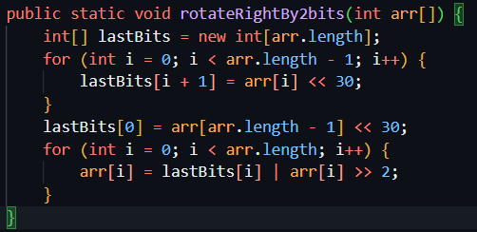

- First we will initialise a array named lastBits which will store the last bits of the left element by shifting 30 bits as it was mentioned we have to shift by 2 bits to the right most element.
- Then we will handle the case for the first element of the array separately
- Then we will run a loop in the original array and shift the original element by right to bits and do OR operartion with the elements we have stored in lastBits array to get the desired result and store in orginal array position

Sample Run-
Original Array:
10 | 11 | 12 | 13

In binary:
000...1010 | 000...1011 | 000...1100 | 000...1101

lastBits[]:
010...000 | 100...0000 | 110...000 | 000...000

arr[i] >> 2 :
000...0010 | 000...0010 | 000...0010 | 000...0011

After OR operation:
010...0010 | 100...0010 | 110...1010 | 000...0011

In Decimal:
1073741826 | -2147483646 | -1073741821 | 3
Output
Problem2_ConvertToAnyBase

Program-
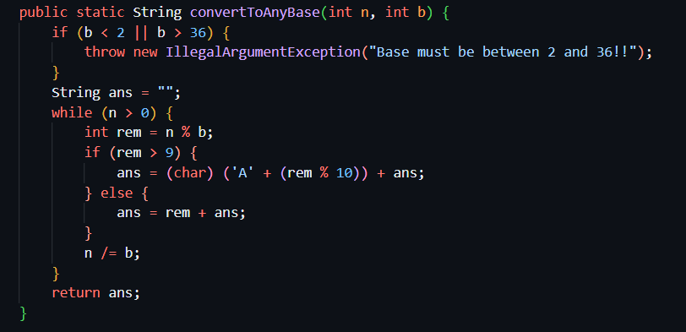

- We will check the condition for the base it must be greater than or equal to 2 and less than or equal to 36,as we know we cant convert to these bases,or we will throw a exception
- First we will create an empty String named ans
- Then we will run a while loop with the condition of number greater than 0
- Then we will calculate the remainder of the number with respect to the base we have to convert and store in a integer variable named rem
- Then we will run a conditional statement where if rem is greater than 9 we will replace it by a character as we know we cant store a 2 digit number and add this to the ans variable and add the ans variable with that
- Else we will just simply add the rem variable before and add the ans variable with that
- Then we will update the number by dividing it with base
- Atlast we will return the ans variable

Output-
Decimal 15 to binary(base 2):
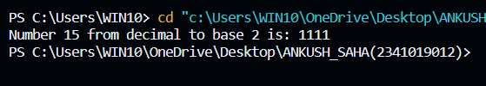
Decimal 127 to octal(base 8):
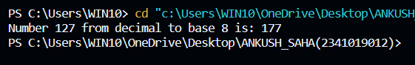
Decimal 1244 to hexadecimal(base 16):
