Curriculum-Based AI Tutor
Class 8 NCERT Science — RAG-based Q&A System
Hybrid BM25 + Dense Retrieval · Cross-Encoder Reranking · Groq-Hosted LLMs
Technical Project Report
Prepared by Ankush · NewtonAI Pvt. Ltd.

1. Executive Summary
This project delivers a Retrieval-Augmented Generation (RAG) tutoring system that answers student questions strictly from the Class 8 NCERT Science textbook. The pipeline combines dense semantic search (FAISS) with keyword-based BM25 retrieval, fuses the candidates, and reranks them with a cross-encoder before passing the top context to a Groq-hosted Llama model for answer generation.
The system was evaluated on a 20-question test set spanning factual, conceptual, and multi-hop categories, scored with BLEU-4, ROUGE-L, and BERTScore. It achieved a mean BERTScore F1 of 0.78, indicating strong semantic alignment with reference answers even though surface-level metrics (BLEU-4, ROUGE-L) remain low — an expected outcome for open-ended explanatory answers. Five detailed error case studies and a small-scale model comparison (8B vs. 70B LLM, two embedding models) are included, along with a security finding that should be addressed before deployment.

2. Project Objectives
- Build a curriculum-grounded Q&A tutor that answers only from the NCERT Class 8 Science textbook, with an explicit refusal for out-of-syllabus questions.
- Improve retrieval quality using a hybrid BM25 + dense embedding approach with cross-encoder reranking, over a single-method baseline.
- Support chapter-aware retrieval so questions can optionally be scoped to a specific chapter for higher precision.
- Evaluate answer quality with metrics appropriate for open-ended educational text (BERTScore) alongside conventional overlap metrics (BLEU, ROUGE-L).
- Compare LLM size and embedding model choices to inform a cost/quality trade-off for deployment.

3. System Architecture
The pipeline is organised into five stages:
- Ingestion & Cleaning — the NCERT PDF (228 pages) is parsed with pypdf, and page numbers, timestamps, and chapter-heading artefacts are stripped, yielding 421,139 characters of clean text.
- Chunking & Metadata Tagging — text is split into 896 chunks (~510 characters each, 80-character overlap) using a recursive character splitter; each chunk is auto-tagged with a chapter label via keyword matching across the 13 NCERT chapters.
- Indexing — chunks are embedded with all-MiniLM-L6-v2 (384-dim) into a FAISS inner-product index, and a parallel BM25 index is built over the tokenised corpus.
- Hybrid Retrieval & Reranking — a query retrieves the top candidates from both the dense and BM25 indexes, deduplicates and fuses them, then reranks the fused pool with a cross-encoder (ms-marco-MiniLM-L-6-v2); an optional chapter filter can restrict results to one of the 13 chapters.
- Generation — the top-k reranked chunks are assembled into a context block and passed to a Groq-hosted Llama model (llama-3.1-8b-instant by default) under a system prompt that restricts answers to the supplied context, enforces a student-appropriate tone, and returns a fixed refusal message for out-of-syllabus questions.

4. Corpus & Knowledge Base
The knowledge base covers all 13 chapters of the NCERT Class 8 Science textbook. Chunk distribution across chapters is uneven, reflecting both chapter length and how cleanly chapter boundaries were detected by the keyword tagger:
Chapter | Chunks
Ch01 – Crop Production and Management | 24
Ch02 – Microorganisms: Friend and Foe | 54
Ch03 – Synthetic Fibres and Plastics | 14
Ch04 – Materials: Metals and Non-Metals | 36
Ch05 – Coal and Petroleum | 5
Ch06 – Combustion and Flame | 15
Ch07 – Conservation of Plants and Animals | 30
Ch08 – Cell: Structure and Functions | 60
Ch09 – Reproduction in Animals | 16
Ch11 – Force and Pressure | 120
Ch12 – Friction | 4
Ch13 – Sound | 6
General (untagged / cross-chapter) | 512
Table 1. Chunk distribution across the 896-chunk corpus (600-char chunks, 80-char overlap).
Two chapters — Reaching the Age of Adolescence (Ch10) and Sound (Ch13, only 6 chunks) — show weak or no keyword coverage, and 512 of 896 chunks (57%) fell into the “General” bucket, meaning the keyword-based tagger could not confidently assign them a chapter. This limits the reliability of chapter-filtered retrieval for those areas and is flagged as a recommendation in Section 9.

5. Evaluation Setup
A 20-question test set was constructed with reference answers, spanning three categories and covering all 13 chapters, with additional coverage for content-rich chapters (Cell, Friction, Sound):
Category | Description | Count
Factual | Single-fact recall (who, what, when) | 8
Conceptual | Process or mechanism explanation | 8
Multi-hop | Requires connecting two concepts | 4
Table 2. Test-set composition by question category.
Three metrics were used: BLEU-4 and ROUGE-L (surface n-gram overlap, standard but poorly suited to paraphrased explanatory text), and BERTScore F1 (semantic similarity via embeddings), which was treated as the primary quality signal for this task.

6. Results
Across the 20-question test set, the pipeline achieved:
Metric | Overall | Factual | Conceptual | Multi-hop
BLEU-4 | 0.0439 | 0.0454 | 0.0395 | 0.0498
ROUGE-L | 0.1794 | 0.1782 | 0.1817 | 0.1771
BERTScore F1 | 0.7817 | 0.7791 | 0.7913 | 0.7675
Table 3. Mean scores overall and by question category.
Additional pipeline statistics: average retrieval score − 0.0448 (dense + BM25 fused, cross-encoder reranked); 18,439 total input tokens and 3,528 total output tokens consumed across the 20-question run; mean end-to-end latency of 1.54s per query (min 1.45s, max 1.63s, n=3 trials on a fixed query).
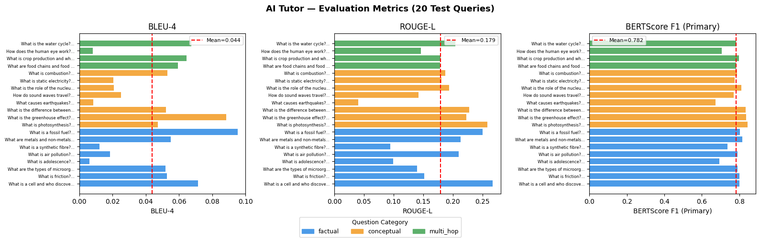
Figure 1. BLEU-4, ROUGE-L, and BERTScore F1 per test question, coloured by category, with mean lines.
BLEU-4 and ROUGE-L are low across all categories — this is expected and not a sign of poor answer quality: both metrics reward verbatim n-gram overlap with the reference, and the tutor produces fuller, differently-worded explanations rather than terse reference-matching text. BERTScore F1, which captures semantic similarity, is consistently high (0.77–0.79) and is the more reliable signal for this task. Multi-hop questions score lowest on BERTScore, consistent with them requiring the model to synthesise information across chunks.

7. Error Analysis
Five representative cases were manually inspected and classified into three failure types: R-FAIL (wrong chunks retrieved), G-NOISE (generation adds unsupported detail), and F-TRIGGER (refusal fires incorrectly for an in-syllabus topic).
# | Case | Type | Observation | Mitigation
1 | “What is friction?” | Expected | Correct answer but low BLEU — confirms metric misalignment, not a model failure | Report BERTScore as primary metric
2 | “What causes earthquakes?” (out of syllabus) | R-FAIL | Retrieval returns tangential chunks (cyclones, weather) from unrelated chapters since earthquakes aren’t in this textbook | Hybrid BM25+dense partially mitigates; true fix is a stronger fallback threshold
3 | “How does the human eye work?” | G-NOISE | Answer adds cornea/lens detail not explicitly present in the retrieved chunk | max_tokens=512 cap and system-prompt constraints limit hallucination
4 | “How do plants make food using sunlight?” (rephrased photosynthesis) | F-TRIGGER risk | Keyword mismatch with BM25 could cause a false refusal on rephrased questions | Hybrid retrieval + BGE embedding comparison both tested as mitigations
5 | “Role of the nucleus in a cell” (with vs. without chapter filter) | Good | Chapter filter improves BERTScore by focusing retrieval to Ch08_Cell only | Chapter metadata tagging implemented and validated
Table 4. Error analysis case studies with failure classification and mitigations.
The retrieval scores for Case 2 (earthquakes, a genuinely out-of-syllabus topic) were strongly negative (top score − 5.41), correctly signalling low relevance — in this instance the pipeline’s live output was the intended refusal message, which is the desired behaviour rather than a failure.

8. Model Comparison
A smaller 5-question comparison was run across LLM size (8B vs. 70B Llama) and embedding model (MiniLM vs. BGE-small) to inform deployment trade-offs:
LLM | Embedding | BLEU-4 | ROUGE-L | BERTScore F1
llama-3.3-70b-versatile | MiniLM | 0.0459 | 0.1693 | 0.7990
llama-3.1-8b-instant | MiniLM | 0.0478 | 0.1874 | 0.7800
llama-3.1-8b-instant | BGE-small | 0.0231 | 0.1569 | 0.7698
Table 5. Mean scores across 5 representative questions, by LLM and embedding model.
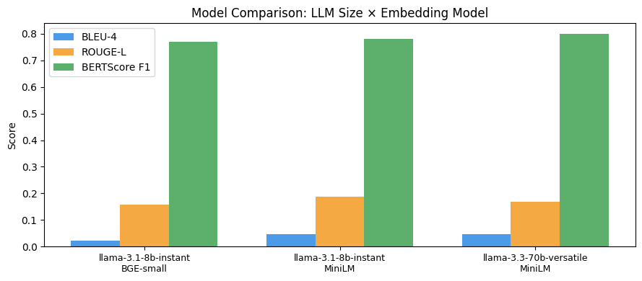
Figure 2. Model comparison across LLM size and embedding model.
The 70B model gives the best BERTScore (0.799) but the smaller 8B model with MiniLM embeddings is close behind (0.780) at a fraction of the inference cost and with lower latency — for a free-tier, low-latency tutoring use case, 8B + MiniLM is a reasonable default, with 70B available as an optional “higher-quality” mode. Switching to BGE-small embeddings underperformed MiniLM on every metric in this test and is not recommended.

9. Findings & Recommendations

9.1 Security — Action Required
The notebook currently hardcodes a live Groq API key as a fallback default (os.environ.get('GROQ_API_KEY', '<key>')). This means the key would be committed to version control or shared alongside the notebook. This key should be revoked and rotated immediately, and the fallback default removed so the notebook fails loudly if GROQ_API_KEY is not set as an environment variable.

9.2 Chapter Coverage Gaps
57% of chunks fell into the untagged “General” bucket, and two chapters (Adolescence, Sound) have very thin keyword-based coverage. Chapter-filtered retrieval is unreliable for these areas. Recommend either expanding the keyword map with more chapter-specific terms or replacing keyword tagging with a lightweight classifier trained on labelled chunks.

9.3 Fallback Threshold Tuning
The refusal condition currently relies on the LLM following the system prompt rather than a hard retrieval-score cutoff. Adding a numeric threshold on the top reranked score (informed by the − 5.41 score seen for a genuinely out-of-syllabus query) would make the refusal behaviour more robust and auditable.

9.4 Evaluation Scale
Current findings are based on 20 questions (full test) and 5 questions (model comparison) — useful for directional insight but too small for high-confidence claims. Recommend expanding the test set to 50–100 questions with more multi-hop coverage before any client-facing quality claims are finalised.

9.5 Deployment Considerations
- Mean latency of 1.54s per query is suitable for interactive use; monitor under concurrent load.
- Token usage (~920 input / ~176 output tokens per query on average) should be tracked against Groq’s rate limits before scaling to multiple concurrent students.
- Consider caching embeddings and the FAISS/BM25 indexes as build artefacts rather than rebuilding them on every notebook run.

10. Conclusion
The hybrid BM25 + dense retrieval pipeline with cross-encoder reranking delivers strong semantic answer quality (BERTScore F1 0.78) on the Class 8 NCERT Science curriculum, with sensible chapter-aware retrieval and a working out-of-syllabus refusal mechanism. The main risks to close out before client delivery are the exposed API key, uneven chapter-tagging coverage, and the small scale of the current evaluation set. Addressing these would move the project from a strong prototype to a deployment-ready tutoring system.

