RAG Chatbot
Project documentation
A chatbot that answers questions from a large private library of PDFs, with the file and page behind every answer. It runs locally on an open-source stack.

Version 1.0
31 October 2026

Contents
1. Overview 3
1.1 What it is 3
1.2 Objective and how it is met 3
1.3 Live demo checklist 3
1.4 Technology 4
2. Getting started 5
2.1 Run the chatbot 5
2.2 Share a public link 5
2.3 Install from scratch 5
2.4 Using the interface 5
2.5 Chat memory 6
3. Architecture 7
3.1 System overview 7
3.2 Hardware placement 7
3.3 Code structure 8
4. Document ingestion 9
4.1 Pipeline 9
4.2 When OCR runs 10
4.3 Repairing broken ligatures 10
4.4 Chunking rules 11
5. Answering questions 12
5.1 End-to-end flow 12
5.2 Chat routing 12
5.3 Retrieval 13
5.4 Generation 15
5.5 Verification 15
6. Data model and storage 16
7. Key design decisions 17
8. Evaluation and results 18
8.1 How to run it 18
8.2 The question set 18
8.3 Metrics 18
8.4 Results 18
8.5 What these metrics cannot show 19
8.6 Latency budget 20
8.7 Demo corpus 20
9. Operations 21
9.1 Commands 21
9.2 Add or update documents 21
9.3 Configuration 21
9.4 Use a hosted language model 22
9.5 Read collected feedback 22
9.6 Troubleshooting 22
10. API reference 24
10.1 Endpoints 24
10.2 Asking a question 24
10.3 The answer object 25
11. Development 26
11.1 Tests 26
11.2 Where to change things 26
11.3 Extending the system 26
11.4 Changing pipeline logic 27
12. Security and limitations 28
12.1 Security 28
12.2 Limitations 28

1. Overview

1.1 What it is
RAG Chatbot lets you ask questions in plain language and get short answers drawn only from a private library of large PDFs. Each answer cites the file and page it came from, and clicking a citation opens that page with the source passage highlighted. If the documents do not cover a question, the chatbot says so rather than guessing.
Everything runs on the local machine using free, open-source models and databases. Document text does not leave the computer, unless you choose to connect a hosted language model.

1.2 Objective and how it is met
Requirement | How it is met
At least 10 PDFs of at least 200 pages | Demo corpus of 10 PDFs and 7,086 pages. The smallest has 244 pages.
Native text extraction | PyMuPDF reads text layers, including block positions.
OCR for scans and embedded images | RapidOCR (PP-OCR on ONNX) reads scanned pages and text inside figures.
Clean and normalize | Unicode normalization, hyphenation repair, header and footer removal, contents and index page filtering, language detection, and repair of broken font ligatures.
Chunk with overlap and metadata | Deterministic sentence-aware chunks of up to 500 tokens with 15 to 30% overlap, keeping file, page range, section and bounding boxes.
Open-source embeddings | BAAI/bge-base-en-v1.5 (MIT license), persisted to the vector database.
ANN index | ChromaDB (Apache-2.0) with an HNSW index.
Reranking | Hybrid vector and BM25 retrieval, refined by the cross-encoder ms-marco-MiniLM-L-6-v2 on focused excerpts.
Generation with provenance | Qwen 2.5 3B through Ollama. Citations resolve to file and page and are checked after generation.
2 to 5 second latency | Warm GPU-hosted model, precomputed indexes and a strict context budget. See section 8.
Evaluation | Built-in measurement of p95 latency, Recall@k, MRR, citation accuracy and hallucination rate.
Reproducibility | Content hashes, settings fingerprints, deterministic chunk IDs and a fixed LLM seed.

1.3 Live demo checklist
The demo must show | Where to see it
PDFs ingested into a vector database with open-source embeddings | Click How it works: 10 PDFs, 7,086 pages, bge-base-en-v1.5, ChromaDB.
Questions through a chat interface | The message box, or the API in section 10.
Real-time retrieval | Every question searches the vector and keyword indexes live.
Answers within 2 to 5 seconds | The time under each answer, and measured results in section 8.4.
Source references (PDF name and page) | The Sources list under each answer.
Ingestion pipeline | Click How it works in the left panel.
Retrieval visualization (top chunks) | Open Top 8 retrieved passages under an answer.
Final answer with citations | The answer text with numbered markers linked to the source pages.

1.4 Technology
Layer | Choice | License
Language and web | Python 3.11, FastAPI, Uvicorn | PSF, MIT, BSD
PDF parsing | PyMuPDF | AGPL-3.0
OCR | RapidOCR | Apache-2.0
Embeddings | bge-base-en-v1.5 via fastembed | MIT, Apache-2.0
Vector database | ChromaDB (HNSW) | Apache-2.0
Keyword index and metadata | SQLite FTS5 (BM25) | Public domain
Reranker | ms-marco-MiniLM-L-6-v2 | Apache-2.0
LLM runtime and model | Ollama, Qwen 2.5 3B | MIT, Qwen Research license
Inference runtime | ONNX Runtime with DirectML on Windows | MIT

PyMuPDF's AGPL license matters if you distribute this software or offer it as a network service. The Qwen 3B model license restricts commercial use, so check it, or switch models with one setting, before commercial deployment.

2. Getting started

2.1 Run the chatbot
With the demo corpus already indexed, you need just two commands. Open a terminal and run:
cd "D:\RAG Chatbot"
uv run ragbot serve
When the terminal shows that the server is running, open http://127.0.0.1:8000 in your browser. The page only works through this address, because the server does the answering. Opening index.html directly will not work. Ollama must also be running; it normally starts with Windows.

2.2 Share a public link
To let anyone use the chatbot through a link, run this instead of serve. It needs no account and costs nothing:
uv run ragbot share
The terminal prints a link ending in trycloudflare.com. A new link can take up to a minute to start working everywhere.
- The link only works while this computer is on and the command is running. Your GPU does the answering, which is what keeps answers fast.
- The link changes each time you restart the command, so share the new one.
- Visitors reach only the chatbot, not your files. Each browser sees only its own chats, and each visitor is limited to 12 questions a minute.
- Questions take turns, because all visitors share one AI model. Several at once will be slower.
- It needs the cloudflared tool on your PATH or at data/tools/cloudflared.exe. It is a free download from Cloudflare's GitHub releases page.

2.3 Install from scratch
You need Python 3.11, uv, Ollama and about 10 GB of free disk. A GPU with at least 4 GB of memory is needed to reach the latency target.
- Install the Python dependencies: uv sync
- Download the language model: ollama pull qwen2.5:3b
- Add PDFs to data/pdfs, or fetch the demo corpus: uv run ragbot download-corpus
- Build the search index: uv run ragbot ingest
- Start the chatbot: uv run ragbot serve
Unchanged PDFs are skipped by ingest, so it is safe to re-run. Only one ragbot process should use the index at a time, so stop serve before running ingest from the command line.

2.4 Using the interface
Control | What it does
Message box | Ask a question. Enter sends, and Shift + Enter adds a new line.
Documents dropdown | Choose All documents, or one PDF to search only that file.
New chat | Starts a fresh conversation with no memory of the current one.
Chats list | Reopens any earlier chat. Chats are saved and survive restarts.
Delete chat | Point at a chat and click the bin icon, then click Delete? to confirm.
Sources | Listed after each answer with file name and page. Click one, or a numbered marker in the text, to see the PDF page with the passage highlighted.
Retrieved passages | Open the panel under an answer to see the top 8 passages it was built from, with their match scores and search ranks. Passages given to the AI model are highlighted.
How it works | Opens the ingestion pipeline (PDF to chunks to embeddings to vector database), with the real numbers for this library.
Like and dislike | Record feedback on an answer. Click again to clear it.

2.5 Chat memory
- Follow-ups work. After "What does git reset do?", you can ask "Why is it dangerous?".
- Repeated questions stay consistent. Asking the same thing again in a chat returns the same answer and says you asked it earlier.
- It can recall the chat. Try "What was my last question?", "What was my first question?" or "What have I asked so far?".
- Each chat is separate. A new chat does not remember other chats.

3. Architecture

3.1 System overview
The application is one Python process plus Ollama, with two separate paths. Ingestion runs offline, turning PDFs into searchable passages. It is slow, and it runs once per document. Answering runs online, turning a question into a cited answer. It only reads precomputed indexes, which is what makes it fast.
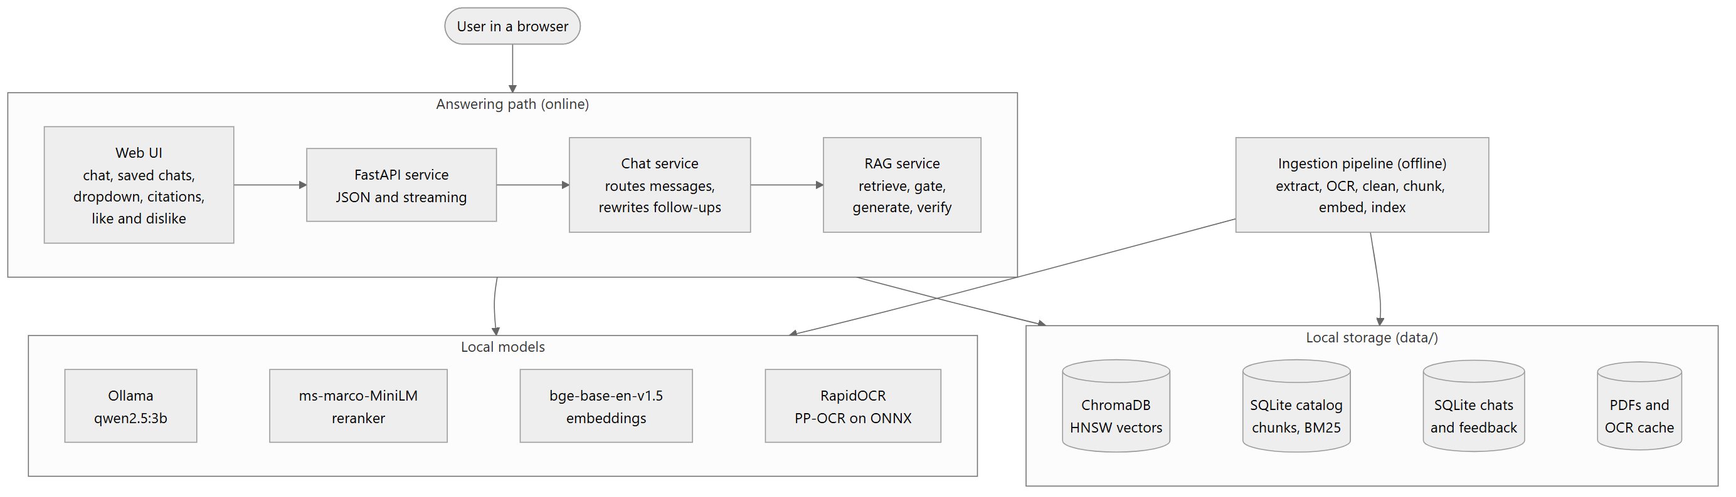
Figure 1. System architecture

3.2 Hardware placement
The 4 GB GPU is dedicated to the language model while serving. Query embedding and reranking run on the CPU. Reranking was first moved to the GPU, which was fast on a quiet machine but stalled for tens of seconds when the GPU was shared, so it stays on the CPU, where its time is steady. During indexing, the GPU does bulk embedding, which measured about 30 times faster than the CPU on this machine (45 passages per second against about 1.4 under load). All 10 PDFs re-index in about 5 minutes once OCR results are cached.
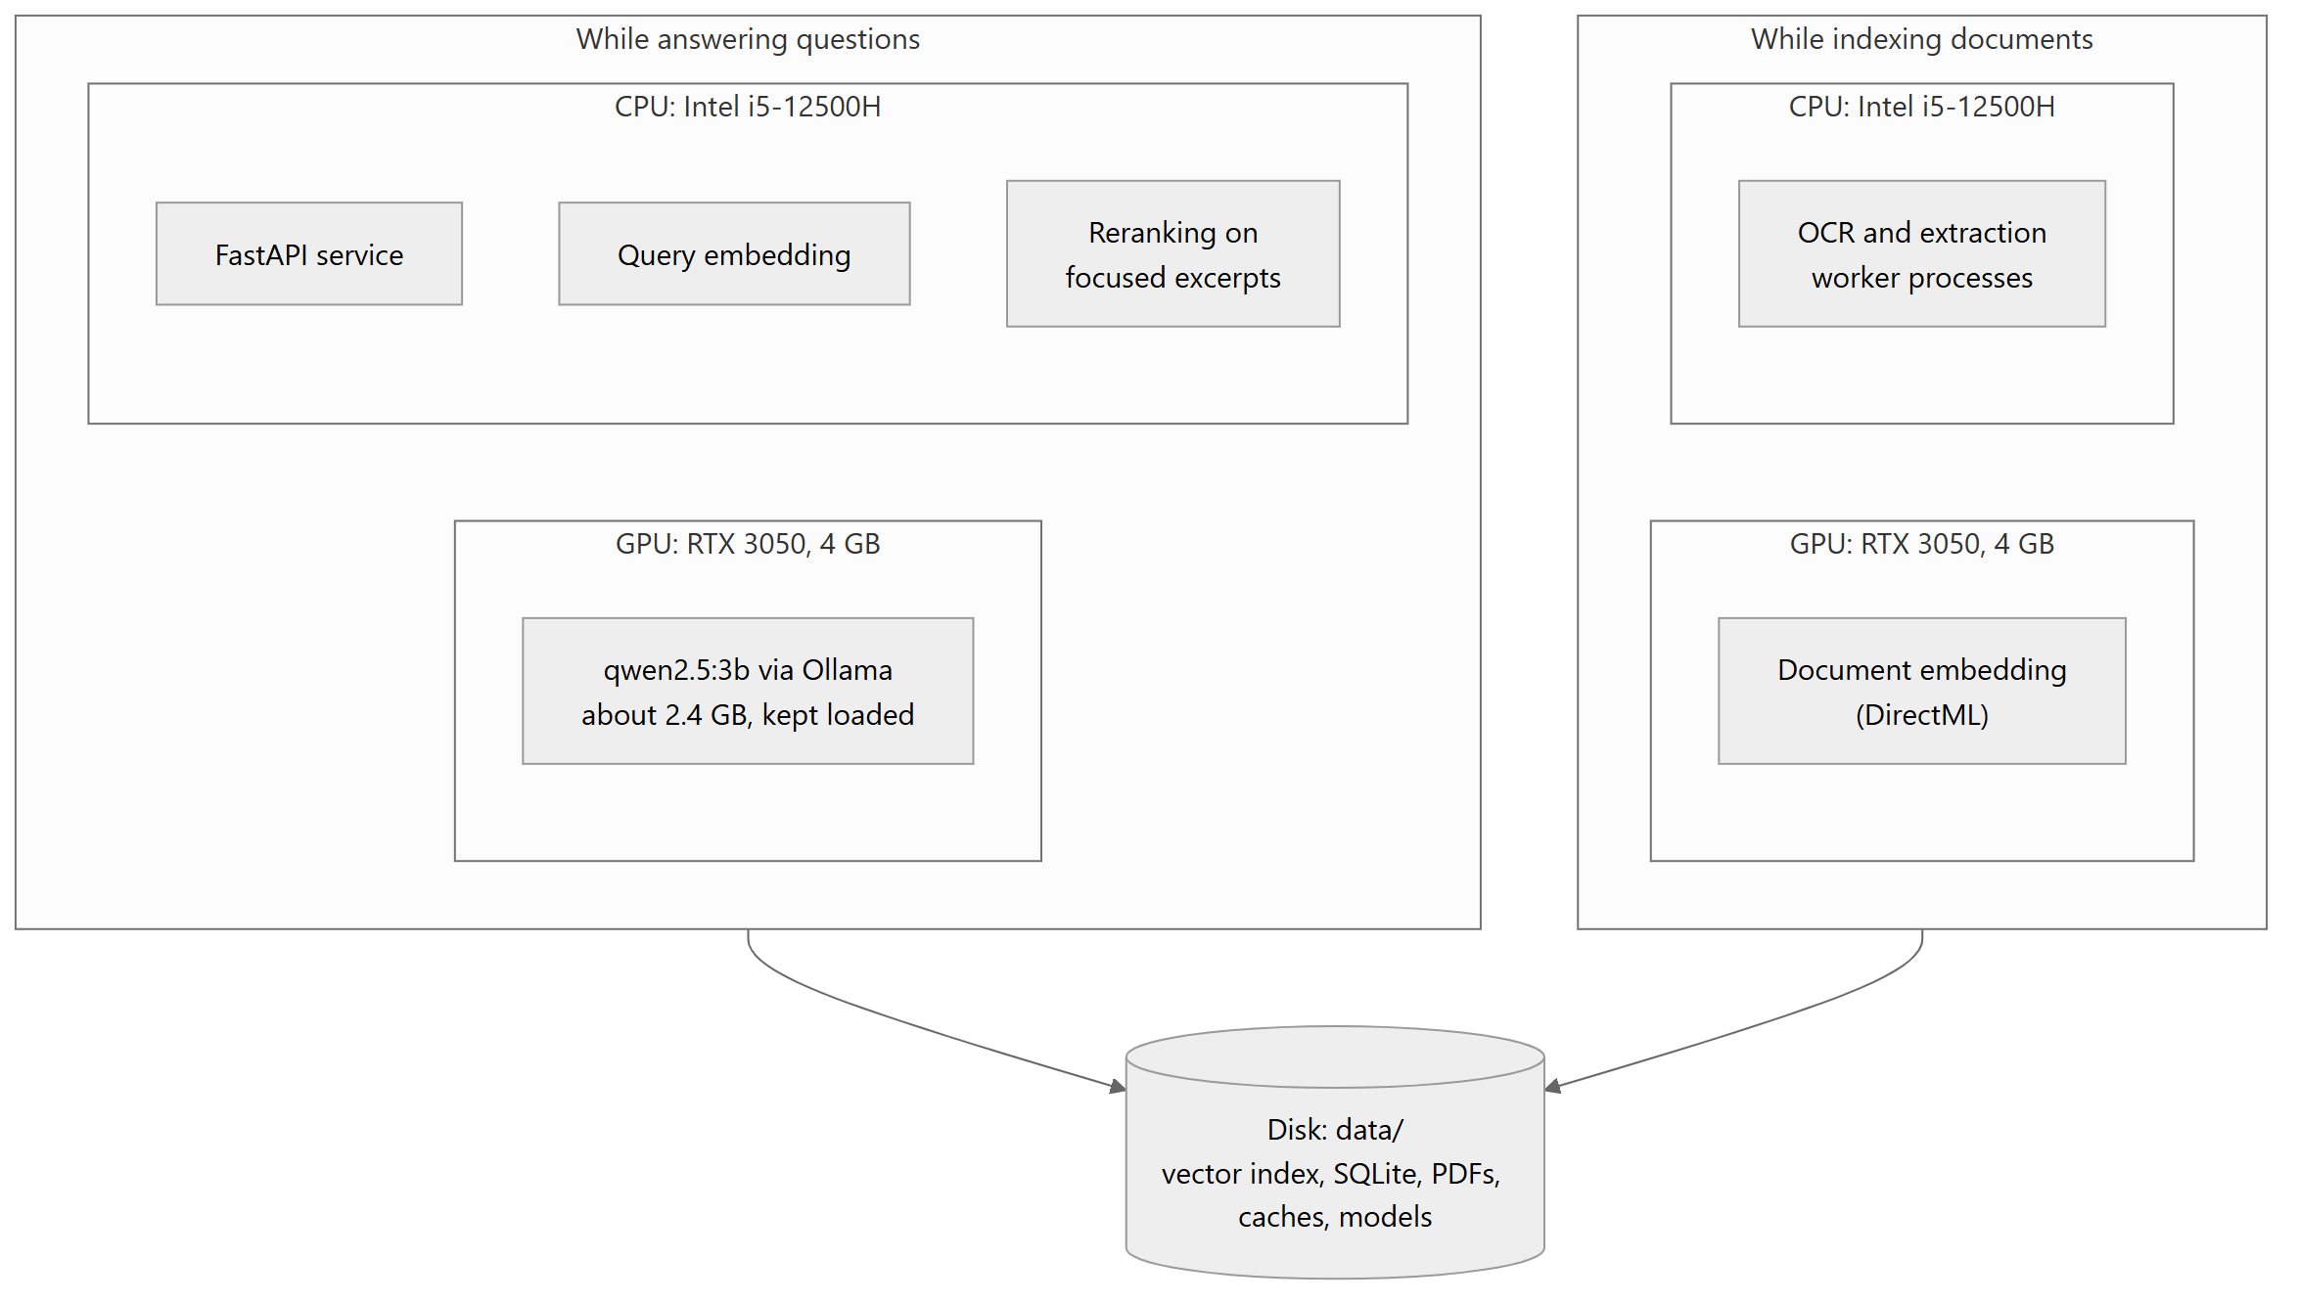
Figure 2. Where each workload runs

3.3 Code structure
src/ragbot/
config.py every setting, overridable with RAGBOT_* variables
domain.py shared data structures
models.py embedding and reranking models
retrieval.py hybrid search, fusion and reranking
service.py retrieve, gate, generate, verify
chat.py chat routing, follow-ups, repeats, recall
cli.py the ragbot command
ingestion/ extract, OCR, clean, chunk, orchestrate, corpus download
generation/ LLM clients, prompts, answer verification
storage/ SQLite catalog, chat store, ChromaDB wrapper
evaluation/ metrics, evaluation runner, OCR accuracy
api/ FastAPI app and the web interface in static/
corpus/manifest.json demo corpus sources and licenses
eval/golden.jsonl evaluation questions with expected file and page
tests/ unit, integration and live scenario tests
data/ PDFs, indexes, caches, models and chats (not in git)

4. Document ingestion

4.1 Pipeline
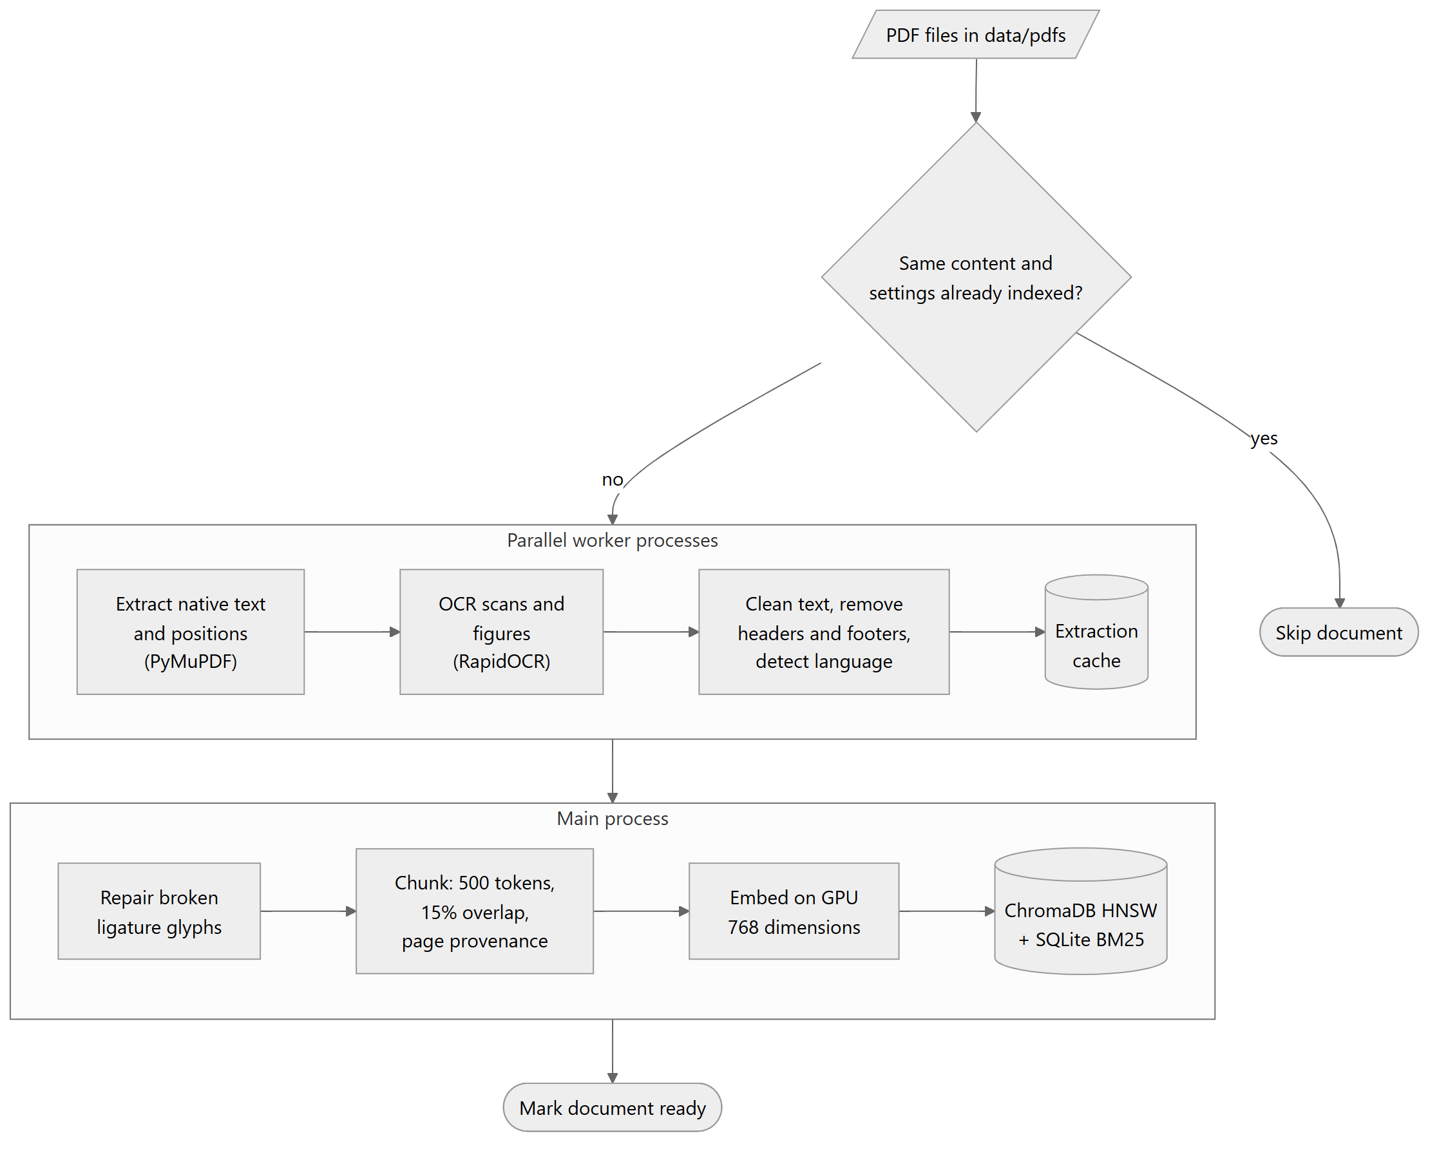
Figure 3. Ingestion pipeline
- Hash. The SHA-256 of the file and a fingerprint of the settings decide whether the work is already done.
- Extract and OCR. Worker processes read each page. Results are cached by content hash, so re-indexing never repeats OCR.
- Clean. Repeated margin text and page numbers are removed, text is normalized, and contents and index pages are set aside because they attract false matches.
- Repair. Broken ligature glyphs are restored (section 4.3).
- Chunk. Sentences are grouped into overlapping passages.
- Embed. The document title and section are embedded with the text, which separates passages that read alike out of context.
- Index. Vectors go to ChromaDB. Text and metadata go to SQLite with an FTS5 keyword index.
A document is marked ready only after all stores are written. If a run crashes, the next run clears the partial data and repeats that document.

4.2 When OCR runs
Native text is preferred because it is exact and fast. OCR handles pages that are really images, pages with a garbled text layer, and text inside figures. OCR output from charts and photos is usually noise, so it is kept only when it looks like prose.
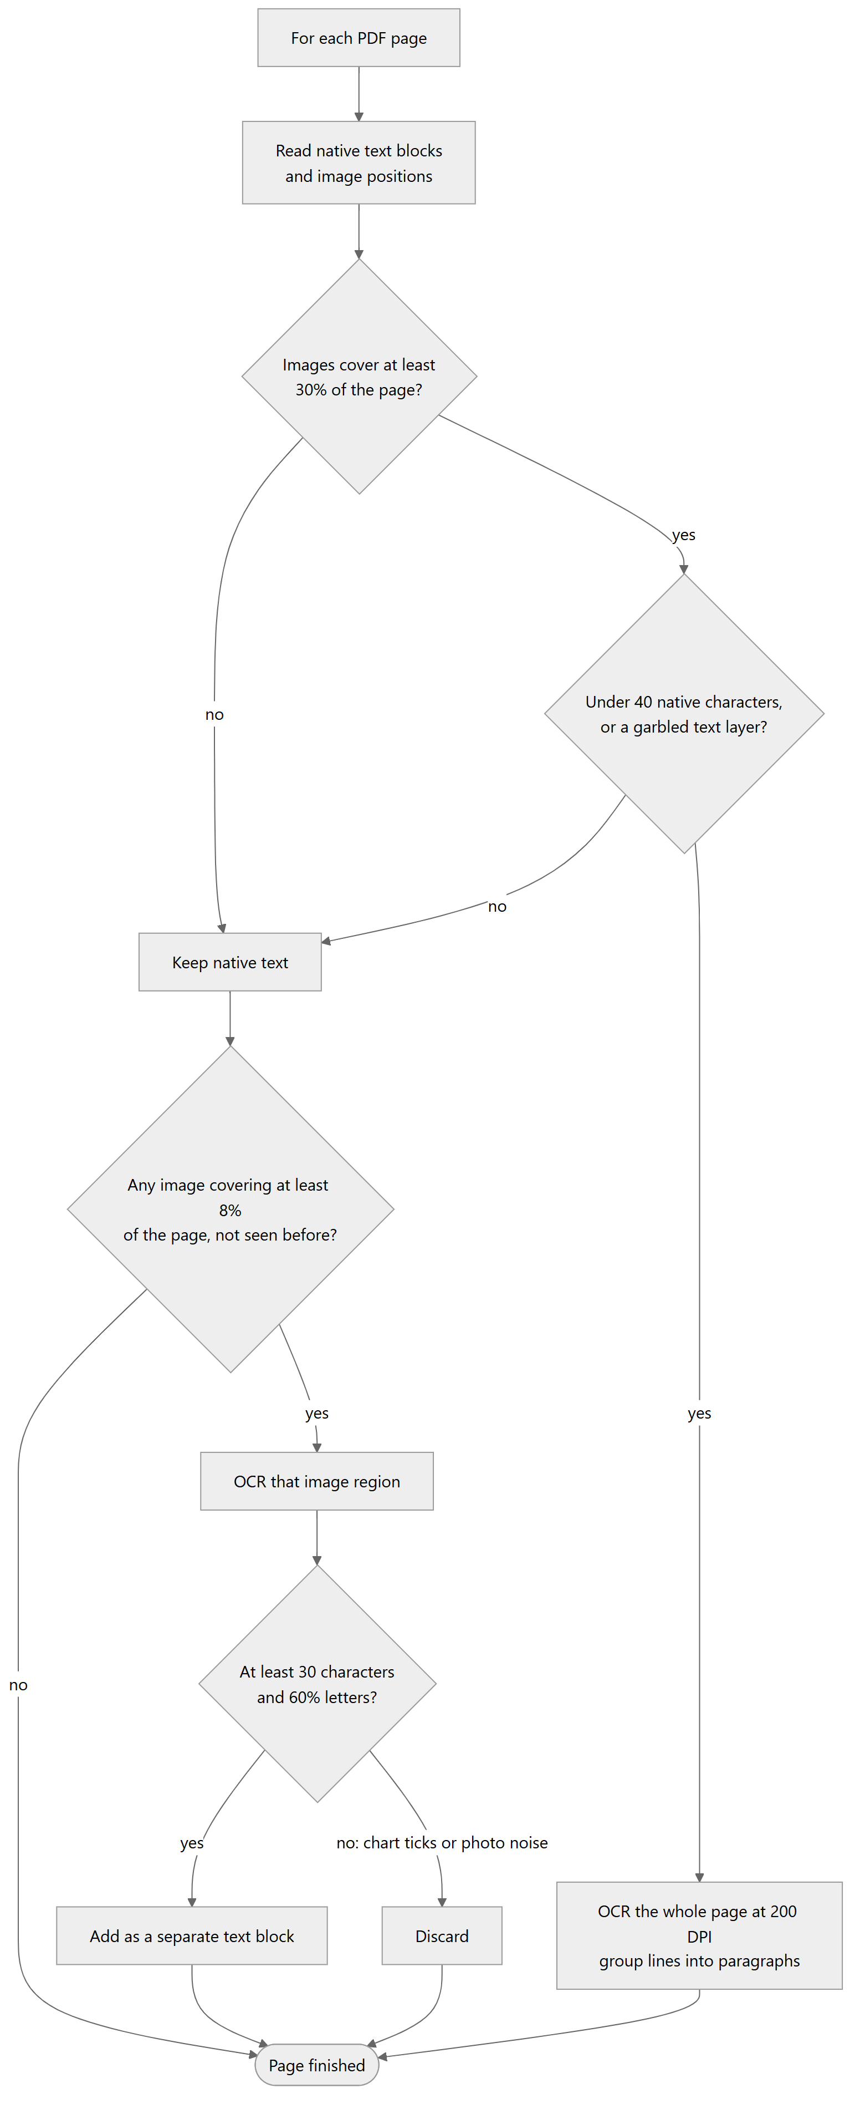
Figure 4. OCR decision for each page

4.3 Repairing broken ligatures
Some PDFs export ligatures such as "ti" as Private Use characters with no Unicode meaning. NIST SP 800-53A was affected: "contingency" extracted with a missing "ti", across thousands of words. Left alone, this would quietly break search on a 733-page document.
The repair needs no per-font table. For each unknown glyph, it tries the common ligatures and picks the one that turns the most damaged words into words the same document also contains intact, for example from an uppercase heading.

4.4 Chunking rules
Rule | Value | Reason
Maximum size | 500 tokens, counted with the embedding model's tokenizer | Matches the model's 512-token input limit, so nothing is lost when embedding.
Overlap | 15 to 30% | A fact near a boundary stays whole in at least one passage. Long sentences are split first, which keeps overlap in this range.
Boundaries | Whole sentences, and a new chunk at each new section | Passages stay readable, and sections are not mixed.
IDs | Hash of document, position and settings | The same input always produces the same chunks.
Provenance | Page range, plus text offsets and a bounding box per block | Lets a citation resolve to the exact page and highlight the block.

5. Answering questions

5.1 End-to-end flow
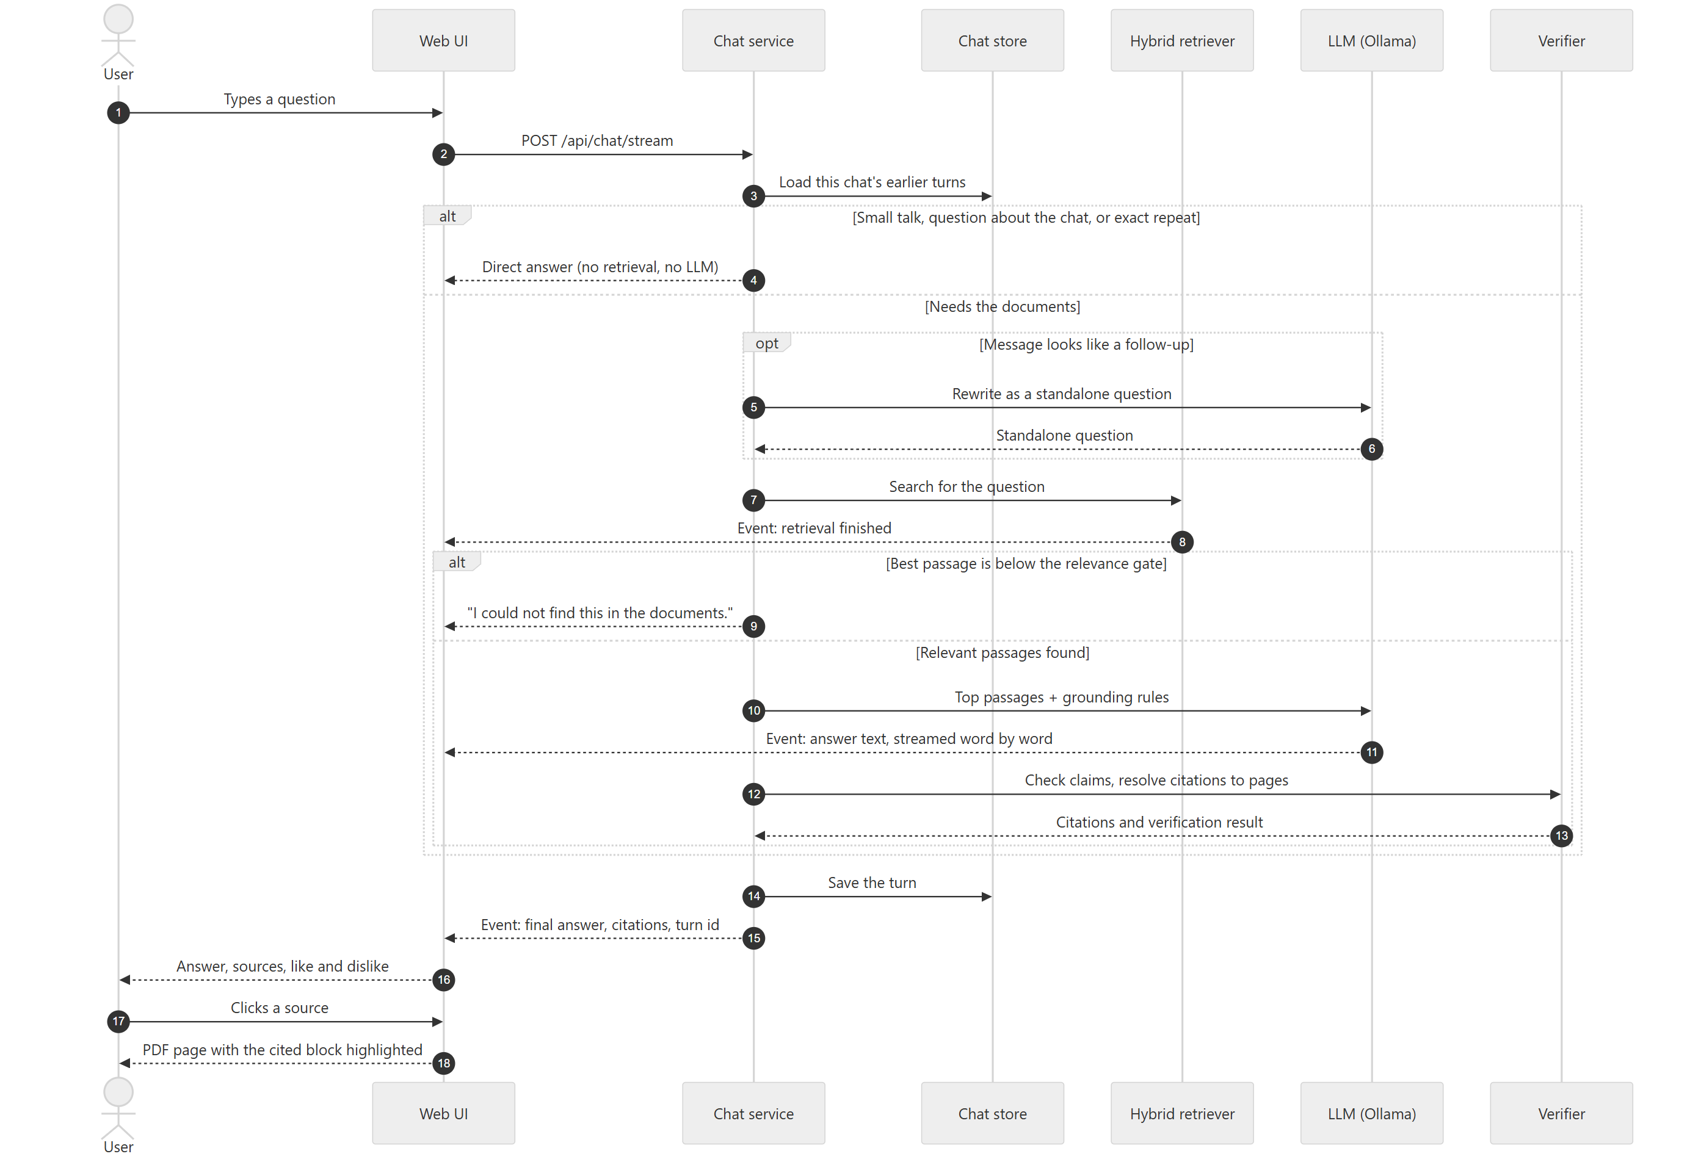
Figure 5. What happens when you ask a question

5.2 Chat routing
Messages that do not need the documents are handled first, without the language model. These answers are exact and instant, and they cannot hallucinate.
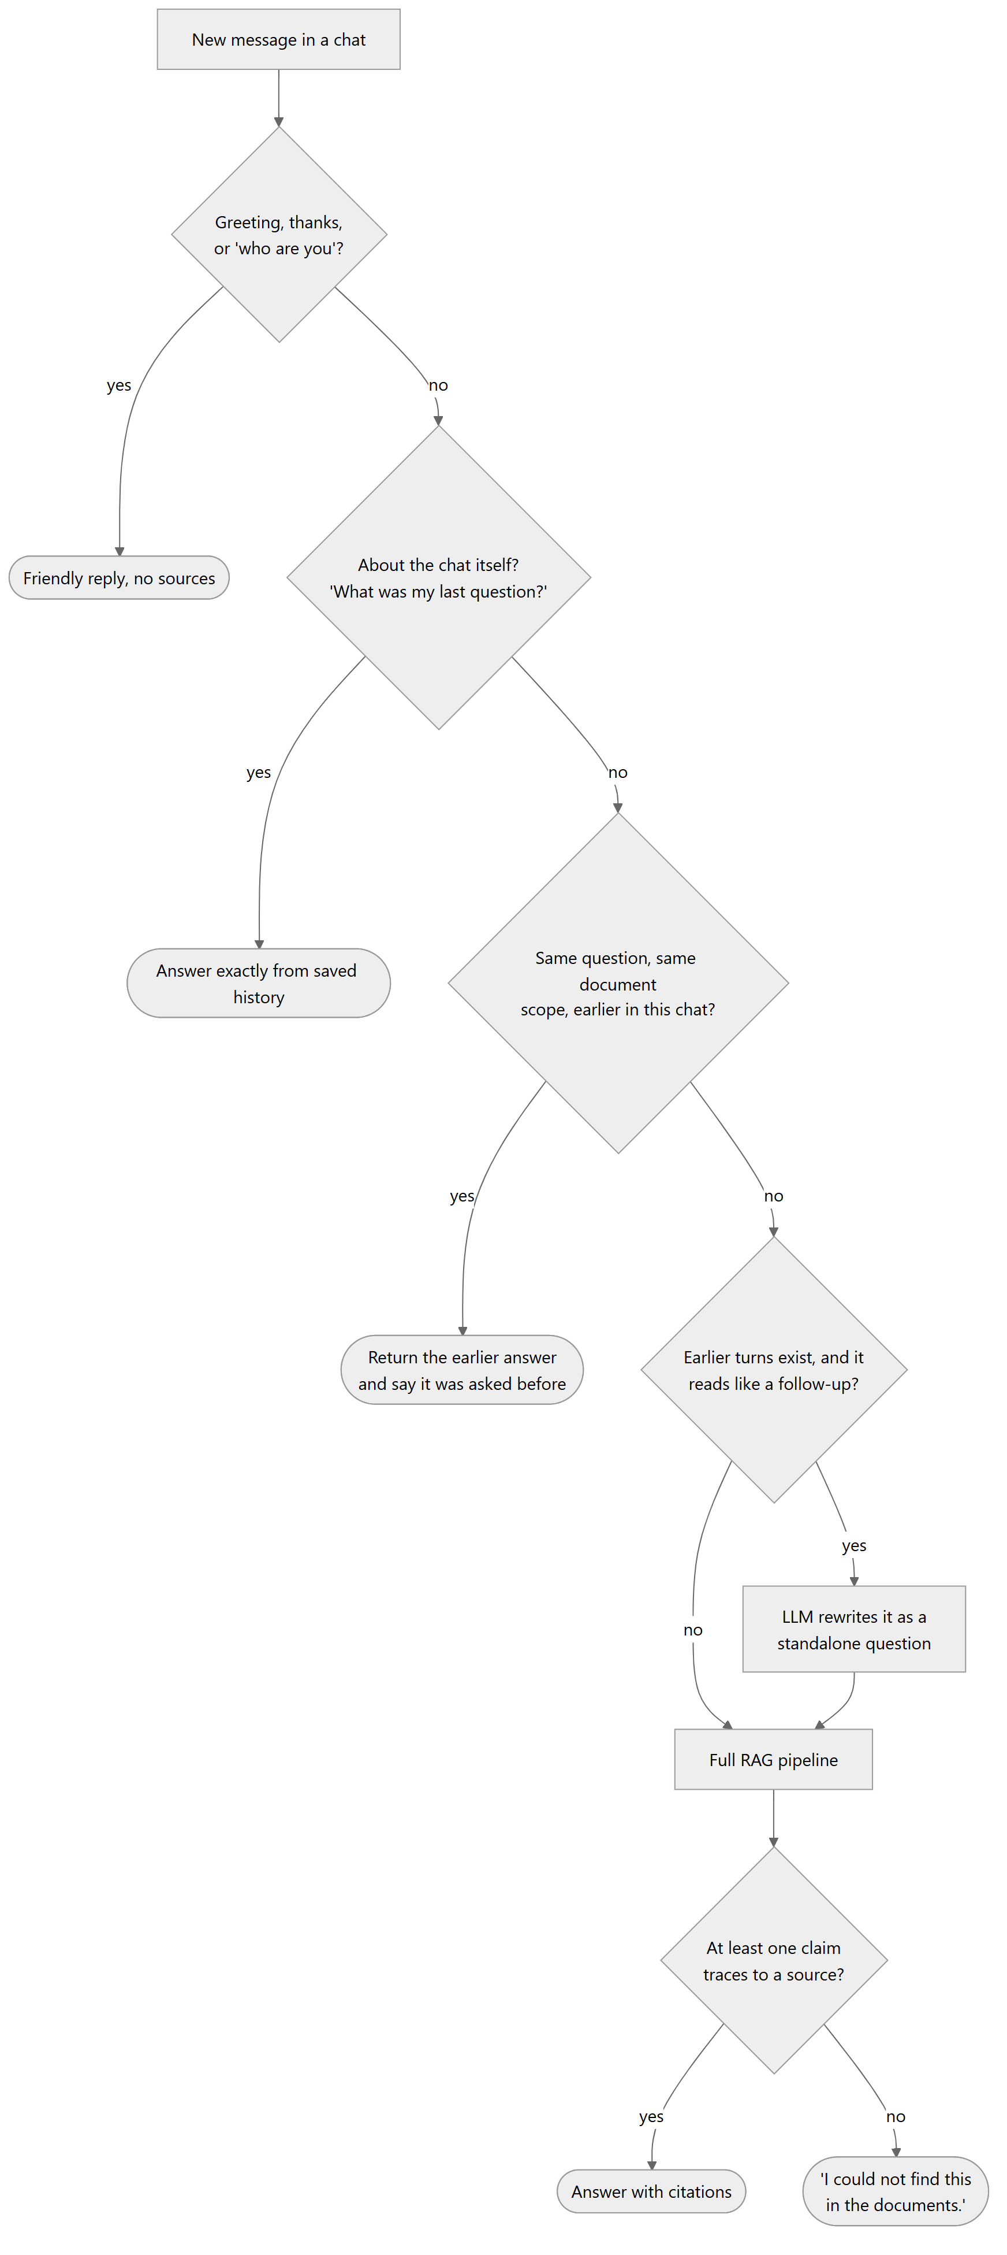
Figure 6. How each message is routed
Follow-ups are rewritten into a standalone question before searching. "Why is it dangerous?" cannot find anything by itself, but "Why is git reset --hard dangerous?" can. The answering model then sees only that standalone question and the sources, so earlier chat text cannot leak into an answer as if it were a documented fact.

5.3 Retrieval
The two search methods have opposite strengths. Vector search finds meaning when the wording differs. BM25 finds exact terms such as SI-07(13) or --hard, which embeddings often blur. Reciprocal rank fusion combines their rankings without needing comparable scores. The cross-encoder then reads each question and passage pair together, which is more accurate but too slow to run on the whole corpus.
- Named documents. A question naming a document, such as "NIST SP 800-82", searches only that PDF. The name is then dropped from the search text, because it appears throughout the document and would otherwise outweigh the words that describe what the user wants. This gives the same result whether All documents or that PDF is selected.
- Exact phrases. Adjacent words are also searched as a phrase, so "discrete process" outranks passages that merely contain either word.
- Focused excerpts. The reranker reads only the best 700 characters of each passage rather than the whole 500 tokens. This was both more accurate and about three times faster, because the model is not distracted by the rest of the passage.
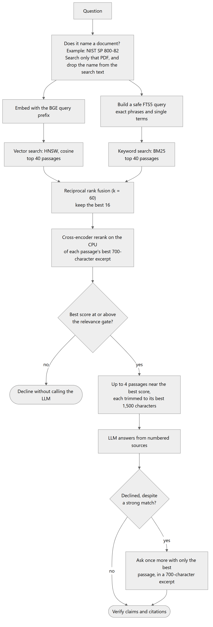
Figure 7. Retrieval funnel

5.4 Generation
The prompt gives the model numbered sources and these rules: use only the sources, cite every sentence, keep exact terms, and reply with a fixed sentence if the answer is not there. It also tells the model to ignore instructions inside the sources, which reduces prompt injection risk from document text. Temperature is 0 and the seed is fixed.
Each source is trimmed to its most relevant 1,500 characters, with the best source placed last, next to the question. If the model declines despite a strong match, it is asked once more with only the best passage in a 700-character excerpt, because a small model can miss an answer surrounded by other text. Removing its ability to decline on that retry was also tested. It answered more questions but more than doubled the wrong answers, so the option to decline stays.

5.5 Verification
After generation, each sentence is checked against the sources it cites.
Check | Result if it fails
Citation points to a real source | The marker is removed.
Numbers in the sentence appear in the cited source, the question or the document's name | The sentence is flagged. A wrong figure can read like a good paraphrase, so numbers are checked strictly.
Content words appear in the source, or the sentence is semantically close to a source sentence | The sentence is flagged, and the user sees a note to check the page.
Sentence has no citation but a source supports it | The citation is added automatically.
No claim in the answer traces to any source | The whole answer is replaced with "I could not find this in the documents."

Citations resolve to the block that best matches the claim, so a passage spanning two pages still cites the right one. This is a lexical and semantic check, not a proof of truth. It catches fabricated facts and wrong numbers well, but a subtly wrong sentence built from words in the source can still pass.

6. Data model and storage
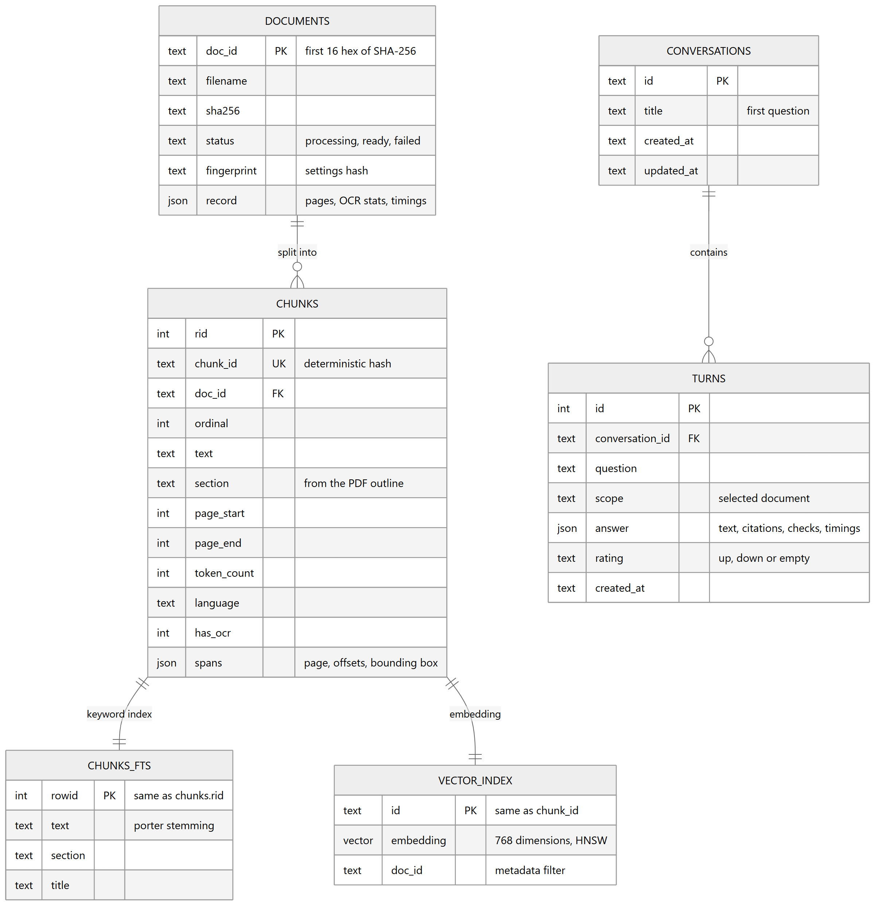
Figure 8. Data model
The catalog and vector index can be rebuilt from the PDFs. Chats live in a separate database, so re-indexing never touches them.
Path | Contents | If deleted
data/pdfs/ | PDFs to index and display | Page previews fail, and documents must be supplied again.
data/raw/ | Original demo corpus downloads | download-corpus fetches them again.
data/cache/ | Extraction and OCR results | The next index repeats OCR, which is slow.
data/index/ | Vector index and catalog | Run ingest to rebuild.
data/chat/ | Chats and feedback | Chats and feedback are lost.
data/models/ | Downloaded model files | Downloaded again on next use.

Back up data/pdfs and data/chat. Everything else can be regenerated.

7. Key design decisions
Decision | Chosen | Alternatives | Why
Vector DB | ChromaDB embedded | Qdrant, Milvus, FAISS | Real HNSW with persistence and no separate server. Isolated behind one class, so it can be swapped.
Keyword search | SQLite FTS5 | rank-bm25, Elasticsearch | Built into Python, updates incrementally, answers in milliseconds, and also stores chunk text.
Embedding | bge-base-en-v1.5 | bge-small, bge-m3 | Better retrieval than the small model, and still fast on CPU for short queries.
Reranker | MiniLM-L-6 on CPU, over focused excerpts | Full passages, GPU, bge-reranker | Steady latency and better measured accuracy. The GPU stalled when shared with the LLM.
OCR | RapidOCR | Tesseract | Installs with pip with no system dependency, and runs from ONNX models.
LLM | Qwen 2.5 3B | qwen3:4b, llama3.2:3b, hosted APIs | Fits fully in 4 GB of VRAM at 65 to 75 tokens per second. qwen3:4b (3.6 GB loaded) and llama3.2:3b (3.1 GB loaded) both spilled onto the CPU. Hosted endpoints are one setting away.
Follow-ups | Rewrite when needed | Send the full history every time | Standalone questions search better, and standalone turns skip the extra cost.
Hallucination control | Refuse and verify | Trust the prompt alone | Prompts reduce invention but do not prevent it. Checking the output catches much of what remains.

8. Evaluation and results

8.1 How to run it
Stop the server first, then run:
uv run ragbot evaluate
uv run ragbot evaluate-ocr
Reports are written to the reports folder. Use uv run ragbot evaluate --retrieval-only for a fast check that skips the language model. Do not use the chatbot during a run, because all questions share one model and queue behind each other, which distorts the timings.

8.2 The question set
- Answerable questions were written by reading pages picked by a seeded random sampler across all 10 PDFs, which avoids favoring famous or easy passages. Each records the file, the page and the facts a correct answer must contain.
- Unanswerable questions are ones the corpus does not cover, such as "What is the boiling point of liquid nitrogen?". The correct behavior is to decline.
The questions were written by the system's author, and the search settings were tuned on the same set, so results may be somewhat optimistic for new documents. Three answer keys were loosened after correct answers used different wording. Treat results as a strong sanity check rather than an independent benchmark. The set is small enough that one question moves a percentage by nearly 2 points.

8.3 Metrics
Metric | Definition
Latency p50 and p95 | Time from question to finished answer on a warm server. p95 means 95% of answers finish within this time.
First word p95 | Time until the answer starts to appear.
Recall@k | Share of answerable questions with a passage from the right file and page in the top k.
MRR | Mean reciprocal rank. 1.0 means the right passage always ranks first.
Answer accuracy | Share of answerable questions where the answer contains every required fact.
Citation accuracy | Share of citations pointing to the expected file and page.
Hallucination rate | Share of all questions where an answerable one got a wrong or unsupported answer, or an unanswerable one was answered rather than declined.
Unanswerable refusal rate | Share of unanswerable questions correctly declined.
OCR word accuracy | Words recovered by OCR compared with the original text layer of the same document.

8.4 Results
Measured on 2026-10-31 with 69 questions (57 answerable, 12 unanswerable), using qwen2.5:3b on an NVIDIA RTX 3050 Laptop GPU with 4 GB of memory.
Measure | Result | Target
Total latency p50 | 1.99 s | Within 2 to 5 s
Total latency p95 | 3.04 s | Up to 5 s
Slowest question | 4.55 s
Answers within 5 s | 100.0%
First word p95 | 2.63 s
Retrieval latency p95 | 2012 ms
Recall@1 | 96.5%
Recall@3 | 100.0%
Recall@5 | 100.0%
Recall@8 | 100.0%
MRR | 0.983
Answer accuracy | 86.0%
Answerable questions declined | 4
Citation accuracy | 92.7%
Hallucination rate | 5.8% | Lower is better
Unanswerable questions declined | 100.0%
OCR word accuracy | 97.1% over 20 pages

Reading these results
- Speed target met. All 69 answers finished within 5 seconds on an otherwise idle GPU. Other programs using the GPU, or several questions at once, slow this down, because every question shares one model.
- Search is strong. The right passage was in the top 3 for 100.0% of answerable questions.
- Not all answers are right. 4 of 57 answerable questions were declined even though the documents hold the answer, and the hallucination rate means 4 of 69 questions got a wrong or partly unsupported answer. Most of the remaining errors come from the small 3 GB language model rather than from search, so a larger model on a bigger GPU is the most direct way to improve them.
- Off-topic questions. All 12 questions the documents do not cover were correctly declined.
- Check important answers. Accuracy is high but not 100%, which is why every answer links to its source page.

8.5 What these metrics cannot show
- Answer accuracy matches required phrases, so a correct answer in different words can count as wrong, and a wrong answer containing the phrases can count as right.
- Citation accuracy can undercount, because the same fact may also appear correctly on another page.
- The scanned demo document is a rasterized digital PDF. It is cleaner than a real paper scan, so OCR accuracy here is an upper bound.

8.6 Latency budget
These are design figures. Measured results are in section 8.4.
Stage | Budget
Query embedding, vector and keyword search | Under 100 ms
Reranking 16 focused excerpts on CPU | About 800 ms
LLM reads about 1,000 tokens at about 2,000 tokens per second | About 0.5 s
LLM writes about 100 tokens at about 70 tokens per second | About 1.5 s
Verification | Under 100 ms
Follow-up rewrite, only when needed | About 0.5 s

8.7 Demo corpus
Document | Pages | OCR pages | Figures read | Passages | License
Dive into Deep Learning | 1,151 | 0 | 35 | 1,795 | CC BY-SA 4.0
FAA Instrument Flying Handbook 8083-15B | 371 | 2 | 224 | 611 | US Government work
NASA Systems Engineering Handbook Rev2 | 297 | 0 | 0 | 403 | US Government work
NIST SP 800-161 r1 Supply Chain Risk Management | 327 | 0 | 9 | 467 | US Government work
NIST SP 800-53A r5 Security Control Assessment | 733 | 0 | 4 | 1,104 | US Government work
NIST SP 800-82 r3 OT Security Guide | 316 | 0 | 19 | 363 | US Government work
Pro Git 2e | 501 | 1 | 157 | 634 | CC BY-NC-SA 3.0
Think Python 2e | 244 | 244 | 0 | 259 | CC BY-NC 3.0
Think Stats 2e | 264 | 0 | 0 | 237 | CC BY-NC-SA 4.0
US Constitution Annotated 2017 | 2,882 | 0 | 0 | 4,757 | US Government work

In total: 7,086 pages and 10,630 passages. Think Python was rasterized to image-only pages to exercise OCR, with its original text layer kept as ground truth for measuring OCR accuracy.

9. Operations

9.1 Commands
Command | Purpose
uv run ragbot serve | Start the web app and API on http://127.0.0.1:8000.
uv run ragbot share | Start the chatbot and a free public link to it.
uv run ragbot ingest | Index new or changed PDFs in data/pdfs.
uv run ragbot ingest --force | Re-index every PDF. OCR results are reused from the cache.
uv run ragbot documents | List indexed documents, their statistics and any failures.
uv run ragbot ask "question" | Ask one question from the terminal.
uv run ragbot download-corpus | Download the public demo corpus.
uv run ragbot evaluate | Run the full quality and latency evaluation.
uv run ragbot evaluate-ocr | Measure OCR accuracy on the scanned demo document.

9.2 Add or update documents
- Stop the server if it is running.
- Copy the PDFs into data/pdfs.
- Run uv run ragbot ingest.
- Run uv run ragbot documents and check that each one shows ready.
- Start the server again.

9.3 Configuration
Override any setting with an environment variable or a .env file in the project folder. Names use the RAGBOT_ prefix.
Variable | Default | Meaning
RAGBOT_LLM_PROVIDER | ollama | ollama, or openai for any OpenAI-compatible endpoint.
RAGBOT_LLM_BASE_URL | http://127.0.0.1:11434 | LLM server address.
RAGBOT_LLM_MODEL | qwen2.5:3b | Model name.
RAGBOT_LLM_API_KEY | none | Key for hosted endpoints.
RAGBOT_LLM_MAX_TOKENS | 160 | Longest allowed answer. Lower is faster.
RAGBOT_CONTEXT_MAX_CHUNKS | 4 | Passages sent to the LLM. Lower is faster.
RAGBOT_CONTEXT_MAX_TOKENS | 1800 | Token budget for those passages.
RAGBOT_CONTEXT_FOCUS_CHARS | 1500 | Excerpt length per passage sent to the LLM.
RAGBOT_RETRY_MIN_LOGIT | 0.0 | Score above which a declined answer gets one retry.
RAGBOT_RERANK_CANDIDATES | 16 | Passages reranked. Lower is faster but can lose accuracy.
RAGBOT_RERANK_FOCUS_CHARS | 700 | Excerpt length per passage for reranking.
RAGBOT_RERANK_USE_GPU | false | Rerank on the GPU, falling back to the CPU if it fails. Not recommended when sharing a small GPU.
RAGBOT_RERANK_ENABLED | true | Turn the cross-encoder on or off.
RAGBOT_MIN_RELEVANCE_LOGIT | -6.0 | Relevance gate. Higher declines more often.
RAGBOT_CHUNK_TOKENS | 500 | Chunk size. Changing it re-indexes on the next ingest.
RAGBOT_CHUNK_OVERLAP_RATIO | 0.15 | Chunk overlap. Changing it re-indexes on the next ingest.
RAGBOT_EMBEDDING_MODEL | BAAI/bge-base-en-v1.5 | Changing it re-indexes on the next ingest.
RAGBOT_EMBEDDING_USE_GPU | true | Use the GPU for bulk document embedding when available.
RAGBOT_OCR_ENABLED | true | Turn OCR off to speed up native-text corpora.
RAGBOT_OCR_DPI | 200 | OCR render resolution.
RAGBOT_INGEST_WORKERS | Up to 4 | Parallel document workers.
RAGBOT_API_HOST | 127.0.0.1 | Bind address.
RAGBOT_API_PORT | 8000 | Port.
RAGBOT_PUBLIC_QUESTIONS_PER_MINUTE | 12 | Question limit per visitor on the public link.

9.4 Use a hosted language model
For machines without a suitable GPU, point the app at any OpenAI-compatible endpoint. Retrieved passages are then sent to that provider, so the data no longer stays local.
RAGBOT_LLM_PROVIDER=openai
RAGBOT_LLM_BASE_URL=https://api.groq.com/openai
RAGBOT_LLM_MODEL=your-model-name
RAGBOT_LLM_API_KEY=your-key

9.5 Read collected feedback
uv run python -c "import sqlite3; [print(r) for r in sqlite3.connect('data/chat/chat.sqlite')
.execute('select rating, question from turns where rating is not null')]"

9.6 Troubleshooting
Symptom | Likely cause | Fix
No answers, or "Can't reach the chatbot server" | The page was opened as a file, or the server is stopped | Run uv run ragbot serve and open http://127.0.0.1:8000.
failed to remove file ... ragbot.exe | Another ragbot process is running | Close it or wait for ingestion to finish, then run the command again.
"The language model is unavailable" | Ollama is not running, or the model is missing | Start Ollama, then run ollama pull qwen2.5:3b.
First answer is slow, later ones are fast | The model is loading into the GPU | This is normal. If it recurs, check for other programs using GPU memory.
Answers often take over 5 seconds | The model is not fully on the GPU, or other jobs are using it. All questions share one model, so they queue. | Run ollama ps, which should show 100% GPU. Close other GPU programs, avoid running tests or evaluations during use, or lower RAGBOT_CONTEXT_MAX_CHUNKS.
Delete chat returns 405, or a new feature does not work | The server was started before the code changed | Stop it with Ctrl+C, run uv run ragbot serve again, and refresh with Ctrl+F5.
Too many "I could not find this" replies | The relevance gate is too strict, or the document is missing | Check uv run ragbot documents, then lower RAGBOT_MIN_RELEVANCE_LOGIT.
A document shows failed | Password protection, or a damaged or empty PDF | uv run ragbot documents shows the reason. Fix the file and ingest again.
A new PDF is missing from the dropdown | The index or server is out of date | Run ingest, restart the server and reload the page.
Index errors after a crash | Partial index writes | Stop the server, delete data/index, and run uv run ragbot ingest. OCR is reused from the cache.

10. API reference
Base URL: http://127.0.0.1:8000, or the public link when sharing. Interactive documentation is served at /docs while the server runs. There is no login. An optional X-Client-Id header (8 to 64 letters, digits or hyphens) keeps a client's chats together. On the public link, questions beyond the limit return 429.

10.1 Endpoints
Method and path | Purpose
POST /api/chat/stream | Ask a question and receive server-sent events.
POST /api/chat | Ask a question and receive the final answer as JSON.
GET /api/conversations | List chats, most recent first.
GET /api/conversations/{id} | All turns in a chat. 404 if unknown.
DELETE /api/conversations/{id} | Delete a chat and its turns. Returns 204, or 404 if unknown.
POST /api/turns/{id}/feedback | Set a rating: up, down or null. 404 if unknown.
POST /api/retrieve | Run search only and see the top chunks with their scores.
GET /api/documents | List documents with ingestion statistics.
GET /api/documents/{id}/pages/{n} | Page image as PNG, with an optional highlight=x0,y0,x1,y1.
GET /api/health | Status, models, LLM availability and index counts.

10.2 Asking a question
{
"question": "What does git reset --hard do?",
"conversation_id": null,
"doc_ids": null
}
Field | Type | Notes
question | String, 1 to 2,000 characters | Required.
conversation_id | String or null | Null starts a new chat. Use the ID from an earlier answer to continue one.
doc_ids | List of strings or null | Null searches all documents.

The streaming endpoint sends these events:
Event | Payload | When
retrieval | chunks, timings | Search has finished. Not sent for direct answers.
token | text | Each piece of the answer as it is written.
final | The full answer | Always last on success.
error | detail | The LLM failed.

10.3 The answer object
Field | Meaning
answer | The answer text, with numbered markers such as [1].
refused | True when the documents do not cover the question.
citations | Each has number, filename, page, page_start, page_end, section, snippet, bbox, has_ocr.
verification | status (verified, partial, unverified, refused, not_applicable), groundedness, and a per-sentence result.
retrieved | The top passages with vector, keyword and rerank scores. Empty for saved answers.
timings | Time per stage in milliseconds, and token counts.
turn_id, conversation_id | IDs for feedback and for continuing the chat.
standalone_question | The rewritten question, when the message was a follow-up.
repeated | True when this returns an earlier answer from the same chat.
conversational | True for small talk and questions about the chat itself.

Errors use standard HTTP status codes with a JSON body containing detail. If the LLM is unavailable, POST /api/chat returns 503 and the streaming endpoint sends an error event.

11. Development

11.1 Tests
uv sync --group dev
uv run pytest -m "not integration" # fast tests, no models or LLM needed
uv run pytest # everything; start the server first for live scenarios
uv run ruff format src tests
uv run ruff check src tests
Test file | Covers
tests/test_ingestion.py | Normalization, boilerplate removal, glyph repair, chunking rules, native and scanned extraction.
tests/test_answering.py | Verification, citations, retrieval helpers, prompts, service gates, metrics.
tests/test_chat.py | Chat history, follow-ups, repeats, chat recall, small talk, feedback, separation between visitors.
tests/test_public_access.py | Visitor identity and the question limit on the public link.
tests/test_focus.py, tests/test_models.py | Excerpt selection, and the reranker's fallback from GPU to CPU.
tests/test_llm_integration.py | Both LLM clients against a live server.
tests/test_live_scenarios.py | End-to-end scenarios against the running server with the real index and model.

11.2 Where to change things
To change | Edit
Any default or setting | src/ragbot/config.py
What the model is told | src/ragbot/generation/prompts.py
How claims are checked | src/ragbot/generation/verification.py
How messages are routed | src/ragbot/chat.py
Search and ranking | src/ragbot/retrieval.py
The interface | src/ragbot/api/static/
Endpoints | src/ragbot/api/app.py
Evaluation questions | eval/golden.jsonl

11.3 Extending the system
- Another vector database. Implement upsert, delete, search and count from storage/vector_store.py, and construct it in build_service.
- Another LLM backend. Implement the LLMClient protocol in generation/llm.py. Most hosted services can already use OpenAICompatibleClient.
- Another embedding model. Set RAGBOT_EMBEDDING_MODEL, RAGBOT_EMBEDDING_TOKENIZER and RAGBOT_EMBEDDING_QUERY_PREFIX. The fingerprint changes, so the next ingest re-indexes automatically.

11.4 Changing pipeline logic
Cached and indexed data are tied to version constants in config.py, so they do not go stale silently.
Bump | When you change | Effect on the next ingest
PIPELINE_VERSION | Extraction, OCR or cleaning before the cache | Repeats extraction and OCR, then re-indexes.
INDEX_VERSION | Repairs after the cache, or chunking logic | Re-chunks and re-embeds, reusing cached OCR.

12. Security and limitations

12.1 Security
- The server binds to 127.0.0.1, so it is reachable only from this computer unless ragbot share is running.
- On the public link, each browser can see, continue, rate and delete only its own chats, and each visitor address has a question limit.
- PDFs are added only through the command line, and there is no upload endpoint.
- Keyword queries quote every term, so user text cannot inject FTS5 operators.
- Text in the interface is escaped before it is rendered.
- There is no login, and browser ids are not passwords. A public link is suitable for this public demo corpus. Do not share a link to private PDFs without adding a login, because anyone with the link can search them.

12.2 Limitations
- Accuracy is measured, not guaranteed. Grounding rules, claim checks and refusals reduce wrong answers, but no language model is 100% accurate. Always check the cited page for important decisions.
- Latency depends on hardware. The 2 to 5 second target assumes a GPU. Hosted language models are supported for machines without one.
- Built for a small demo. There is no login, and one AI model answers one question at a time, so many simultaneous visitors will wait in a queue.
- The public link depends on this computer. It stops when the computer sleeps or the command stops. Fully always-on hosting would need a cloud server and a hosted AI model.
- One process at a time. ChromaDB's embedded mode should not be opened by two processes at once, so stop serve before running ingest from the command line.
- English first. Language is detected, but the embedding model and OCR defaults are tuned for English.
- Tables and diagrams. Layout-heavy tables are read as text, and diagrams without readable text are not searchable.

