**Day 02**

/*1:Write a program that accepts numbers continuously as long as the number is positive and prints the

sum of the given numbers.

2. Write a program to accept two integers x and n and compute x raised to n.

3. Write a program to accept a character, an integer n and display the next n characters.

4. Write a program to calculate factorial of a number.

For e.g. factorial of 5 = 5! = 5 *4*3*2*1 = 120

5. Write a program to calculate factors of a given number.

6. Accept two numbers and calculate GCD of them.

7. Write a menu driven program to do following operations :

a) Compute area of circle

b) Compute area of rectangle

c) Compute area of triangle

d) Exit

Display menu, ask choice to the user, depending on choice accept the parameters and perform the

operation. Continue this process until user selects exit option.

8. Write a program to print all prime numbers between 1 to n*/

#include <iostream>

#include <cmath>

using namespace std;

// Function to calculate factorial of a number

int factorial(int n) {

if (n == 0 || n == 1)

return 1;

else

return n * factorial(n - 1);

}

// Function to calculate GCD of two numbers

int gcd(int a, int b) {

if (b == 0)

return a;

return gcd(b, a % b);

}

// Function to check if a number is prime

bool isPrime(int n) {

if (n <= 1)

return false;

for (int i = 2; i <= sqrt(n); ++i) {

if (n % i == 0)

return false;

}

return true;

}

int main() {

int choice;

char ch;

do {

cout << "Menu:\n";

cout << "1. Sum of positive numbers\n";

cout << "2. Compute x raised to n\n";

cout << "3. Display next n characters\n";

cout << "4. Calculate factorial of a number\n";

cout << "5. Calculate factors of a number\n";

cout << "6. Calculate GCD of two numbers\n";

cout << "7. Print all prime numbers between 1 to n\n";

cout << "8. Exit\n";

cout << "Enter your choice: ";

cin >> choice;

switch(choice) {

case 1: // Sum of positive numbers

{

int num, sum = 0;

cout << "Enter positive numbers (enter a negative number to stop):\n";

while (true) {

cin >> num;

if (num < 0)

break;

sum += num;

}

cout << "Sum of the given numbers: " << sum << endl;

break;

}

case 2: // Compute x raised to n

{

int x, n;

cout << "Enter x and n: ";

cin >> x >> n;

cout << x << " raised to " << n << " is: " << pow(x, n) << endl;

break;

}

case 3: // Display next n characters

{

char ch;

int n;

cout << "Enter a character: ";

cin >> ch;

cout << "Enter the number of characters to display: ";

cin >> n;

cout << "Next " << n << " characters after " << ch << " are: ";

for (int i = 1; i <= n; ++i) {

cout << static_cast<char>(ch + i) << " ";

}

cout << endl;

break;

}

case 4: // Calculate factorial of a number

{

int num;

cout << "Enter a number: ";

cin >> num;

cout << "Factorial of " << num << " = " << factorial(num) << endl;

break;

}

case 5: // Calculate factors of a number

{

int num;

cout << "Enter a number: ";

cin >> num;

cout << "Factors of " << num << " are: ";

for (int i = 1; i <= num; ++i) {

if (num % i == 0)

cout << i << " ";

}

cout << endl;

break;

}

case 6: // Calculate GCD of two numbers

{

int a, b;

cout << "Enter two numbers: ";

cin >> a >> b;

cout << "GCD of " << a << " and " << b << " is: " << gcd(a, b) << endl;

break;

}

case 7: // Print all prime numbers between 1 to n

{

int n;

cout << "Enter a number n: ";

cin >> n;

cout << "Prime numbers between 1 to " << n << " are: ";

for (int i = 2; i <= n; ++i) {

if (isPrime(i))

cout << i << " ";

}

cout << endl;

break;

}

case 8: // Exit

cout << "Exiting program...\n";

break;

default:

cout << "Invalid choice!\n";

}

cout << "Do you want to continue (y/n)? ";

cin >> ch;

} while (ch == 'y' || ch == 'Y');

return 0;

}

PS C:\Users\datta\OneDrive\Desktop\CDAC 2024\CPP\Day 2> g++ .\day2.cpp

PS C:\Users\datta\OneDrive\Desktop\CDAC 2024\CPP\Day 2> .\a.exe

Menu:

1. Sum of positive numbers

2. Compute x raised to n

3. Display next n characters

4. Calculate factorial of a number

5. Calculate factors of a number

6. Calculate GCD of two numbers

7. Print all prime numbers between 1 to n

8. Exit

Enter your choice: 1

Enter positive numbers (enter a negative number to stop):

1 2 3 -1

Sum of the given numbers: 6

Do you want to continue (y/n)? y

Menu:

1. Sum of positive numbers

2. Compute x raised to n

3. Display next n characters

4. Calculate factorial of a number

5. Calculate factors of a number

6. Calculate GCD of two numbers

7. Print all prime numbers between 1 to n

8. Exit

Enter your choice: 2

Enter x and n: 2 5

2 raised to 5 is: 32

Do you want to continue (y/n)? y

Menu:

1. Sum of positive numbers

2. Compute x raised to n

3. Display next n characters

4. Calculate factorial of a number

5. Calculate factors of a number

6. Calculate GCD of two numbers

7. Print all prime numbers between 1 to n

8. Exit

Enter your choice: 3

Enter a character: d

Enter the number of characters to display: 4

Next 4 characters after d are: e f g h

Do you want to continue (y/n)? y

Menu:

1. Sum of positive numbers

2. Compute x raised to n

3. Display next n characters

4. Calculate factorial of a number

5. Calculate factors of a number

6. Calculate GCD of two numbers

7. Print all prime numbers between 1 to n

8. Exit

Enter your choice: 4

Enter a number: 5

Factorial of 5 = 120

Do you want to continue (y/n)? y

Menu:

1. Sum of positive numbers

2. Compute x raised to n

3. Display next n characters

4. Calculate factorial of a number

5. Calculate factors of a number

6. Calculate GCD of two numbers

7. Print all prime numbers between 1 to n

8. Exit

Enter your choice: 5

Enter a number: 10

Factors of 10 are: 1 2 5 10

Do you want to continue (y/n)? y

Menu:

1. Sum of positive numbers

2. Compute x raised to n

3. Display next n characters

4. Calculate factorial of a number

5. Calculate factors of a number

6. Calculate GCD of two numbers

7. Print all prime numbers between 1 to n

8. Exit

Enter your choice: 6

Enter two numbers: 10 15

GCD of 10 and 15 is: 5

Do you want to continue (y/n)? y

Menu:

1. Sum of positive numbers

2. Compute x raised to n

3. Display next n characters

4. Calculate factorial of a number

5. Calculate factors of a number

6. Calculate GCD of two numbers

7. Print all prime numbers between 1 to n

8. Exit

Enter your choice: 7

Enter a number n: 20

Prime numbers between 1 to 20 are: 2 3 5 7 11 13 17 19

Do you want to continue (y/n)? n

PS C:\Users\datta\OneDrive\Desktop\CDAC 2024\CPP\Day 2>

/*7. Write a menu driven program to do following operations :

a) Compute area of circle

b) Compute area of rectangle

c) Compute area of triangle

d) Exit

*/

#include <iostream>

#include <cmath>

using namespace std;

// Function to compute the area of a circle

double areaCircle(double radius) {

return M_PI * radius * radius;

}

// Function to compute the area of a rectangle

double areaRectangle(double length, double width) {

return length * width;

}

// Function to compute the area of a triangle

double areaTriangle(double base, double height) {

return 0.5 * base * height;

}

int main() {

char choice;

do {

cout << "\nMenu:\n";

cout << "a) Compute area of circle\n";

cout << "b) Compute area of rectangle\n";

cout << "c) Compute area of triangle\n";

cout << "d) Exit\n";

cout << "Enter your choice: ";

cin >> choice;

switch(choice) {

case 'a': // Compute area of circle

{

double radius;

cout << "Enter the radius of the circle: ";

cin >> radius;

if (radius < 0) {

cout << "Radius cannot be negative.\n";

break;

}

cout << "Area of the circle: " << areaCircle(radius) << endl;

break;

}

case 'b': // Compute area of rectangle

{

double length, width;

cout << "Enter the length and width of the rectangle: ";

cin >> length >> width;

if (length < 0 || width < 0) {

cout << "Length and width cannot be negative.\n";

break;

}

cout << "Area of the rectangle: " << areaRectangle(length, width) << endl;

break;

}

case 'c': // Compute area of triangle

{

double base, height;

cout << "Enter the base and height of the triangle: ";

cin >> base >> height;

if (base < 0 || height < 0) {

cout << "Base and height cannot be negative.\n";

break;

}

cout << "Area of the triangle: " << areaTriangle(base, height) << endl;

break;

}

case 'd': // Exit

cout << "Exiting program...\n";

break;

default:

cout << "Invalid choice!\n";

}

} while (choice != 'd');

return 0;

}

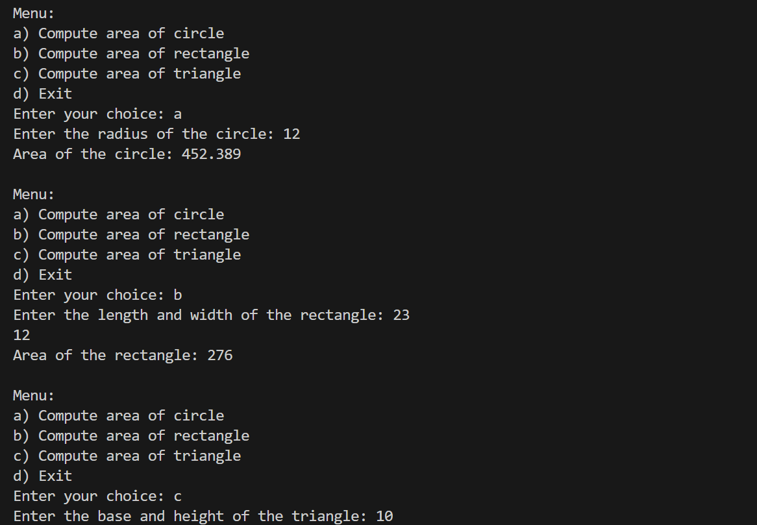

/*1:Write a program to create an array of integers and perform following operations on that array like

finding the sum, average, maximum and minimum number in that array. Accept the numbers of the

array from user.*/

#include <iostream>

using namespace std;

int main() {

int n;

cout << "Enter the size of the array: ";

cin >> n;

int arr[n];

cout << "Enter " << n << " numbers:\n";

for (int i = 0; i < n; ++i) {

cin >> arr[i];

}

// Finding sum

int sum = 0;

for (int i = 0; i < n; ++i) {

sum += arr[i];

}

cout << "Sum of numbers: " << sum << endl;

// Finding average

double average = static_cast<double>(sum) / n;

cout << "Average of numbers: " << average << endl;

// Finding maximum

int maximum = arr[0];

for (int i = 1; i < n; ++i) {

if (arr[i] > maximum) {

maximum = arr[i];

}

}

cout << "Maximum number: " << maximum << endl;

// Finding minimum

int minimum = arr[0];

for (int i = 1; i < n; ++i) {

if (arr[i] < minimum) {

minimum = arr[i];

}

}

cout << "Minimum number: " << minimum << endl;

return 0;

}

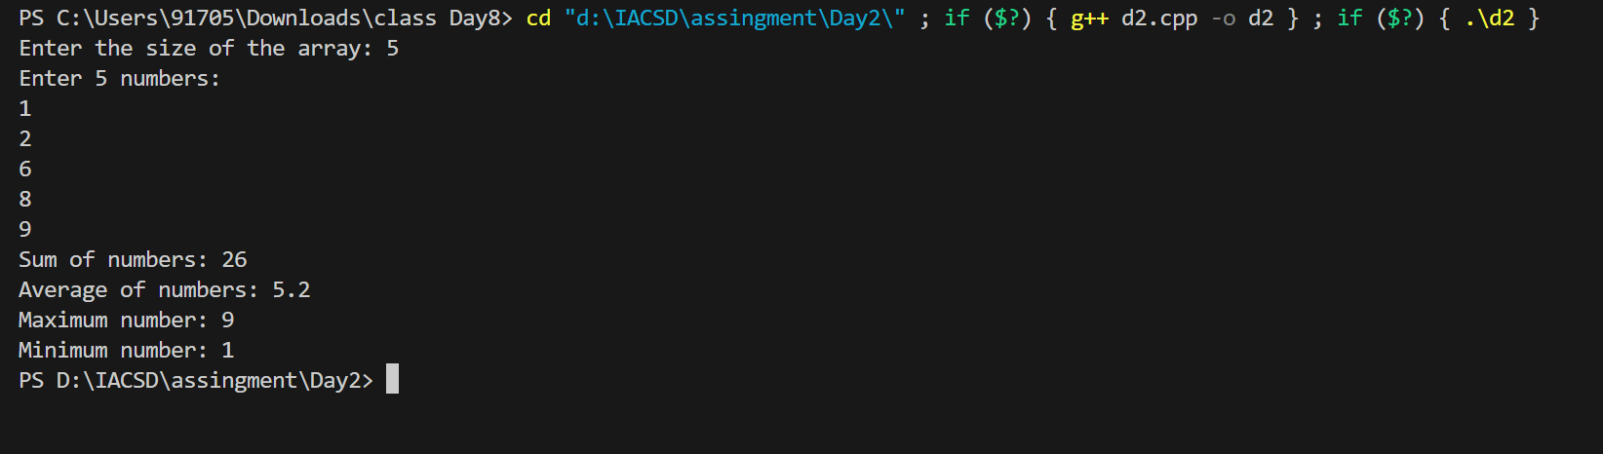

/*2: Write a program to Accept a number and display its sum of digits.:ex 568 5+6+8*/

#include <iostream>

using namespace std;

int main() {

int num, sum = 0;

cout << "Enter a number: ";

cin >> num;

int temp = num;

while (temp > 0) {

sum += temp % 10;

temp /= 10;

}

cout << "Sum of digits of " << num << " is: " << sum << endl;

return 0;

}

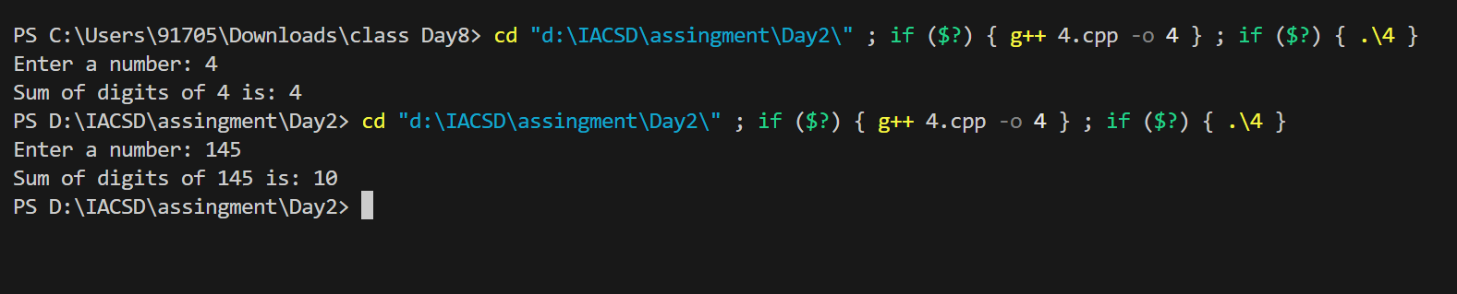

/*3:. Write a program to find sum of all even and odd numbers between 1 to n. */

#include <iostream>

using namespace std;

int main() {

int n;

cout << "Enter a number: ";

cin >> n;

int sumEven = 0, sumOdd = 0;

for (int i = 1; i <= n; ++i) {

if (i % 2 == 0)

sumEven += i;

else

sumOdd += i;

}

cout << "Sum of even numbers between 1 to " << n << ": " << sumEven << endl;

cout << "Sum of odd numbers between 1 to " << n << ": " << sumOdd << endl;

return 0;

}

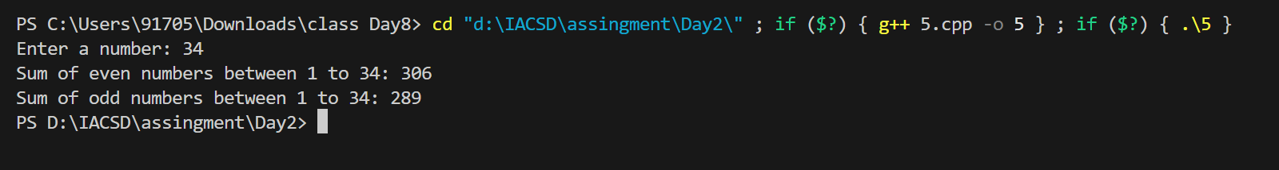

/*4:. Write a program to print all Prime numbers between 1 to n.

*/

#include <iostream>

using namespace std;

bool isPrime(int n) {

if (n <= 1)

return false;

for (int i = 2; i * i <= n; ++i) {

if (n % i == 0)

return false;

}

return true;

}

int main() {

int n;

cout << "Enter a number: ";

cin >> n;

cout << "Prime numbers between 1 to " << n << " are: ";

for (int i = 2; i <= n; ++i) {

if (isPrime(i))

cout << i << " ";

}

cout << endl;

return 0;

}

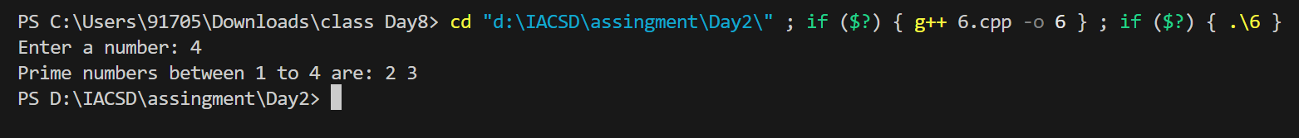

/*5:Write a program to accept array from user .Accept number from user and search number is present in array or not.

*/

#include <iostream>

using namespace std;

int main() {

int n;

cout << "Enter the size of the array: ";

cin >> n;

int arr[n];

cout << "Enter " << n << " numbers in the array:\n";

for (int i = 0; i < n; ++i) {

cin >> arr[i];

}

int num;

cout << "Enter a number to search in the array: ";

cin >> num;

bool found = false;

for (int i = 0; i < n; ++i) {

if (arr[i] == num) {

found = true;

break;

}

}

if (found)

cout << num << " is present in the array.\n";

else

cout << num << " is not present in the array.\n";

return 0;

}

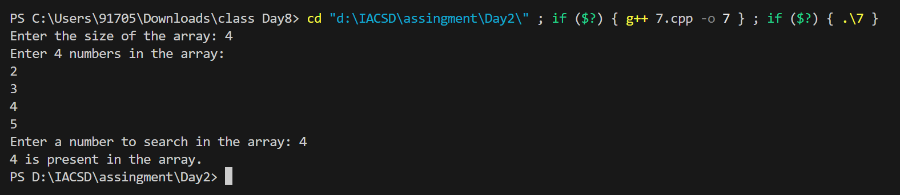

/*6:Write a program to print following pattern.

*

* *

* * *

* * * *

* * * * **/

#include <iostream>

using namespace std;

int main() {

int n;

cout << "Enter the number of rows: ";

cin >> n;

for (int i = 1; i <= n; ++i) {

for (int j = 1; j <= i; ++j) {

cout << "* ";

}

cout << endl;

}

return 0;

}

