**Day 03**

**/*1:Write a program to create student class with data members rollno, marks1,mark2,mark3.**

**Accept data (acceptInfo()) and display using display member function.**

**Also display total,percentage and grade.*/**

**#include <iostream>**

**#include <string>**

**using namespace std;**

**class Student {**

**private:**

**int rollno;**

**float marks1, marks2, marks3;**

**public:**

**void acceptInfo() {**

**cout << "Enter Roll Number: ";**

**cin >> rollno;**

**cout << "Enter Marks for Subject 1: ";**

**cin >> marks1;**

**cout << "Enter Marks for Subject 2: ";**

**cin >> marks2;**

**cout << "Enter Marks for Subject 3: ";**

**cin >> marks3;**

**}**

**float calculateTotal() const {**

**return marks1 + marks2 + marks3;**

**}**

**float calculatePercentage() const {**

**return (calculateTotal() / 3.0f);**

**}**

**char calculateGrade() const {**

**float percentage = calculatePercentage();**

**if (percentage >= 90)**

**return 'A';**

**else if (percentage >= 80)**

**return 'B';**

**else if (percentage >= 70)**

**return 'C';**

**else if (percentage >= 60)**

**return 'D';**

**else if (percentage >= 40)**

**return 'E';**

**else**

**return 'F';**

**}**

**void display() const {**

**cout << "Roll Number: " << rollno << endl;**

**cout << "Marks for Subject 1: " << marks1 << endl;**

**cout << "Marks for Subject 2: " << marks2 << endl;**

**cout << "Marks for Subject 3: " << marks3 << endl;**

**cout << "Total Marks: " << calculateTotal() << endl;**

**cout << "Percentage: " << calculatePercentage() << "%" << endl;**

**cout << "Grade: " << calculateGrade() << endl;**

**}**

**};**

**int main() {**

**Student student;**

**student.acceptInfo();**

**cout << "\nStudent Information:\n";**

**student.display();**

**return 0;**

**}**

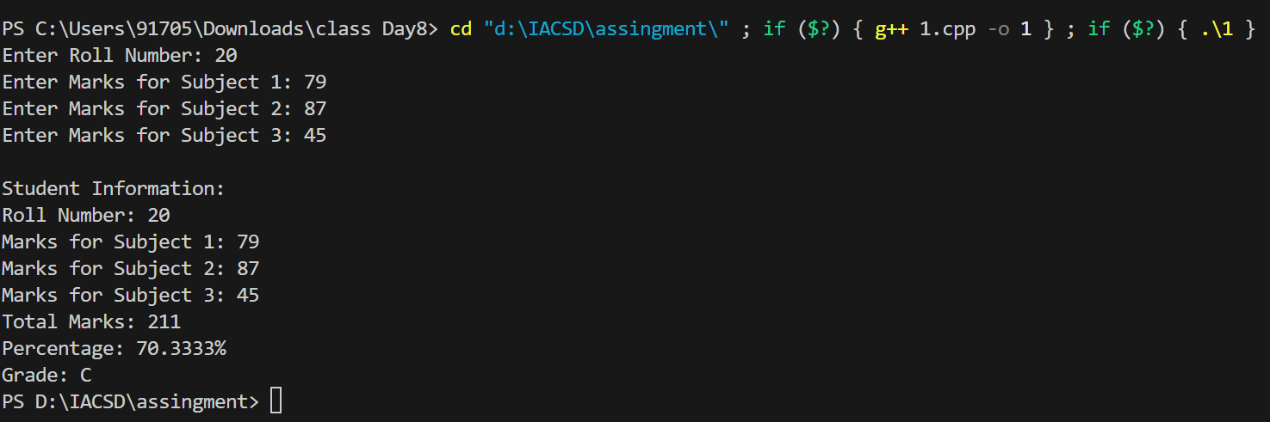

**/*1. Create a class Person with data members as name, age, city. Write getters and setters for all the data**

**members. Also add the display function. Create Default and Parameterized constructors. Create the**

**object of this class in main method and invoke all the methods in that class.**

**\*/**

**#include<iostream>**

**using namespace std;**

**class Person**

**{**

**private:**

**string name;**

**int age;**

**string city;**

**static int counter;**

**public:**

**Person(){**

**this->name = " ";**

**this->age = 0;**

**this->city = " ";**

**counter ++;**

**}**

**Person(string name, int age, string city){**

**this-> name = name;**

**this -> age = age;**

**this -> city =city;**

**counter ++;**

**}**

**void display(){**

**cout<<"Counter : "<<counter<<endl;**

**cout<<"Name : "<<name<<endl;**

**cout<<"Age : "<<age<<endl;**

**cout<<"City : "<<city<<endl;**

**}**

**void acceptInf(string name, int age, string city){**

**this-> name = name;**

**this -> age = age;**

**this -> city =city;**

**// counter ++;**

**}**

**static void showCounter(){**

**cout<<"Total Numer Object Created :"<<counter<<endl;**

**}**

**void setName(string name){**

**this -> name = name;**

**}**

**string getName(){**

**return name;**

**}**

**void setAge(int age){**

**this -> age = age;**

**}**

**int getAge(){**

**return age;**

**}**

**void setCity(string city){**

**this -> city = city;**

**}**

**string getCity(){**

**return city;**

**}**

**};**

**int Person :: counter = 0;**

**int main(){**

**Person p1;**

**p1.display();**

**// p1.showCounter();**

**cout<<"-----------"<<endl;**

**Person p2("Abc", 18, "Xyz");**

**p2.display();**

**// p2.showCounter();**

**cout<<"-----------"<<endl;**

**Person p3;**

**p3.acceptInf("DEF", 20, "FGH");**

**p3.display();**

**p3.showCounter();**

**cout<<"-----------"<<endl;**

**p3.setName("Lala");**

**p3.setAge(50);**

**p3.setCity("Bombay");**

**cout << "Name of Person " << p3.getName() << endl;**

**cout << "Age of Person " << p3.getAge() << endl;**

**cout << "City of Person " << p3.getCity() << endl;**

**// p3.display();**

**p3.showCounter();**

**return 0;**

**}**

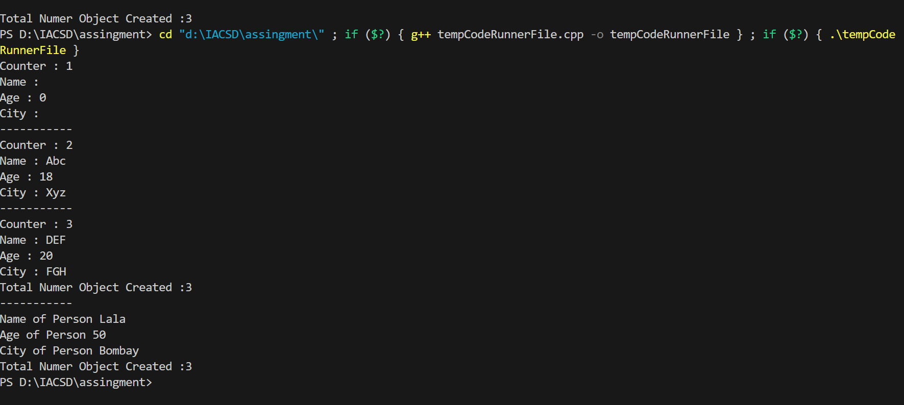

**/*2. Create a class Date with data members as dd, mm, yy. Write getters and setters for all the data members. Also add the display function. Create Default and Parameterized constructors. Create the**

**object of this class in main method and invoke all the methods in that class.**

**\*/**

**#include <iostream>**

**using namespace std;**

**class Date{**

**private:**

**int day, month, year;**

**public:**

**void assingDate(int day, int month, int year){**

**this->day = day;**

**this->month = month;**

**this->year = year;**

**}**

**void display(){**

**cout<<day<<"/"<<month<<"/"<<year<<endl;**

**}**

**bool isLeapYear(){**

**cout<<"---checking leapYear----"<<endl;**

**if (year % 4 == 0)**

**{**

**return true;**

**}else{**

**return false;**

**}**

**}**

**};**

**int main(){**

**Date d1;**

**d1.display();**

**d1.assingDate(5,5,2011);**

**d1.display();**

**cout<<"-------------"<<endl;**

**Date d2;**

**d2.assingDate(2,2,2000);**

**int leap = d2.isLeapYear();**

**if (leap)**

**{**

**cout<<"Leap Yaer"<<endl;**

**}else{**

**cout<<"Not Leap Yaer"<<endl;**

**}**

**d2.display();**

**return 0;**

**}**

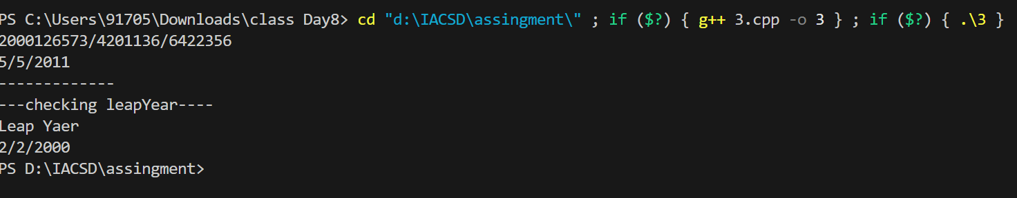

**/*3. Create a class Book with data members as bname,id,author,price. Write getters and setters for all the**

**data members. Also add the display function. Create Default and Parameterized constructors. Create**

**the object of this class in main method and invoke all the methods in that class.**

**\*/**

**#include <iostream>**

**using namespace std;**

**class Book{**

**private :**

**string bookName ;**

**int bookId;**

**string author;**

**int price;**

**int static counter ;**

**public :**

**Book(){**

**this -> bookName = " ";**

**this -> bookId = 0 ;**

**this -> author = " " ;**

**this -> price = 100;**

**counter ++;**

**}**

**Book(string bookName,int bookId,string author, int price ){**

**this -> bookName = bookName;**

**this -> bookId = bookId;**

**this -> author = author;**

**this -> price = price;**

**counter ++;**

**}**

**void diplay(){**

**cout<<bookId<<endl;**

**cout<<bookName<<endl;**

**cout<<author<<endl;**

**cout<<price<<endl;**

**}**

**static void showCounter(){**

**cout<<"Number of object created : "<<counter <<endl;**

**}**

**void setBookName(string bookName){**

**this -> bookName = bookName;**

**}**

**string getBook(){**

**return bookName;**

**}**

**void setPrice(int price){**

**this -> price = price;**

**}**

**int getPrice (){**

**return this -> price;**

**}**

**};**

**int Book :: counter = 0 ;**

**int main(){**

**// Book b;**

**// b.diplay();**

**cout<<"---------"<<endl;**

**Book d("Boo1",101,"noone",7);**

**d.diplay();**

**d.setPrice(700);**

**d.setBookName("Book 2");**

**d.diplay();**

**d.showCounter();**

**return 0;**

**}**

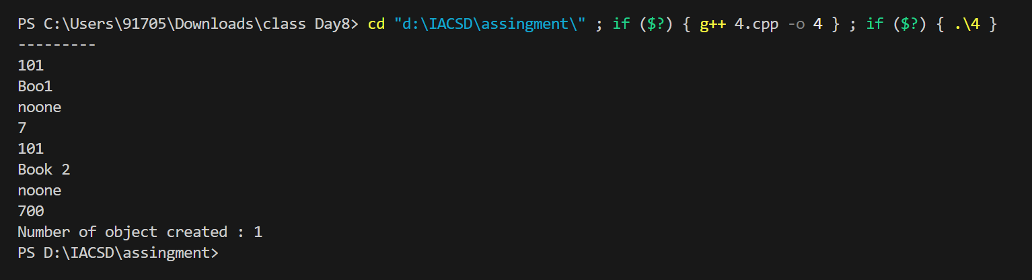

**/*4. Create a class Point with data members as x,y. Create Default and Parameterized constructors. Write**

**getters and setters for all the data members. Also add the display function. Create the object of this**

**class in main method and invoke all the methods in that class.**

**\*/**

**#include <iostream>**

**using namespace std;**

**class Point**

**{**

**private:**

**int x , y;**

**public:**

**Point(){**

**cout<<"----Df Constru------"<<endl;**

**x = 1;**

**y = 2;**

**}**

**Point(int x , int y){**

**cout<<"-----Para Constr-----"<<endl;**

**this->x = x;**

**this->y = y;**

**}**

**void acceptCoordinate(int x, int y){**

**this->x = x;**

**this->y = y;**

**}**

**void displayCoordinate(){**

**cout<<"x = "<<x<<" y = "<<y<<endl;**

**}**

**};**

**int main(){**

**Point p1;**

**p1.acceptCoordinate(5,10);**

**p1.displayCoordinate();**

**cout<<"-------------"<<endl;**

**Point p2;**

**p2.displayCoordinate();**

**cout<<"-------------"<<endl;**

**Point p3(45,60);**

**p3.displayCoordinate();**

**return 0;**

**}**

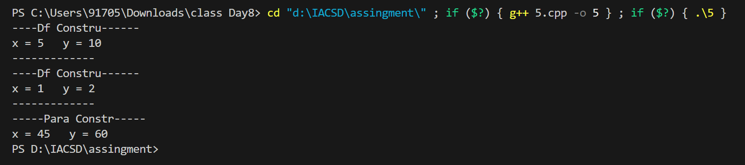

**/*5. Create a class ComplexNumber with data members real, imaginary. Create Default and Parameterized constructors. Write getters and setters for all the data members. Also add the display function. Create the object of this class in main method and invoke all the methods in that class.**

**\*/**

**#include <iostream>**

**using namespace std;**

**class ComplexNumber**

**{**

**private:**

**int i, r;**

**public:**

**ComplexNumber(){**

**this -> i = 1;**

**this -> r = 1;**

**}**

**ComplexNumber(int r, int i){**

**this -> r = r;**

**this -> i = i;**

**}**

**void diplay(){**

**cout<<r<<" "<<i<<"i"<<endl;**

**}**

**void setRealNumber(int r){**

**this -> r = r;**

**}**

**void setImaginaryNumber(int i){**

**this -> i = i;**

**}**

**int getRealNumber(){**

**return r;**

**}**

**int getImaginaryNumber(){**

**return i;**

**}**

**};**

**int main(){**

**ComplexNumber c;**

**c.diplay();**

**cout<<c.getRealNumber()<<endl;**

**return 0;**

**}**

