Selenium WebDriver

Duration: 48 + 18 Hrs

* WebDriver
  + Concept of Automation
  + Introduction to Selenium
  + Configuration
  + Basic methods of WebDriver
    - Launching different browsers
    - get()
    - getTitle()
    - getCurrentUrl()
    - getPageSource()
    - close()
    - quit()
  + Locators
    - Name
    - Id
    - ClassName
    - CssSelector
    - LinkText
    - PartialLinkText
    - Xpath
    - TagName
  + Handling controls (WebElements)
    - Text Box
    - Command Button
    - Links
    - Checkbox
    - Radio button
    - Drop down list
    - List box
  + Synchronization
    - Thread.Sleep()
    - Implicit Wait
    - Explicit Wait
    - Fluent Wait
    - PageLoadTimeout
  + Handling Table
  + Handling Multiple Windows
  + Handling Alerts
  + Handling File uploads
  + Robot Class
  + Handling Menus
  + Mouse Actions
    - Hovering the mouse
    - Click
    - Right Click
    - Double Click
    - Drag and drop
  + Headless browser
  + Screen shot
* TestNG
  + What is Framework
  + Introduction to TestNG
  + Configuration / Installation
  + Executing single test
  + Executing multiple tests
  + Setting the priority
  + Reports
    - Normal Report
    - HTML Report
  + Annotations
    - @Test
    - @BeforeTest
    - @AfterTest
    - @BeforeMethod
    - @AfterMethod
    - @Parameters
  + Data Driven Testing using @DataProvider
  + Modular Framework
    - Execute / Skip single test / multiple tests
    - Execute single / multiple classes
    - Execute / skip single / multiple groups
  + Keyword Driven Framework
    - Read data from .properties
    - Read from Excel file
  + Page Object Model (POM)
  + Data Driven Framework (Apache POI)
    - Read the data from Excel
    - Write the data to Excel
    - Pass the data to test case from Excel
  + Hybrid Framework
* Maven
  + Introduction
  + Configuration
  + Configuring the pom.xml file
  + Adding dependencies
  + Execution
  + Extent Report
* Cucumber
  + Introduction to BDD
  + Configuration
  + Components of BDD
    - Feature File
    - Step Definition
    - Runner Class
  + Keyword in feature file
    - Feature
    - Scenario
    - Given
    - When
    - Then
    - And
    - Background
    - Examples
    - Scenario Outline
  + Multiple Scenarios
  + Passing parameters to Step Definition
  + Tags in cucumber
  + Hooks in Cucumber
  + Reports
  + Data Driven Testing

**Software Testing**

Process of checking the **C**orrectness, **C**ompleteness, **S**ecurity and **Q**uality of a developed software.

Manual Testing

* Test Scenario
* Test Case
* Test Data
* RTM

Process

* Entering data in text box
* Clicking on buttons
* Selecting the value/s from check box, radio button, drop down list, list box
* Navigating from one page to another
* Verifying actual result with expected result
* Marking the test case as Pass or Fail

Manual tester uses their Hand-Eye-Brain co-ordanitation

**Automation testing is performing all above actions via a Machine.**

Machine in this context is **Test Automation Tool**.

Every test tool is a software.

Every tool understands specific programming language, so needs to give instructions via any one of the supporting programming language. (Java, C#, Python, Ruby, VBScript, JavaScript)

**Advantages**

* Time consuming
* Correctness
* Less human efforts
* Reusability
* Regression Testing
* Less human errors
* 100% test coverage
* Cost cutting

**Process of Automation**

* Planning
* Selection of Tool
  + Type of application
  + Cost of tool
  + Support availability
  + Report generation
  + HR Availability
* Test script creation
* Test data creation
* Execute the script
* Generate the report
* Maintance

**Selenium**

It is suite / bundle of test automation tools to test **Web Based Applications. (Web Sites)**

**Components of Selenium**

1. Selenium IDE – Record and playback mech
2. Selenium Grid – Parallel execution on multiple platform, multiple browsers
3. ~~Selenium RC – Remote Control~~
4. Selenium WebDriver

**Selenium WebDriver**

* Test automation tool to test web based applications (Web site)
* API
* Interface in Java

Create 2 folders

1. YourName_Selenium Demos
2. Selenium Jar Files

**Pre-Requisite for Selenium WebDriver**

* Windows 10 (Minimum)
* Java 11 (Minimum)
* At least one **Updated Browser**
* Java Editor
  + Eclipse
  + Idea Intellj
* **Selenium Jar file**
  + Open selenium.dev website in any browser
  + Click on Downloads link
  + Download Latest stable version [4.34.0](https://github.com/SeleniumHQ/selenium/releases/download/selenium-4.34.0/selenium-server-4.34.0.jar)
  + Open your downloads folder
  + Copy this file and paste in the 2nd folder (Selenium Jar Files)

**Eclipse Configuration**

* Open Eclipse
* Select your 1st folder as a workspace using browse button
* Click on Launch button
* Go to File 🡪 New 🡪 Java Project
* Give the name to Project
* Select Java version (Minimum 11)
* **Uncheck Create module-info.java file checkbox**
* Click on Finish
* Create a Package
* Create a class in this package
* Right click on you project (in package explorer) 🡪 Build path 🡪 Configure Build path
* Click on Libraries Tab
* Click on Classpath
* Click on Add Extern JARs… button
* Open your 2nd folder and select the file which you have downloaded in earlier steps. (selenium-server-4.34.0.jar)
* Click on Open button  
  **Make sure that this file is inside the class path**
* Click on Apply and Close

**Methods of Selenium**

1. Creating Object of WebDriver 🡪 Launch the blank browser window
2. get() 🡪 Launch the specific URL. URL should be Absolute
3. close() 🡪 Will close the current browser window which is opened by WebDriver object.
4. getTitle() 🡪 Will return the title of the Web Page opened in browser by WebDriver object. (String)
5. getCurrentUrl() 🡪 Will return the URL of the Web Page (String)
6. getPageSource() 🡪 Will return the rendered HTML of the page. (String)
7. findElement() 🡪 Will read and return the single control on the page. (WebElement)

**Common Exceptions in WebDriver**

1. InvalidArgumentException 🡪 Your URL is in wrong format. URL should be absolute URL. Which starts with http
2. SessionNotCreatedException 🡪 Your browser and Selenium versions are not compatible with each other. Check both versions (Both should be latest).
3. NoSuchElementException 🡪 Selenium is not able to locate the control due to
   1. Value of locator is wrong

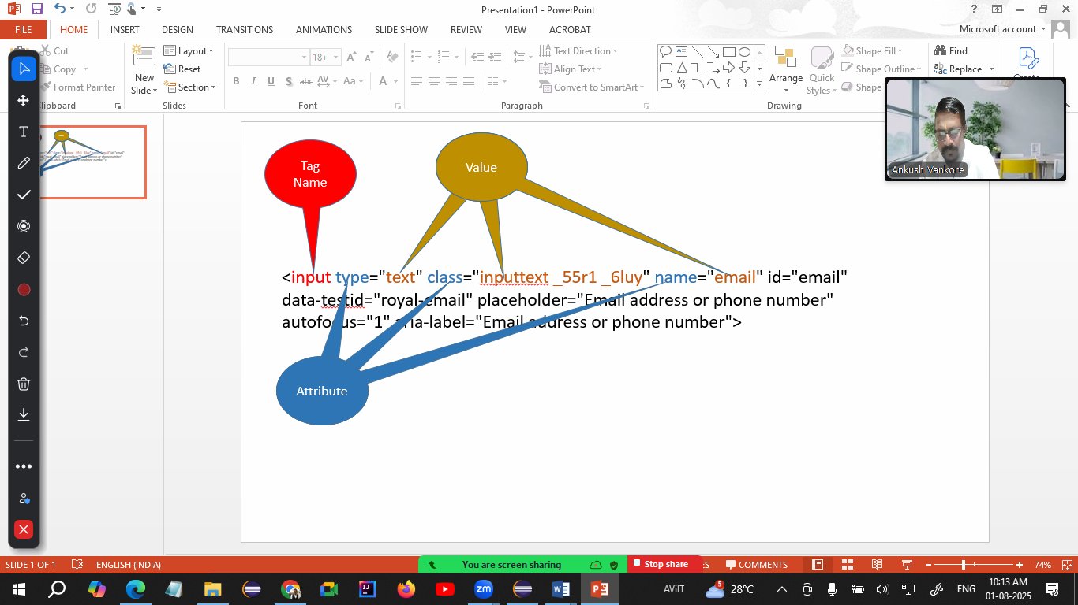

**Locators in Selenium**

Locator is the way of identifying any control / WebElement on the page

1. Name
2. Id
3. ClassName
4. CssSelector
5. LinkText
6. PartialLinkText
7. Xpath
8. TagName

**WebElement**

* Every control on the page is treated as WebElement
* It is an **interface** in WebDriver API to store any control.
* **Methods**
  + sendKeys() 🡪 Will enter some text in the text box. It appends the text to existing text.
  + click() 🡪 Will click on any control.