Selenium WebDriver

Software Testing:
It is process of checking the Correctness, Completeness, Security and Quality of developed software application.

Process of Testing
- Gather Requirements
- Creating Test Scenarios
- Creating Test Cases
- Creating Test Data
- Execution
- Reporting

Steps while testing
- Enter some data in text boxes
- Clicking on buttons
- Navigating from one page to another
- Selecting single option / multiple options via list box, drop down list, radio button, check box etc.
- Comparing the actual result with expected result
- Mark the test case as pass or fail

Automation Testing
- This is the process of performing all above actions via a machine
- Machine in this context is an automation testing tool.
- Every automation testing tool is a software
- Every tool understand some specific programming language.
- Instructions needs to be provided via any one of the supporting programming language.

Advantages of Automation Testing
- Saves time
- Reduces human errors
- 100% test coverage
- Repetition is more easy
- Automated report
- Cost saving

Process of Automation
- Planning
- Selection of tool
  - Type of application
  - Budget
  - Support availability
  - Testers availability
- Creating the script
- Create the test data
- Execute the script
- Generate the report

Types of Automation Testing Tools
- Functional testing / GUI testing
  - Selenium WebDriver
  - Tosca
  - Playwright
  - QTP
- Performance Testing
  - JMeeter
  - Load Runner
- API Testing
  - Postman
  - REST API
- Security Testing
  - Web Scrab

Selenium
It is suite/bundle of Test automation Tools those are used to test Web Based / Browser based application (Web Sites).

Components of Selenium
- Selenium IDE
- Selenium GRID
- Selenium RC
- Selenium WebDriver

Selenium WebDriver
- Test automation tool to test web based applications
- It is an API
- It is an Java Interface

Create 2 folder
- YourName_SeleniumDemos
- Selenium Jar Files

Pre-requisite for WebDriver
- Windows 10
- Minimum Java 11
- IDE
  - Eclipse
  - Idea Itellij
  - VS Code
- Updated browser
- Selenium Jar File

Configuration of Selenium WebDriver
- Open selenium.dev site
- Click on Downloads
- Click on Latest stable version 4.38.0
  - This will download the Selenium Jar file
- Open Downloads folder from your computer
- Copy this downloaded file and paste to the 2nd folder (Selenium Jar Files)
- Open Eclipse
- Create a new Java Project
- Make sure that you are unchecking Create module-info.java checkbox
- Create a package inside this project
- Create a class inside this package
- For Selenium Configuration
  - Right click on Project Build path Configure Build Path
  - Click on Libraries
  - Click on classpath
  - Click on Add external JARs…
  - Select the file which we have downloaded in earlier steps
  - Click on Apply and Close

Methods of WebDriver
- Create object of WebDriver Launch the blank browser
- get() This will open a specific URL. Pass the absolute URL.
- driver.manage().window().maximize() Will maximize the browser window.
- close() Will close the current browser window which is opened by WebDriver object.
- getTitle() Will return the title of the web page that is currently opened in browser. (String)
- getCurrentUrl() Will return the URL of the page that is currently opened in browser. (String)
- getPageSource() Will return the HTML code of the web page. (String)
- findElement() Will find and return the single control on the web page. It locates the first occurrence. (WebElement)
- findElements() Will find and return multiple controls on the web page. (List<WebElement>)

Common Exceptions in Selenium
- InvalidArgumentException The URL is not in the correct format. Selenium expects the absolute URL. (absolute URL starts with http)
- NoSuchElementException Selenium is unable to locate a control on the page. Possible reasons are
  - Wrong locator value.
  - Locator value may be dynamic.
  - Synchronization issue.
- InvalidSelectorException The value of locator is in invalid format.

Locators in Selenium:
Locators are the ways / strategies to find the WebElement on the page.
- Name
- Id
- ClassName
- CssSelector
- XPath
- LinkText
- PartialLinkText
- TagName

WebElement
- Every control (like textbox, radio button, checkbox, label etc) is treated as WebElement in Selenium.
- WebElement is an interface.
- Methods:
  - sendKeys() Will enter some text in the text box. Will append the text.
  - click() Will click on any control.
  - getText() Will return the text on the control. (String)
  - isSelected() Will check that whether the checkbox / radio button is selected or not. (boolean)
  - isEnabled() Will check that whether the control is enabled or disabled. (boolean)
  - isDisplayed() Will check that whether the control is visible or not. (boolean)

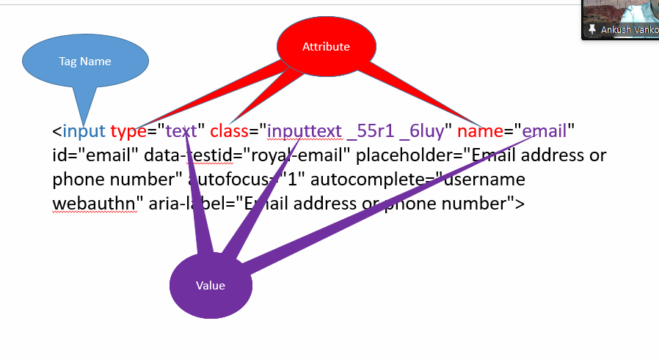
ClassName Locator:
A control can have multiple classes applied, such multiple classes are separated via space.
While using className locator pick up any one class from all those multiple classes.

CssSelector Locator
A technique that can be used to locate any control using any one or multiple attribute.
Types
- Using Single Attribute
Syntax:
tagName[attribute=”value”]
input[data-testid="royal-email"]
- Using Multiple Attributes
Syntax
tagName[attribute1=”value”][attribute2=”value”]
- Using Special Characters
  - ^ - Starts With
  - $ - Ends With
  - * - Contains

Pattankodoli bus stand Take right turn Hupare Nagar Water Tank Lane No 9 House No 1128

XPath (XML Path)
XPath is a way to find any control by providing its exact location / path on the page.
Types
- Absolute XPath
Starts with html
- Relative XPath
Starts with //
  - Taking reference of parent tag
Syntax
//tagName[@attribute=”value”]/tagName
  - Taking reference of current tag

Handling Dropdown List / List Box
- If any one of the control is having <select> tag, then such control is treated as Dropdown list / list box.
- Selenium has provided special class to handle drop down list ie. Select.
- Drop down list / list box can be handled only via Select class.
Test Case
- Display Selected Country
- Display total no of countries
- Display list of all countries.
- Select UAE from the list
- Display this selected country.

Methods.
- getFirstSelectedOption() Will return the selected option form Drop down list. (WebElement)
- getOptions() Will return the list of all the options from the drop down list / list box (List<WebElement>)
- selectByContainsVisibleText()
- selectByValue()
- selectByIndex()
- selectByVisibleText()
- getAllSelectedOptions() Will return list of all selected options from list box (List<WebElement>)
- isMultiple() Will check that whether the control allows to select multiple options or not. (boolean)
- deselectByValue()
- deselectByIndex()
- deselectByVisibleText()
- deselectByContainsVisibleText()
- deselectAll()

Synchronization (Waits in Selenium)
Process of adjusting speed of tool with speed of application.
- Thread.sleep() Will pause the execution of script for specified milliseconds.
  - It takes mandatory delay
  - It is applicable to single statement only.
- ImplicitWait()
  - It doesn’t take mandatory delay.
  - It is applicable to throughout the script.
- ExplicitWait()
  - It is applicable to single statement only.
  - It doesn’t take mandatory delay.
  - It can handle different types of conditions such as elementToBeClickable, visibliltyOfElementLocated, alertToBePresent.
- FluentWait() – it is the next version of ExplicitWait additionally we can handle some exception.
  - It is applicable to single statement only.
  - It doesn’t take mandatory delay.
  - It can handle different types of conditions such as elementToBeClickable, visibliltyOfElementLocated, alertToBePresent.
  - We can handle exception as well.
w - withTimeout
i - ignoring
p - pollingEvery
u - until
- PageLoadTimeout()

