Ankush Vankore

Selenium WebDriver

* Intro
* Configuration
* Locators
* Handling multiple controls
  + Textbox
  + Button
  + Radio button
  + Check box
  + Dropdown list
  + Synchronization / Waits in selenium
  + List box
  + Tables
  + Alerts
  + Mouse Actions
  + Multiple window handling
  + Screenshot
  + Robot class

TestNG

* Introduction
* Configuration
* Executing single test case
* Executing multiple tests
* Assertion
* Annotations
* Frameworks
  + Linear
  + Modular
  + Data driven
  + Keyword driven
  + Page Object model
  + Hybrid

Introduction to Maven

* Intro
* Configuration
* Adding dependencies
* Executing scripts
* Generating reports

BDD Framework using Cucumber

* Intro
* Configuration
* Components
  + Feature file
  + Step Def
  + Runner class
* Keywords in Cucumber
* Tags
* Data driven testing
* Hooks

Java

1. Language Basics
   1. Variables
   2. Data types
   3. Displaying the data
   4. Conditions
   5. Loops (for loop , enhanced for loop)
   6. Arrays
   7. Functions / Methods
2. Class and object
   1. Create class and object
   2. Constructor
   3. Static methods and static members
3. Inheritance
   1. Interface
4. Collections
   1. List
   2. Set
   3. Map
5. Exception Handling
   1. throws keyword

Software Testing:

Process of verifying the **C**orrectness, **C**ompleteness, **S**ecurity and **Q**uality of developed software application.

In manual testing, tester is using hand-eye-brain co-ordanitation.

* Entering some data in text box
* Selecting the data from check box, dropdown list, radio button
* Taking actions, clicking the button
* Navigation from one page to another
* Checking the expected result v/s actual result

Automation means performing all above actions using some automation testing tool. (Testing Tool, Automation Tool)

Every tool is a software.

Instructions needs to be provided using any one of the supporting programming language.

**Advantages of Automation**

* Saves the time
* Reduces the resources
* Reduces the man power
* Reduces human errors
* Useful in regression testing
* Efficiency
* Less manual efforts
* Increase the productivity
* Avoids the repetition
* Cost saving
* Data security
* 100% test coverage
* Increase the quality
* Can be executed from any place
* Consistency
* Accuracy
* Scalability
* Reusability

**Need of automation**

* Quick testing
* Speed
* Avoid repetition
* Cost Saving
* Saves the time
* Maintain Quality
* Reduces human errors
* Testing on different Environment

**When to do Automation?**

* Stable requirements
* Stable build
* Repeated test scenarios
* Regression testing
* Different Environment

**Which TCs should automate?**

* Regression
* Performance
* Cross browser
* API Testing
* Data Driven Testing

**Types of Automation Testing**

* Unit Testing (JUnit / NUnit)
* API Testing (Postman / RestFULL API)
* GUI Testing / Functional Testing (Selenium WebDriver, TOSCA, QTP, Appium, Winium)
* Performance Testing (JMeeter, LoadRunner)

**Tool selection**

* Technology supported
* Budget
* Reports
* Tool availability (Market)

**Process of Automation**

* Planning
* Tool selection
* Creation of the Test Script (Code for automation)
* Test Data creation
* Execution
* Report
* Maintance

**Selenium**

Is the bundle / suite of test automation tools to test WEB BASED APPLICATIONS. (Web Sites)

Components of Selenium

1. Selenium IDE
   1. Record and playback
   2. Generates the script automatically
   3. Very basic level tool.
   4. Doesn’t support for any framework
   5. Reusability is very less
2. Selenium Grid
   1. Parallel testing on multiple browsers, multiple OS, multiple machines
3. Selenium RC (Deprecated)
4. Selenium WebDriver

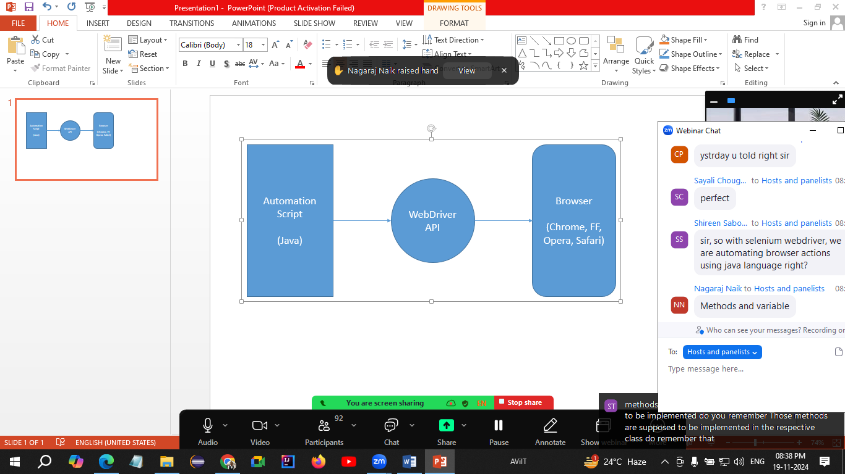

Selenium WebDriver

* Is an automation tool for testing web based applications.
* An interface in Java.
* An API

Pre-Requisite

* Minimum Java 11 (JDK 11)
* Minimum Windows 10
* Any one latest (Updated) browser
* Any one Editor
  + Eclipse
  + Idea IntelliJ
* Selenium Jar file (Latest)

Configuration of Selenium WebDriver

1. Create 2 folders on D drive
   1. YourName_SeleniumWebDriverDemos
   2. WebDriver Jar Files
2. Open selenium.dev 🡪 Click on Downloads 🡪 Download Latest Stable Version
3. Open Downloads folder and copy this file to the 2nd Folder which you created in step 1
4. Open Eclipse
5. Select the first folder (YourName_SeleniumWebDriverDemos) which you have created in step 1 as a workspace
6. Click on Select Folder
7. Click on Launch
8. Create a project
   1. File 🡪 New 🡪 Java Project
   2. Give any meaningful name
   3. Select Environment variable as JavaSE-11 (Minimum)
   4. **Uncheck Create module-info.java file checkbox.**
   5. Click on Finish
9. Create a package inside this project
10. Create a class inside this package
11. Configure Selenium Jar files to the project
    1. Right click on Project 🡪 Build Path 🡪 Configure Build path 🡪
    2. Click on Libraries tab
    3. Click on Classpath
    4. Click on Add External Jars…
       1. Open the 2nd folder which you have created in 1st step
       2. Select the Selenium-server file
       3. Click on Open button
       4. Click on Apply and Close button

Project Structure of Java program in Eclipse

1. ~~Workspace (The folder where you are storing all your programs)~~
2. ~~Project~~
3. ~~Package~~
4. ~~Class~~

Selenium Methods

1. Launching the browser – Create object of WebDriver interface (This will launch the blank browser window)
2. get() – Used to launch the URL
3. driver.manage().window().maximize() – Will maximize the browser window.
4. close() – Will close the browser window which is opened by WebDriver object.

Common Exceptions

1. SessionNotCreatedException – The WebDriver version and Browser version are not matching
2. InvalidArgumentException – The URL is not in the correct format. (URL should be Absolute, starting with http)