Module Name: Selenium WebDriver
Trainer Name: Ankush Vankore
Sessions: 19

Contents
- Selenium WebDriver
  - Introduction to Automation Testing
  - Components of Selenium
  - Configuration / Installation of Selenium WebDriver
  - Launching different browser
  - Reading the title
  - Reading the URL
  - Reading the page source
  - Locators
    - Name
    - ID
    - ClassName
    - CssSelector
    - LinkText
    - PartialLinkText
    - XPath
    - TagName
  - Handling multiple controls
    - Text box
    - Command button
    - Radio button
    - Check box
    - Drop down list
    - List box
    - Hyperlinks
  - Synchronization (Waits in Selenium)
    - Thread.sleep()
    - ImplicitWait
    - ExplicitWait
    - FluentWait
    - PageLoadTimeout
  - Handling the table
  - Handling multiple windows
  - JavascriptExecutor
  - Handling Alerts
  - Handling File Upload control
  - Robot Class
  - Handling Menus
  - Handling frames
  - Handling #Shadow DOM
  - Mouse Actions
    - Click
    - Right Click
    - Double Click
    - Drag and Drop
  - Screenshot
- TestNG
  - Introduction
  - Installation
  - Adding multiple tests in single class
  - Setting the priority
  - Annotations
    - @Test
    - @BeforeTest
    - @AfterTest
    - @BeforeMethod
    - @AfterMethod
    - @DataProvider
    - @Parameters
  - Executing single / multiple tests via XML file
  - Parallel Execution
  - Parameterization
  - Keyword Driven Framework
  - Data Driven Framework
  - Page Object Model (POM)
  - Apache POI (Excel Handling)
- Maven
  - Creating project
  - Configuration of Project via pom.xml file
  - Adding dependencies in pom.xml file
  - Execution
  - Extent Report
- Cucumber
  - Introduction to BDD
  - Feature File
  - Step Definition
  - Runner Class
  - Keywords
    - Feature:
    - Scenario:
    - Given
    - When
    - Then
    - And
    - Background:
    - Examples:
    - Scenario Outline
  - Tags in Cucumber
  - Hooks in Cucumber
  - Data Driven Testing in Cucumber

Java Knowledge
- Basics
  - Variables,
  - Data types
  - Operators
  - If, if else, nested if else, switch case
  - Loops (for loop, enhanced for loop / for each)
  - Functions
  - Arrays (2 D Array)
- Class & Object
  - Creating class
  - Creating object of class
  - Constructor
  - Static members, functions
- Inheritance
  - extends keyword
  - Abstract Class
  - Interface
- Exception Handling
  - throws keyword
  - try – catch block
- Collections
  - List
  - Set
  - Map

What is Software Testing?
It is process of identifying Correctness, Completeness, Security and Quality of developed software application.

Process of Manual Testing
- Analyze requirements
- Identify test scenarios
- Create test cases
- Create Test Data
- Execution
- Report

Steps involved
- Entering some text in the text box
- Clicking on command buttons
- Navigation from one page to another
- Hovering on some controls
- Selecting options from check box, radio button, drop down list, list box
- Submitting the from
- Compare actual result with expected result
- Mark test case either as pass or as fail

What is mean by Automation Testing?
- It the process of performing all above actions via a machine
- A machine in this context is Test Automation Tool (Automation Testing Tool)
- Instructions to tool needs to be provided via any one of the supported programming language. (Selenium understands Java, JavaScript, Ruby, Python, C# .Net)

Advantages of Automation Testing
- Save time
- More accuracy
- Faster Execution
- Help in regressing testing
- Reduces the cost
- Less / no human errors
- 100% Test coverage
- More accuracy
- Reusability
- Data driven testing
- CICD
- Consistency
- Easy reporting
- Compability Testing
- Parallel Execution
- Efficiency

When to Automate?
- Regressing
- Performance Testing
- Security Testing
- Stable build / Stable requirements

Types of Automation Testing
- Functional Testing / GUI Testing
  - Selenium
  - Tosca
  - APPIUM
  - Playwright
  - Cypress
- API Testing
  - Postman
  - REST API
- Unit testing
  - JUnit
  - NUnit

Process of Automation
- Planning
- Selecting the tool
  - Type of application
  - Easy to use
  - Availability
  - Cost of tool
  - HR Availability
  - Community support
- Create a script
- Generate Test Data
- Execution
- Report
- Maintance

Selenium
Selenium is bundle / suite of automation testing tools to test browser based / web based applications (Web Sites)
Components of Selenium
- Selenium IDE – Record and playback
- Selenium Grid – Parallel Execution
- Selenium RC – Remote Control
- Selenium WebDriver

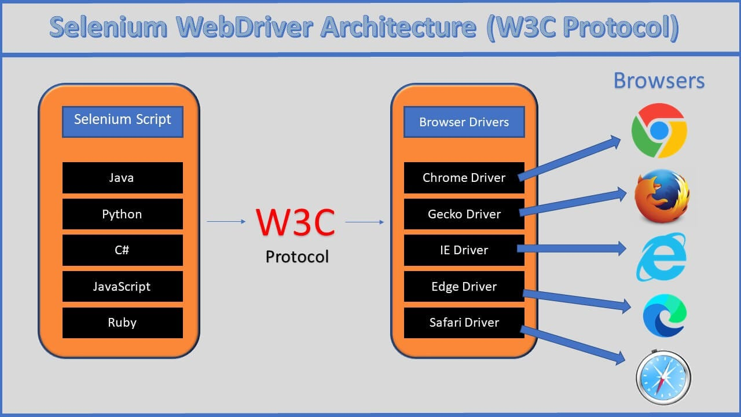

Selenium WebDriver
- An automation testing tool to test Web Based application.
- It is an API
- WebDriver is an interface.

Create 2 Folders
- YourName_SeleniumDemos
- Selenium Jar Files

Pre-Requisite for Selenium WebDriver
- Windows 10
- Java 11 (Minimum)
- Updated browser
- IDE for Java
  - Eclipse
  - Intellij
  - VS Code
- Selenium Jar File

Download Selenium Jar File
- Launch https://www.selenium.dev/ site
- Click on Downloads
- Download the file
Latest stable version 4.38.0
- Copy this file from Downloads folder and paste in 2nd Folder (Selenium Jar Files)

Eclipse Configuration for Selenium WebDriver
- Open Eclipse
- Click on Browse button and Select the 1st folder which we have created earlier.
- Click on Launch
- Create a new Java Project File New Java Project Give name
- Uncheck Create module-info.java file checkbox.
- Click on Finish
- Right click on Project New Package (com.WebDriverDemos)
- Right Click on Package New Class (D01LaunchingChrome)
- Right click on Project Build Path Configure Build Path Click on Libraries
- Click on ClassPath
- Click on Add External JARs…
- Select the Selenium Jar file which we have downloaded
- Click on Apply and Close

Selenium WebDriver Methods
- Create Object of WebDriver Launch blank browser Window
- get() Launch the URL. Always pass absolute URL.
- driver.manage().window().maximize() Will maximize the browser window.
- close() Will close the current browser window which is launched by WebDriver object.
- getTitle() Will return the title of page which is currently opened in browser. (String)
- getCurrentUrl() will return the URL of the page which is currently opened in browser. (String)
- getPageSource() Returns HTML source code of the page (String)
- findElement() Used to read / find any single control on the web page. Always locates for first occurrence. (WebElement)
- findElements() Used to read / find multiple controls on the page. (List<WebElement>)
- getWindowHandles() Returns the list of id’s of all the windows those are opened by WebDriver object. (Set<String>)
- quit() Will close all browser windows / tabs.

Common Exceptions
- InvalidArgumentException The URL is not in the correct format. URL must be absolute. (Should start with http:// or https://)
- NoSuchElementException Selenium is unable to read this control due to
  - The locator value may be wrong.
  - The value of locator may by dynamic.
  - Synchronization issue
  - The control may be inside the <iframe>
- InvalidSelectorException The value of locator is not in the correct format.
- SessionTimeoutException The page is not loaded within 30 seconds. Which is the default timeout for driver.get().
- ElementClickInterceptedException Selenium is unable to click on the element because the control is hidden by some another control.
- NoAlertPresentException You are trying to handle alert but there is no alert present.

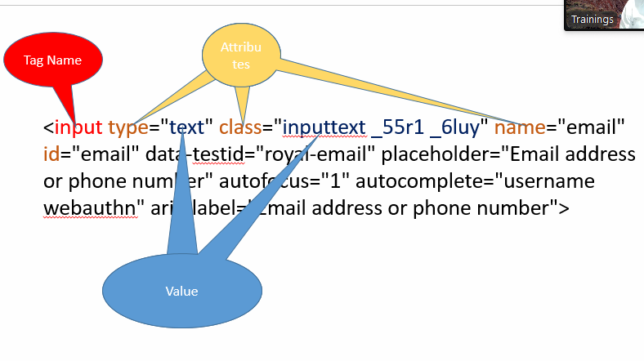
Locators
Locators are the ways / strategy via which you can identify any WebElement on the page.
- Name
- Id
- ClassName
- CssSelector
- XPath
- LinkText
- PartialLinkText
- TagName

WebElement:
- Every control on the web page (like button, text box, radio button, link etc.) is treated as WebElement in Selenium.
- It is an interface in Selenium.
- Methods:
- sendKeys() Will enter some text in the text box. Always append the text if tere is some text already present.
- click() Will click on any control.
- getText() Will return the text on the control. (String)
- getAttribute() /getDomAttribute() Will return the value of any attribute (String)
- isSelected() Will check whether the check box / radio button is selected or not. (boolean)
- isEnabled() Will check that whether the control is enabled or disabled (boolean)
- isDisplayed() Will check that whether the control is visible or not (boolean)
- submit() If the control is having type=”submit” attribute then instead of calling .click method you can call .submit()
- getLocation() Returns the location of any control (Point)

className Locator:
- Used to identify any WebElement via its class attribute.
- Multiple classes are separated via space. Pick any one class name as a locator while reading any control.

cssSelector Locator
- The technique to identify the WebElement on the page using any one or multiple attributes of the control.
- cssSelector can be only in forward direction (parent>child)
- Type
  - Using single attribute
Syntax:
tagName[attribute=”value”]
input[autocomplete="username webauthn"]
input[data-testid="royal-email"]
  - Using multiple attributes
Syntax:
tagName[attribute1=”value”][attribute2=”value”]
  - Using special characters.
    - ^ - Starts with
    - $ - Ends With
    - * - Contains

LinkText Locator:
- The locator especially designed for handling links / hyperlinks
- Links are always having tag name as <a>
- You are supposed to pass the inner text from this <a> inner text </a>

Pattankodoli Bus stand Take a right turn Hupare Nagar Go straight Water Tank Lane No 9 House No 1128

XPath Locator (XML Path)
- Absolute XPath
Always starts with html
- Relative XPath
Starts with //
And can be created in 2 ways
  - Taking the reference of parent tag
  - Taking the reference of exact control

Handling Dropdown List / List Box
- If any one of the control is having <select> tag then only it will be treated as dropdown list / list box in selenium.
- Selenium has provided a special class called as Select to handle drop down list / list box.
- Methods
  - getFirstSelectedOption() Return the selected element / option from the drop down list. (WebElement)
  - getOptions() Return list of all the elements / options from the dropdown list or list box (List<WebElement>)
  - selectByVisibleText() Selects the option by using the inner text on element.
  - selectByContainsVisibleText() Selects the option by using partial text from the inner text.
  - selectByValue() Selects the option by using value of attribute value. This method accepts String parameter.
  - selectByIndex() Selects the option by using the zero based index number of element. This method accepts integer value as a parameter.
  - getAllSelectedOptions() Returns list of all the selected elements from list box. (List<WebElement>)
  - isMultiple() Checks that whether the control (<select>) allows you to select multiple options or not. (boolean)
  - deselectByIndex()
  - deselectByValue()
  - deselectByVisibleText()
  - deselectByContainsVisibleText()
  - deselectAll()

Operations on Country Drop down list
- Display selected country
- Display total no of countries from the list
- Display list of all the countries from the list
- Select United Kingdom from the list
- Display selected country.

Click anywhere in Dev Tool
Hit Control + Shift + P
Type Focus
Click on Emulate a Focused Page

Synchronization (Waits in Selenium)
It is the process of adjusting speed of tool with speed of application.
- Thread.sleep() We can pause the execution of script for specified milliseconds.
  - It takes mandatory delay
  - It is applicable to single statement only.
- ImplicitWait
  - It doesn’t take mandatory delay
  - It is applicable to entire script. (Write it only once it applicable to entire script)
- ExplicitWait (WebDriverWait Class)
  - It is applicable to single statement only
  - It doesn’t take mandatory delay
  - We can handle the condition like elementToBeClickable, visibliltyOfElementLocated, alertIsPresent
- FluentWait Is the next version of ExplicitWait which can handle exception as well
  - It is applicable to single statement only
  - It doesn’t take mandatory delay
  - We can handle the condition like elementToBeClickable, visibliltyOfElementLocated, alertIsPresent
  - Can handle exception as well
w - withTimeout
i - ignoring
p - pollingEvery
u - until
- PageLoadTimeout() Will wait for specified time till the page get loaded to avoid SessionTimeoutException.

Handling Table
- Display all headers
- Display total no of rows
- Display any Row

JavascriptExecutor Interface
- Used to execute some methods of JavaScript
- Scroll the page
- Click on the control
- Enter some values in the text box

Navigation Methods
- back()
- forward()
- refresh()
- navigate().to()

Handling Alert
Alert is like a pop-up window which
- don’t have (x) close button
- We are not able to inspect this alert
- Is alert is present, we cannot perform any operation on the page.
Types of Alert
- Normal Alert (Having only Ok button)
- Confirmation Alert (Having Ok & Cancel Button)
- Prompt Alert (Input Box) (You can enter some text there)
Selenium has a special interface called as Alert to handle such alerts.
Methods
- driver.switchTo().alert() Will switch to the alert.
- getText() Will return the text on the alert. (String)
- accept() Will click on Ok button
- dismiss() Will click on Cancel button
- sendKeys() Will enter the text on Prompt box

Handling File Upload
If any one of the control is having type=”file” attribute, such a control is known as File Uload control.
To upload any file you just need to call .sendKeys(“Path of the file”);

Handling Mouse Actions
- Hover
- Drag and Drop
- Click
- Double Click
- Right Click
- To perform above actions, Selenium has provided a special class Actions class
Methods
- moveToElement() Will hover the mouse on any control.
- perform() Will perform the said action on the control.
- contextClick() Will do the right click on any control.
- doubleClick() Will do the double click on any control.

TestNG (Test Next Generation)
It is the framework for automation testing which will make your automation easy.
Framework Set of rules, guidelines and best practices for making automation easy.

Advantages:
- Combine multiple tests in one class
- Allows to execute single / multiple tests
- Allows to set priorities to the tests.
- Uses annotations (Word which gives some additional meaning to the method / class)
  - @Test
  - @BeforeTest
  - @AfterTest
  - @BeforeMethod
  - @AfterMethod
  - @DataProvider
  - @Parameters
- Allows to create automated report
  - Normal report
  - HTML Report
- Parameterization
- Allows to execute test in parallel
- Allows assertion to mark any test case as pass or fail
- Allows to execute / skip tests in a group.
- Allows data driven testing
- Allows to design the different frameworks
  - Linear Framework
  - Keyword driven framework
  - Data Driven Framework
  - Page Object Model
  - Hybrid Framework

Annotations
- @Test This method will be treated as a test case. This method will get executed.
- @BeforeTest This is the method that will get executed only once before executing 1st test case.
- @AfterTest This is the method that will get executed only once after executing last test case.
- @BeforeMethod This is the method that will get executed Before every test case.
- @AfterMethod This is the method that will get executed After every test case

Sequence of Test execution
BeforeTest
BeforeMethod
Test 1
AfterMethod
BeforeMethod
Test 2
AfterMethod
BeforeMethod
Test 3
AfterMethod
BeforeMethod
Test 4
AfterMethod
AfterTest

Points to be noted about Configuration methods
- They can appear anywhere in the class. (Sequence doesn’t matter)
- They need not to be in pair

Data Driven Testing
- Executing single test for multiple times with multiple data set.
- @DataProvider is used to implement.

