Module No: 3
Name of Module: Selenium WebDriver
Name of Trainer: Ankush Vankore
Total no of Sessions: 19

- Selenium WebDriver
  - Introduction of Automation Testing
  - Components of Selenium
  - Configuration of WebDriver
  - Launching different browsers
    - Chrome
    - Edge
    - Firefox
  - Methods of WebDriver
    - get()
    - getTitle()
    - getCurrentUrl()
    - getPageSource
    - close()
    - quit()
  - Locators
    - Name
    - Id
    - ClassName
    - CssSelector
    - XPath
    - LinkText
    - PartialLinkText
    - TagName
  - Handling controls (WebElement)
    - Text Box
    - Command Button
    - Hyperlinks
    - Check box
    - Radio button
    - Drop down list
    - List box
  - Synchronization (Waits is Selenium)
    - Thread.sleep()
    - Implicit Wait
    - Explicit Wait
    - Fluent Wait
    - PageLoadTimeout
  - Handling web tables
  - Handling multiple windows / tabs
  - Handling Alerts
  - JavascriptExecutor Interface
    - Scrolling
    - Clicking the control
  - Handling File Upload
  - Robot class
  - Handling menus
  - Handling Frames (Iframe)
  - Handling #shadow-dom
  - Handling mouse actions
    - Hover
    - Click
    - Right Click
    - Double Click
    - Drag and Drop
  - Screenshot
- TestNG
  - Introduction
  - Installation
  - Writing multiple tests
  - Executing single / multiple tests
  - Annotations
    - @Test
    - @BeforeTest
    - @AfterTest
    - @BeforeMethod
    - @AfterMethod
  - Setting priority to tests
  - Reporting
  - Data driven testing via @DataProvider
  - Parameterization (Reading the data from .xml file)
  - Keyword Driven Framework
  - Page Object Model (POM)
  - Data Driven Framework (Apache POI)
    - Read the data from Excel
    - Write the data to Excel

- Introduction to Maven
  - Introduction
  - Configuration
  - Adding dependencies
  - Maven Architecture
  - Extent Report
  - Listeners
  - Execution
- Cucumber (BDD)
  - Introduction
  - Configuration
  - Components of Cucumber
    - Feature File
    - Step Definition
    - Runner Class
  - Keywords in Cucumber
    - Feature
    - Scenario
    - Given
    - When
    - Then
    - And
    - Background
    - Examples
    - Scenario Outline
  - Tags in Cucumber
  - Hooks in Cucumber
  - Data Driven Testing in Cucumber

Java Revision
- Language Basics
  - Variables
  - Data types
  - Conditions
  - Loops (for, enhanced for loop)
  - Function
  - Arrays
- Class and Object
  - Access Specifiers
    - public
    - private
    - protected
    - default
  - Constructor
  - Static members, static functions
- Inheritance
  - extends keyword
  - super class and sub class
  - Concrete Class and Abstract Class
  - Interface
- Collections
  - List
  - Set
- Exception Handling
  - try-catch
  - throws keyword

What is Software Testing?
It is a process of checking the Correctness, Completeness, Security and Quality of developed software application.

Process of Testing
- Gather the requirements
- Create Test Scenarios
- Create Test Cases
- Generate Test Data
- Execution
- Reporting

Process / steps during Execution
- Entering the data in box
- Clicking on a button
- Selecting the value/s from check box, radio button, drop down lists, list box
- Navigating from one page to another
- Handling alerts, popups
- Uploading the files
- Handling Multiple windows
- Verifying the Expected result with Actual Result
- Mark the test case as pass or fail

What is automation testing?
- Performing all above actions with the help of a machine
- Machine in this context is Test Automation Tool / Automation Testing Tool
- Every tool is a software
- The instructions to the tool are provided via any one of the supporting programming language like Java, C#.Net, JavaScript, Ruby, Python

Advantages of Automation Testing
- Saves time
- Saves efforts
- Reduces the cost
- More accuracy
- Reusability
- Faster
- Regression Testing makes easy
- 100% test coverage
- Data driven testing
- Compatibility testing

Test cases that needs to be automated
- Regression Testing
- Load testing / Performance Testing
- Security Testing
- API Testing
- Data Driven Testing

Types of Tools
- Unit Testing
  - JUnit
  - NUnit
- Functional Testing
  - Selenium
  - Tosca
  - QTP
  - Playwright
  - Appium
- API Testing
  - Postman
  - Rest API

Process of Automation
- Planning
- Selection of the Tool
  - Type of application (SUT / AUT)
  - Budget
  - Availability of tool
  - Easy to use
  - Availability of tool
  - Reporting
- Scripting
- Generating The Test Data
  - Synthetic Data
    - ECP
    - BVA
    - EG
  - Real Data
    - XML
    - Excel file
- Execution
- Report
- Maintance

Selenium
Selenium is suite or bundle of test automation tools to test web (browser) based application.

Components of Selenium
- Selenium IDE – Record and playback
- Selenium Grid – Parallel Execution
- Selenium RC – Remote Control
- Selenium WebDriver

Selenium WebDriver
- It is automation testing tool to test any kind of Web Based Application
- You can execute / test your WebDriver script on different browsers like Chrome, Edge, Safari, Firefox
- WebDriver is an API
- WebDriver is an Interface in java

Pre-Requisite
- Minimum Windows 10
- Minimum Java 11
  - Check on command prompt by java –version
- Any one updated browser
  - Chrome
  - Firefox
  - Safari
  - Edge
- Editor (IDE for Java)
  - Eclipse
  - Idea Intellij
  - VS Code
  - Notepad
- Selenium Jar File

Configuration
- Create 2 folders (on D or E Drive)
  - YourName_SeleniumDemos (Sanjeevani_SeleniumDemos)
  - Selenium Jar Files
- Open https://selenium.dev
- Click on Downloads Link
- Download Latest stable version 4.39.0
- Open Downloads folder
- Copy this file and paste in 2nd folder (Selenium Jar Files)

Eclipse Configuration
- Open Eclipse
- Select your 1st folder (Which we have created in earlier steps) as a workspace by clicking on Browse Button
- Click on Launch button
- Close the Welcome window
- Click on File menu New Java Project
- Give name to the project
- Select the latest version of Java (1.8 is not allowed)
- Uncheck Create module-info.java file checkbox
- Click on Finish button
- Create a package inside this project (com.WebDriverDemos)
- Create a Class inside this package
- Right click on Project (in Package Explore)
- Build Path Configure Build Path
- Click on Libraries
- Click on Class Path
- Click on Add External JARs button
- By navigating the 2nd folder (Selenium Jar Files) Select the file selenium-server-4.39.0.jar
- Click on Open
- Click on Apply and Close

Selenium WebDriver Methods
- Create Object of WebDriver Launch the blank browser window
- get() Open the web site by providing URL.
- driver.manage().window().maximize() Will maximize the browser window
- close() Will close the current browser window which is launched by WebDriver object.
- getTitle() Will return the title of the page. (String)
- getCurrentUrl() Will return the URL of the page that is currently opened in browser by WebDriver object. (String)
- getPageSource() Will return the source code (rendered html) of the page (String)
- findElement() Will find a single control on the page. Will always locates the first occurrence. (WebElement)

Common Exceptions in WebDriver
- InvalidArgumentException You have given wrong URL. URL is not in the correct format. URL should be absolute. Absolute URL starts with http / https
- NoSuchElementException Selenium is not able to find this control / WebElement because
  - The locator value may be wrong.
  - The locator value may be dynamic
- InvalidSelectorException The locator value is not in the correct format.
- StaleElementReferenceException The WebElement you are trying to interact is not available on the page. This happens when you switched from one page to another and your control is on 1st page.

WebElement
- Every control (like text box, radio button, checkbox, command button, drop down list, list box, link, options from drop down list) is treated as WebElement in Selenium WebDriver.
- WebElement is an interface.
- To store any control on the page you need to create object on WebElement.
- Methods
  - sendKeys() Used to enter some text in the text box. Will append the text if there is some text already present in the text box.
  - click() Will click on any control.
  - getText() Will return the text on the control. (String)
  - getAttribute() / getDomAttribute() Will return the value of any attribute. (String)

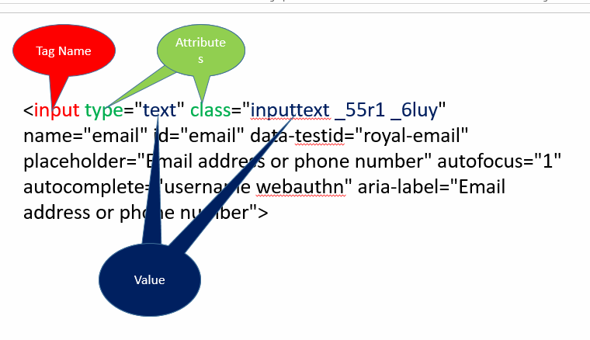

Locators
- Locators are the way to identify / locate any control on the web page
- Locators are the strategies to identify controls on the page.

- Name
- Id
- ClassName
- CssSelector
- XPath
- LinkText
- PartialLinkText
- TagName

Locator className
- To locate any control by using the value of attribute class
- The control may having multiple classes applied. Such a multiple classes are separated via space.
- While using className locator pick any one class name from such multiple classes.

Locator cssSelector:
- This is the technique / locator via which you can locate any control by using any one or multiple attributes of the control.
- Types
  - Using Single Attribute
Syntax:
tagName[attribute=”value”]
input[data-testid="royal-email"]
  - Using Multiple Attributes
Syntax:
tagName[attribute1=”Value”][attribute2=”value”]
  - Using Special Characters
    - ^ Starts With
    - $ Ends With
    - * Contains Text
    - .
    - #

Pattankodoli Bus Stand Take a right turn Hupare Nagar Water Tank Lane No 9 House No 1128

XPath XML Path
Types
- Absolute XPath
- Relative XPath

